1. Import the Titanic Dataset from the link Titanic Data Set.

Perform the following:

a. Preprocess the passenger names to come up with a list of titles that represent families and represent using appropriate visualization graph.

ANS.

**pass_titles <- ""**

**for(i in 1:891){**

**pass_titles <- c(pass_titles,pass_names[[i]][2])**

**}**

**pass_titles <- pass_titles[-1]**

**titles <- ""**

**for( i in 1:891){**

**temp <- strsplit(pass_titles[i],"\\.")**

**titles <- c(titles,temp)**

**}**

**titles[1] <- NULL**

**title_category <- ""**

**for(i in 1:891){**

**title_category <- c(title_category,titles[[i]][1])**

**}**

**title_category <- title_category[-1]**

**title_category <- as.factor(title_category)**

**levels(title_category)**

**summary(title_category)**

**others <- 0**

**for(i in 1:17){**

**if(i == 8 || i == 9 || i == 12 || i == 13 )**

**{**

**next()**

**}**

**else{**

**others <- others + summary(title_category)[i]**

**}**

**}**

**# We have grouped small categories such as Capt , Col ,Don.....etc into 'others'**

**title_category <- c(summary(title_category)[8],summary(title_category)[9],summary(title_category)[12],summary(title_category)[13],others)**

**label <- c("Master","Miss","Mr.","Mrs.","Others")**

**library(plotrix)**

**pie3D(title_category,labels = label,main="List of Titles")**

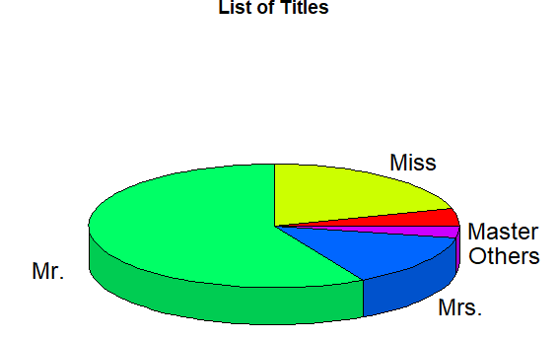

b. Represent the proportion of people survived from the family size using a graph.

ANS.

**pass_names <- ""**

**for( i in 1:891){**

**temp <- strsplit(titanic_train$Name[i],",")**

**pass_names <- c(pass_names,temp)**

**}**

**pass_names[[1]] <- NULL**

**pass_surnames <- ""**

**for(i in 1:891){**

**pass_surnames <- c(pass_surnames,pass_names[[i]][1])**

**}**

**pass_surnames <- pass_surnames[-1]**

**class(pass_surnames)**

**pass_surnames <- as.factor(pass_surnames)**

**pass_surnames_list <- levels(pass_surnames)**

**pass_surnames_list_count <- rep(0,times=667)**

**count <- 0**

**for(i in 1:667){**

**n1 <- pass_surnames_list[i]**

**for(j in 1:891){**

**n2 <- pass_surnames[j]**

**if(n1 == n2)**

**count <- count + 1**

**}**

**pass_surnames_list_count[i] <- count**

**count <- 0**

**}**

**pass_surnames_list_count <- as.factor(pass_surnames_list_count)**

**family_size <- levels(pass_surnames_list_count)**

**#summary(pass_surnames_list_count)**

**family_size_count <- table(pass_surnames_list_count)**

**titanic_survived <- data.frame(titanic_train$Survived,pass_surnames)**

**count<- rep(0,times=891)**

**titanic_survived <- data.frame(titanic_survived,count)**

**colnames(titanic_survived) <- c("survived","surnames","family_size")**

**for(i in 1:891){**

**n <- titanic_survived$surnames[i]**

**for(j in 1:667){**

**if(n == pass_surnames_list[j]){**

**titanic_survived$family_size[i] <- pass_surnames_list_count[j]**

**break**

**}**

**}**

**}**

**c1 <- table(titanic_survived$survived,titanic_survived$family_size)**

**barplot(c1,xlab="Family Size",col=c("red","blue"),legend=c("Not Survived","Survived"),beside = T)**

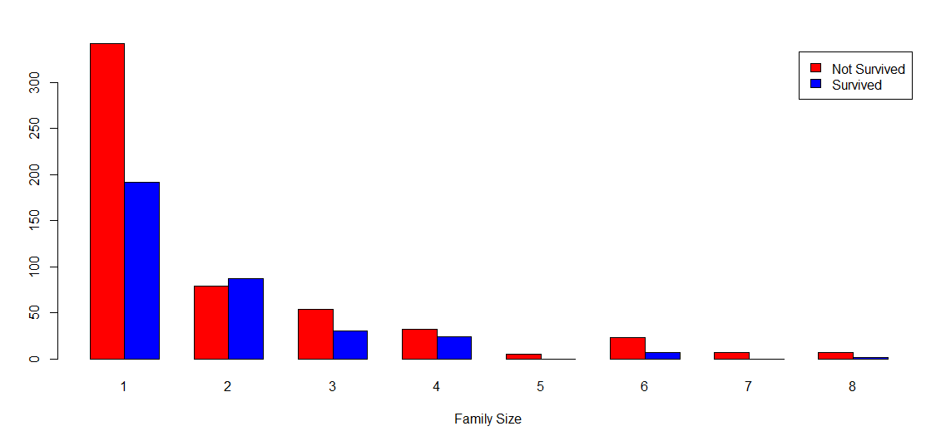

c. Impute the missing values in Age variable using Mice Library, create two different graphs showing Age distribution before and after imputation.

ANS.

**sum(is.na(titanic_train$Age))**

**install.packages("mice")**

**library(mice)**

**md.pattern(titanic_train)**

***# We found there are total 177 missing values in AGE attribute of titanic_train dataset.***

**mice_imputes = mice(titanic_train, m=5, maxit = 40)**

**Imputed_data=complete(mice_imputes,5)**

**hist(titanic_train$Age, freq=F, main='Age: Original Data',**

**col='darkgreen')**

**hist(Imputed_data$Age, freq=F, main='Age: MICE Output',**

**col='lightgreen')**

