1. Import the Titanic Dataset from the link Titanic Data Set.

Perform the following:

a. Is there any difference in fares by different class of tickets?

Note - Show a boxplot displaying the distribution of fares by class.

ANS.

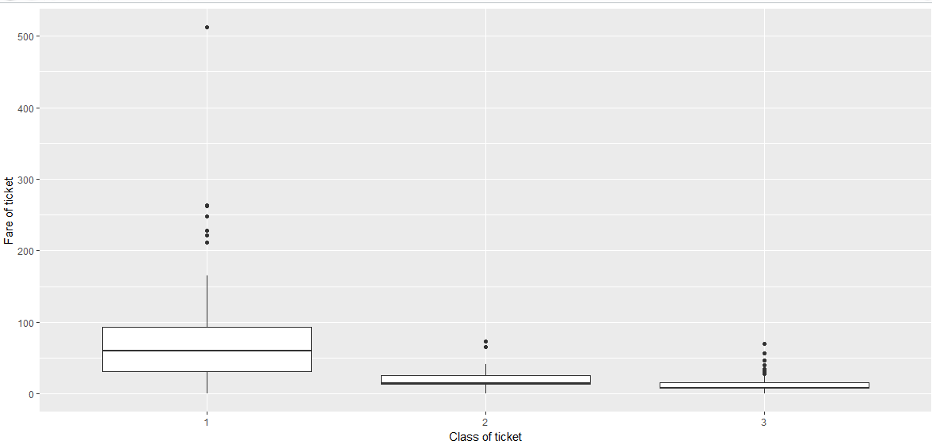

As the two variables are independent

b. Is there any association with Passenger class and gender?

Note – Show a stacked bar chart.

ANS.

$H_{0}:$ There is no association between Passenger class and gender.

$H_{a}$: There is association between Passenger class and gender.

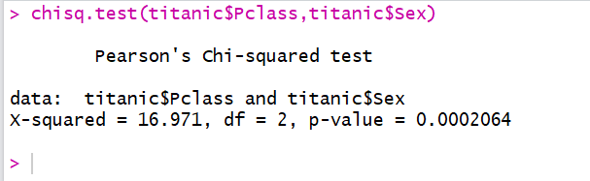

As p-value is < 0.05 we accept null hypothesis. Thus there is association between Passenger class and gender.

c <- table(titanic$Pclass,titanic$Sex)

barplot(c,legend=c("1","2","3"))

