Q1. Histogram for all variables in a dataset mtcars. Write a program to create histograms for all columns.

Ans. **CODE:**

library(purrr)

library(tidyr)

library(ggplot2)

mtcars %>%

keep(is.numeric) %>%

gather() %>%

ggplot(aes(value)) +

facet_wrap(~ key,scales = "free") +

**geom_histogram()**

**OUTPUT:**

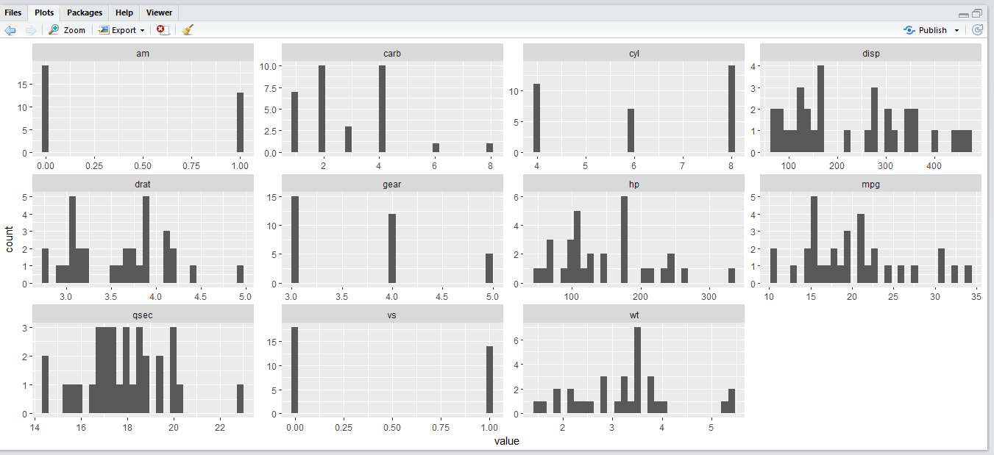

Q2. Check the probability distribution of all variables in mtcars.

ANS. **CODE**

mtcars %>%

keep(is.numeric) %>%

gather() %>%

ggplot(aes(value)) +

facet_wrap(~ key,scales = "free") +

**stat_density()**

**OUTPUT**

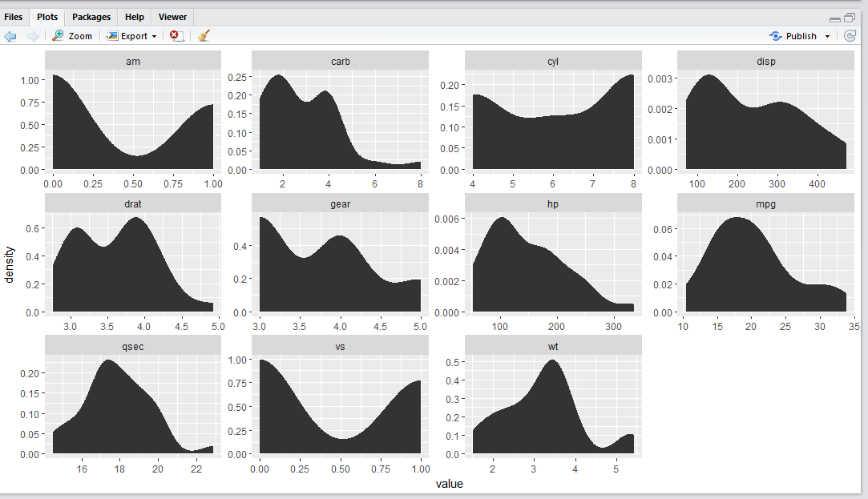

Q3. Write a program to create boxplot for all variables.

ANS. **CODE**

***miles_per_gallon <- rep(mtcars[,2],times=5)***

***miles_per_gallon <- unlist(miles_per_gallon)***

***mtcars[,c(3,9,10,11,12)] %>% gather() %>%***

***ggplot(aes(x=factor(value),y=miles_per_gallon)) +***

***geom_boxplot() + facet_wrap(~key)***

**OUTPUT**

