1. Write a program to create barplots for all the categorical columns in mtcars.

ANS.

***library(tidyr)***

***library(ggplot2)***

***library(dplyr)***

***matcars <- NULL***

***matcars <- mtcars[,c(3,9,10,11,12)]***

***matcars %>%***

***gather() %>%***

***ggplot(aes(x=factor(value))) +***

***facet_wrap(~ key,scales = "free") +***

***geom_bar() + theme_bw()***

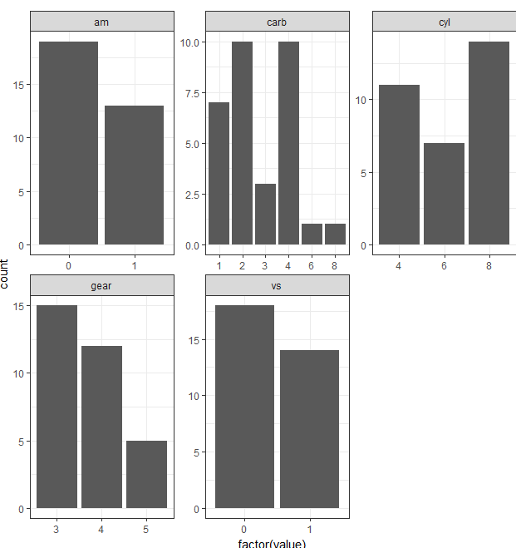

1. Create a scatterplot matrix by gear types in mtcars dataset.

ANS. **pairs(~gear + mpg + cyl + disp + hp + drat + wt + qsec + vs + am + carb, data = mtcars, main = "Simple Scatterplot Matrix",col="blue")**

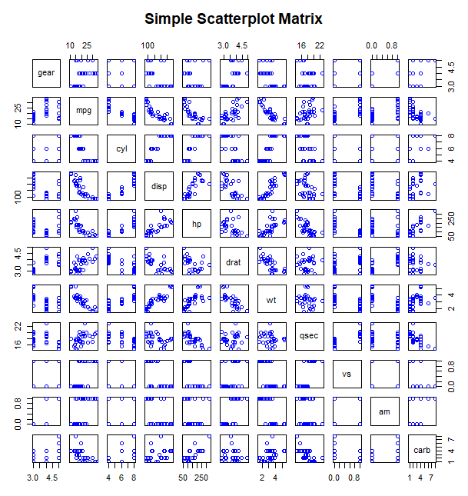

1. Write a program to create a plot density by class variable.

ANS.

***d <- density(mtcars$mpg)***

***plot(d,main="Density")***

***polygon(d,col="green",border = "black")***

