1. Use the package RcmdrPlugin.IPSUR.

data(RcmdrTestDrive)

and perform the below operations:

1. Calculate the average salary by gender and smoking status.

ANS.

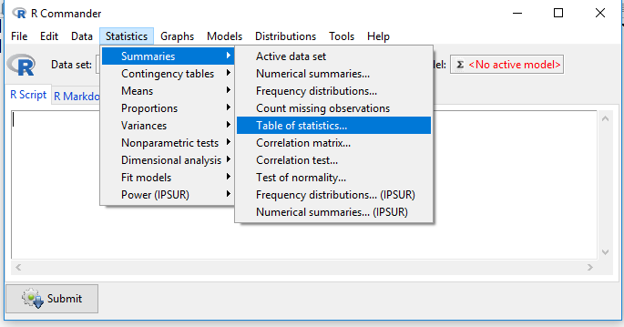

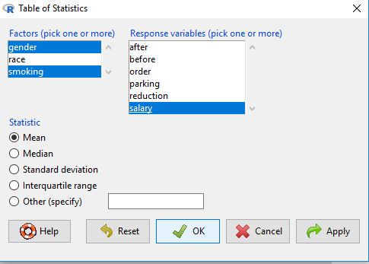

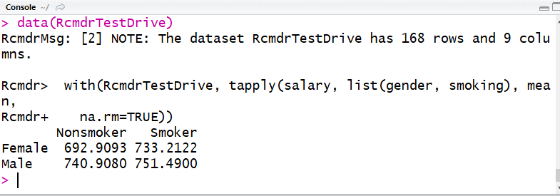

1. Which gender has the highest mean salary?

ANS.

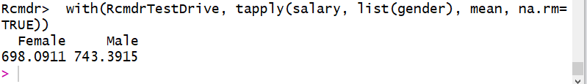

**MALE is having the highest mean salary.**

1. Report the highest mean salary.

ANS.

**Highest mean salary according to gender is 743.3915.**

**Highest mean salary according to gender and smoking status is 751.49.**

1. Compare the spreads for the genders by calculating the standard deviation of salary by gender.

ANS.

