Q1. If Z is norm (mean = 0, sd = 1)

Find P(Z > 2.64)

Find P(|Z| > 1.39)

ANS.

**P(Z>2.64):**

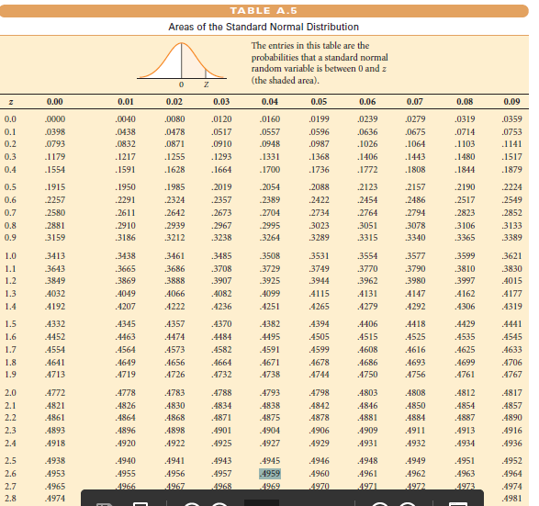

From above table we get value of area between z=0 and z=2.64

Area=0.4959

To have P(Z>2.64), 0.5 – Area= 0.5- 0.4959=0.0041

Alternatively we can also use pnorm() function of R to find P(Z<2.64)

Then to get desired answer we need to substract that area from 1.

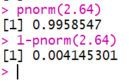

**P(|Z|<1.39):**

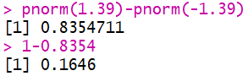

Q2. Suppose p = the proportion of students who are admitted to the graduate school of the University of California at Berkeley, and suppose that a public relation officer boasts that UCB has historically had a 40% acceptance rate for its graduate school. Consider the data stored in the table UCBAdmissions from 1973. Assuming these observations constituted a simple random sample, are they consistent with the officerâ..s claim, or do they provide evidence that the acceptance rate was significantly less than 40%? Use an Î± = 0.01 significance level.

ANS.

$H_{0}$: p = 0.4

$H_{a}$: p < 0.4

We reject null hypothesis if $\hat{p}$ is too small i.e

If $\frac{\hat{p}-0.4}{\sqrt{0.4(1-0.4)/n}}$ < ${-Z}_{α}$

α = 0.01 Thus to find ${-Z}_{0.01}$ we use **qnorm()** function of R.



Now we will find out our test statistic.

***ucb_data <- as.data.frame(UCBAdmissions)***

***View(ucb_data)***

***summary(ucb_data$Admit)***

***dim(ucb_data)***

***phat <- 12/(24)***

***t <- (phat-0.4)/sqrt(0.4*0.6/(24))***

***t***

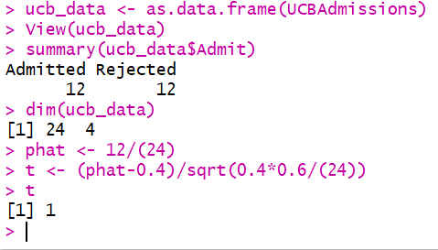

From above calculations it is clear that our test statistic is not less than ${-Z}_{0.01}$. So we accept null hypothesis i.e. $H_{0}$.

Thus we can say that **the observed data are consistent with the officer’s claim at α = 0.01 Level of Significance.**