1. Calculate the P Value for the test in Problem 2.

ANS.

We use pnorm() for finding the probability.

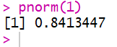

2. How do you test the proportions and compare against hypothetical props? Test Hypothesis: proportion of automatic cars is 40%.

ANS.

