Q1. What are the names of all the countries in the databases which start with the letter "B"

(sorted by their names)?

SQL QUERY:

**select country**

**from country**

**where country like 'B%';**

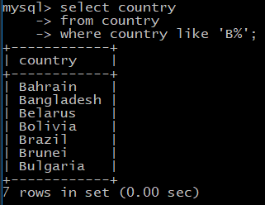

Q2. Return the first names (sorted) of all the actors with the last name "berry".

SQL QUERY:

**select first_name as "First Name"**

**from actor**

**where last_name='berry';**

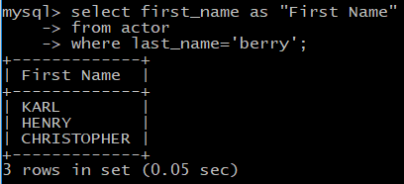

Q3. Find all the films whose length is more than 184 (inclusive). Order the results by the length

(and for films with the same length order them by their name). Return their title and the length.

SQL QUERY:

**select title,length**

**from film**

**where length>=184**

**order by length,title;**

