The sakila-schema.sql file contains all the CREATE statements required to create the structure of the Sakila database including tables, views, stored procedures, and triggers.

The sakila-data.sql file contains the INSERT statements required to populate the structure created by the sakila-schema.sqlfile, along with definitions for triggers that must be created after the initial data load.

The sakila.mwb file is a MySQL Workbench data model that you can open within MySQL Workbench to examine the database structure. For more information, see [MySQL Workbench](https://dev.mysql.com/doc/workbench/en/).

1. Extract the installation archive to a temporary location such as C:\temp\ or /tmp/. When you unpack the archive, it creates a directory named sakila-db that contains the sakila-schema.sql and sakila-data.sql files.
2. Connect to the mysql command line.

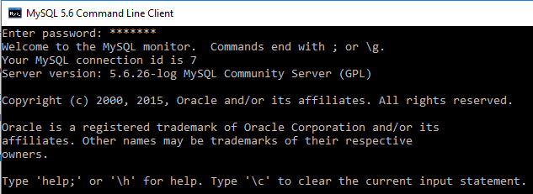

1. Execute the sakila-schema.sql script to create the database structure by using the following command:



1. Execute the sakila-data.sql script to populate the database structure with the following command:



1. Confirm that the sample database is installed correctly. Execute the following statements. You should see output similar to that shown here.

