A tree is a nonlinear hierarchical data structure that consists of nodes connected by edges.

**Height of a Node**

The height of a node is the number of edges from the node to the deepest leaf (ie. the longest path from the node to a leaf node).

**Depth of a Node**

The depth of a node is the number of edges from the root to the node.

**Height of a Tree**

The height of a Tree is the height of the root node or the depth of the deepest node.

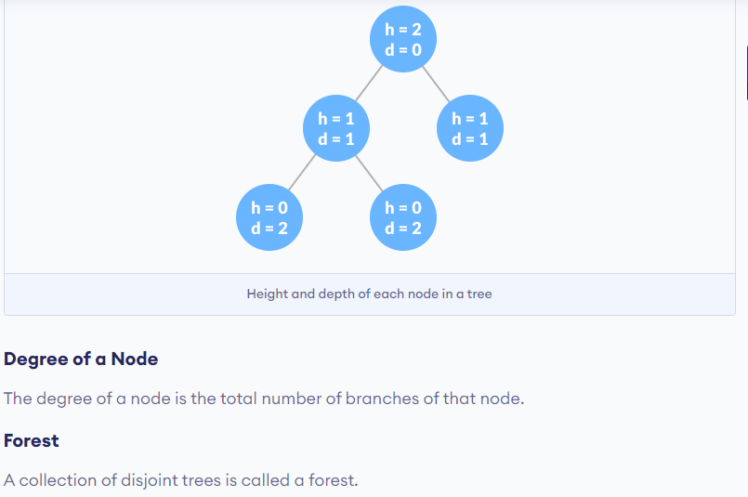

Tree Applications

Binary Search Trees(BSTs) are used to quickly check whether an element is present in a set or not.

Heap is a kind of tree that is used for heap sort.

A modified version of a tree called Tries is used in modern routers to store routing information.

Most popular databases use B-Trees and T-Trees, which are variants of the tree structure we learned above to store their data

Compilers use a syntax tree to validate the syntax of every program you write.

# BINARY TREE

A binary tree is a tree data structure in which each parent node can have **at most** two children.

