**Advance Blind Turn Traffic Indicator and Accident**

**Prevention System**

**Research Paper**



**Department of Computer Science and Information Technology**

**Acropolis Institute of Technology & Research, Indore**

**Bachelor of Technology**

**(Computer Science and Information Technology)**

**Under the Supervision of:- Submitted By:-**

**Prof. Nisha Rathi Mam Aman Sharma (0827CT191008)**

**Aniket Tiwari (0827CT191010)**

**Ashwin Vyas (0827CT191012)**

ABSTRACT

According to Million Death Study (MDS), about 2.3 million people die in India per year. In that 137 thousand is because of road accidents. That is about 377 people per day. In that 3.7% because of failed to look the road. The main reason for the accident in the curve roads is because drivers are not able to see the vehicle or obstacles coming from the other end of the curve. Due to very high speed, it is difficult to control the vehicle, and the chances of falling to a cliff increase. With the inclusion of both visual (type of vehicle) and speed of the vehicle, the current situation in the corner can be showcased. The system alerts the driver before entering the corner itself on Real-Time basis so that driver can take precautionary steps to sail through the corner. The proposed idea of visual-based Blind turn traffic indicator and accident prevention system can greatly improve the safety of the people traveling through those roads.

**Key-Words***:-* IOT,Deep Learning, CNN(Convolutional Neural Network), Vehicle detection, Vehicle Speed detection.

INTRODUCTION

Traditional ways to prevent accidents in blind turn are achieved by blowing the horn, using dipper and Convex Mirrors (Road Safety Mirrors) that are used to alert other drivers. Gaps in the present system are as follows:

1. Limited range of vision of convex mirrors

2. Rain or foggy weather

3. Nonfunctioning of horn/dipper

4. Least chance of hearing horn sound

The purpose of the proposed system is to reduce the number of accidents on mountain roads and blind turns. Thus, the system helps to prevent fatal accidents that are very frequent in blind corners especially at high-risk accident-prone blind corners.

Related Work or Literature Review

EXCEL SHEET- LINK

Motivation

There are many dangerous roads in the world like mountain roads, narrow curve roads, T roads. Some mountain roads are very narrow and they have many curves.

The problems in these curve roads is that the drivers are not able to see the vehicle or obstacles coming from another end of the curve.

Hence there is a need of many road safety systems. To avoid these problems in curve roads of mountain areas, we have proposed this vehicle accident prevention system**.**

.

Problem Domain

It is an IOT and DL based Accident prevention system. The project's main objective is to prevent accidents on the blind turns especially in hilly areas .

Problem Definition

There are many accidents due to blind turns and U-turns especially in hilly areas because the drivers of one side are not aware that the vehicle is coming on the other side and at what speed and which type of vehicle, due to which it leads to accidents.

Representation or System Design

In First Module, we will alert driver by placing Ultrasonic Sensor on both side of the road before the curve and keeping LED lights on other side of the curve, so that if vehicle comes from one end of the curve sensor will sense the vehicle and turn OFF the GREEN LED and turn ON the RED LED at the opposite side of the road. By looking at the Red LED light driver can become alert and can slow down the speed of the vehicle.

In Second Module,we will check the frequency shift of vehicle with Microwave Doppler Radar Sensor which Send’s the signal to processor to calculate speed and after calculations it will display speed of the vehicle.

In the third module, we will capture images of vehicles, and these images will be processed with the help of Deep Learning algorithm CNN convolutional neural networks along with VeRi datasets determine the type of the vehicle. In this module, we will also count the number of vehicles which will be displayed on screen along with the type of vehicle

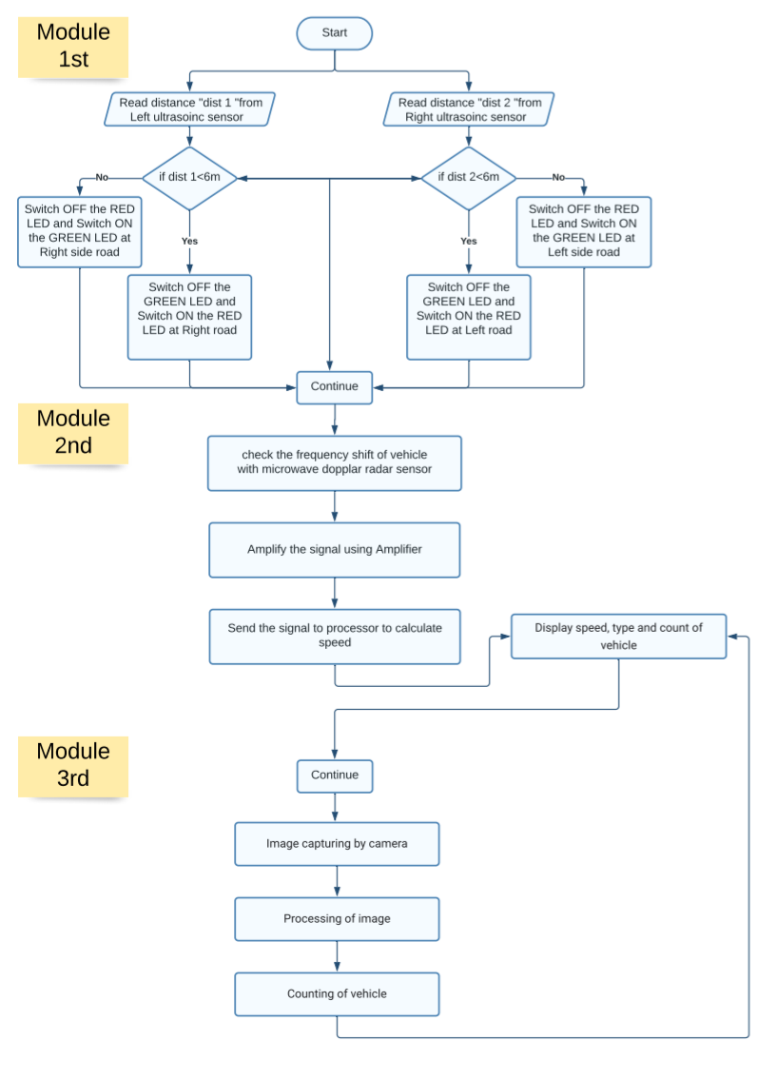

Innovative Content :-

After doing Literature review, we have found that mostly on blind turns they have only red light green light signals to alert drivers but this is not an accurate solution for the problem especially in foggy or rainy season. As a result of this we are proposing a system that will detect vehicle its speed and also the type of vehicle to the drivers for better understanding of the situation in blind corners.

Future Work

Conclusion

The purpose of this project is to reduce the number of accidents at mountain roads and blind turns. Thus, the system helps to prevent head-on collision and also a fatal accident that is very frequent in blind corners. With the inclusion of both visual (type of vehicle) and speed of the vehicle, the current situation in the corner can be showcased. The system alerts the driver before entering the corner itself so that driver can take precautionary steps in order to sail through the corner. Thus, it will be an effective solution that can be implemented in mountain and ghat roads where mirrors cannot be used effectively due to all whether conditions. This system can greatly improve the safety of the passengers traveling through those roads.

Acknowledgement

The authors sincerely thank Prof. RUCHIKA CHOUHAN Mam, HOD Prof. SHILPA BHALERAO, and CSIT Department for her Expert guidance and support throughout the work. The Authors also thank ACROPOLIS INSTITUTE OF TECHNOLOGY AND RESEARCH and RGPV University for the infrastructure and Support provided.

Reference

# References

|  |  |
| --- | --- |
| [1] | jesss Prabawa gozali, Min-yen Kan and Hari Sundara, "How to people organize Event," *ACM DIGITLAL LIBRARY,* pp. 315-324, 2012. |
| [2] | Jeffrey M Zacks, "How we organize our experience into event," *dcl.wustl.edu,* vol. 24, no. 4, 2010. |
| [3] | Andrea M armani and svlvain gigan , "how to organize an online conference," *nature.com,* vol. 5, no. 4, pp. 235-256, 2020. |
| [4] | Deniel G Morrow, "Prominent characters and events organize narrative understanding," *sciencedirect.com,* vol. 24, no. 3, pp. 304-319, 1985. |
| [5] | gert olthusis and Florieke Eggermont, "What is it like to organize a large scale education event for fellow student," *BMC medical education,* vol. 22, no. 1, pp. 1-8, 2022. |
| [6] | john B Nezlek, "Multi level random coefficient analyses of event and interval contingent data in social and personality psychology research," *Sage journals,* vol. 27, no. 7, pp. 771-785, 2001. |
| [7] | Nic Fleming, "How to organize a conference thats open to every one," *Gale,* vol. 571, no. 7766, p. 46, 2019. |
| [8] | Kenneth F Backman, sheila J Backman and Muzaffer uysal, "Event tourism," *ingentaconnect.com,* vol. 3, no. 1, pp. 15-24, 1995. |
| [9] | . D. R, G. R, S. k. T, V. K and V. K, “Android Application for Event MAnagement System,” *International Conference on System, Science, Control, Communication, Engineering and Technology,* vol. 02, pp. 323-330, 2016. |
| [10] | Nikita M. Bawankar, Ankita T. Tembhurne and Gayatri R. Chatap, “EVENT MANAGEMENT SYSTEM,” *CSE SRM College of Engineering,* vol. 7, no. 2, pp. 128-131, 2021. |
| [11] | Amir Saleem, Davood Ahmed Bhat and Omar Farooq Khan, “Review Paper on an Event Management System,” *International Journal of computer and Mobile Computing,* vol. 6, no. 7, pp. 40-43, 2017. |
| [12] | Mr.J Nagesh Babu, Ms Surjana J M and Ms Sushma Kulkerni, “Event Management System,” *IFERP,* vol. 6, no. 5, pp. 24-26, 2019. |
| [13] | Sachin Ajay Kumar Pasi, Altaf Taher Shah and Amol B. Kasture, “A STUDY AND IMPLIMENTATION OF EVENT MANAGEMENT SYSTEM USING SMARTPHONE,” *IJIRMPS,* vol. 6, no. 5, pp. 75-78, 2018. |
| [14] | Deepanshu Goyal, Arbab Ali and Md Nasfis haider, “Projrct report research on Online Event Management System,” *Turkish Journal of Computer and Mathematics Education,* vol. 12 No. 6, pp. 5297-5303, 2021. |
| [15] | Arsheen . Khan , Aarti Pundalik and Tanvi Shainde, “EVENT MANAGEMENT SYSTEM,” *IRJET,* vol. 6, no. 1, pp. 1752-1754, 2019. |
| [16] | Arsheen Khan , Aarti Pundalik and Tanvi Shinde, "Event Management System," *IRJET,* vol. 6, no. 1, pp. 1752-1754, 2019. |
| [17] | Akash Verma, Gunjan Srivastava, Himanshu Verma and MAyank Johri, "Study on Event Management Applications," *Dr. A.P.J. Abdul Kalam Technical University ,* vol. 2, no. 4, pp. 99-104, 2017. |
| [18] | Muller Seitz and G. Schubler, "FROM EVENT MANAGEMENT TO MANAGING EVENTS," *Technische University Kalseslasuter,* pp. 1-34, 2013. |
| [19] | Kenneth f. Backman, "Event Management Research," *Clemson University,* pp. 1-3, 2017. |
| [20] | Prof. Khalil pinjari and Nur Khan, "Smart Event Management System," *INTERNATIONAL journal of Computer Science Trends abd Technology,* vol. 4, no. 2, pp. 161-164, 2016. |

END