Survey Participation & Incentive Optimization
Project Report | Propensity Modeling, Incentive Response & Economic Optimization
Development data: 170,056 invitations | Final untouched test: 29,944 invitations

1. Executive Summary
The Survey Participation & Incentive Optimization project was designed to move survey outreach from broad, largely uniform incentive assignment toward an AI-assisted next-best-action approach. The objective was to identify respondents with the highest likelihood of completing a survey, estimate how completion probability changes with incentive level, and select the incentive that maximizes modeled economic value. The final architecture combines a propensity model, an incentive-response model, business-derived survey economics, and an incentive optimizer. On the untouched test period, the final propensity model achieved ROC-AUC 0.6977, PR-AUC 0.3228, and 2.34x lift in the highest propensity decile. The optimized policy reduced modeled incentive expenditure by approximately 81%, from $90,486.54 to $17,153.50, while increasing model-based expected economic value from $6,728.61 to $77,305.89. These economic results are scenario estimates, not realized savings or causal effects, and should be validated through randomized experimentation before production deployment.

2. Objective and Data Foundation
The project used four logically separated Excel sources: respondents, surveys, invitations, and responses. The sources were merged at runtime into an invitation-level modeling dataset. The final dataset contained 200,000 invitations, approximately 63,000 clicks and 30,000 completions, with an overall completion rate of about 15.14%. No train/test labels were stored in the source files. Instead, a temporal split based on invitation date was generated in code, reducing the risk of future information leaking into model development.
A key design principle was to eliminate the leakage present in an earlier notebook, where completion-related outcome variables were used as predictors. The new feature set uses respondent, survey, historical engagement and invitation-context information while explicitly excluding completion outcomes, future timestamps and identifiers.

3. Phase I – Propensity Model Development
Five candidate classifiers were evaluated: Logistic Regression, Decision Tree, Random Forest, Gradient Boosting and HistGradientBoosting (HGB). Evaluation covered ROC-AUC, PR-AUC, log loss, Brier score, F1, top-decile lift and cumulative gain. HGB produced the strongest overall ranking performance. Logistic Regression was retained as an interpretable benchmark. Decision Tree and Random Forest offered no meaningful advantage, while Gradient Boosting required substantially more training time without sufficient improvement.
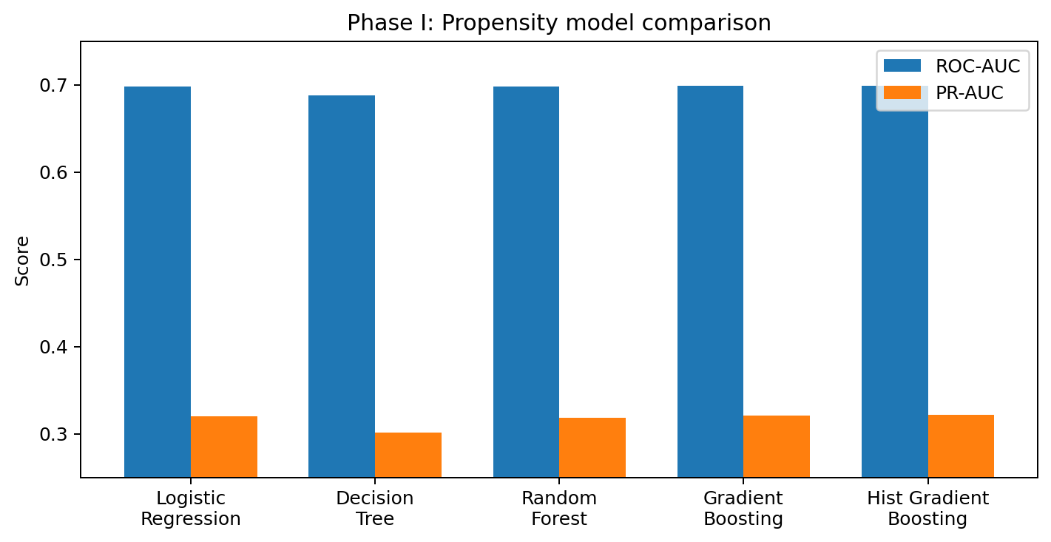

4. Phase II – Hyperparameter Tuning
The leading Logistic Regression and HGB models were tuned using time-aware cross-validation. Logistic Regression used a compact ten-candidate grid, while HGB used a 243-candidate grid. HGB tuning was computationally expensive, but validation performance was almost unchanged: tuned HGB ROC-AUC was 0.6958 versus 0.6953 for the baseline. This established that further parameter search was unlikely to produce meaningful business improvement, so the project moved to calibration and economic optimization.

5. Phase III – Calibration and Final Propensity Assessment
Calibration was investigated using sigmoid and isotonic methods. Neither improved the validation results: raw HGB had log loss 0.4128 and Brier score 0.1272, versus 0.4159/0.1282 for sigmoid and 0.4155/0.1281 for isotonic. Raw HGB was therefore retained. On the final untouched test set, the highest propensity decile achieved a 39.63% completion rate versus approximately 16.94% overall, producing 2.34x lift. Completion increased consistently across the deciles, demonstrating useful audience ranking.
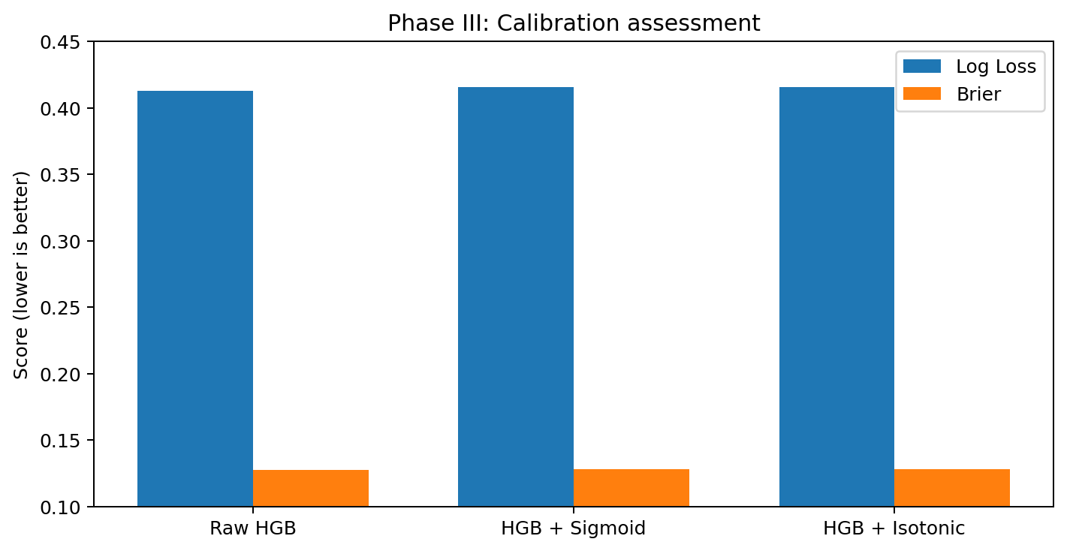
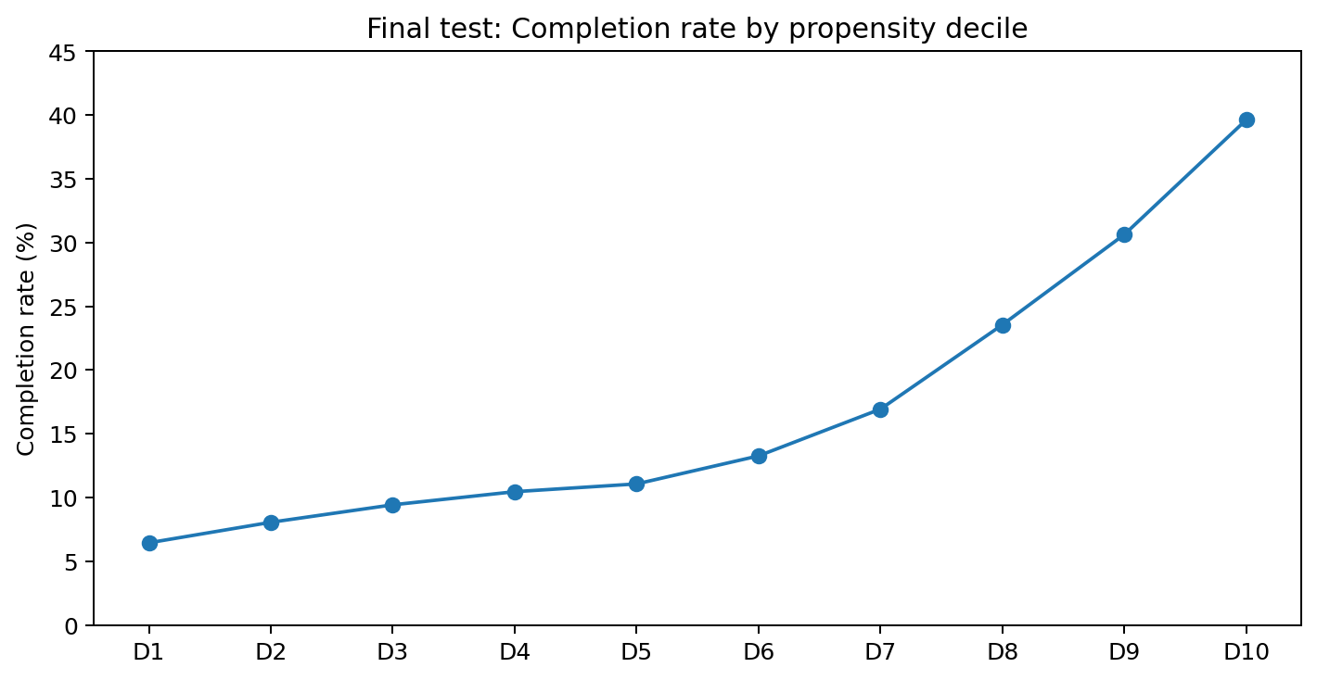

6. Phase IV – Incentive Response and Economic Optimization
Historical incentive assignment was first assessed using development data. Completion showed a broad upward relationship with incentive: the lowest incentive quantile had 13.53% completion while the highest had 16.94%. However, assignment differences across observed respondent and survey characteristics were very small, and the data is observational, so this relationship cannot be interpreted as a causal incentive effect.
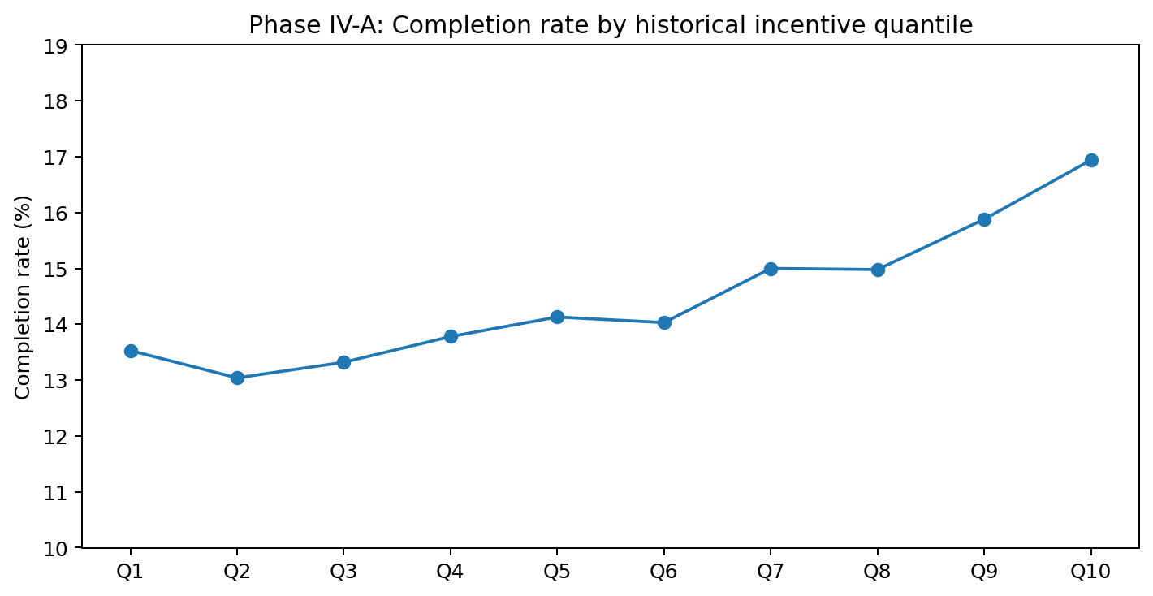
An HGB incentive-response model was then developed using incentive amount and a squared incentive term to capture nonlinear response. Candidate incentives ranged from $0.50 to $15.00, matching observed historical support. The response model achieved test ROC-AUC 0.6977, PR-AUC 0.3228, log loss 0.4187 and Brier score 0.1297.
Economic value was assigned using business rules: Consumer and Retail surveys were valued at $2–$5, B2B, Finance and Technology at $15–$30, and Healthcare at $50–$100. Within each segment, value was scaled by survey length. The optimizer evaluated each candidate incentive using Expected Value = predicted completion probability × survey economic value − incentive.

7. Phase V – End-to-End Final System
For final evaluation, train and validation periods were combined for development while the 29,944-record test period remained untouched. The resulting flow was: respondent and survey context → propensity HGB → candidate audience → incentive-response HGB → candidate incentives → economic value → economic optimizer → next-best action.
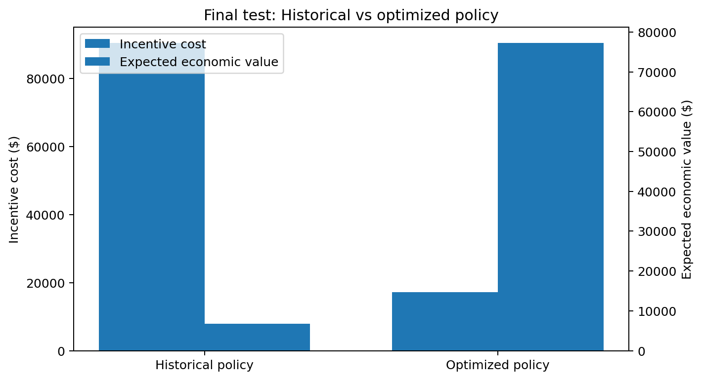
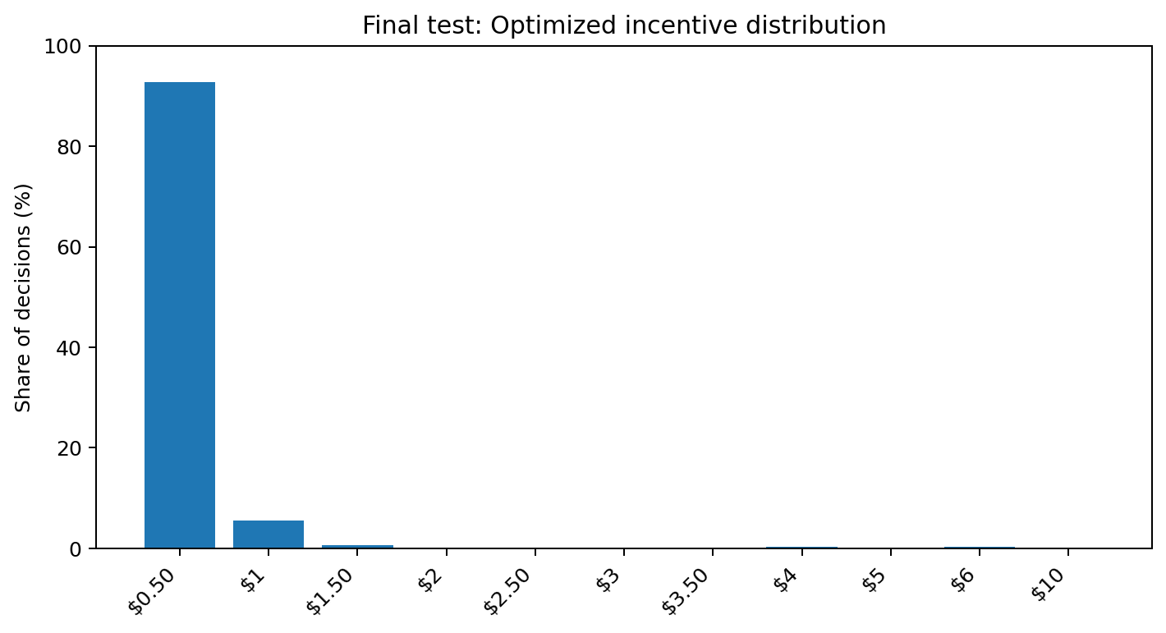

8. Outcomes, Interpretation and Next Steps
The final test policy assigned the minimum observed incentive of $0.50 to 92.77% of decisions, with smaller groups receiving higher incentives. Historical test incentive expenditure was $90,486.54 compared with $17,153.50 under the optimized policy, an 81.0% modeled reduction. Model-based expected economic value increased by $70,577.28. These figures are counterfactual model estimates under business assumptions; they are not evidence that the organization would realize an 81% cash saving in live operations.
The project therefore establishes a strong analytical prototype rather than a causal optimization system. Before production deployment, the policy should be validated through a randomized experiment with multiple incentive arms such as $0, $0.50, $2, $4 and $6. The $0 case should remain an experimental hypothesis because no historical observations existed at that level. A productization consideration is that the current propensity model includes historical incentive amount as a feature; if audience selection must occur before an incentive is assigned, this feature should be removed or the propensity model should be explicitly defined as conditional on a planned baseline incentive.
Overall, the project demonstrates an end-to-end framework for moving from descriptive survey analytics to decision optimization: rank respondents by completion propensity, model response to incentive levels, attach business value, and select the economically optimal next action. The statistical performance is useful for ranking, the economic layer makes the model actionable, and randomized validation provides the path from model-based recommendation to measured business impact.

