1. Json schema validator

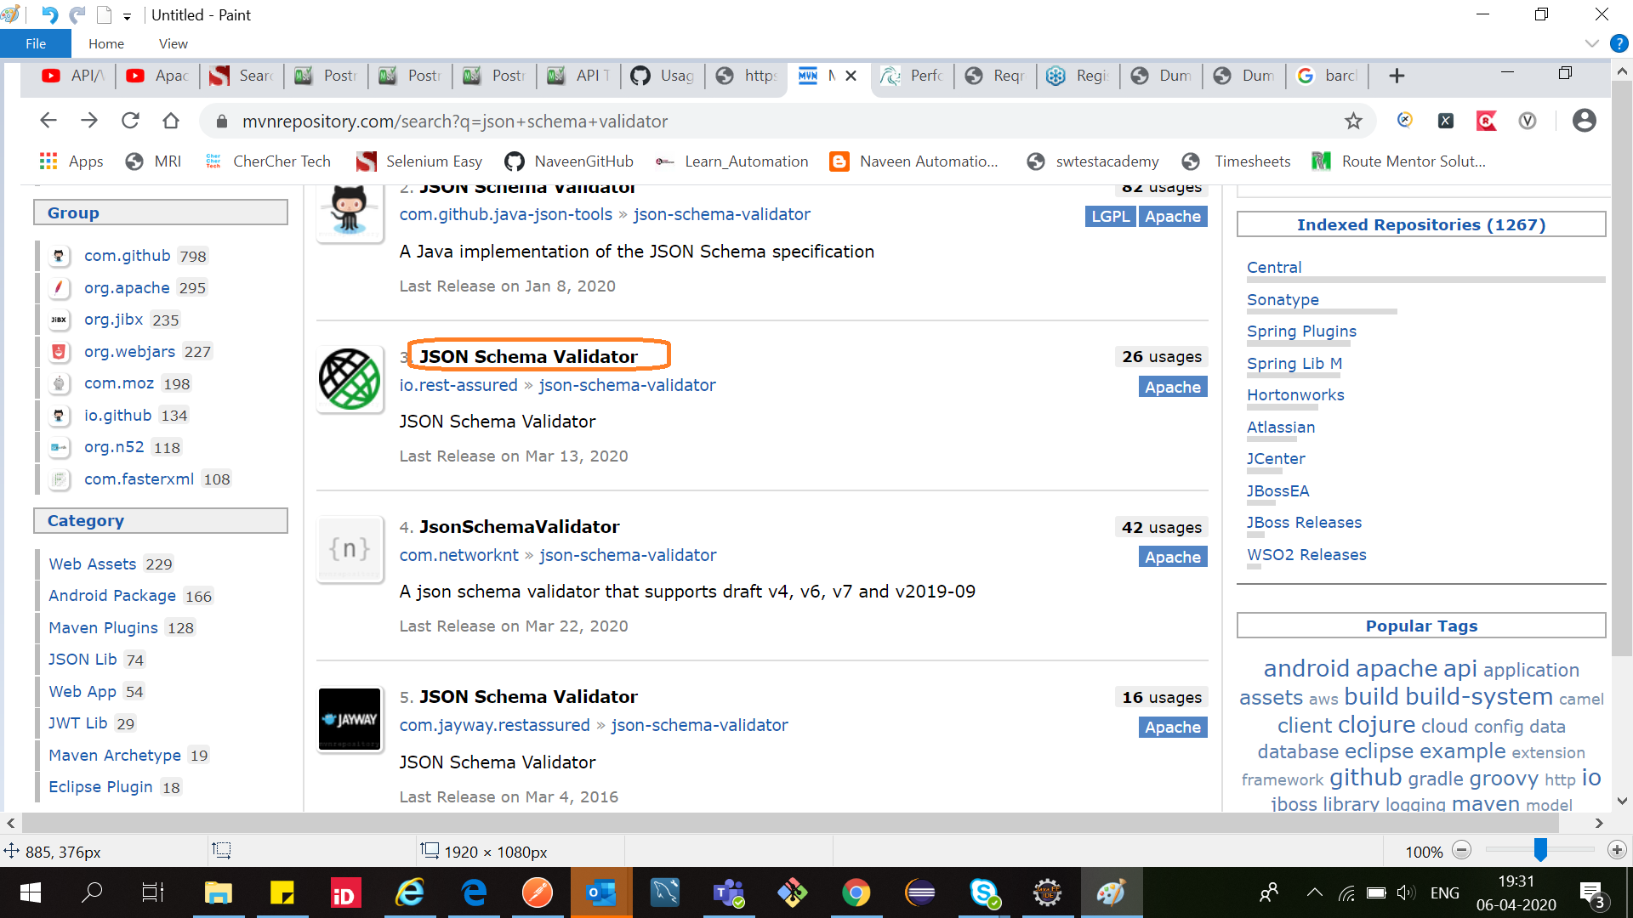

2. Json Path

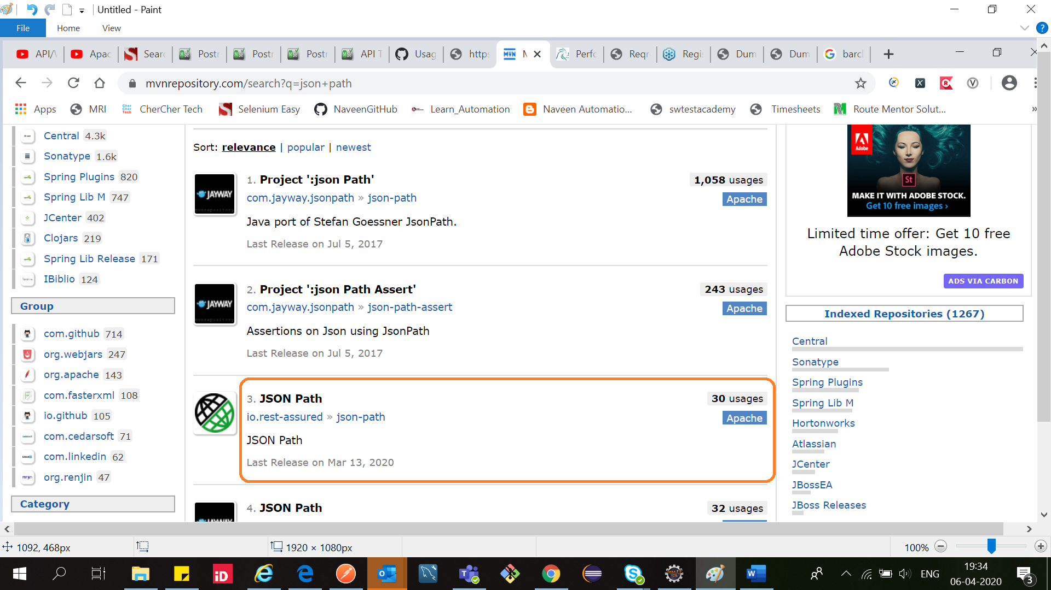

3.XML path

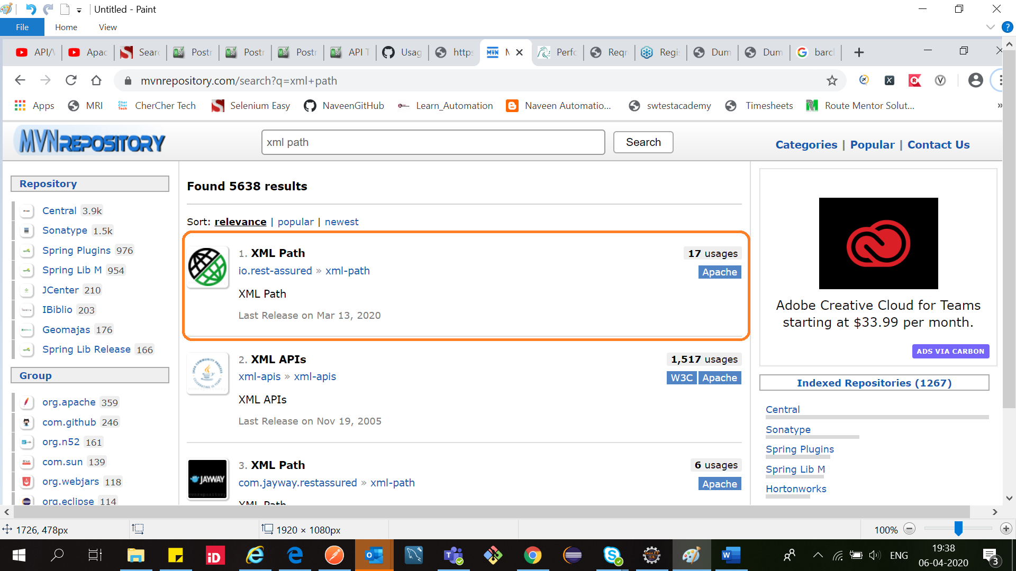

4. TestNG

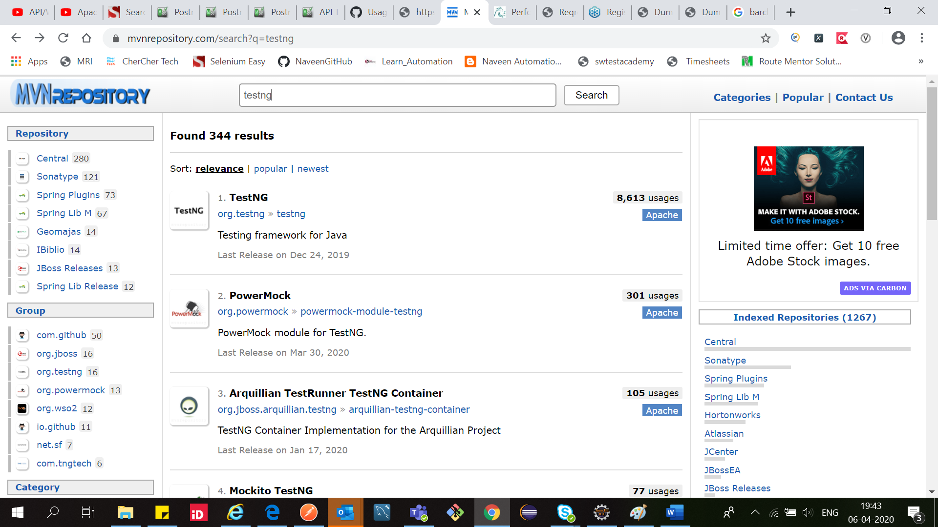

5.Java Hamcrest

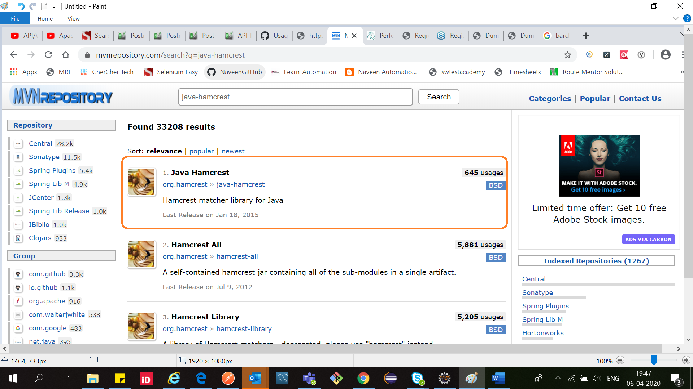

5.Harmcrest core

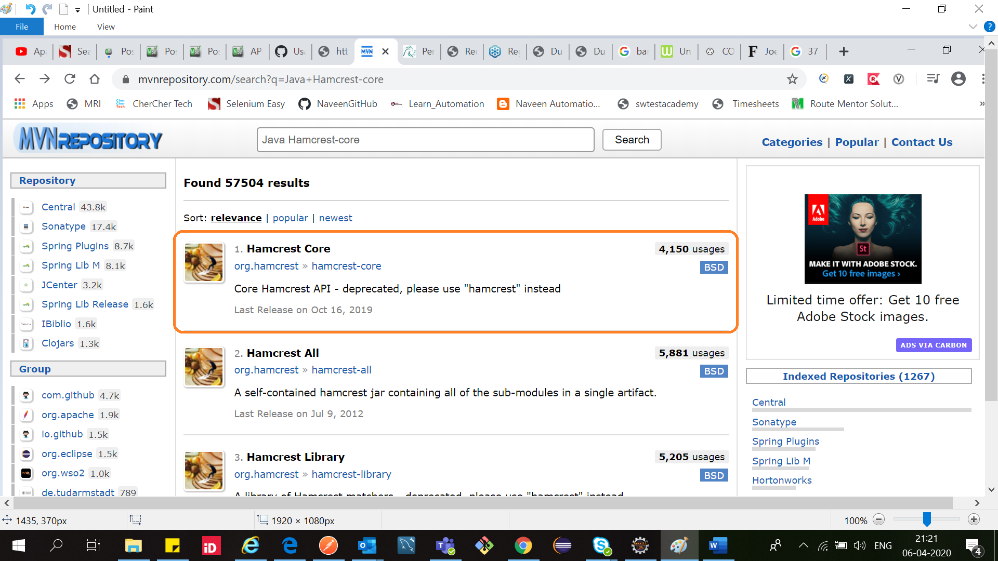

6.Harmcrest library

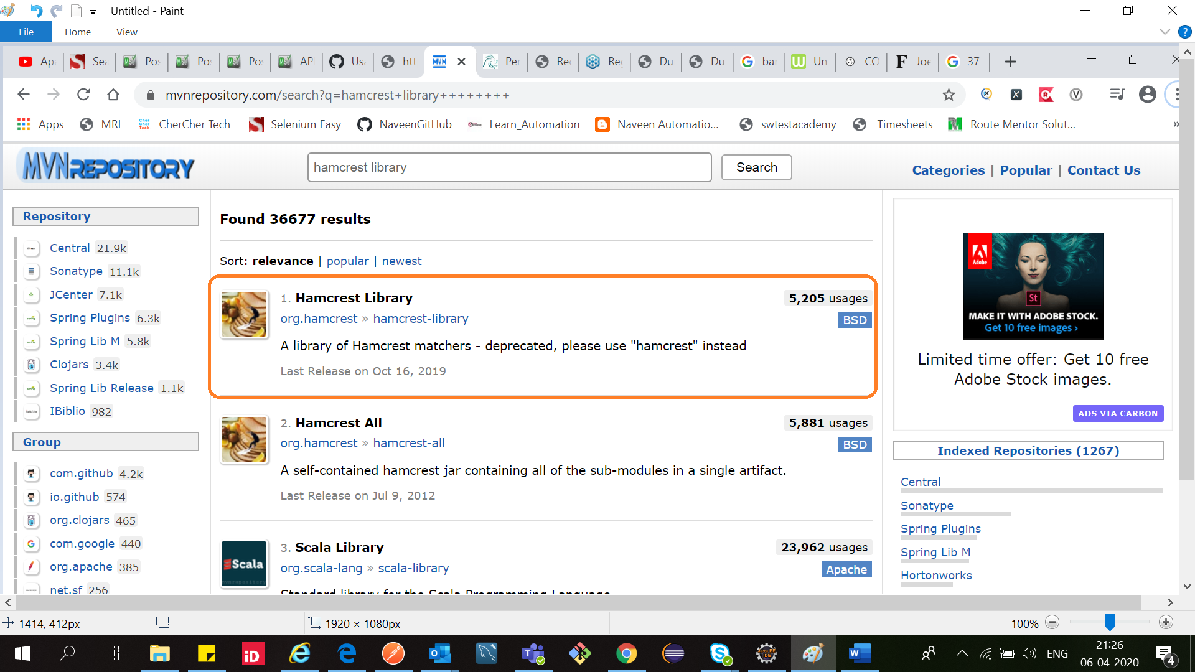

7. hamcrest-all

hamcrest-all= Harmcrest library+ hamcrestcore+ javahamcrest

**Note**

If you add hamrestall then no need to add these 3 dependencies(Harmcrest library+ hamcrestcore+ javahamcrest)

