**CODINGMART ASSIGNMENT**

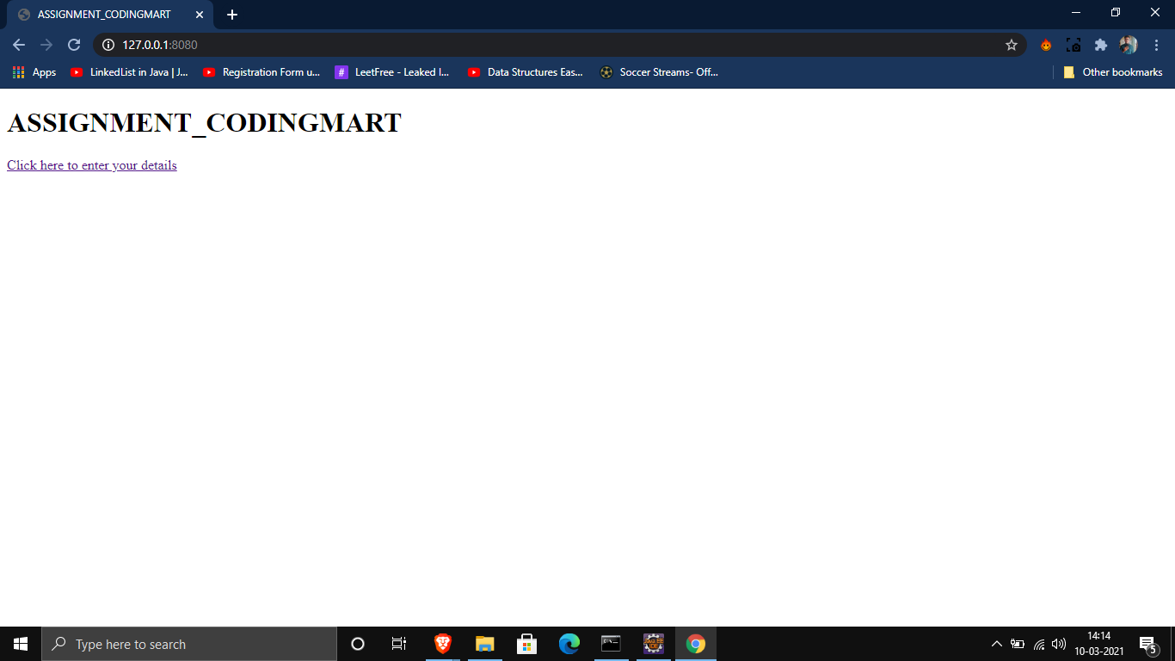

**Page 1:**

Welcome page where you click on the hyperlink to go to the page where .

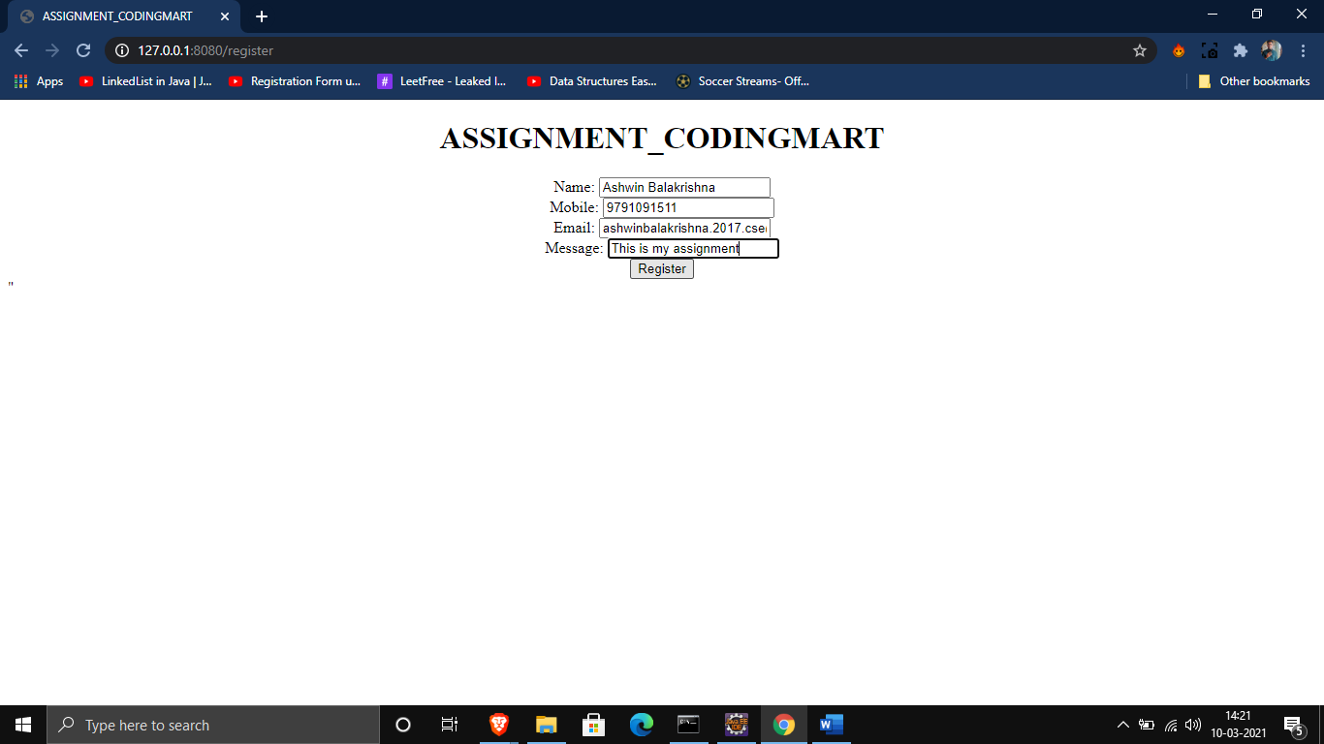

**Page2:** Fill in the required details.

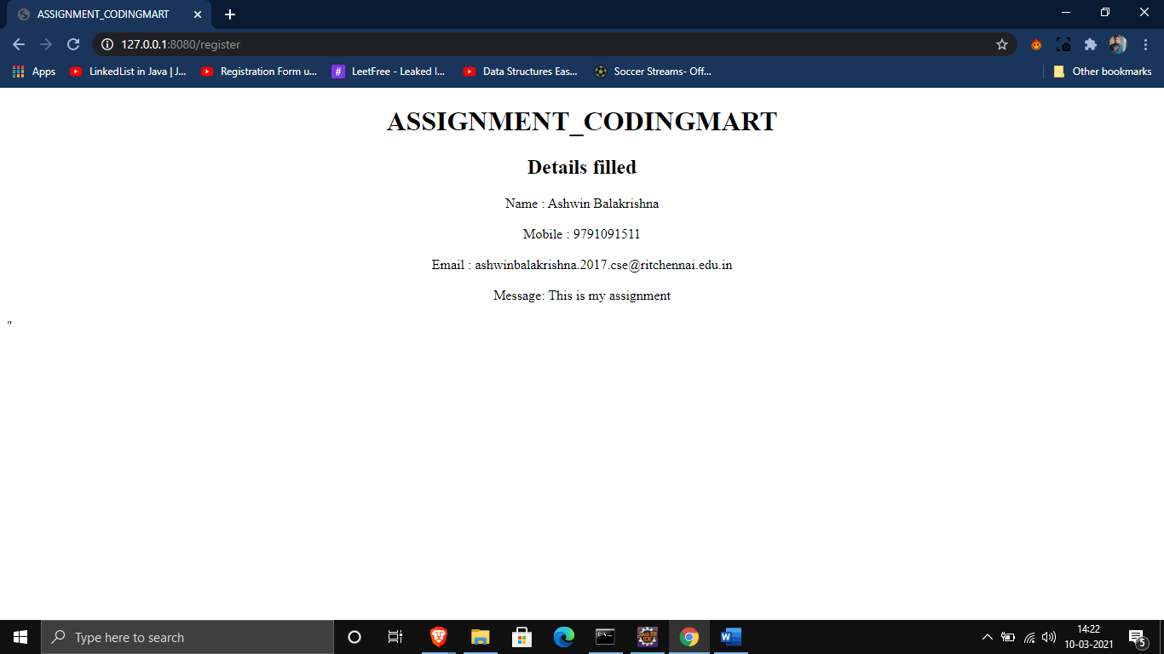

**Page3:** Details filled are displayed.