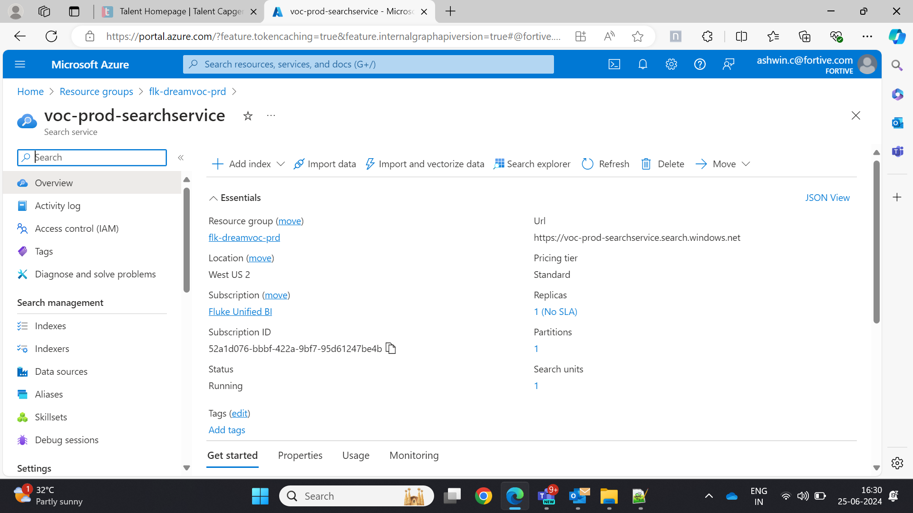

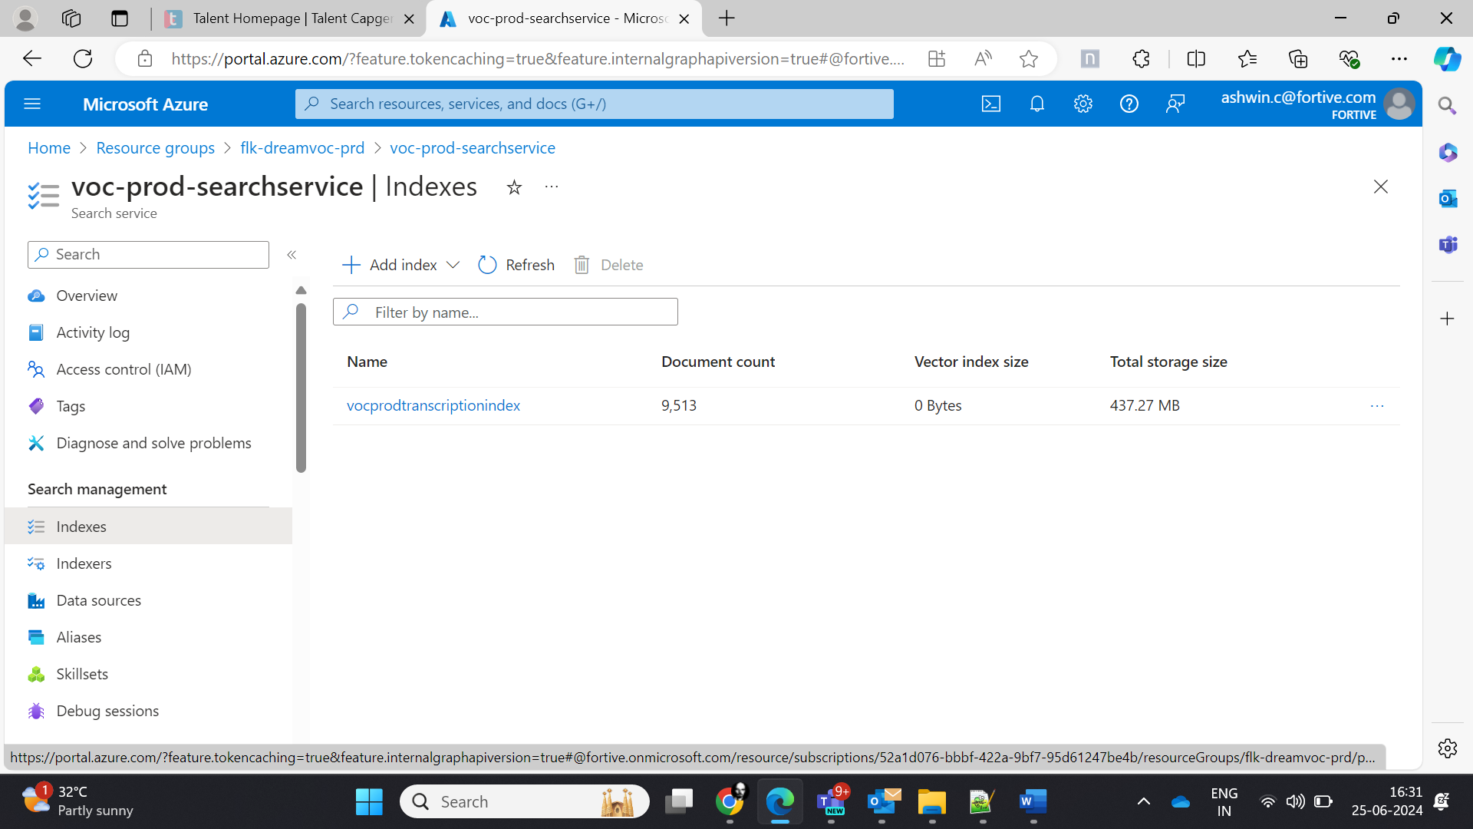

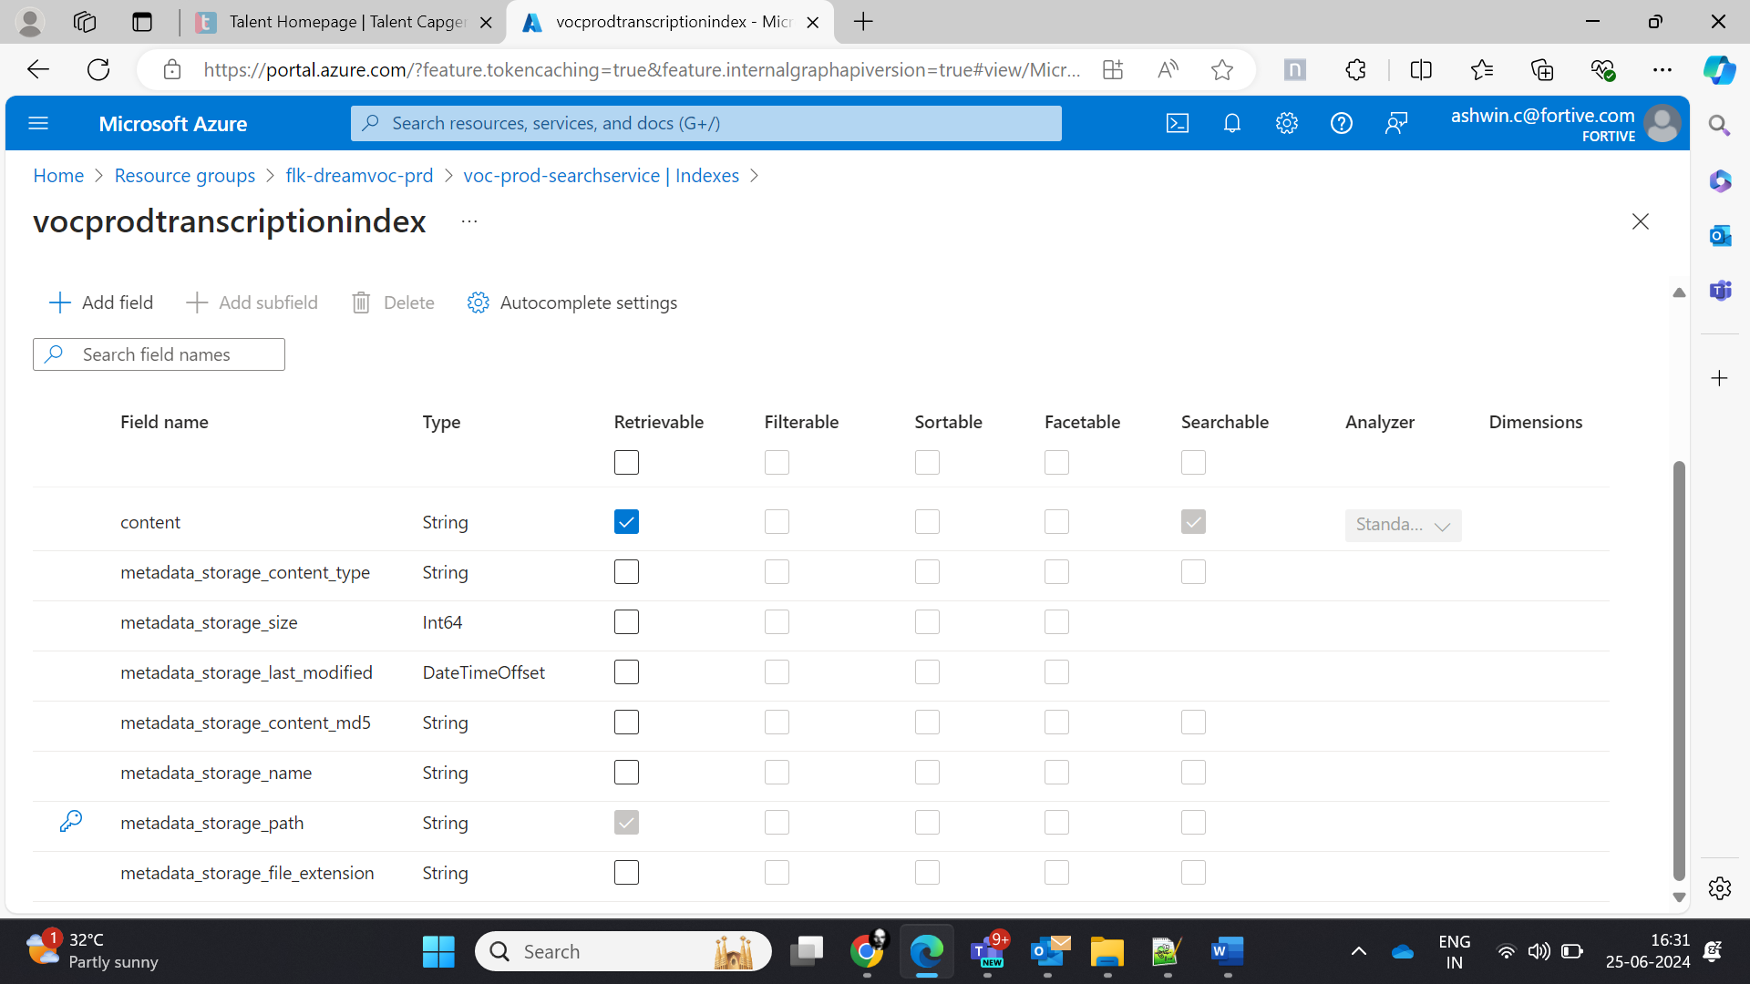

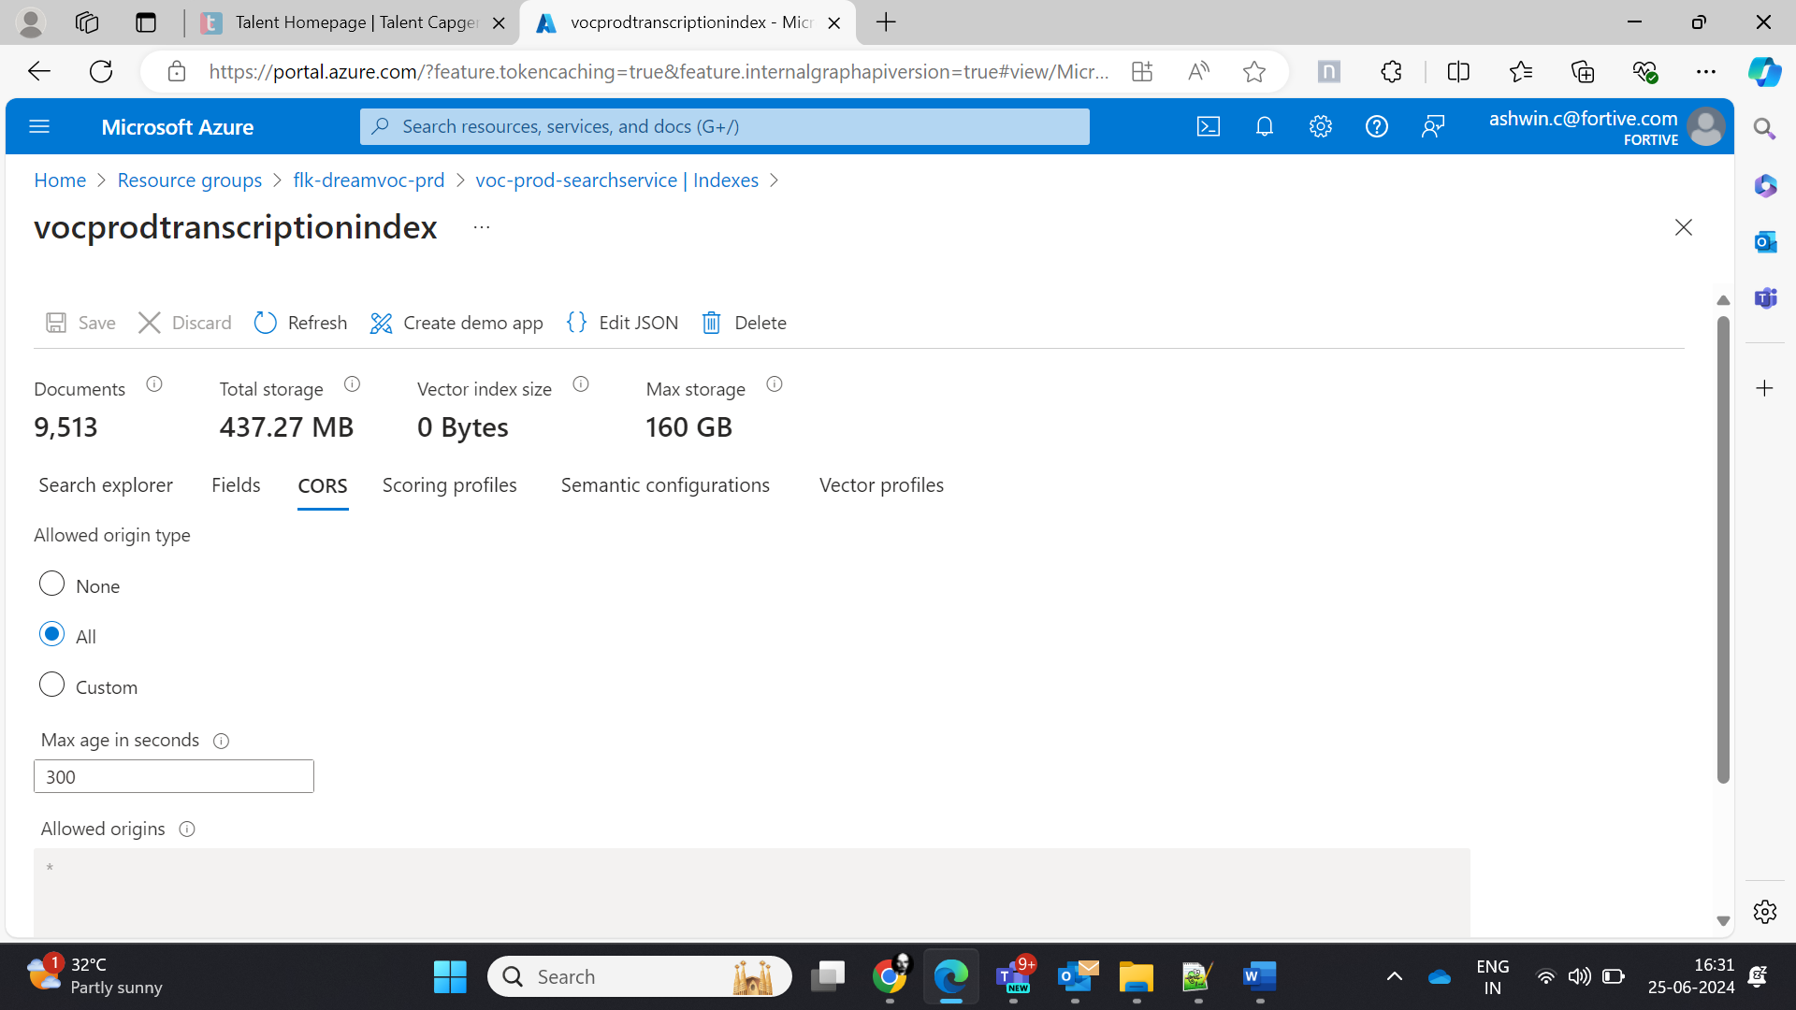

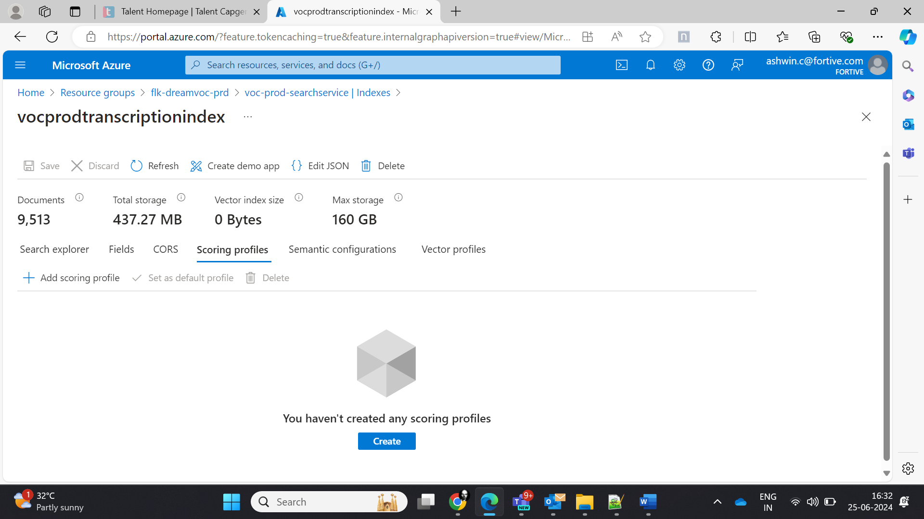

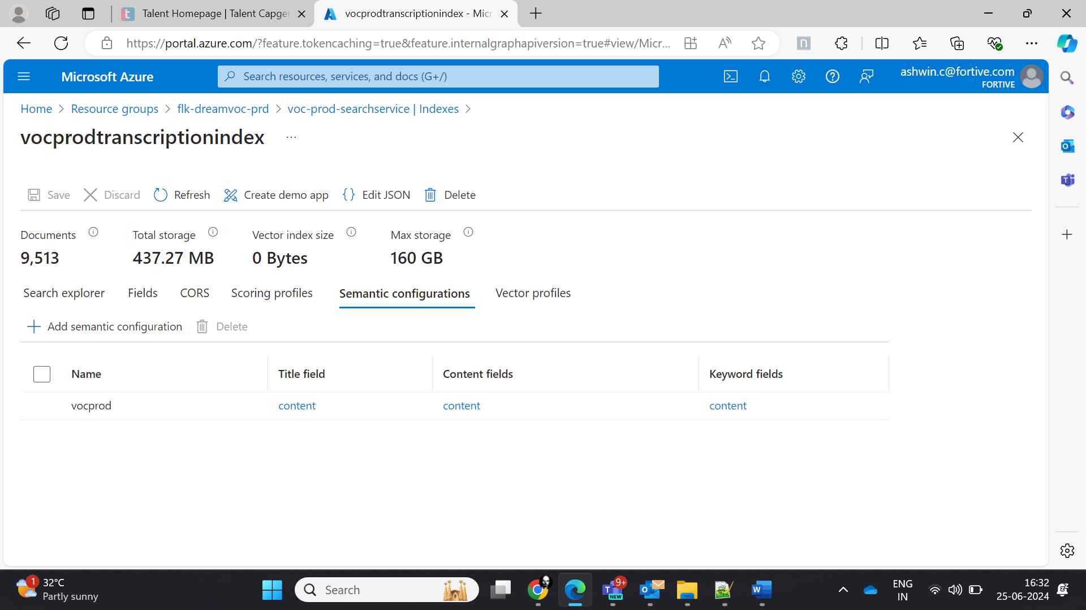

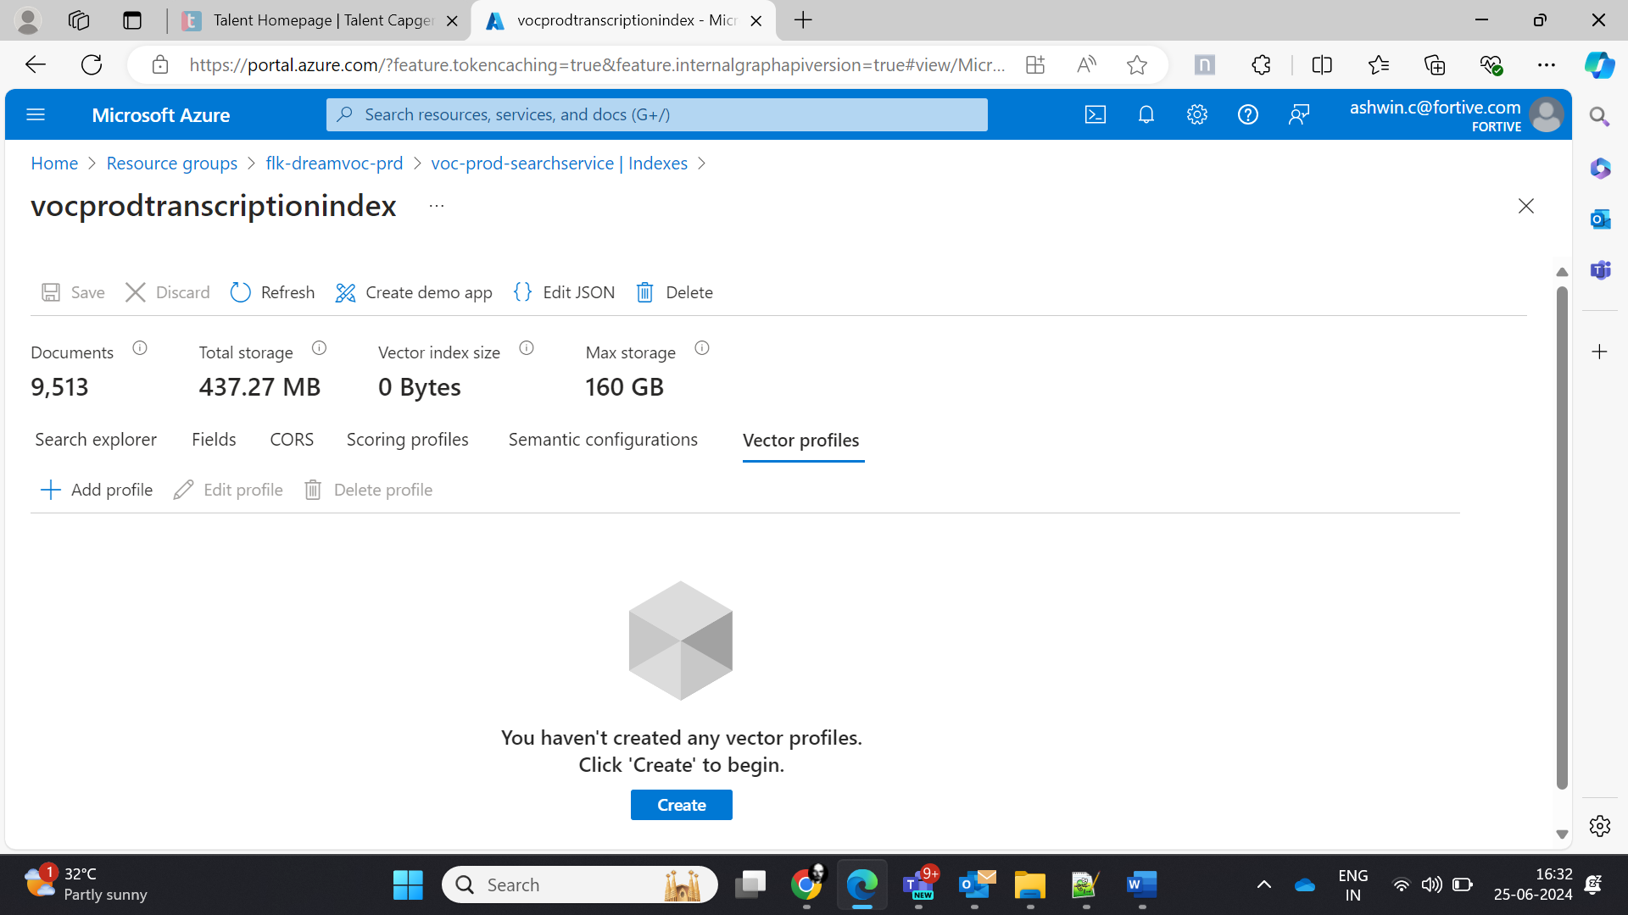

Indexer:

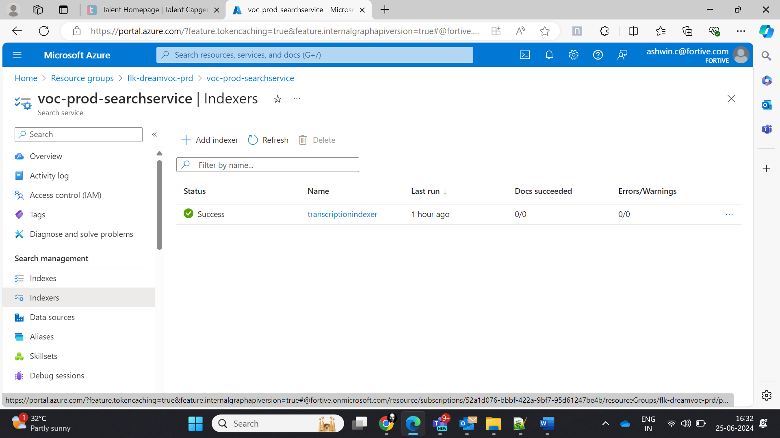

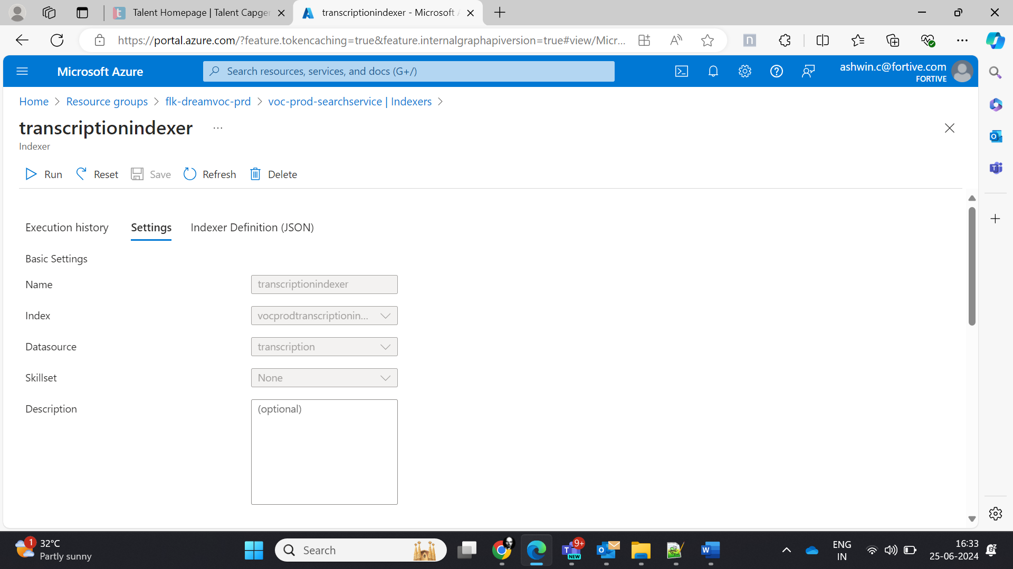

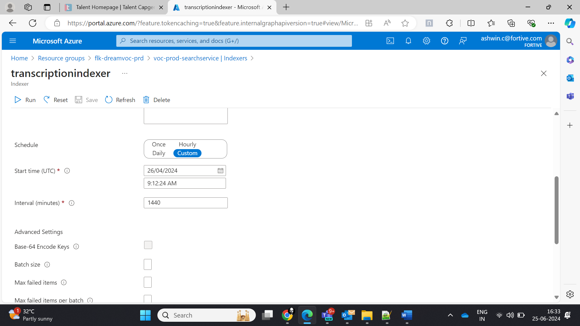

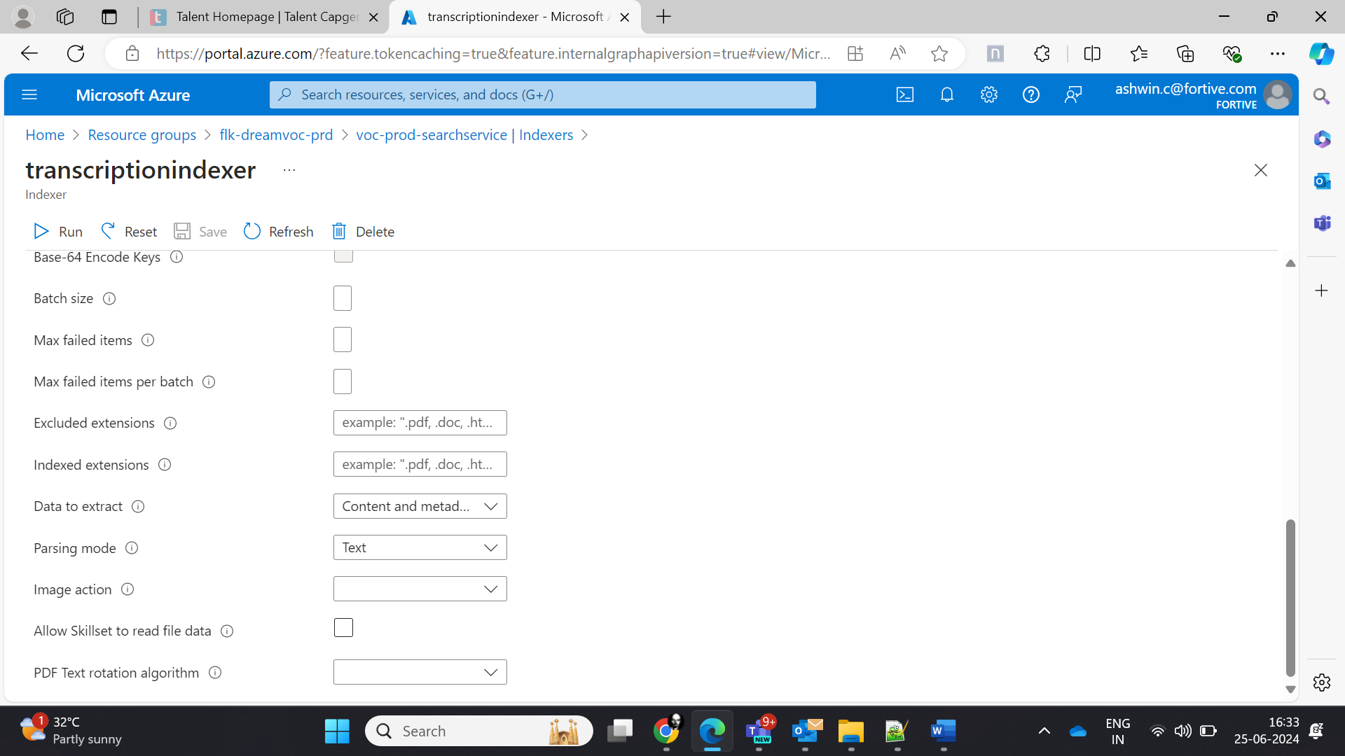

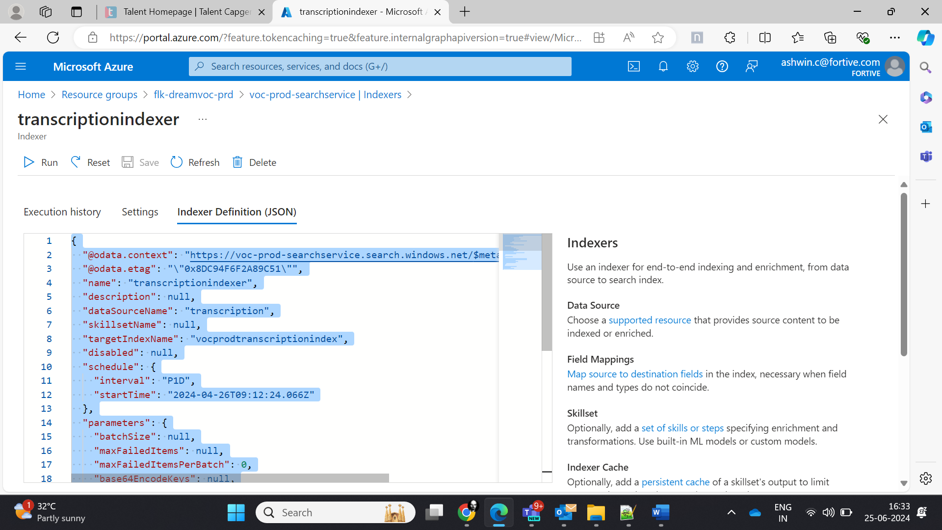

JSON:

{

  "@odata.context": "https://voc-prod-searchservice.search.windows.net/$metadata#indexers/$entity",

  "@odata.etag": "\"0x8DC94F6F2A89C51\"",

  "name": "transcriptionindexer",

  "description": null,

  "dataSourceName": "transcription",

  "skillsetName": null,

  "targetIndexName": "vocprodtranscriptionindex",

  "disabled": null,

  "schedule": {

    "interval": "P1D",

    "startTime": "2024-04-26T09:12:24.066Z"

  },

  "parameters": {

    "batchSize": null,

    "maxFailedItems": null,

    "maxFailedItemsPerBatch": 0,

    "base64EncodeKeys": null,

    "configuration": {

      "dataToExtract": "contentAndMetadata",

      "parsingMode": "text"

    }

  },

  "fieldMappings": [

    {

      "sourceFieldName": "metadata_storage_path",

      "targetFieldName": "metadata_storage_path",

      "mappingFunction": {

        "name": "base64Encode",

        "parameters": null

      }

    }

  ],

  "outputFieldMappings": [],

  "cache": null,

  "encryptionKey": null

}

**Data source:**

