This document is a guide to solving one of the commonly faced permission issue when a web app is deployed using Azure Open AI studio. The error occurred when a web app was deployed in the Azure Open AI studio portal.

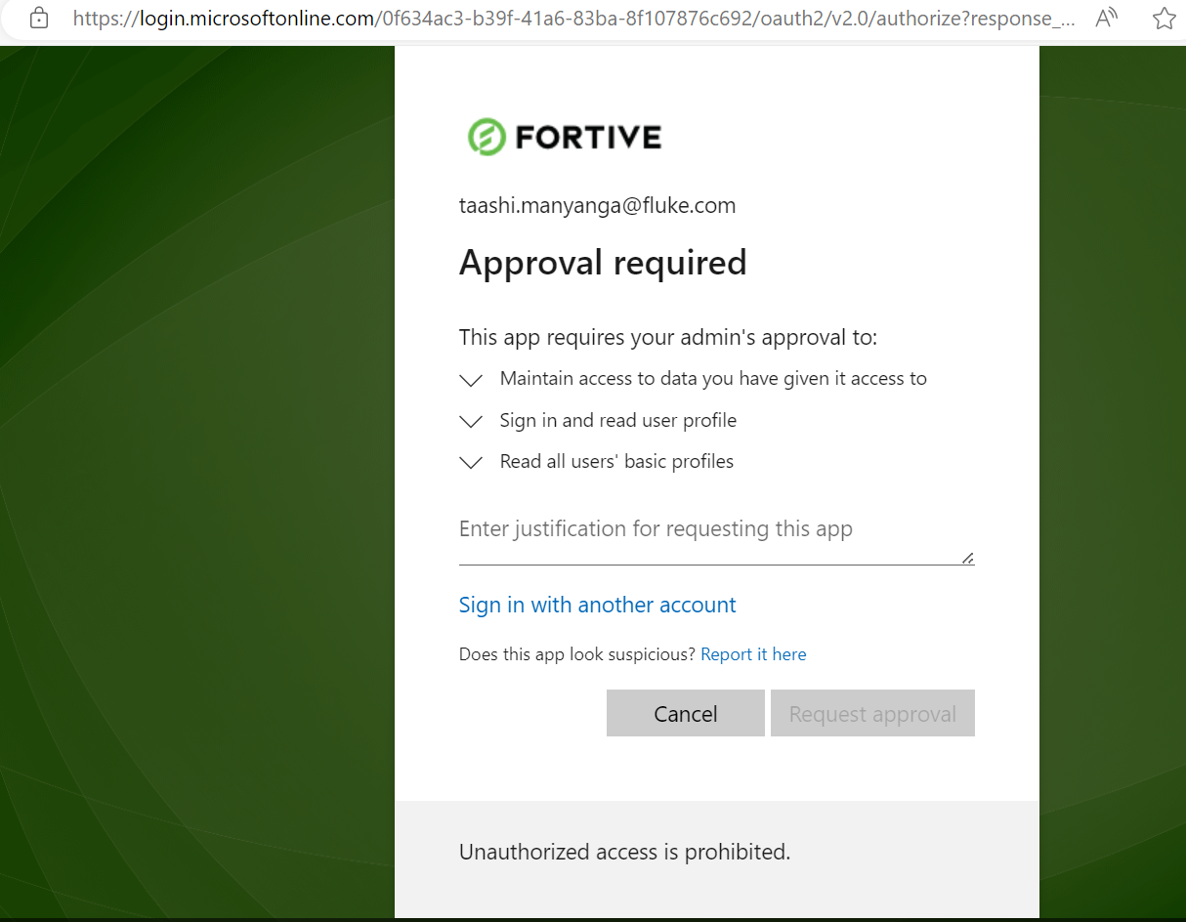

When ever someone tried to access the app including the person who deployed the webapp they occurred the following the page.

**Solution**

1] Go to deployed webapp and go to the Authentication section in Settings.   
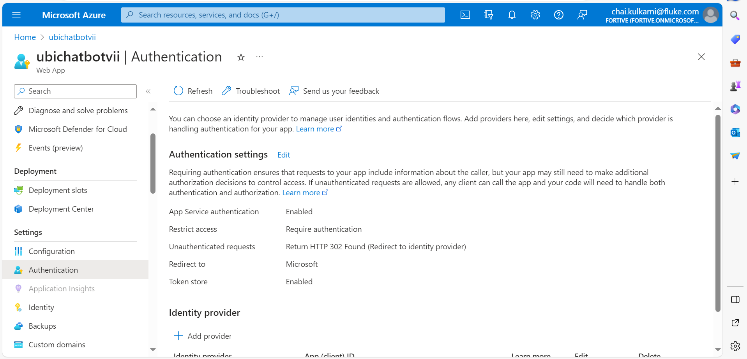

2] Scroll down and delete the existing and Remove authentication.

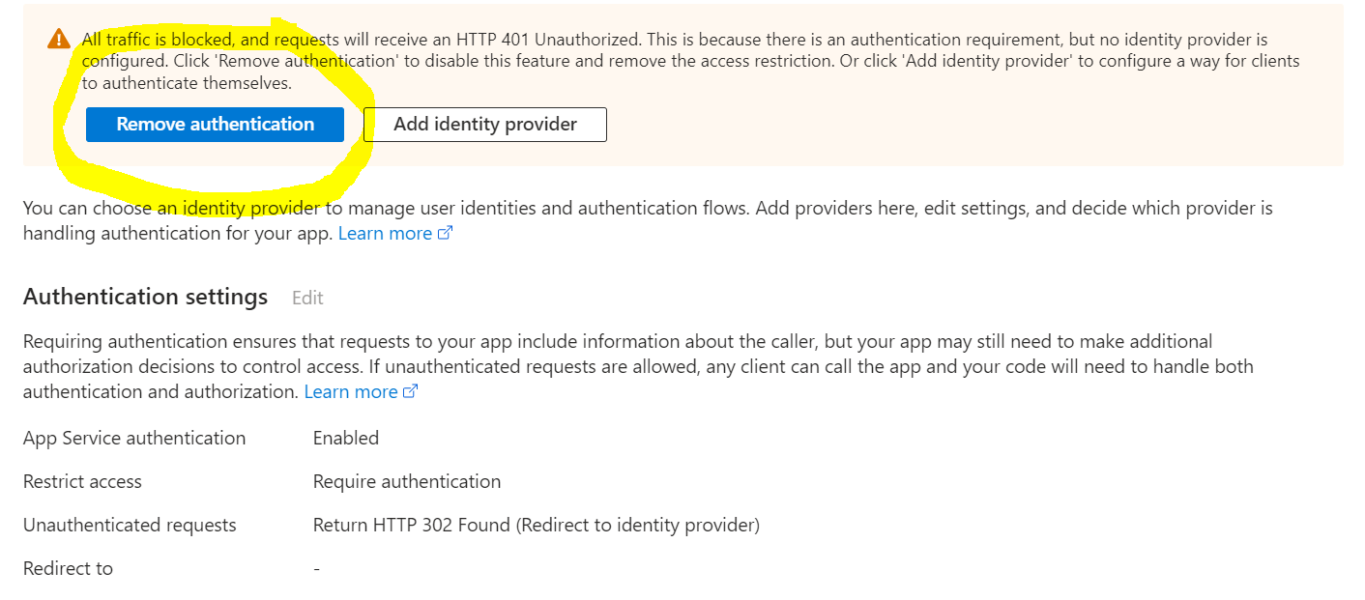

3] Now click on Add Identity provider.

4] Select Microsoft and click next and now change the name of App. And click on add.

5] wait for 10 mins and now the app should be accessible.