# Transmission Block

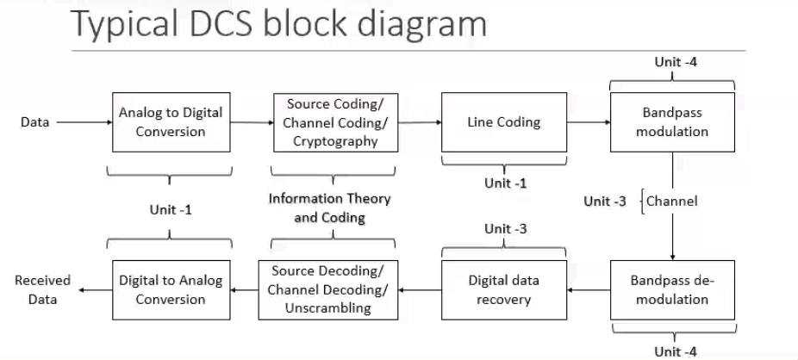

Typical DCS block Diagram

## Source Coding

## Channel coding

Parity set of data that adheres to certain rules. Data could be corrupted, parity bits helps in data recovery.

Next Step

## line coding

Line means channel, message needs to be in form of electrical waveform There are various methods. To be done before data is sent. Over large areas, data needs to be band pass modulated, PM is relevant in Digital communication, over high frequency, quine process. May or not be applied.

## Digital Reovery

Logical information

Remove the parity unscrable the data

reconvert to analog from digital.

## Unit 1: Intro to digital communication

## Unit 2: Random Signal Theory

## Unit 3: Designing of Receiver

## Unit 4: Digital Modulation Schemes

# Expected course Outcomes

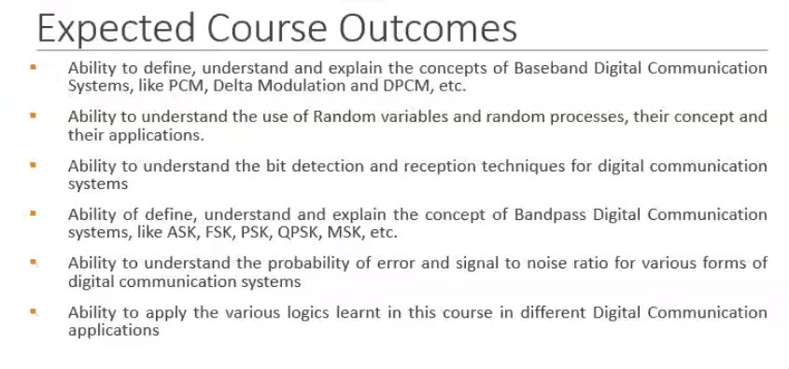

ExCourseOutcomes