1.

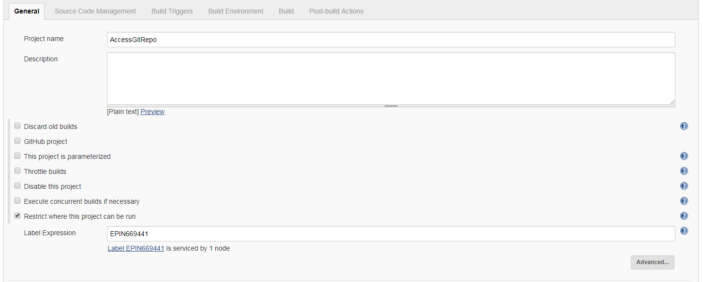

2.

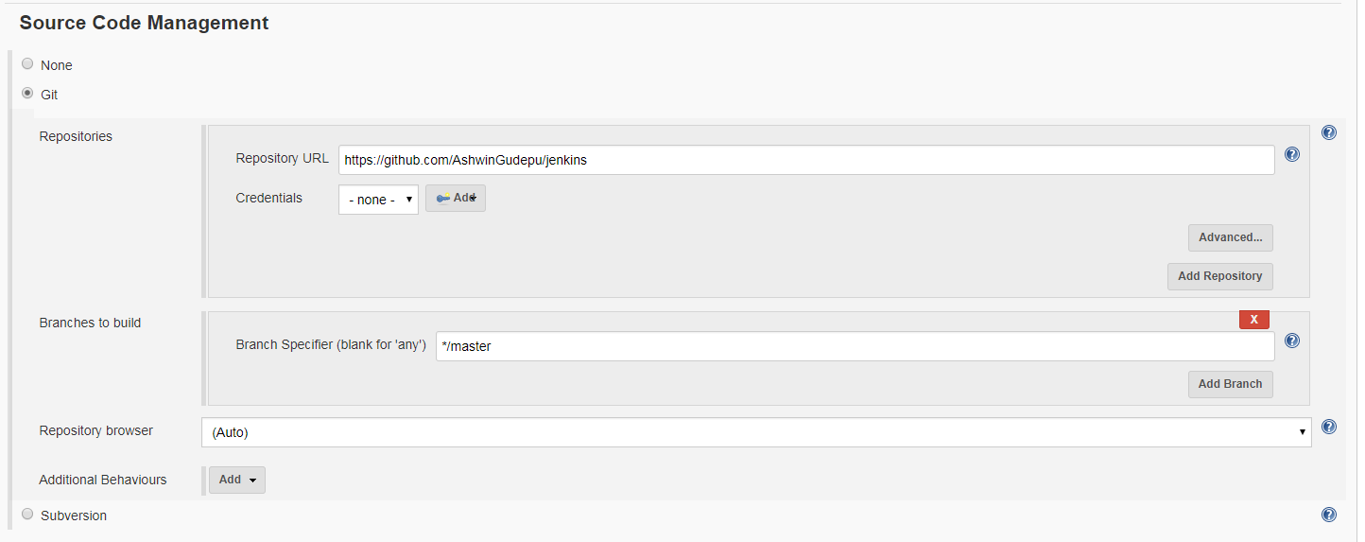

3

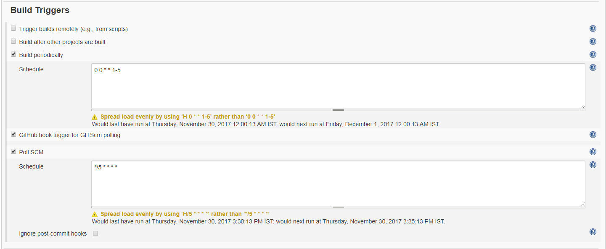

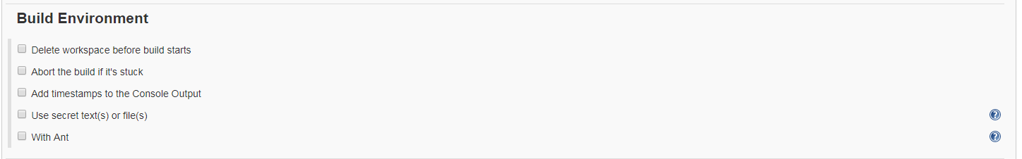

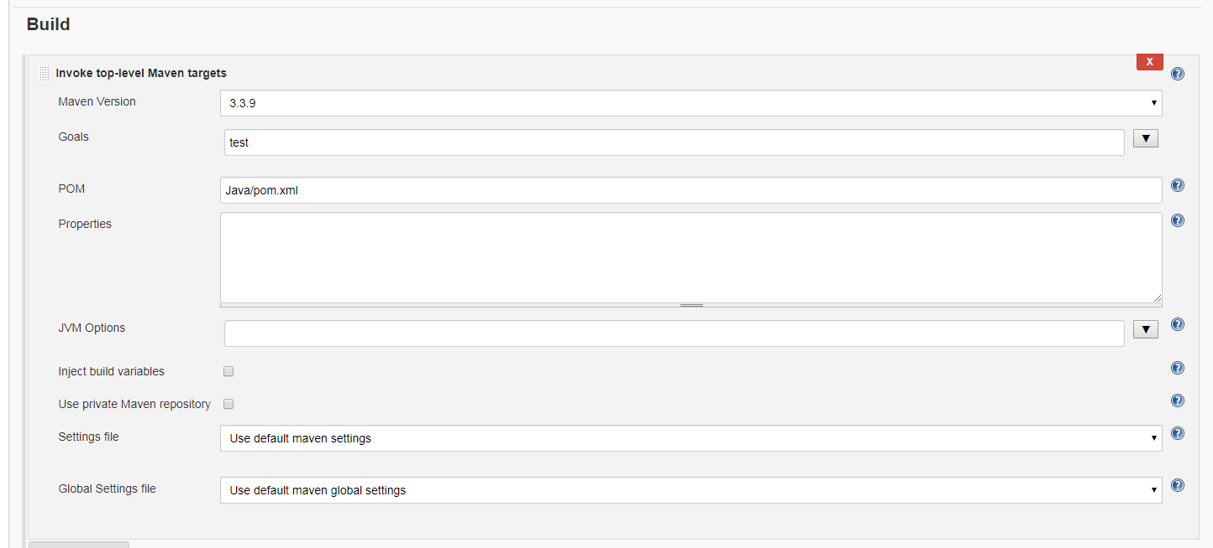

1. Every code push. This job will be trigger for every code push
2. Midnight Run

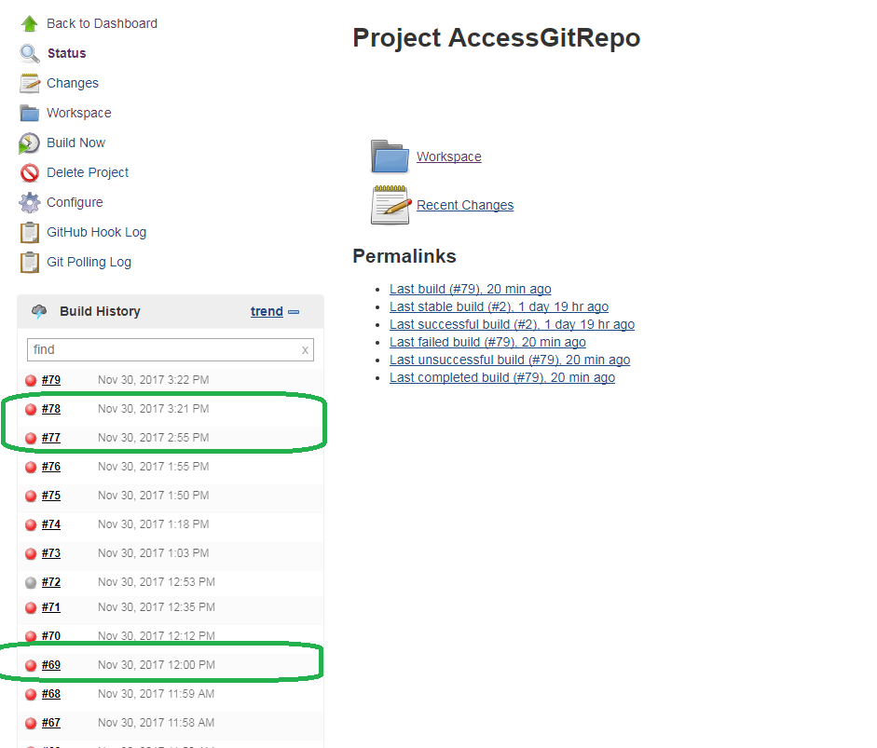

**GLOBAL CONFIGURATION:**

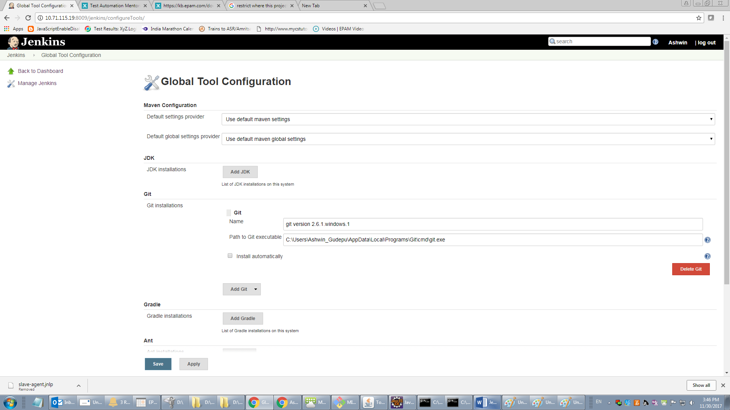

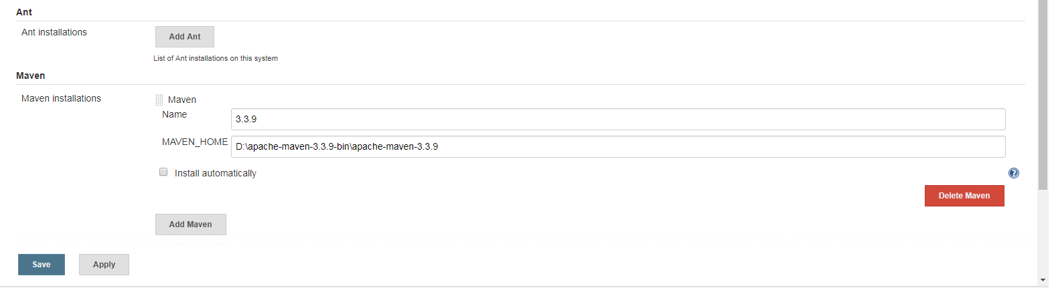

FOR Creating/Running SLAVE:

**1. Dowload** slave-agent.jnlp

2. **Dowload** slave.jar

**Run the two jars:**

java -jar slave.jar -jnlpUrl http://localhost:8009/jenkins/computer/EPIN669441/slave-agent.jnlp -secret 29073b1e3da10a88106b677324e38d816eccbcba7159a0f547b395d88f50edc1 -workDir "D:\SlaveFolder"

**MASTER:**

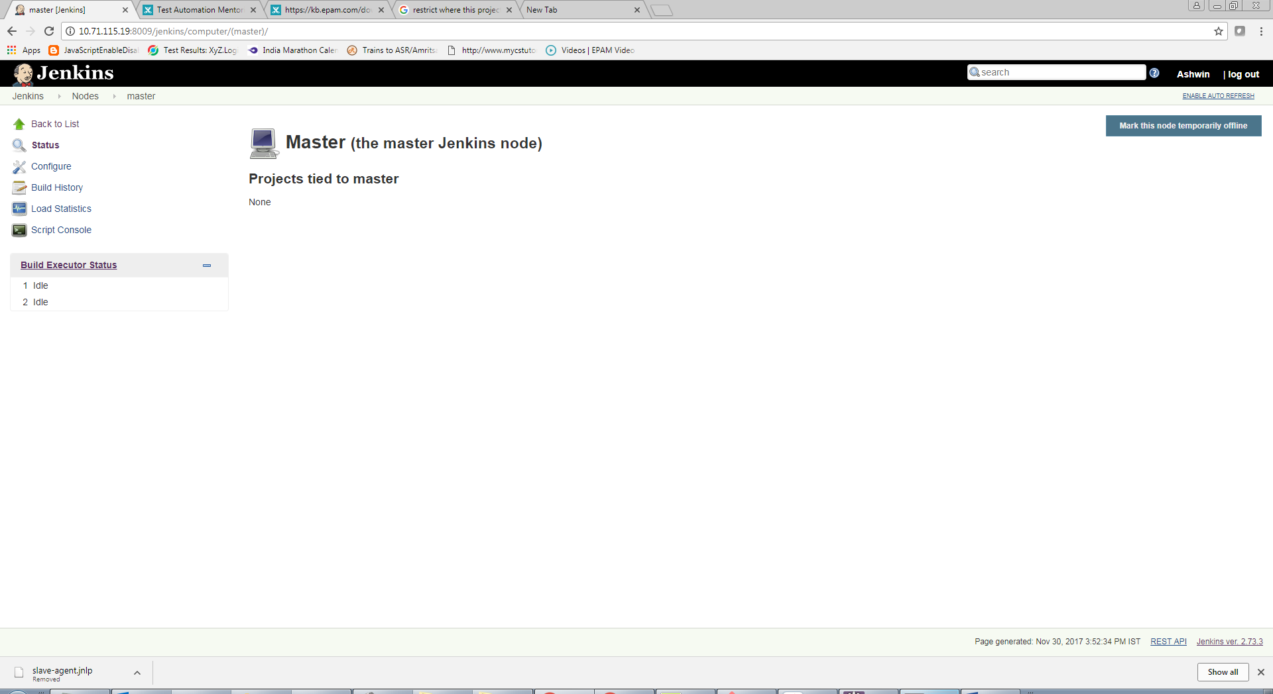

**SLAVE:**

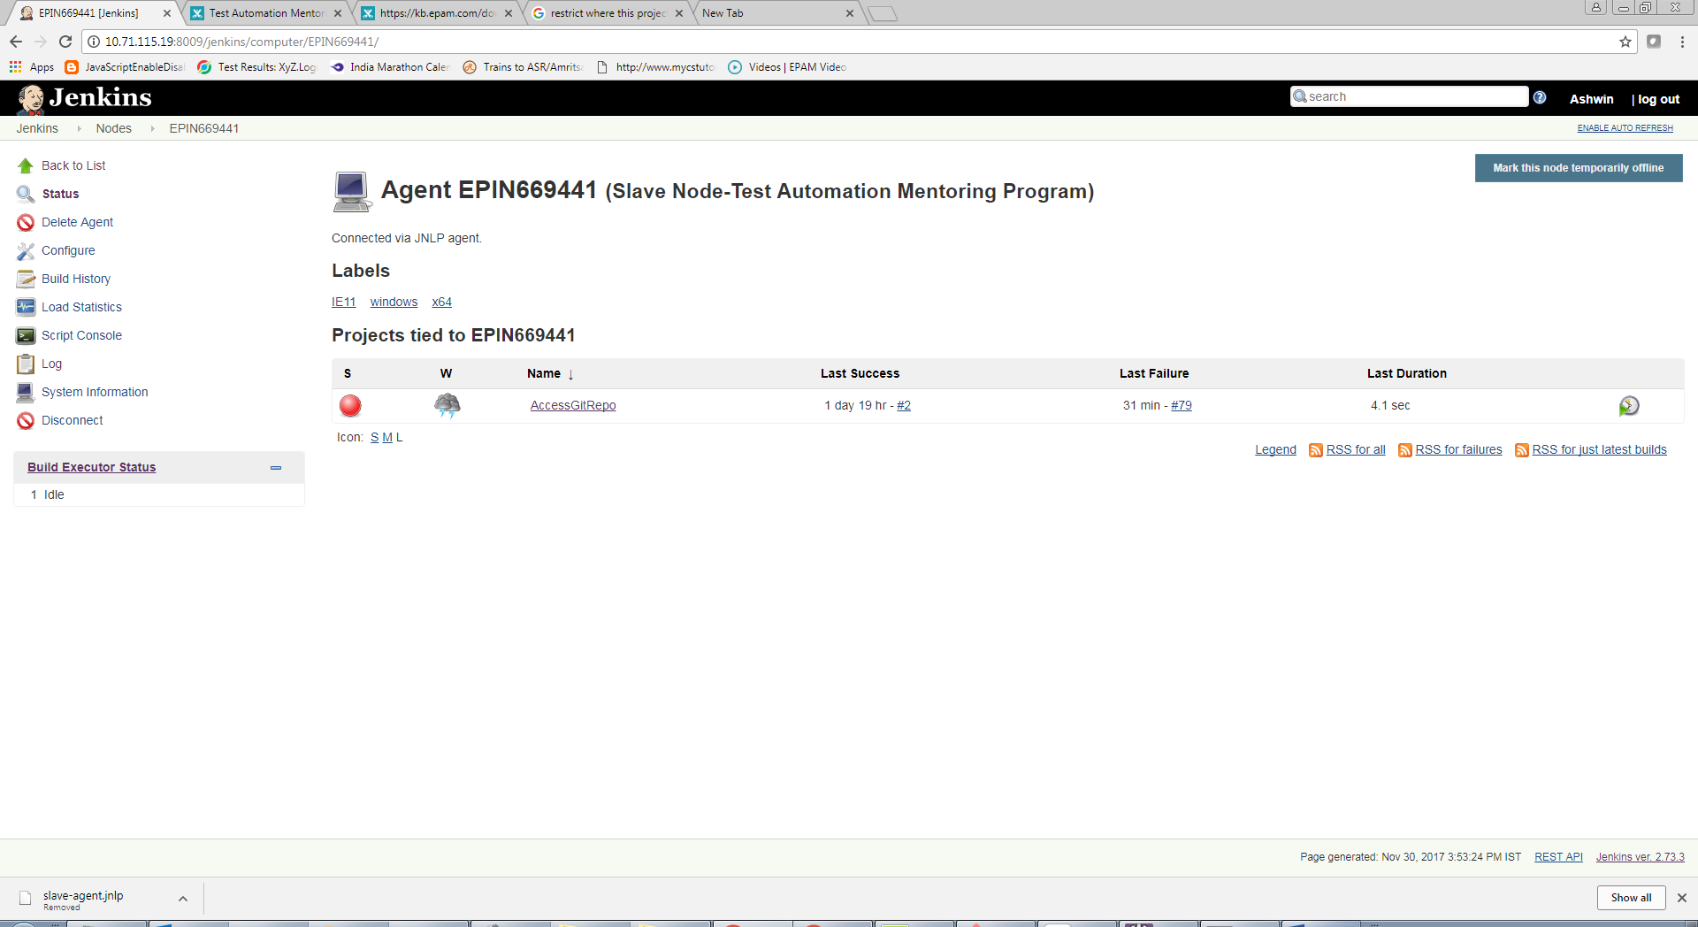

**MASTER AND SLAVE:**

