**Note:** GUI of Locker-Hide works same as that of Locker-Encrypt

1) Tab which allows user to hide and restore folders.

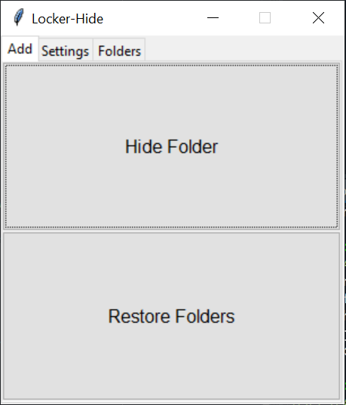

2) Selecting the folder to hide.

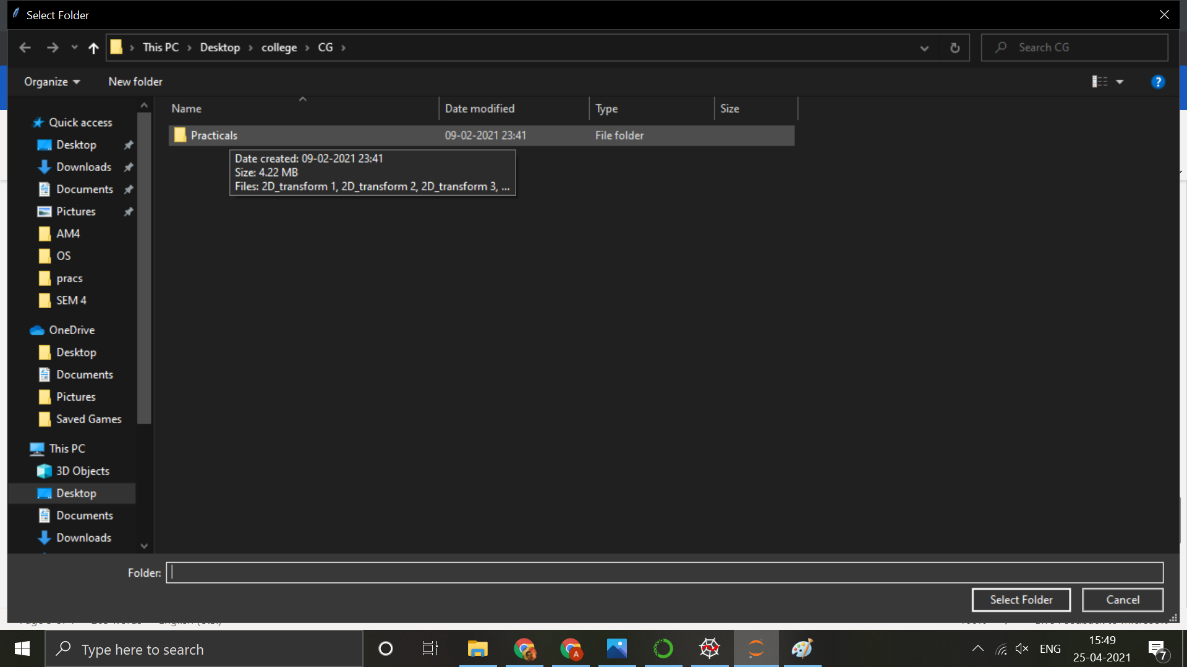

3) The Notebook “Settings” Tab that allows the user to set and change the password for the folders.

Here, we are setting a password.

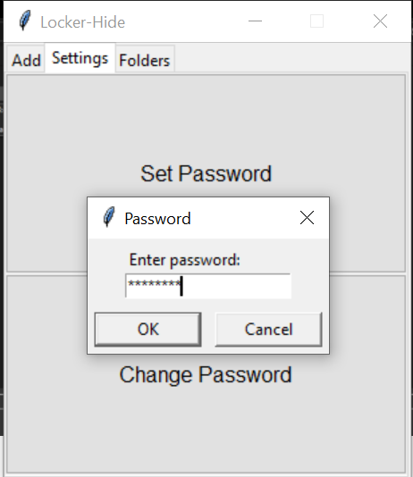

4) For changing the password, the user must enter the correct “Old password”.

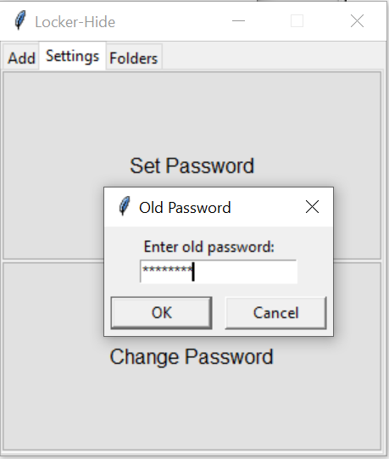 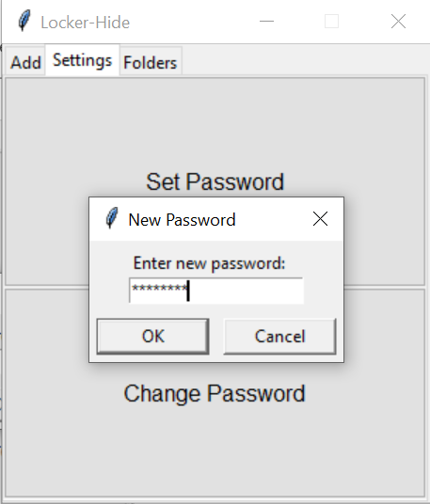

5) The tab which includes a ListBox, where the hidden folders will be listed.

This ListBox allows multiple selections, which can be restored together.

Once selected proceed to restore( goto ‘Add’ tab).

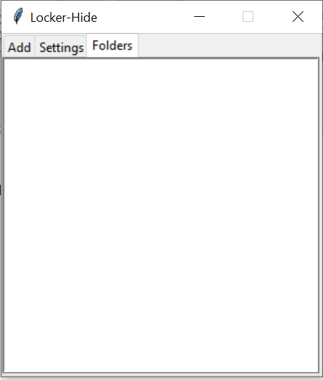

6) Restoring the folders once user has entered the correct password.

The details of the folder which was restored will be notified to the user.

