# In order to run this application you need to do the following steps:

If→ Python 3 is not installed on windows:

Download and install Python 3 from Microsoft Store:

Search: Python 3.9

Click on: Get

If→ You do not have Anaconda/Spyder -- install them as follows:

<https://www.anaconda.com/products/individual> → Download Anaconda from this link

<https://medium.com/@GalarnykMichael/install-python-anaconda-on-windows-2020-f8e188f9a63d>

(Use this as installation guide)

1. Search Powershell in windows

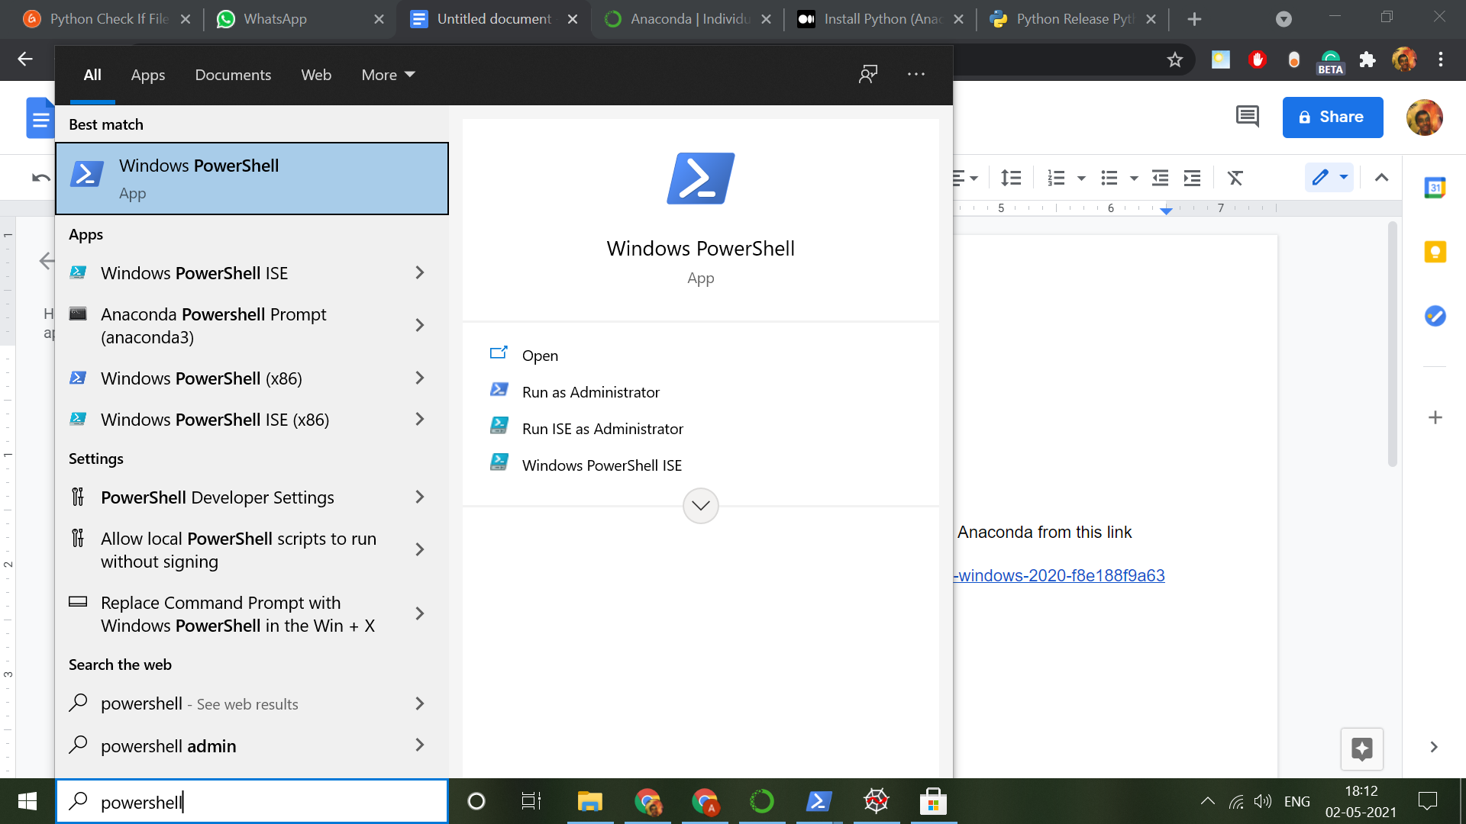

1. Open it and then type:

pip install cryptography

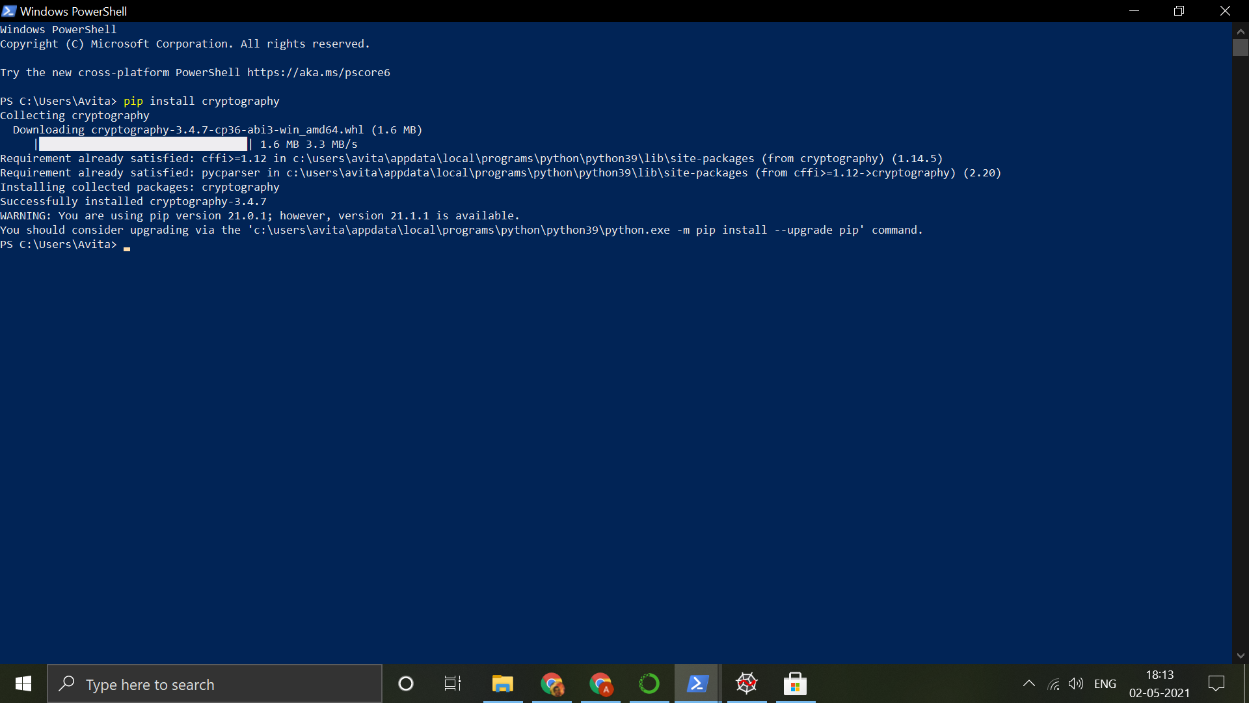

1. Open Anaconda

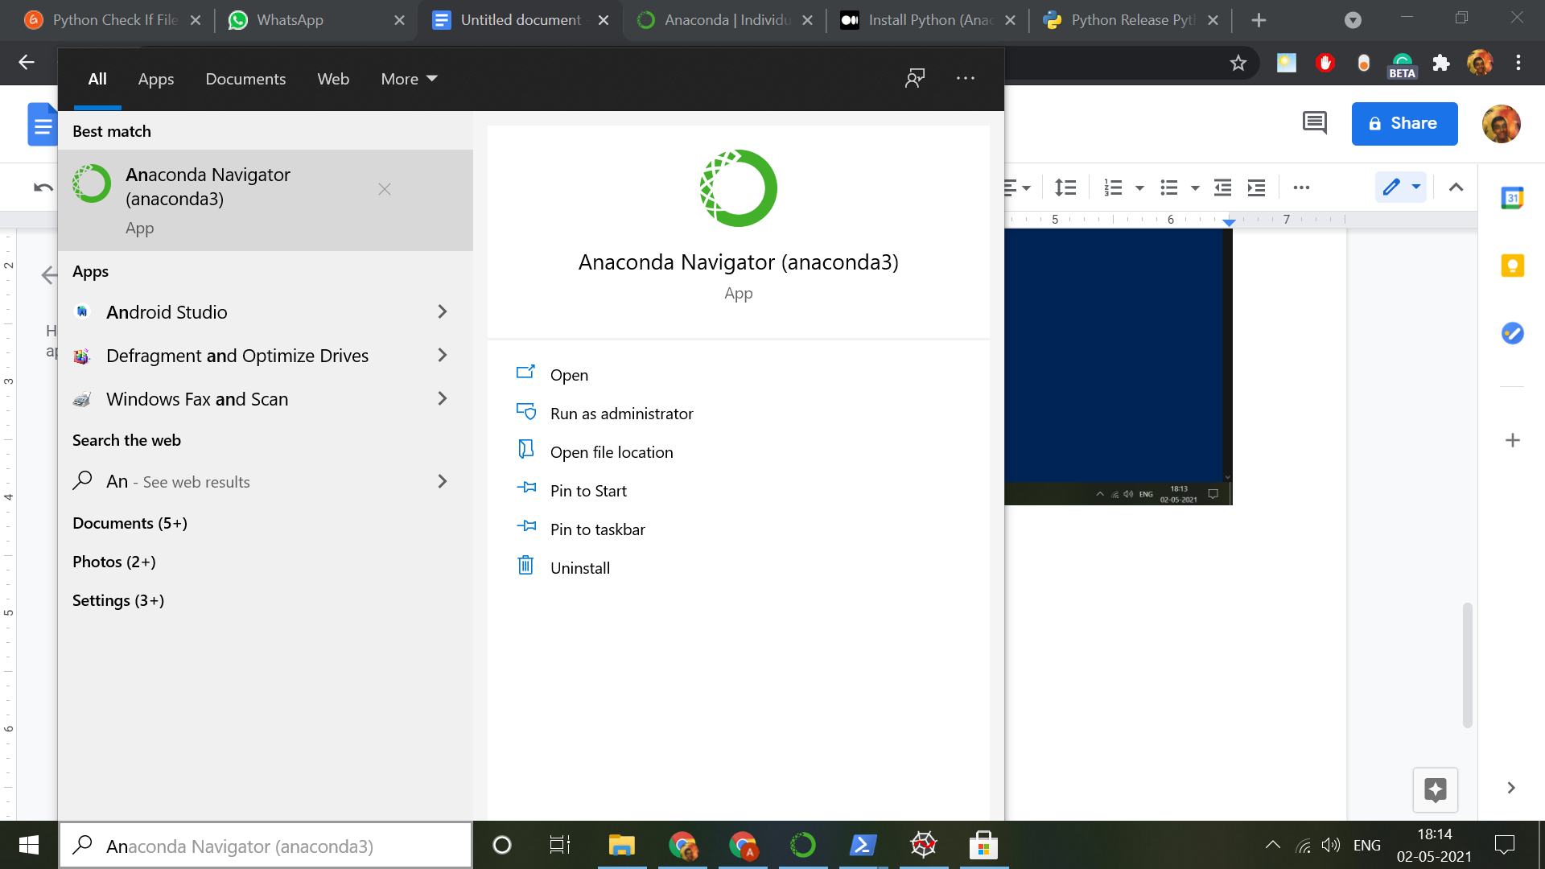

1. Open Spyder

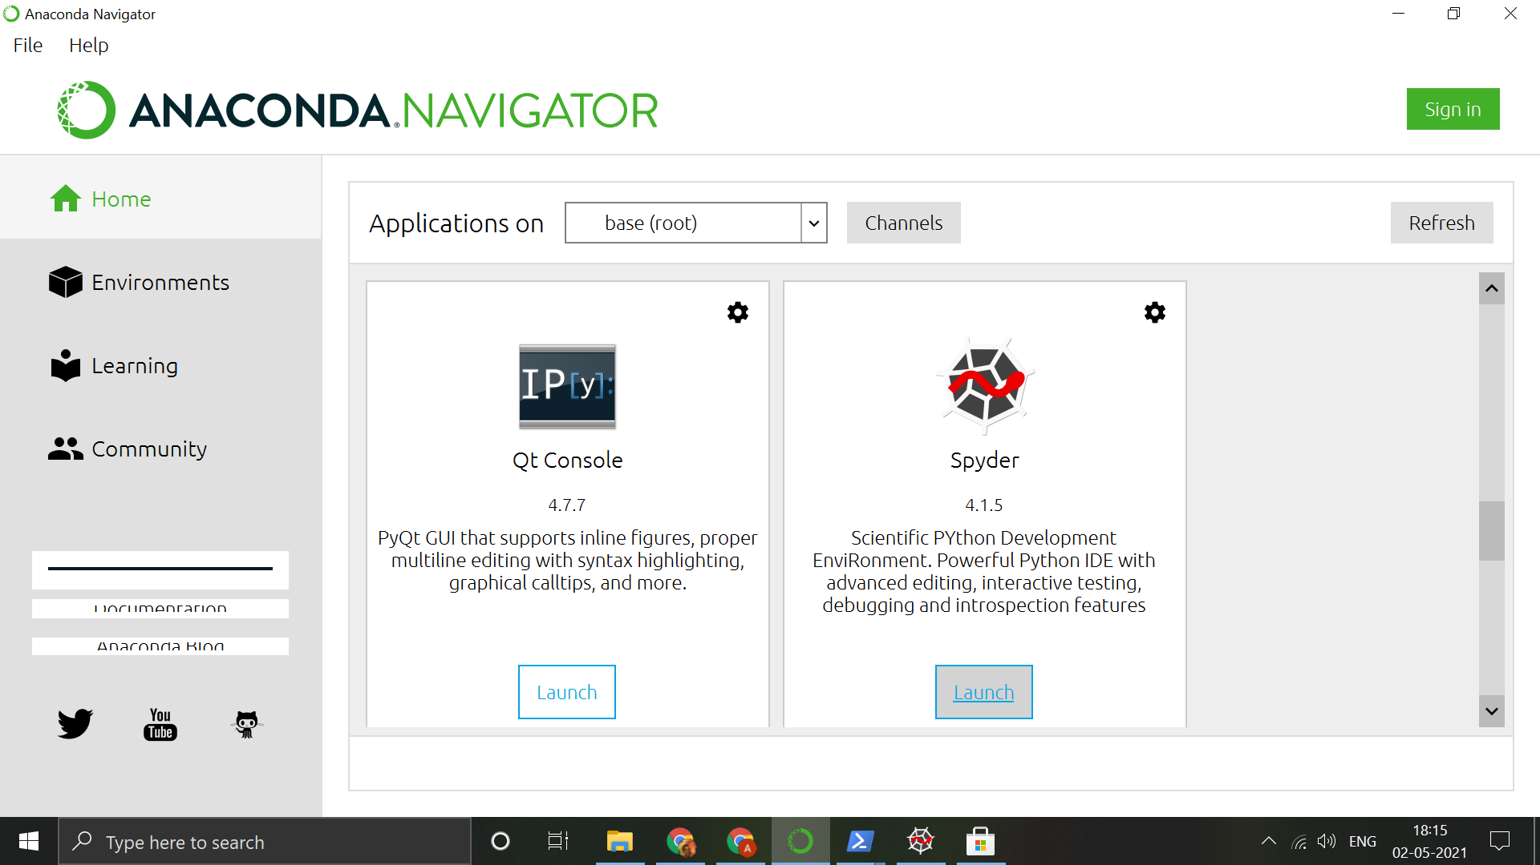

1. Goto File-->Open File → locker.py (Given in the drive folder)

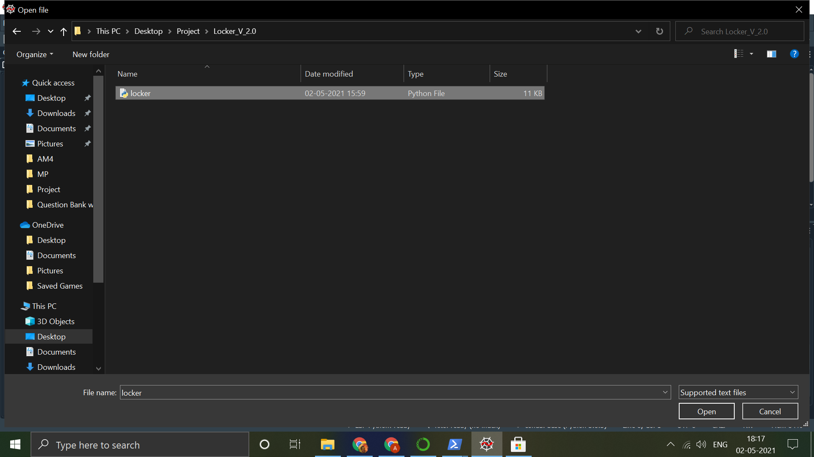

1. Once opened, Click on the ‘Run File’ button.

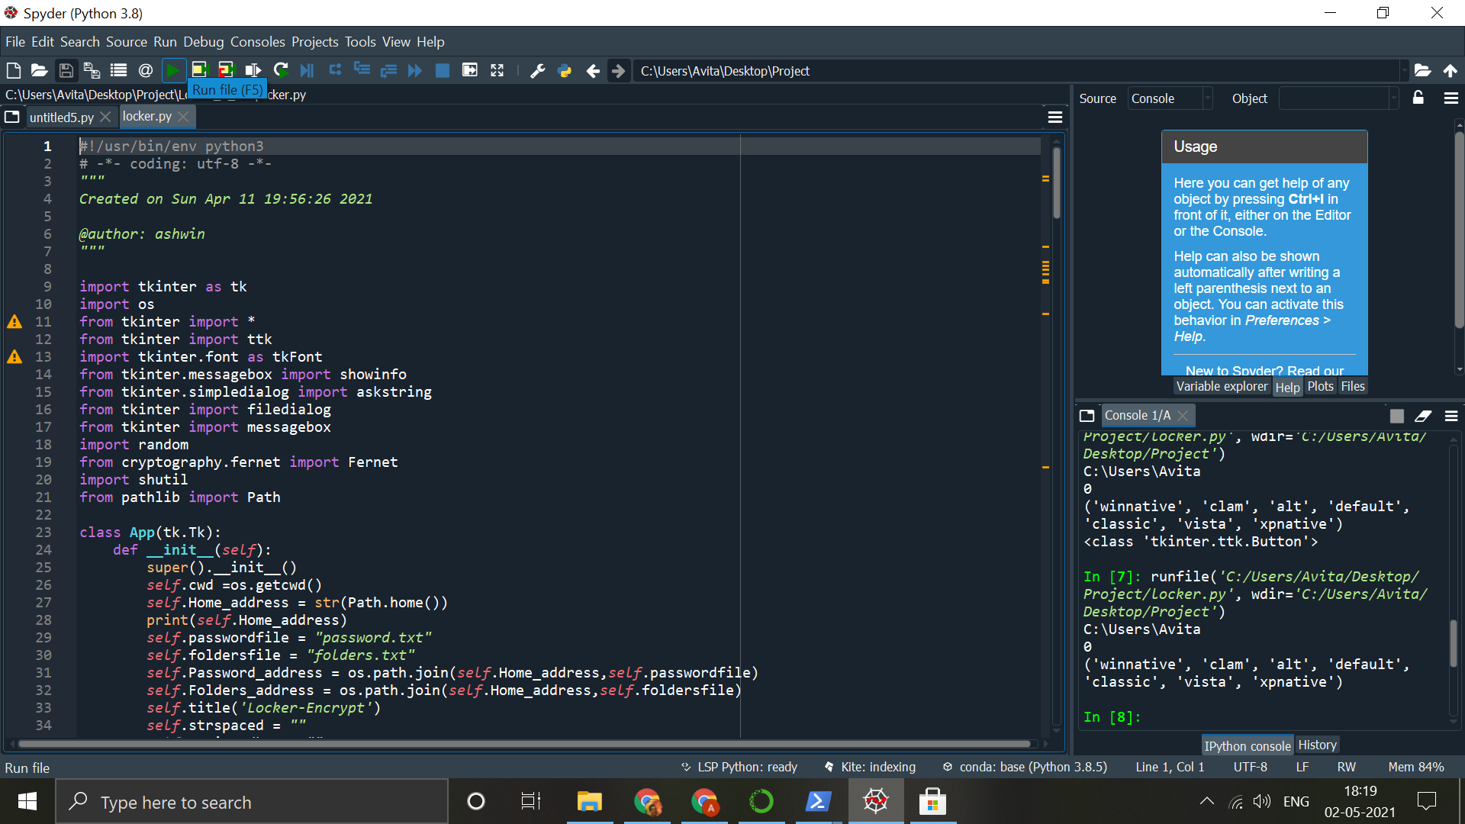

1. The application should be opened like this

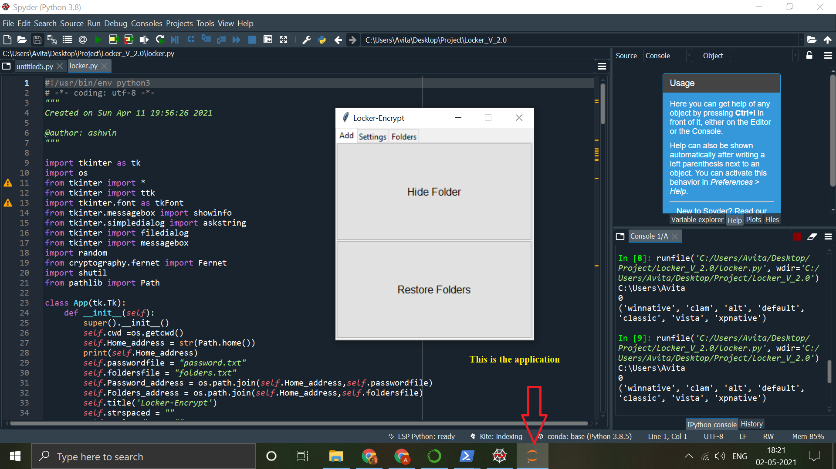

1. Go to settings and set a password.

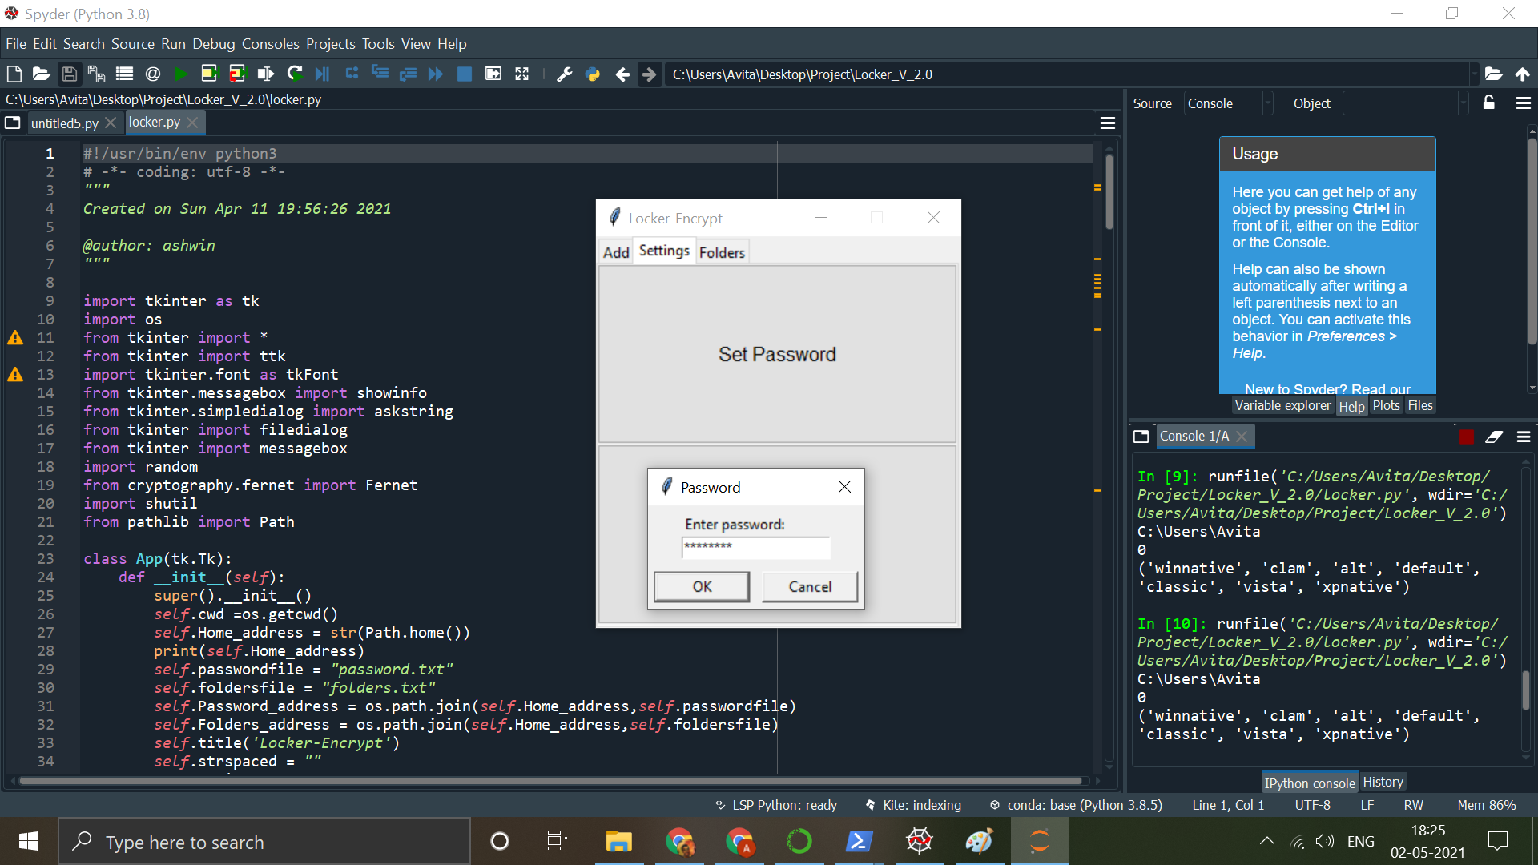

Now your program should be ready to “Encrypt-Hide” Folders.

Read “INFO” available in the drive folder for important usage information.