While replying to some convo..
1. In reply to your request...
2. With reference to our discussion/ your mail yesterday
3. Further to our meeting last week
4. This is with reference to....

Common Starting lines:
1. Writing
• to inform you that …
• to confirm ...
• to request...
• to enquire about ...
• to update
2. Greetings from KPIT (outside the organization)
3. Hope this email finds you in good health

For making an request
1. I would appreciate it if you would ...
2. I would be grateful if you could ...
3. Could you please send me ...
4.Could you possibly tell us / let us have ...
5. In addition, I would like to receive ...
6. I would appreciate your immediate attention to this matter

Sharing a good news

1. We are pleased to announce that ...
2. I am delighted to inform you that ..
3. You will be pleased to learn that ...

Sharing unpleasant news

1. We regret to inform you that ...
2. I'm afraid it would not be possible to ...
3. Unfortunately, we cannot / we are unable to ...

--> While multiple points
1. Use bullet points
2. if with description, seperate para for each bullete point

--> great closing lines

1. Request you to share the update by the end of today.

2. Will look forward to your thoughts on the above proposal.

3. Please share the stated details once you get the confirmation from the client's side.
4. Please feel free to reach out to me in case you have any queries.

--> Signature
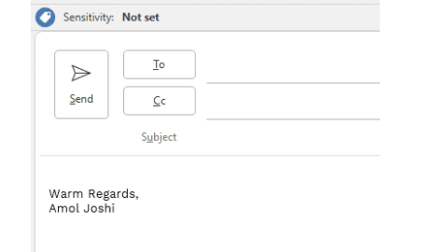
1. For internal stakeholders -->

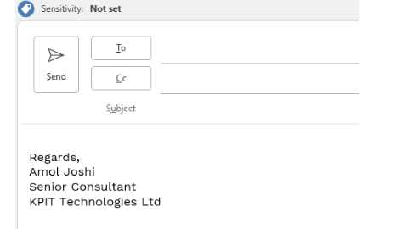
2. For external stakeholders -->
(or instead of organization mail we can also add call no)

To write proper emails use --> Audience, Purpose & Tone

Some common acronyms -->
PFA: Please find attached
- FYI: For your information
- EOD: End of Day

•

•
Work Sans is the preferred font in KPIT.

Some email examples:
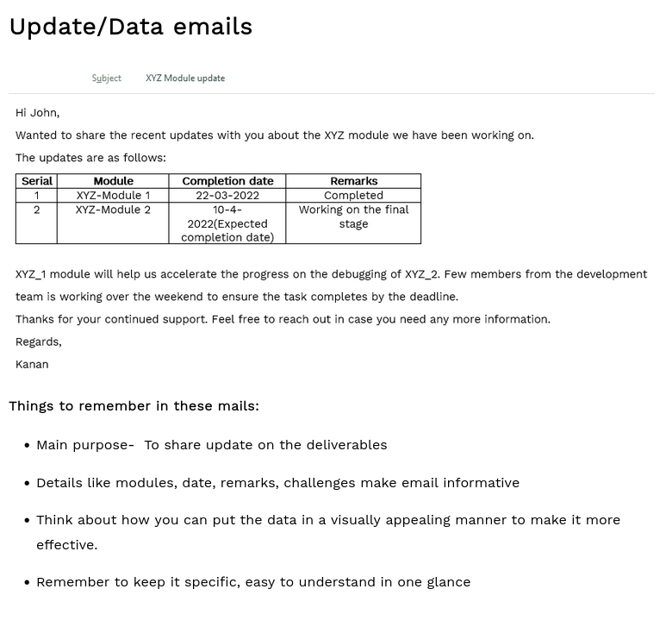
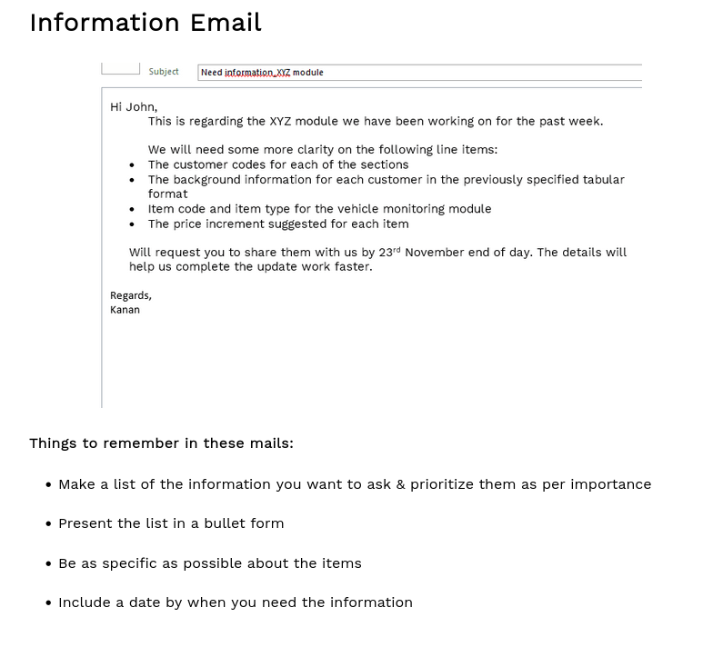

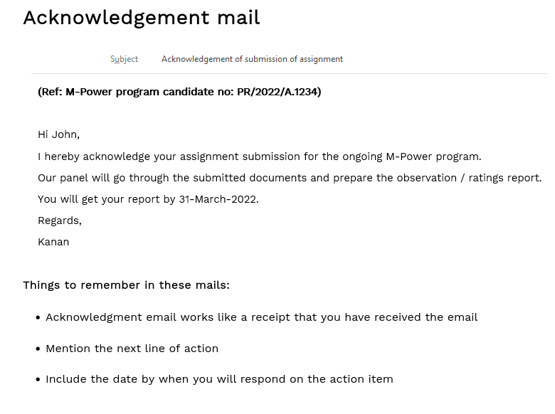
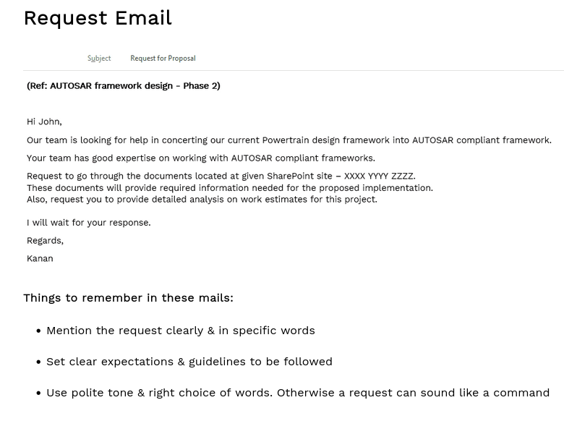

for email writing phrases write --> https://www.youtube.com/watch?v=gjqmdcThcns

email for complained about delayed deliveries:- https://www.youtube.com/watch?v=q41VacMmVnI&t=22s

email writing for apology structure:
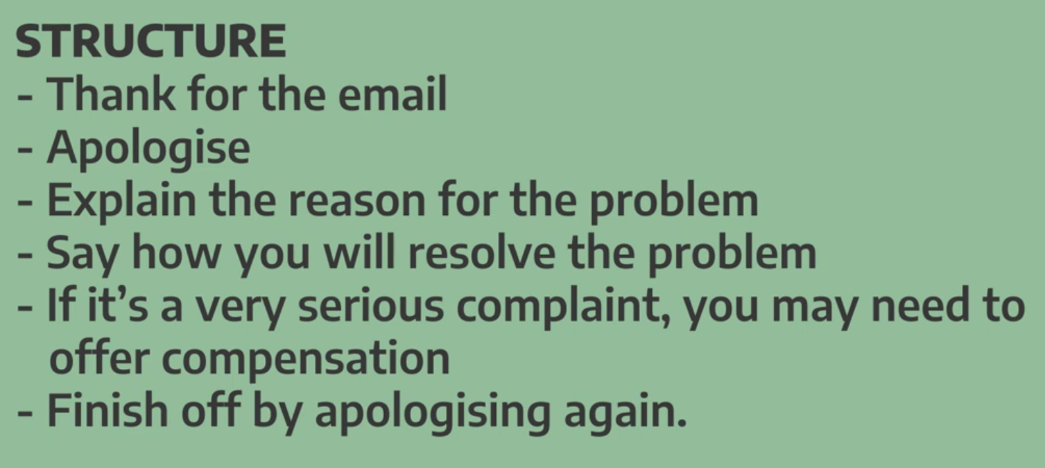
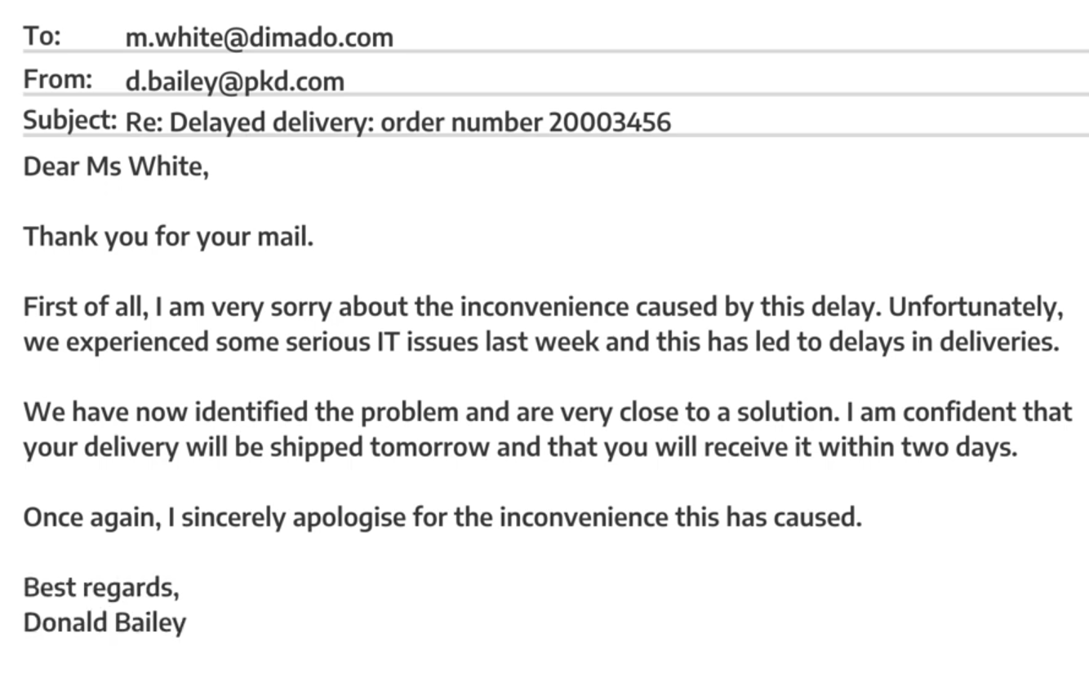

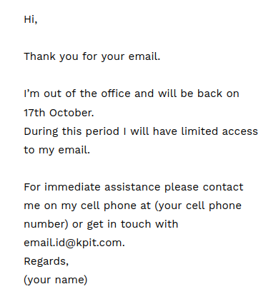
For out of office response:

I know you are super busy, but
my: I am reaching out to your regarding....

Following up on my previous email
my: As per our previous discussion..

Sorry to bother you but..
my: I would appreciate your guidance on this...

Email1: Off lately the team is assigned with a new project & the members are working beyond timing. Write to your manager and request to add more members to your team for the project.

To: Manager
cc: _

To: Manager

Subject: Request to Add Additional Team Members to Project - ADAS

Hi Vedant,

I hope you are doing well.

Off lately, Our team has been assigned with a new project, ADAS, and all the team members are working beyond regular working hours to meet the project deliverables. While the team is putting its best efforts, the current work load has become challenging to manage within given timeline.

To ensure timely delivery and maintain work quality, I request you to consider adding few more team members to the project. Extra workforce will help to distribute workload more effectively and reduce extended working hours for team.

Thank you for your understanding and support. I look forward for your guidance on this matter.

Best Regards,
Ashwin Mahajan

Email2: Write an email to your team members to inform them about the Anti-Lock Braking System (ABS) project. Include deadlines, tasks to work on and support needed from the team.

To: entire project team

Subject: Information about new Project – Anti-Lock Braking System (ABS)

Hi Team,

I am writing to inform you that we are about to initiate a new project titled “Anti-Lock Brake System (ABS)”. This email provides an overview of all the necessary details regarding the project.

The client of this project is HONDA and they wanted to develop an efficient ADAS system for their new bike Honda hyper_bullete 350.
Refer to following tasks to be completed along with their deadlines:
- Requirement Gathering (30/09/2025)
- Project Development (30/011/2025)
- Bugs Resolution (30/01/2026)
- Testing (30/03/2026)
- Final Submission (30/06/2026)

I hope you are all excited for our new project. Please, take a note that the final deadline is 30th June 2026 and hope that we will successfully deliver it on time.
I am looking forward for your support. In case of any additional queries, feel free reach out.

Best Regards,
Ashwin Mahajan

Email3: Write an email to our manager to seek clarity about your role and responsibility in the team. You can also suggest a teams connect to discuss the same.

To: Manager

Subject: To seek clarity about role and responsibilties in team.

Hi Vishwas,

I am writing this email to get clarity about my role and responsibilities in team.

Our team is currently handling the project of Anti-Lock Brake System (ABS) under the guidance of team lead – Arjun. While, most of things are going well, as a new Joinee, I am still unaware of the my responsibilities to support our team in development. As of now, I am working with ‘Braking Module’ of project, which will be submitted until tomorrow.

As a suggestion, I think we can schedule a team’s connect to get clarification on same. I encourage you to arrange same as per your flexible timings.

I hope that you will process my request. Looking forward for your response.

Best Regards,
Ashwin Mahajan

Email 4: Write an email to your manager on requesting support with identifying and fixing the bugs in Engine control unit (ECU) software. Please share any issue you have encountered and your suggestions for resolving them.

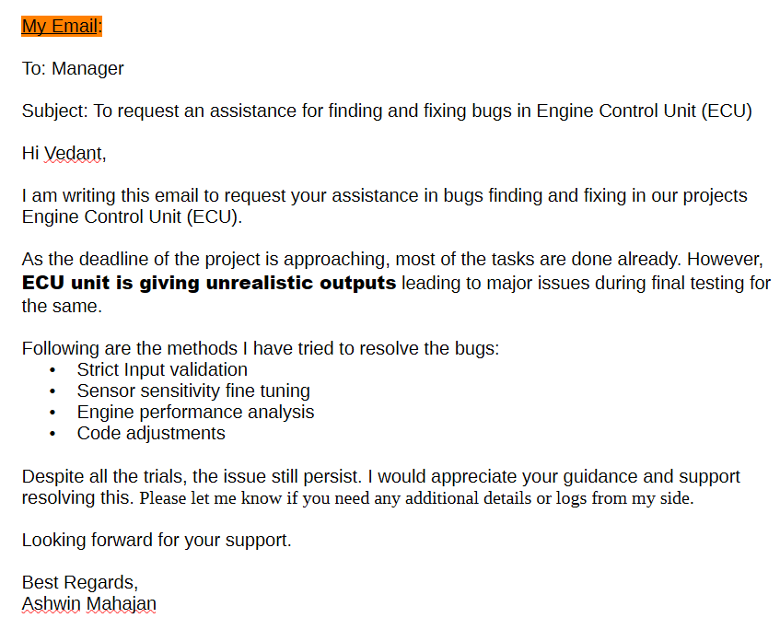
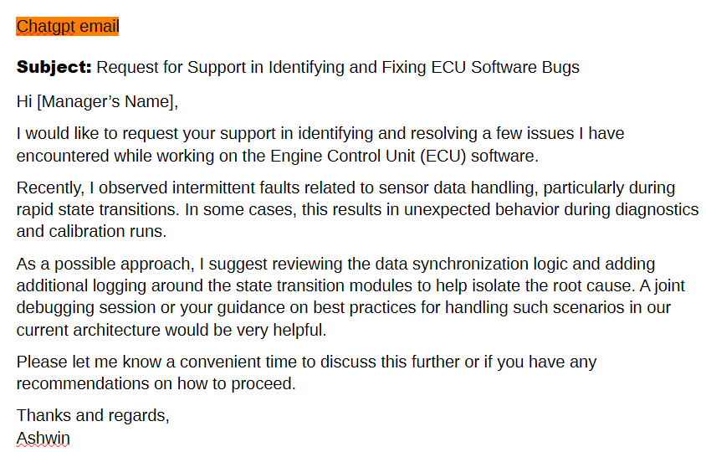

Email3: Write an email to the testing team requesting re-execution of failed test cases for the ADAS module. Include details of the failed scenarios, expected outcomes, and required completion timeline.

To: Testing Team

cc: Manager

Subject: To Request Re-Execution of Failed Test Cases – ADAS Module

Hi Testing team,

I hope you are doing well.

I am writing to request re-execution of certain test cases for ADAS module that failed during previous test cycle. The failures observed in specific edge case scenarios and now working fine after some minor code modifications for same.

Please, refer to following

