Day 1 -> 21/11/2025

1. Python is dynamically typed → dynamic type assignment

2. id(variable) → gives the memory location of the stored value

3. data types →

- number: int, float, complex
- boolean: bool
- string: str

4. Some of the types in python are mutable or some are immutable. Meaning changing value of variable will result in creating new memory location and then assign new value and then variable will point it there.

5. we can print values by separating them with commas. (use sep=’’ in print to print with separator, end=’’ for printing at end)

6. using .split() on string converts it into list

7. Range takes 3 values range(start, end+1, increment) → just like c++ for loop

8. same with string slicing [start, end, step]

9. list →

- type(), len() → for length
- append() → always add element at end
- insert(idx,value) → inserting at particular index
- list.reverse() → changes inplace → reverses the list
- for idx,data in enumerate (12):
  - print(idx, data) → to print idx and data at particualr index of list
- while assigning list variable to another , reference is shared and no new created. When explicitly call (l7 = l2.copy()) then it creates copy not reference. print(l7 is l2) which checks the id → no need to do manually. For comparing elements (l7==l2).
- Combine 2 list list1 + list2. If used (list1.extend(list2)) elements of list2 added in list1
- list1.remove(11) → delete this ele from list
- try : … except ValueError as e:
- list.pop(idx) → removing via index

nested list also possible

Day2 → 24/11/2025

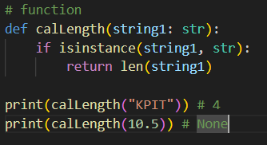
1. in function, we can specify return type by → arrow

2. now if function return nothing still we printing we will get ‘None’

3. can check the type using (isinstance)

4. Keyword Arguments:

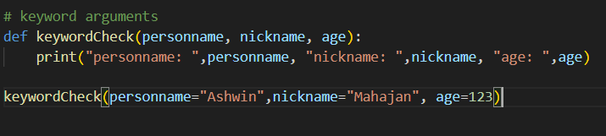
- are a way of passing values to a function by specifying the parameter name, not just the order.
- If using this then we can change the order by providing name.
- Positional argument should not follow key word argument (it is imp). I any function positional argument should not appear after keyword argument
- Here we can also use default arguments.
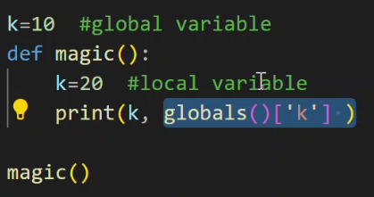
5. The rule for global and local scope is same.

- If want to refer the values from global even if we have same name in local then we can use this thing.
- Also, if nested function we can use ‘nonlocal’ to point to the non-local thing.

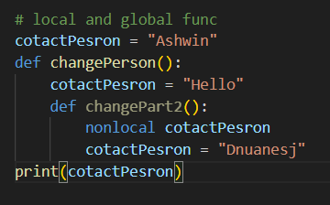

- Like this

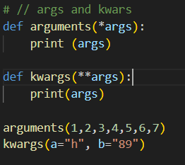
6. args and kkwargs

- *args — accepts any number of positional (non-keyword) arguments
- **kwargs — accepts any number of keyword arguments
- cannot use int as key → remember that

7. Working with dictionaries.

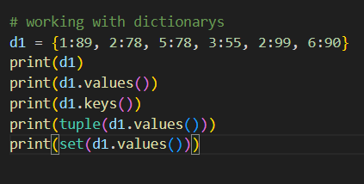
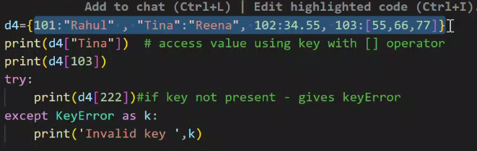

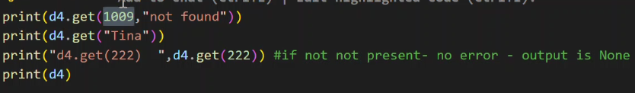
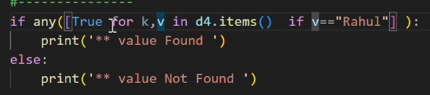

8. Questions to solve:

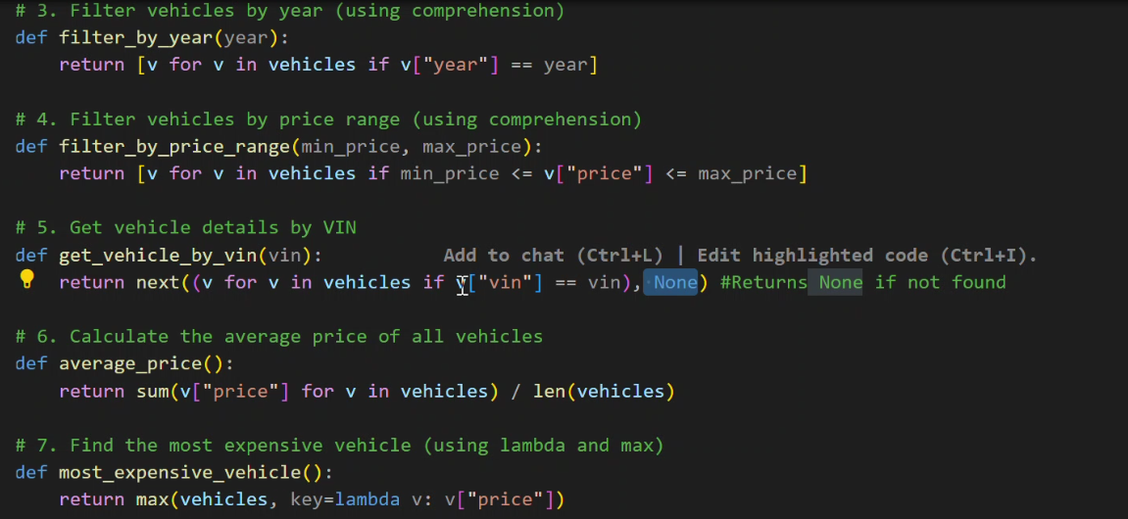

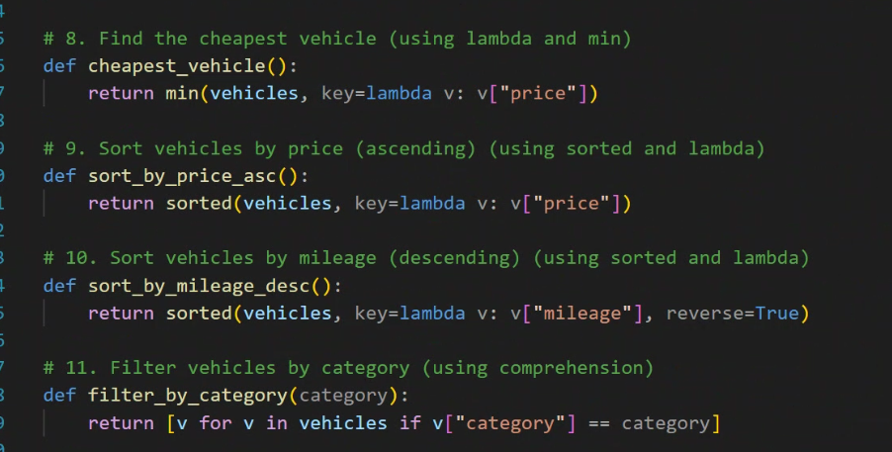

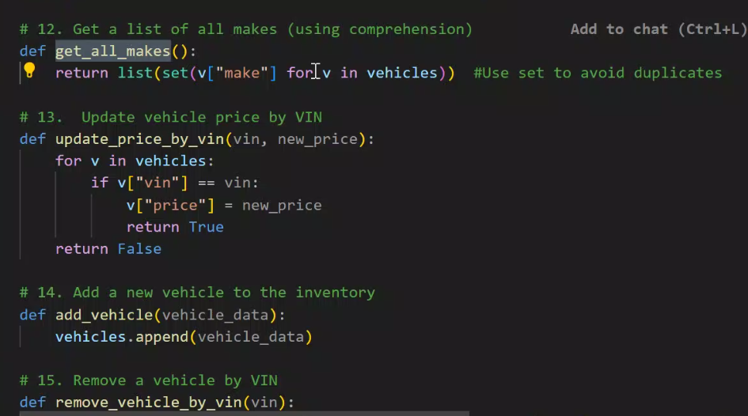
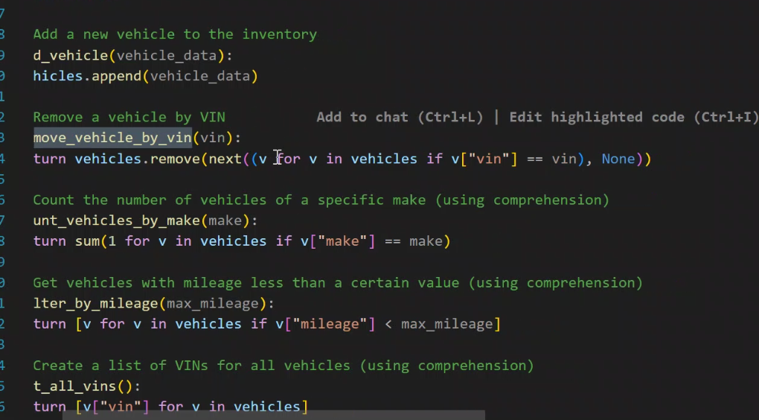

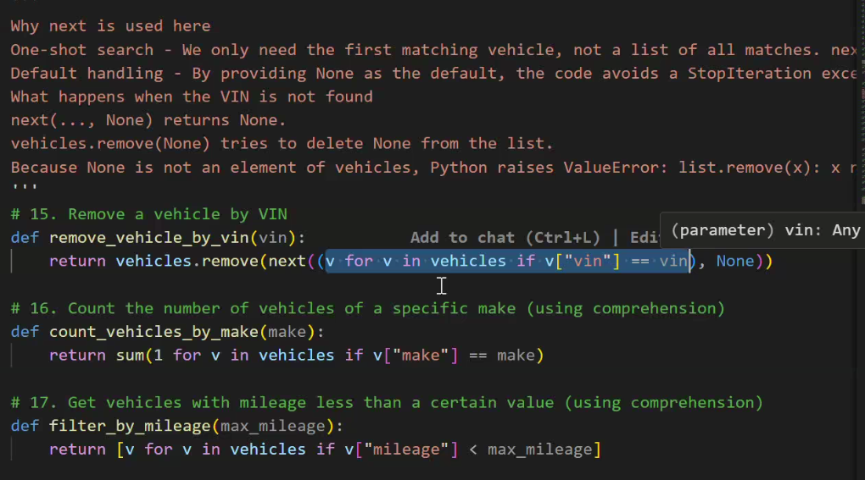

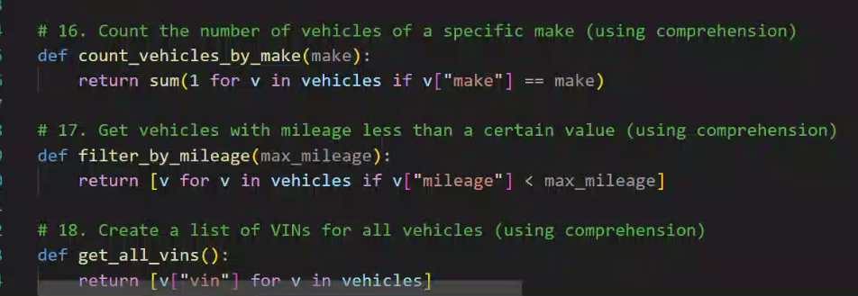

9. Lambdas:- they are anonymous functions used to write simple functions.

- Never for sake of the re usability

10. anytime encountered the things like printing generator list. Just convert it into list by [] this braces

Todays IMP:

- filter function : list(filter(is_odd, numbers))
- typically used to filter something (is_odd is lambda while the numbers is ‘list’)
- decides whether to keep each element

- map function: list(map(lambda x:x**2, a))
- mapping a value to a specific function
- decides how to transform each elements

- from functool import reduce: resultList = reduce(lambda x,y: x-y,l1)
- reducing all list values in one by applying same operation again and again

Day3 → 25/11/2025

1. Self Learning :- set and map

2. Question to solve :- create class with all previous example yesterday. Should learn about enum. Should separate the code in multiple files

3. Object Oriented Programming:

- class constructor --> def __init__(self)
- self --> mandatory argument to each non static member function. Used to access object internally or it refers to to current object.
- def __repr__(self): --> string representation of obj by returning string. Just like overloaded << operator
- also can write show data function.
- Adding __attr (double underscore) at start will make the variable as private attribute.

4. while writing getter for any attribute we should first an-note it by @property

5. for setter method we should use decorator @attr_name.setter -> in setter also check the instacnce of the data type else throw the exception.
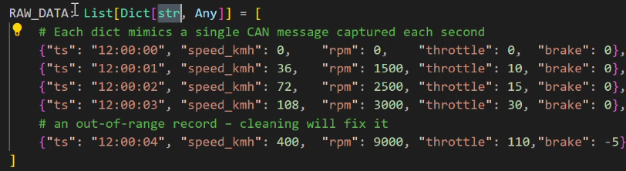
6. for creating something with particular declaration (importing Dict, List and Any for typing)

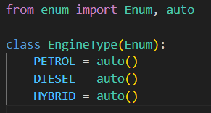

7. for creating enum classes in python.
Here auto takes cares of assigning the no (id) which might gets assigned randomly if we did not use auto.
(funny part) do not need to write getEnumString function. Because just type attr_name.value (for value) and attr_name.name for name

Day4 → 26/11/2025
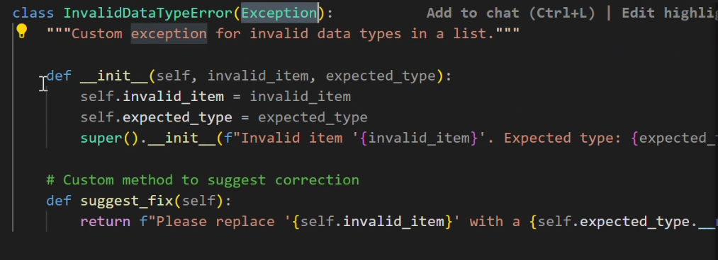

1. ways to add custom exceptions

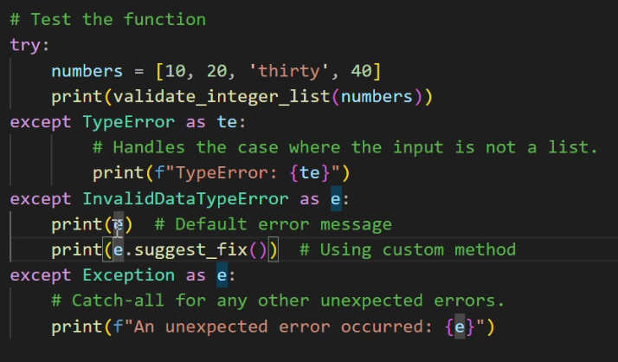

2. For inheritance use super() keyword to call base class inheritance

Day 1Dec

1. for static data member include it directly in class

2. for class methods don’t pass self as a param in input just use @classmethod as decorator

3. @classmethods can be accessed without creation of object.

4. static methods do not even take the input of ‘cls’

Day 2Dec

• Python can be used to read and write data. Also it supports reading and writing data to files.
• File is a named location on disk to store related information. It is used to permanently store data in a non-volatile memory (e.g. hard disk).
• Generally we divide files into two categories:
– Text file
– Binary file

Mode | Description
r | Open a file for reading.
w | Opens a file for writing only. Overwrites the file if it exists. If the file does not exist, creates a new file for writing.
r+ | Opens for reading and writing (cannot truncate a file).
w+ | For writing and reading (can truncate a file).
a | Open for appending at the end of the file without truncating it. Creates a new file if it does not exist.
t | Open in text mode.
b | Open in binary mode.
x | Open for exclusive creation, failing if the file already exists.

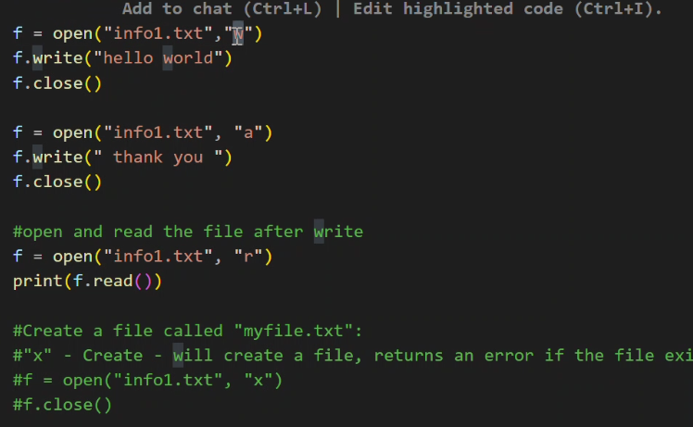

1. Opening and performing some operations

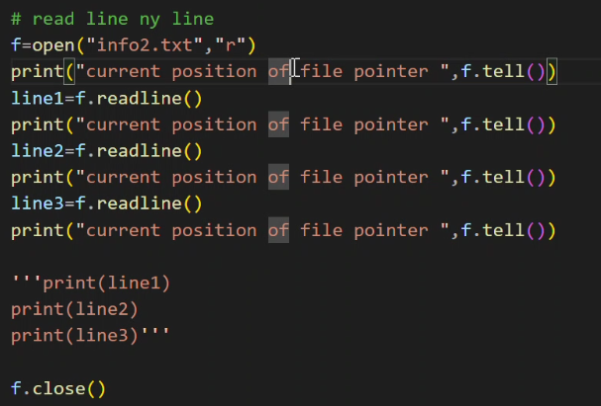
2. Reading the file line by line

pandas function names:-

1. pd.Series() -> with idx (both explicit and implicit)

2. The fundamental Pandas object is called a DataFrame.
It is a 2-dimensional, size-mutable, potentially heterogeneous, tabular data structure.
A DataFrame can be created in multiple ways. It can be created by passing in a dictionary or a list of lists to the pd.DataFrame() method, or by reading data from a CSV file.

3. reading data from csv :- pd.read_csv()

4. list of list to dataframe ->
data = [['Tom', 20], ['Jack', 30], ['Meera', 25]]
df = pd.DataFrame(data, columns=['Name', 'Age'])
print(df)

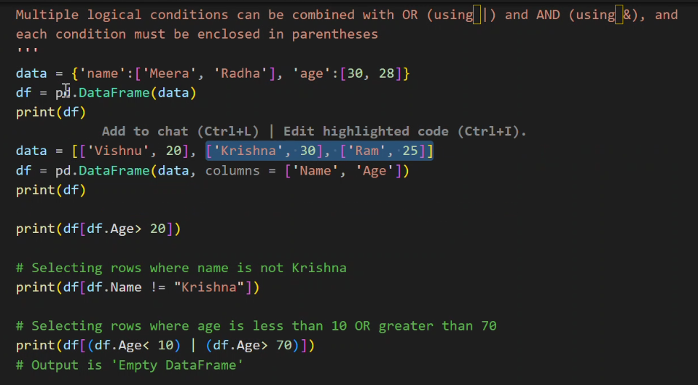

5. multiple logic condition:

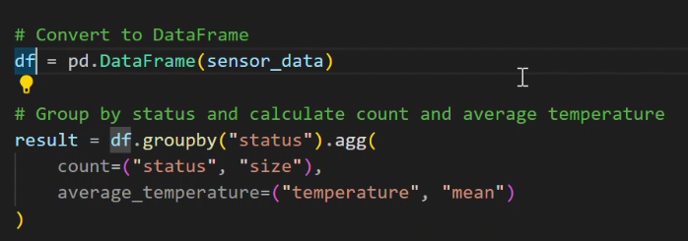
6. Some df functions

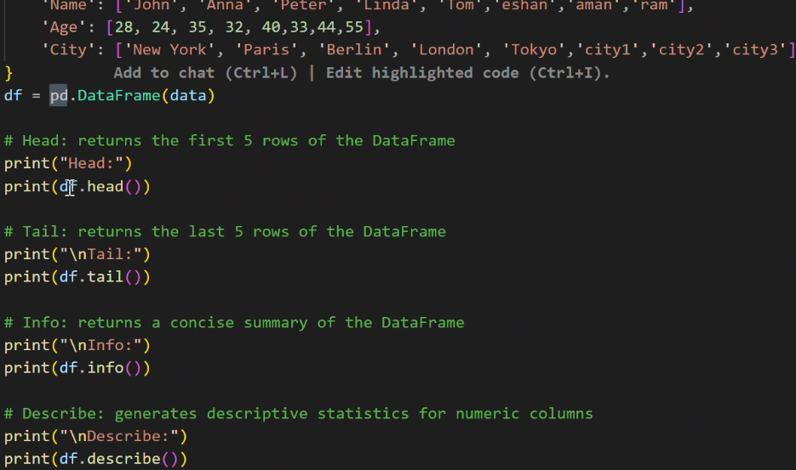

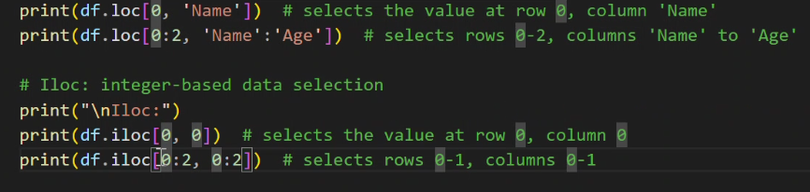

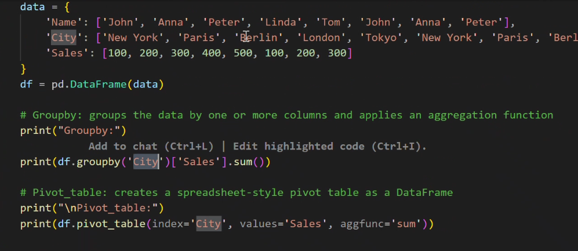
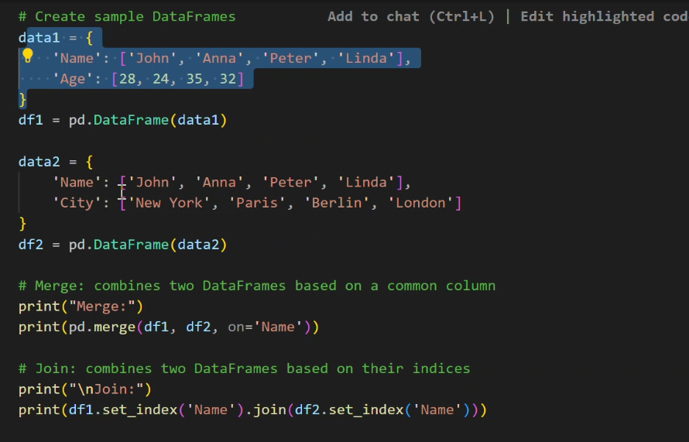

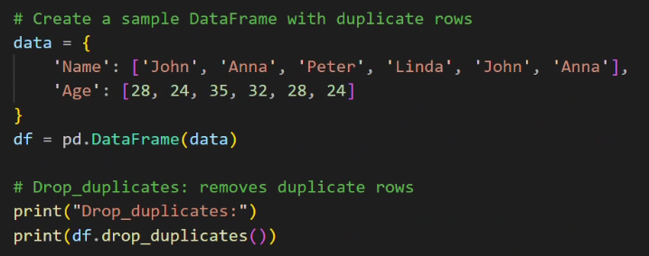

​regular expressions:

Regular Expression in Python
In Python, we have module “re” that helps with regular expressions.
So you need to import library re before you can use regular expressions in Python.
Use this code → import re
The most common uses of regular expressions are:
• Search a string (search and match)
• Finding a string (findall)
• Break string into substrings (split)
• Replace part of a string (sub)
Let’s look at the methods that library “re” provides to perform these tasks.
import re
result = re.match(r'AV', 'AV Analytics Vidhya AV')
print(result.start()) # Output: 0
print(result.end()) # Output: 2

re.search(pattern, string):
It is similar to match() but it doesn’t restrict us to find matches at the beginning of the string only.
Unlike the previous method, here searching for pattern ‘Analytics’ will return a match.
import re

result = re.search(r'Analytics', 'AV Analytics Vidhya AV')

print(result.group(0)) # Output: Analytics

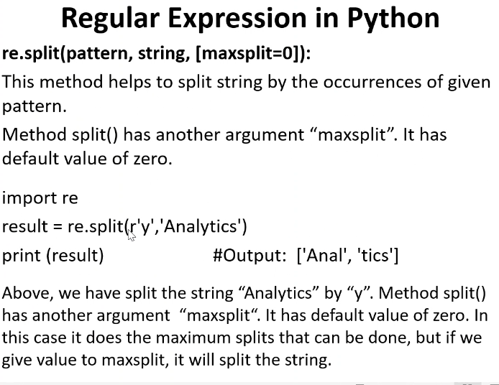

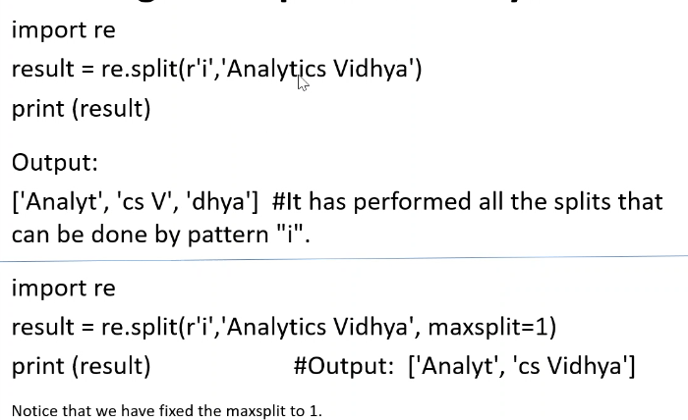

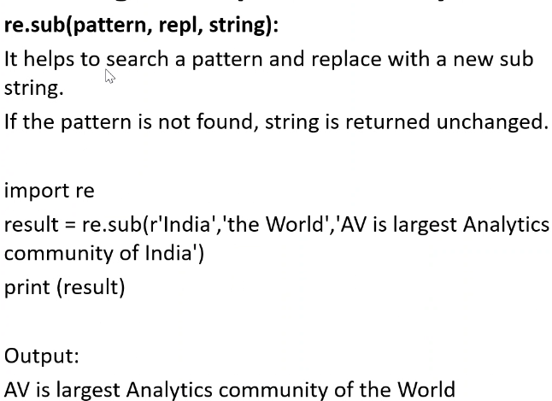

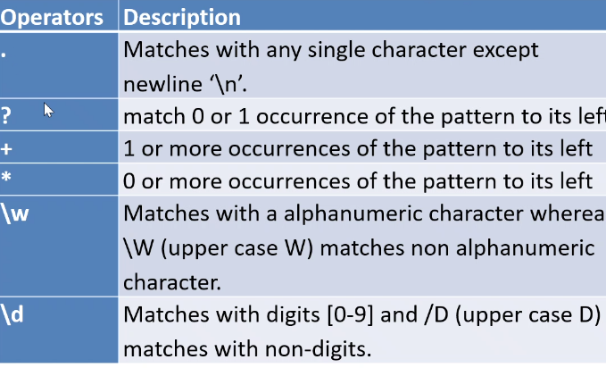

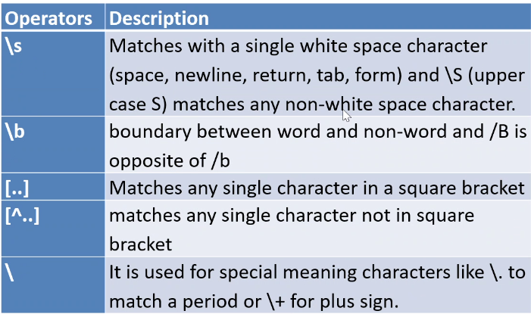

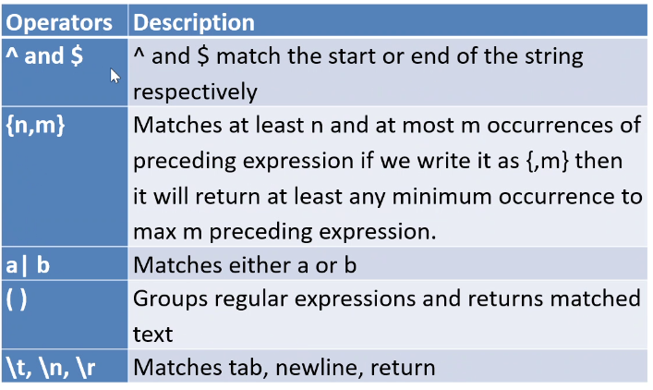

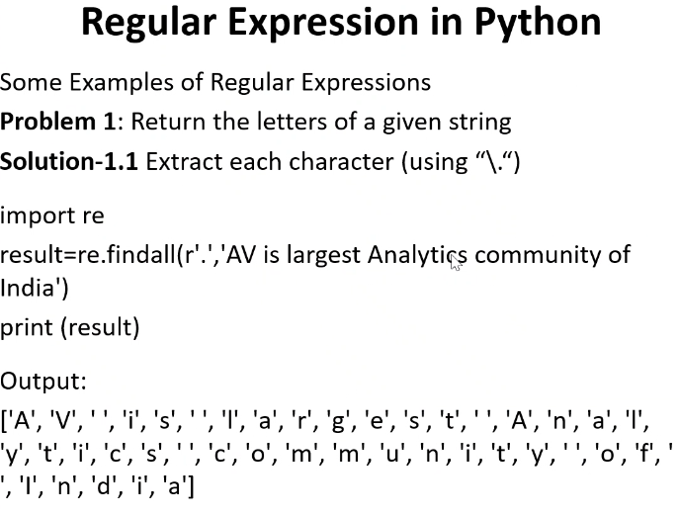

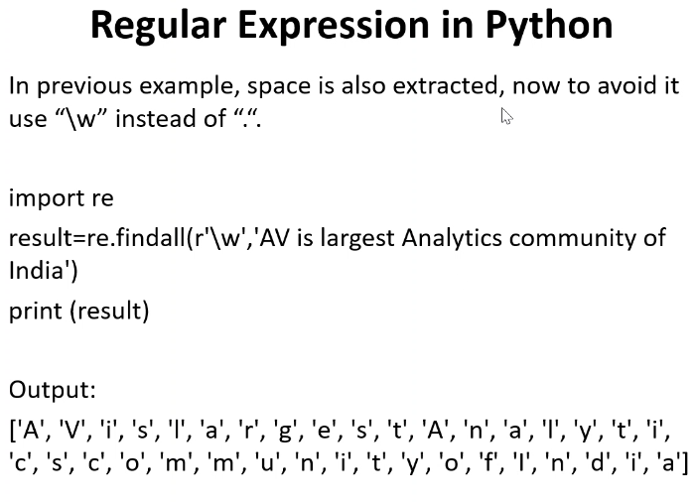

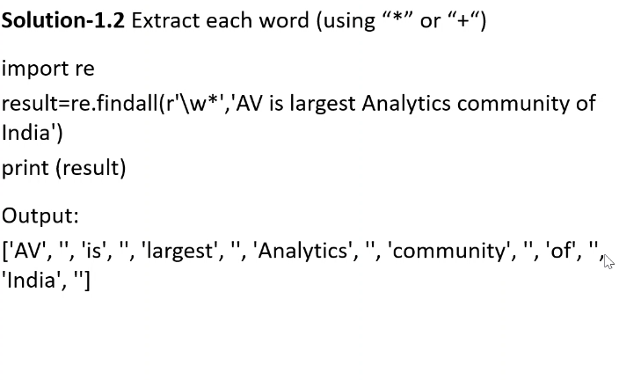

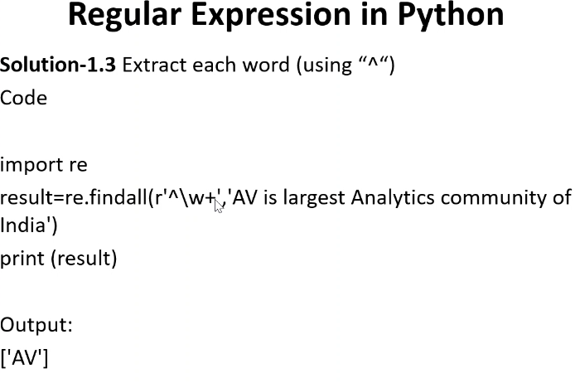

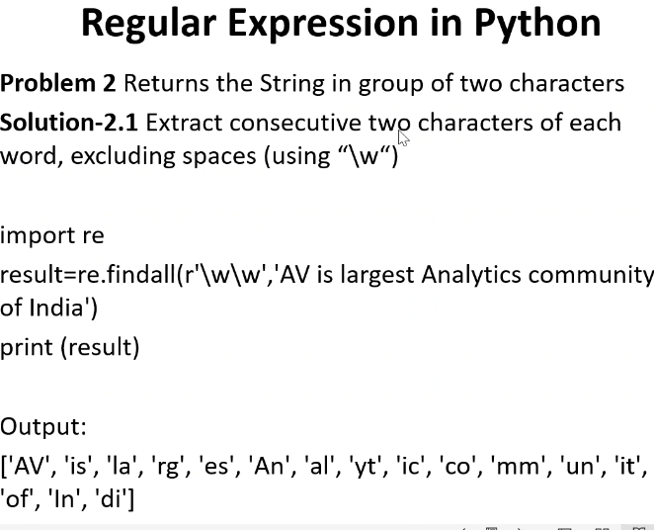

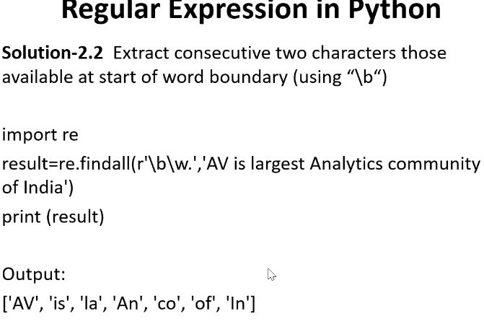

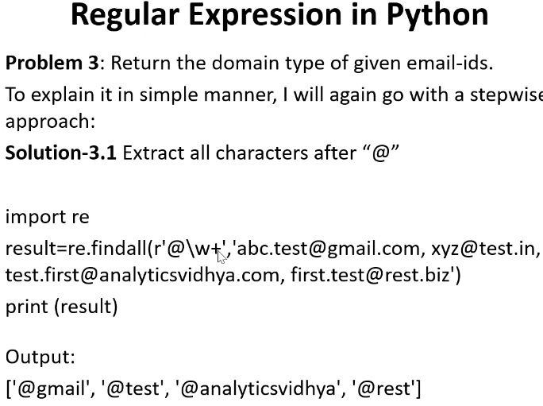

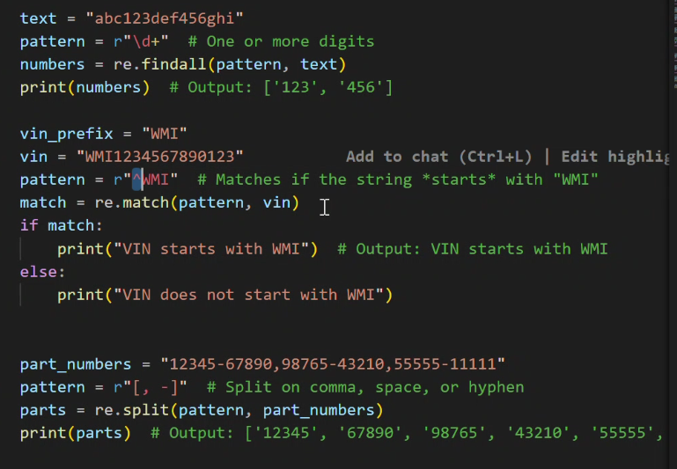

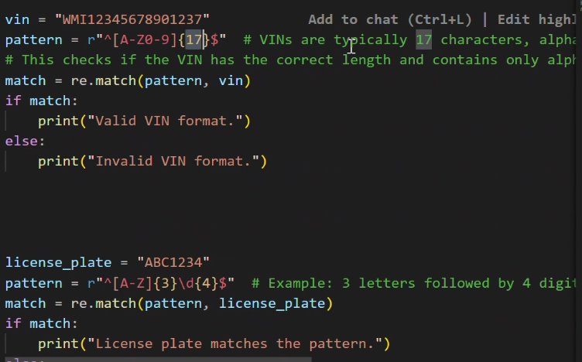

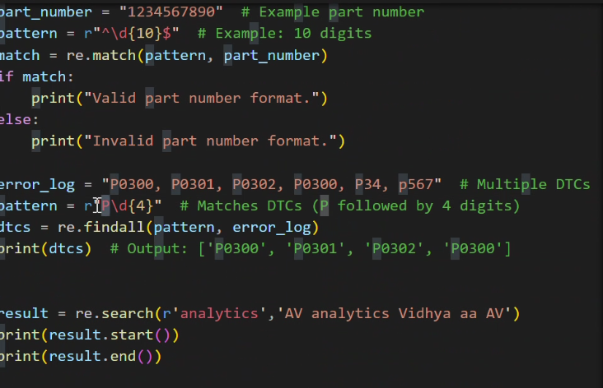

Some Regex expression use cases:

Operator | Meaning / Description | Example | What It Matches
. | Matches any single character except newline \n | a.b | acb, a1b, a$b (anything between a and b)
? | Matches 0 or 1 occurrence of the pattern to its left | colou?r | color, colour
+ | Matches 1 or more occurrences of the pattern to its left | a+ | a, aa, aaa
* | Matches 0 or more occurrences of the pattern to its left | ba* | b, ba, baa, baaa
\w | Matches any alphanumeric character (A–Z, a–z, 0–9) and _ | \w\w | A1, ab, 9Z
\W | Matches any non-alphanumeric character | \W | @, #, -, !, space
\d | Matches any digit (0–9) | \d\d | 12, 05, 99
\D | Matches any non-digit character | \D | A, !,
[...] | Matches any one character present inside the brackets | [abc] | a or b or c
[^...] | Matches any one character NOT present inside the brackets | [^abc] | any character except a, b, or c

