Need: Decision Making, Alignment, Productivity

Meeting Lifecycle:
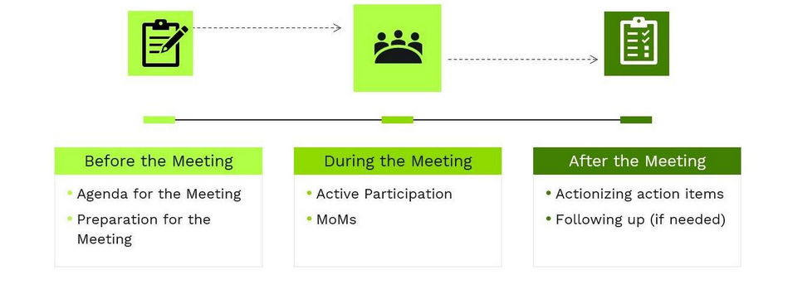

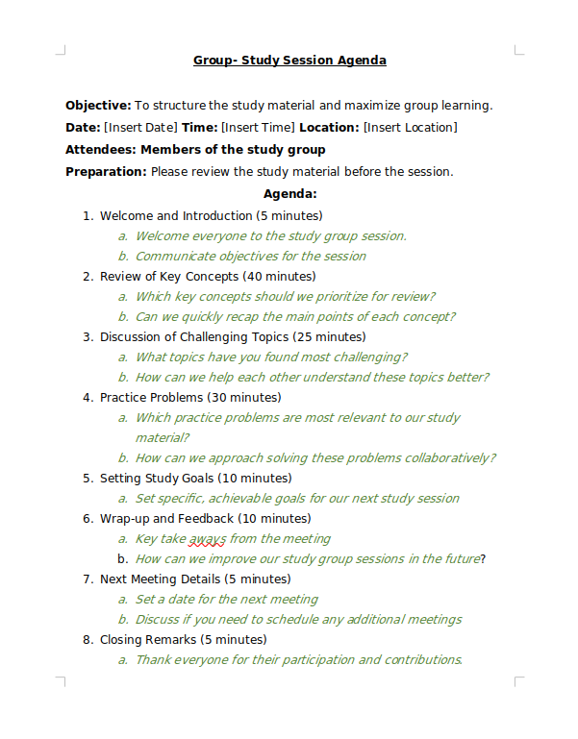
1. Before Meeting :
- The objective of the meeting
- Topic it should cover and flow
- Who to include and timing

How actually the agenda is written

R.A.S.L.C. --> Responsible, Accountable, Support, Informed, Consulted

2. During the meeting :
- This is where the actual discussion commences on the agreed agenda.
a. Effective Meeting Communication:

- C.L.E.M: Clarity + Listening + Engadgement (Deliver)
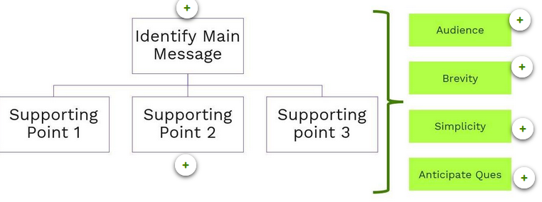

- Tone of Speech:
1. Energy , Rate of speech, Pitch and Quality
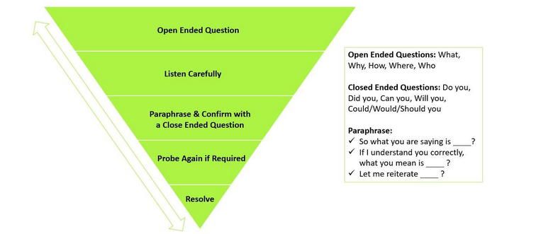

b. Minutes of Meeting (MoM)
- writen record that summarizes duscussions
ex. (Date and Time->Agenda->Attendance->Notes->Action Items)

3. After Meeting
- Review Notes, take actions

