Four skills of learning a language:
- Listening
- Speaking
- Reading
- Writing

Grammer:
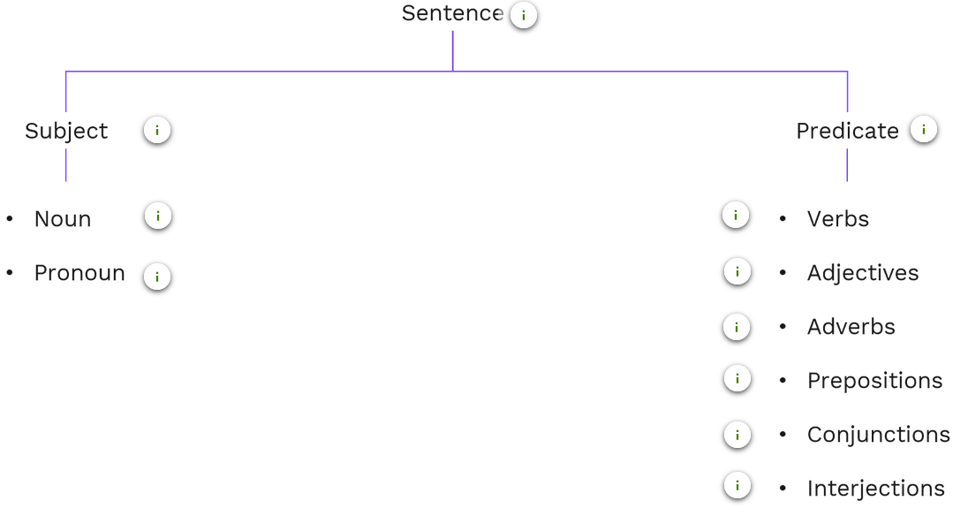
- Verb --> Great! Smita and her friend are the only brilliant girls with highest score in class.

- Adjective --> Great! Smita and her friend are the only brilliant girls
with highest score in class.

- Adverb --> Great! Smita and her friend are the only brilliant girls with highest score in class.
- Preposition --> Great! Smita and her friend are the only brilliant girls with highest score in class.
- Conjuction --> and, or
- Interjection --> Great!
- Infinitive: The base form of a verb preceded by "to".
- Gerunds are verb forms ending in "-ing" that function as nouns.

Articles
- The article 'a' or 'an' are called indefinite articles because they do not state which person or thing is being talked about.
- ex. 'A laptop' can mean any laptop; nothing specific. 'An engineer' means any engineer.
- Definite articles (the) can be used before singular countable nouns, plural countable nouns and uncountable nouns.
Example: the book, the books, the rice or the milk
"The books I bought last weekend are on the table in my room"
when to use ‘the’ :
- Used when someone or something is already mentioned before
- Used with Countable and Uncountable nouns. E.g. : All the company reports are saved on my laptop.

Subject verb agreement
- SVA, simply means the subject of the sentence and verb must agree with each other. This means both need to be singular or both need to be plural.

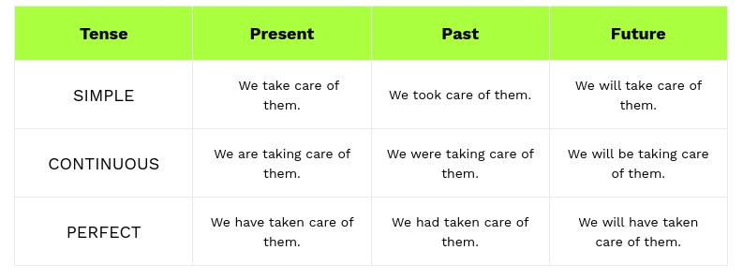
Tenses:

Non-Verbal Communication:
- Facial Expression.
- Eye Contact
- Gestures
- Postures

Confidence cycle
Confidence cycle --> Thought, Feeling, Behaviour
steps to prepare confidence --> research, orgnize , anticipate , structure

PREP Framework
PREP -
1. Point --> Starting with main idea
2. Reason --> Explain why it matters
3. Explanation --> Suppot it evidence or illustration
4. Point --> end by enforcing our main idea.

