Three Time Monsters :- Distraction, Multitasking, procastination

1. Distraction --> have 2 strategies : Big Rocks, Time Boxing

2. Multitasking --> have 2 startegies : Chunking - Eat the Elephant, Pomodoro Technique(25 min work 5 min break )

3. Procrastination --> have 3 strategies:
- Parkinson's Law: Longer we take to complete a task, the difficult it appears. So, use shorter deadlines
- Eat the Frog: Doing most critical tasks at start of the day
- Golden Key : three question 1. Do I know what to do ? 2. Do I know how to do it? 3. Am I motivated to do it? Do the circumstances allowed me to do it?

Time Management Matrix:-
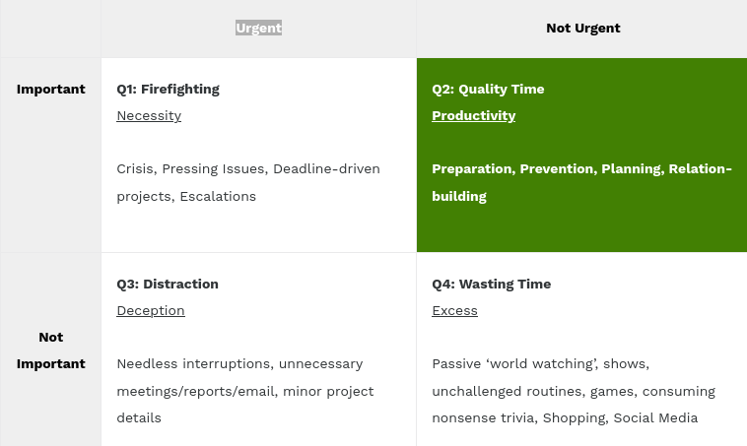

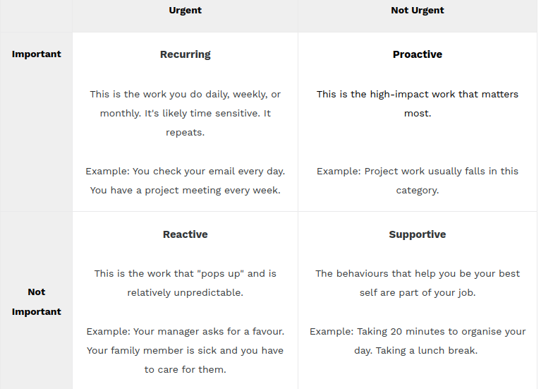

Proactive communication:-

F.A.S.T. --> Fix a time, Anything not used, Some other clutter, Trash

S.M.A.R.T --> Specific, Measurable, Acheivable, Relevant, Time Bound

