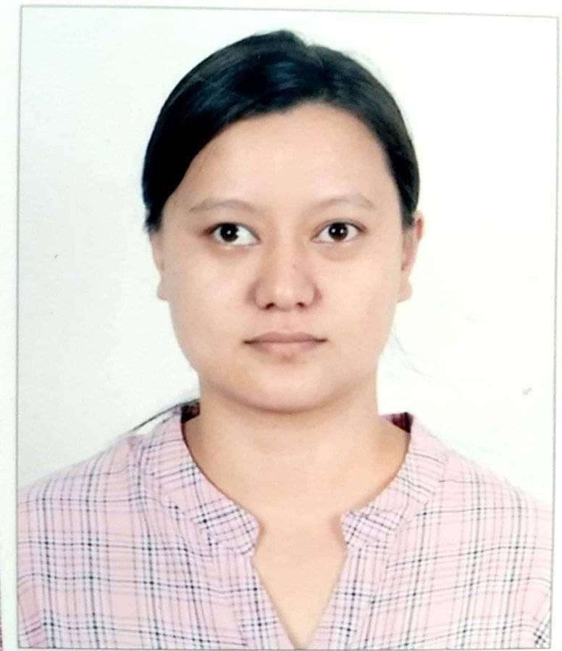
CURRICULUM VITAE

Anjali Maharjan
Nayabazar, Kathmandu
Mobile No. : 9849208272
Email Id : maharjan.anj@gmail.com
ACADEMIC QUALIFICATION

S.No. | Qualification | University / Board | Year | Per %
1 | M.Sc.Microbiology | TU | 2018 | 72.60%
2 | B.Sc.Microbiology | TU | 2012 | 71.43%
3 | 10+2 (Science) | HSEB | 2009 | 73.60%
DISSERTATION
Titled “Antimicrobial Susceptibility Profile, Biofilm Formation and Detection of fimH Virulence Gene in Uropathogens from Clinical Samples”, January, 2018 funded by University Grants Commission (UGC).
PUBLICATION
Co-author of the research article “Biofilm Formation and Detection of icaD gene in Staphylococcus aureus isolated from Clinical Specimens” published in The Open Microbiology Journal, 2019, 13, 230-235.
WORK EXPERIENCE
- Laboratory Incharge (Biology), United Academy, Kumaripati, Lalitpur, May 2019 till date.
- Laboratory Teacher (Botany), National School of Sciences, Lainchaur, Kathmandu, May 2018 to April 2019.
- Program Officer, Health, Education, Empowerment and Development (HEED) Nepal, NGO, Thamel, Kathmandu, January to December 2017.
- Research Intern, Annapurna Research Center, Maitighar, Kathmandu, June to December 2016.
- “Proposal Writing and Poster Preparation” workshop conducted by Amrit Campus, March 3, 2018.
TRAININGS
- “SPSS and R Basics Training” conducted by Kathmandu Center for Genomics and Research Laboratory and Microbiology Research Society, August 12-14, 2017.
- “Basic Human Cell Line Culture Training” conducted by Annapurna Research Center, September 4-8, 2016.
- Community Service and Volunteerism program of Nepal School of Social Work, August 17, 2014 - May 17, 2015.
- Public Speaking training (15 days) conducted by Prajapati Yuva Khala, Jyatha, Kathmandu, November, 2009.
CONFERENCES/ SEMINARS
- “Fourth National Summit of Health and Population Scientists in Nepal” organized by Nepal Health Research Council (NHRC), April 11-12, 2018.
- Poster presentation on research “Antimicrobial Susceptibility Profile, Biofilm Formation and Detection of fimH Virulence Gene in Uropathogens from Clinical Samples” at the 3rd International South Asian Biotechnology Conference organized by Nepal Biotechnology Association and Central Department of Biotechnology, Tribhuvan University in collaboration with South Asian University, New Delhi, March 16-18, 2017.
- “Be The Change” Interactive Seminar organized by Together For Nepal, November 10- 12, 2016.
- “Envision- Life Science and Medicine-II” organized by Kathmandu Centre for Genomics and Research Laboratory, September 16, 2016.
- “Symposium on Microbiology and One Health Concept in Nepal” organized by Nepalese Society for Microbiology and American Society for Microbiology, September 3, 2016.
- “Brain Drain to Brain Gain Series” organized by Biotechnology Society of Nepal.
- “5th National Conference on Microbiology” organized by Nepalese Society for Microbiology, November 15-16, 2014.

SKILLS AND INTEREST
Computer Skills | Microsoft Office Package, Adobe Photoshop, Statistical Package for the Social Sciences (SPSS)
Language Skills | Nepali, English, Nepal Bhasa, Hindi
Interests | Reading, Travelling

