1. Plot a histogram,

10, 13, 18, 22, 27, 32, 38, 40, 45, 51, 56, 57, 88, 90, 92, 94, 99

Ans: import matplotlib.pyplot as plt

data = [10, 13, 18, 22, 27, 32, 38, 40, 45, 51, 56, 57, 88, 90, 92, 94, 99]

plt.hist(data, bins=10, color='blue', edgecolor='black')

plt.xlabel('Values')

plt.ylabel('Frequency')

plt.title('Histogram of Data')

plt.show()

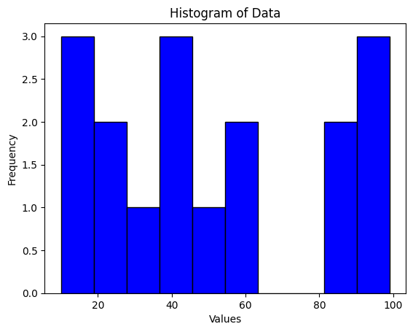

2. In a quant test of the CAT Exam, the population standard deviation is known to be 100. A sample of 25 tests taken has a mean of 520. Construct an 80% CI about the mean.

Ans: The 80% confidence interval about the mean is approximately (495.6,544.4)

3. A car believes that the percentage of citizens in city ABC that owns a vehicle is 60% or less. A sales manager disagrees with this. He conducted a hypothesis testing surveying 250 residents & found that 170 residents responded yes to owning a vehicle.

1. State the null & alternate hypothesis.
2. At a 10% significance level, is there enough evidence to support the idea that vehicle owner in ABC city is 60% or less.

Ans:

Null Hypothesis:

The null hypothesis typically represents the status quo or the belief that there is no effect or no difference. In this case, the null hypothesis states that the percentage of citizens in city ABC owning a vehicle is 60% or less.

Alternate Hypothesis:

The alternative hypothesis represents what the researcher is trying to demonstrate. In this case, the alternate hypothesis states that the percentage of citizens in city ABC owning a vehicle is greater than 60%.

4. What is the value of the 99 percentile? 2,2,3,4,5,5,5,6,7,8,8,8,8,8,9,9,10,11,11,12

Ans: The 99th percentile of the given data set is 12.

5. In left & right-skewed data, what is the relationship between mean, median & mode? Draw the graph to represent the same.

Ans:

In left-skewed (negatively skewed) data:

* **Mean:** The mean will typically be less than the median, and both will be less than the mode.
* **Median:** The median will be greater than the mean.
* **Mode:** The mode will be greater than the median, and both will be greater than the mean.

In right-skewed (positively skewed) data:

* **Mean:** The mean will typically be greater than the median, and both will be greater than the mode.
* **Median:** The median will be less than the mean.
* **Mode:** The mode will be less than the median, and both will be less than the mean.

Now, let's visualize this with simple sketches:

Left Skewed(Negatively Skewed)data:

Mode

|

| Median

| |

| | Mean

| | |

| | |

| | |

---|------------|--------|--------------------

Right Skewed(Positively Skewed)data:

Mode

|

| Median

| |

| | Mean

| | |

| | |

----|------------|--------|--------------------