Game Design Document

Fill up the following document

1. Write the title of your project.

Catch the Thief

1. What is the goal of the game?

To catch a thief that has stolen a precious diamond

1. Write a brief story of your game.

A police tries to stop a thief who has stolen a diamond and is trying to escape the city in a car. The thief car moves left to right continuously and the police car have to stop the thief car by hitting the car with two bullets. The police car has a limited number of bullets and if the police car misses any shot the velocity of the movement of the thief car increases and if the police car could not hit the thief car two times then the player looses and the thief escapes.

1. Which are the playing characters of this game?

* Playing characters are the ones who respond to the user based on the input from the user.
* Cars, monkeys, dinos, wizards, etc., are the playing characters in the game.

|  |  |  |
| --- | --- | --- |
| Number | Character Name | What can this character do? |
| 1 | Police car | Can hit bullets |
| 2 |  |  |
| 3 |  |  |
| 4 |  |  |
| 5 |  |  |
| 6 |  |  |
| 7 |  |  |
| 8 |  |  |

1. Which are the Non-Playing Characters of this game?

* Non-Playing characters are the ones that don't have an action or behavior when the user interacts with the game.
* Hurdles, stones, bananas, coins, etc., are non-playing characters in the game.

|  |  |  |
| --- | --- | --- |
| Number | Character Name | What can this character do? |
| 1 | Thief car | Escape the city |
| 2 |  |  |
| 3 |  |  |
| 4 |  |  |
| 5 |  |  |
| 6 |  |  |
| 7 |  |  |
| 8 |  |  |

Draw your imagination of this game. What does this game look like?

* Draw the game either on your computer or on paper.
* 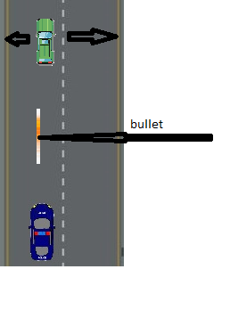Add images of the game scenes to show each of the playing and non-playing characters at least once.

How do you plan to make your game engaging?

By making the velocity of the thief car increase in every bullet missed by the police car to shoot the thief car