**Software Engineering Group Assignment-02**

**System Modeling**

Group Members:

Ashwin Sai Vagu (vagua01)

Sai Nikhil Attili (attis01)

Sudhanshu Marimganti (sudhm01)

Abhinav Narayana Kapa (kapaa01)

**1. Class Diagrams**

Client side:

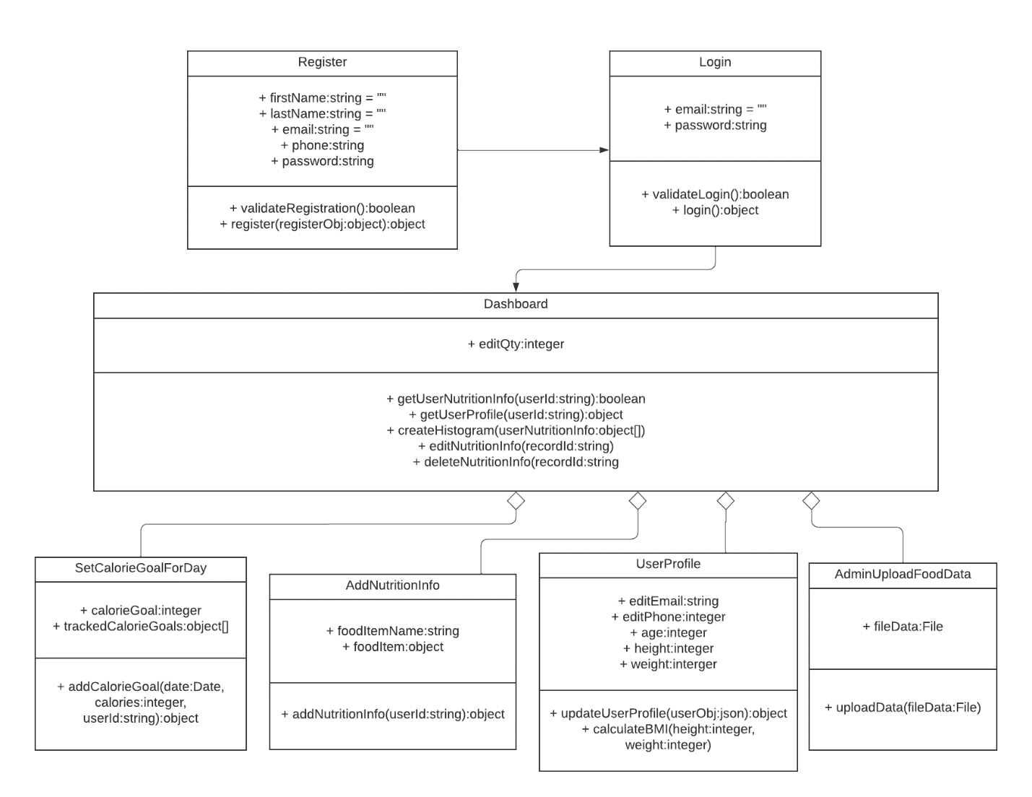

Server side:

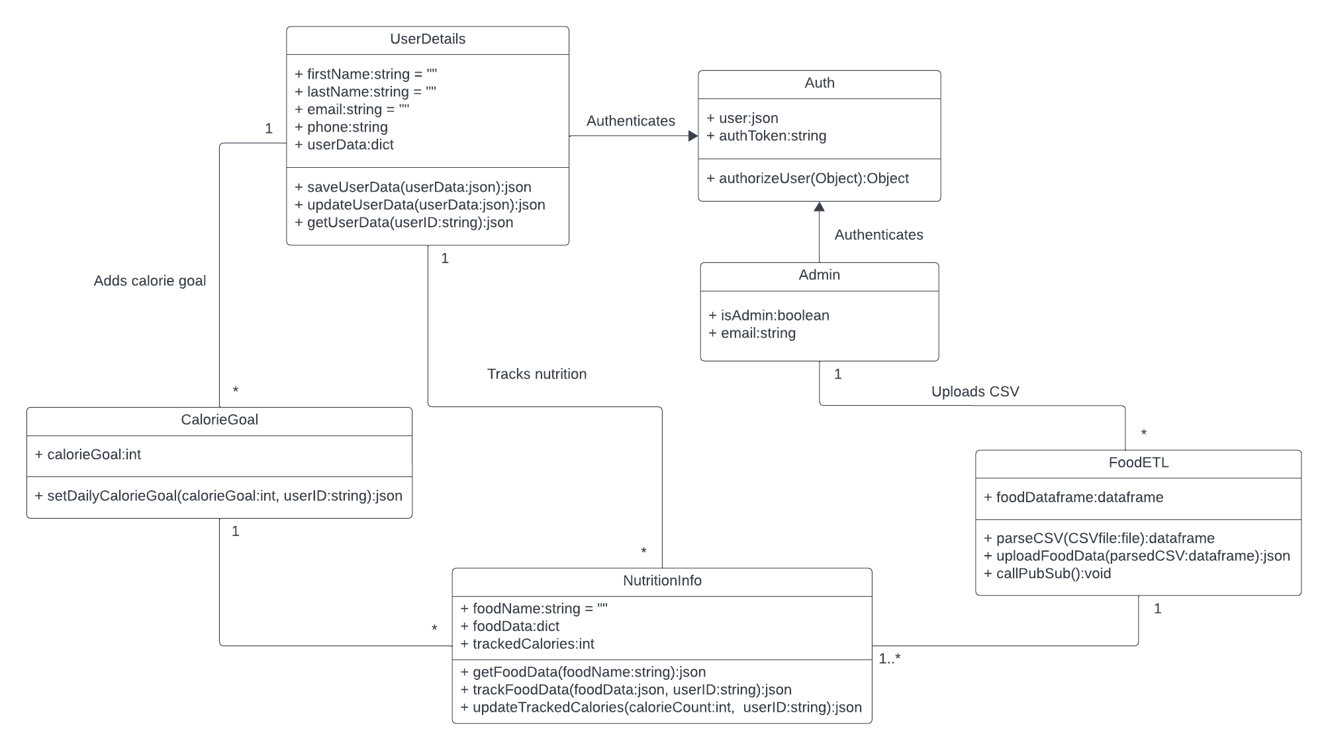

**2. Sequence Diagrams**

1. Authenticating and Logging in users:

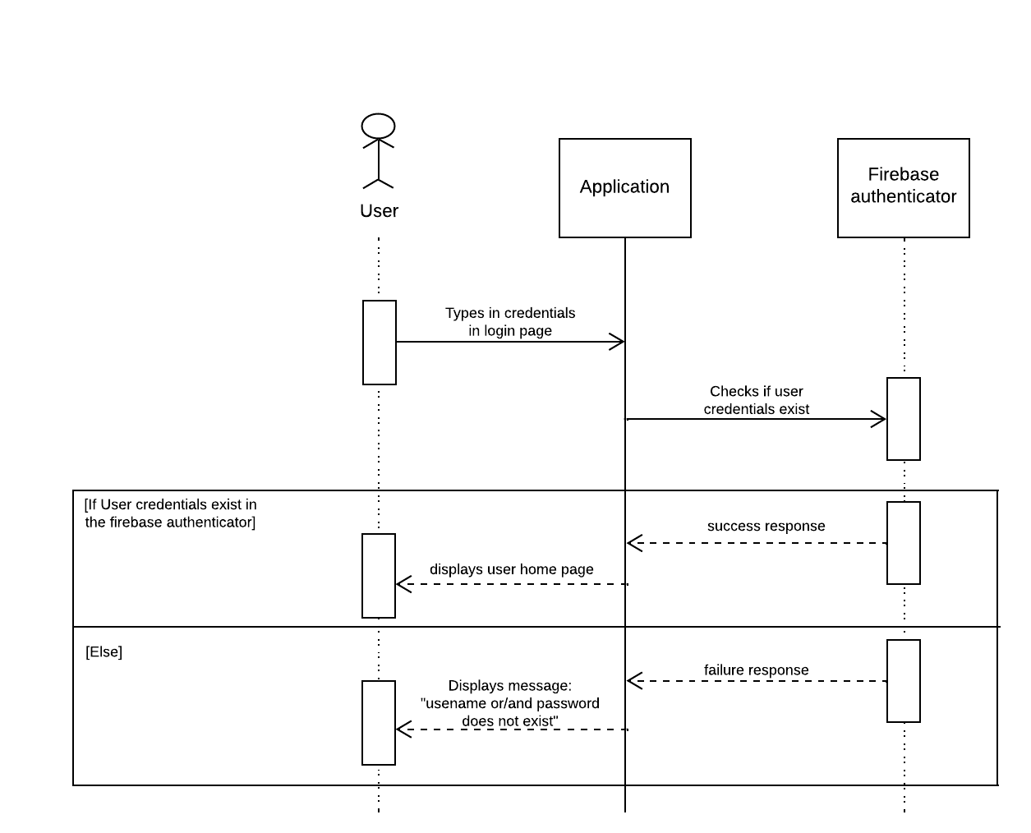

2. Registering a User:

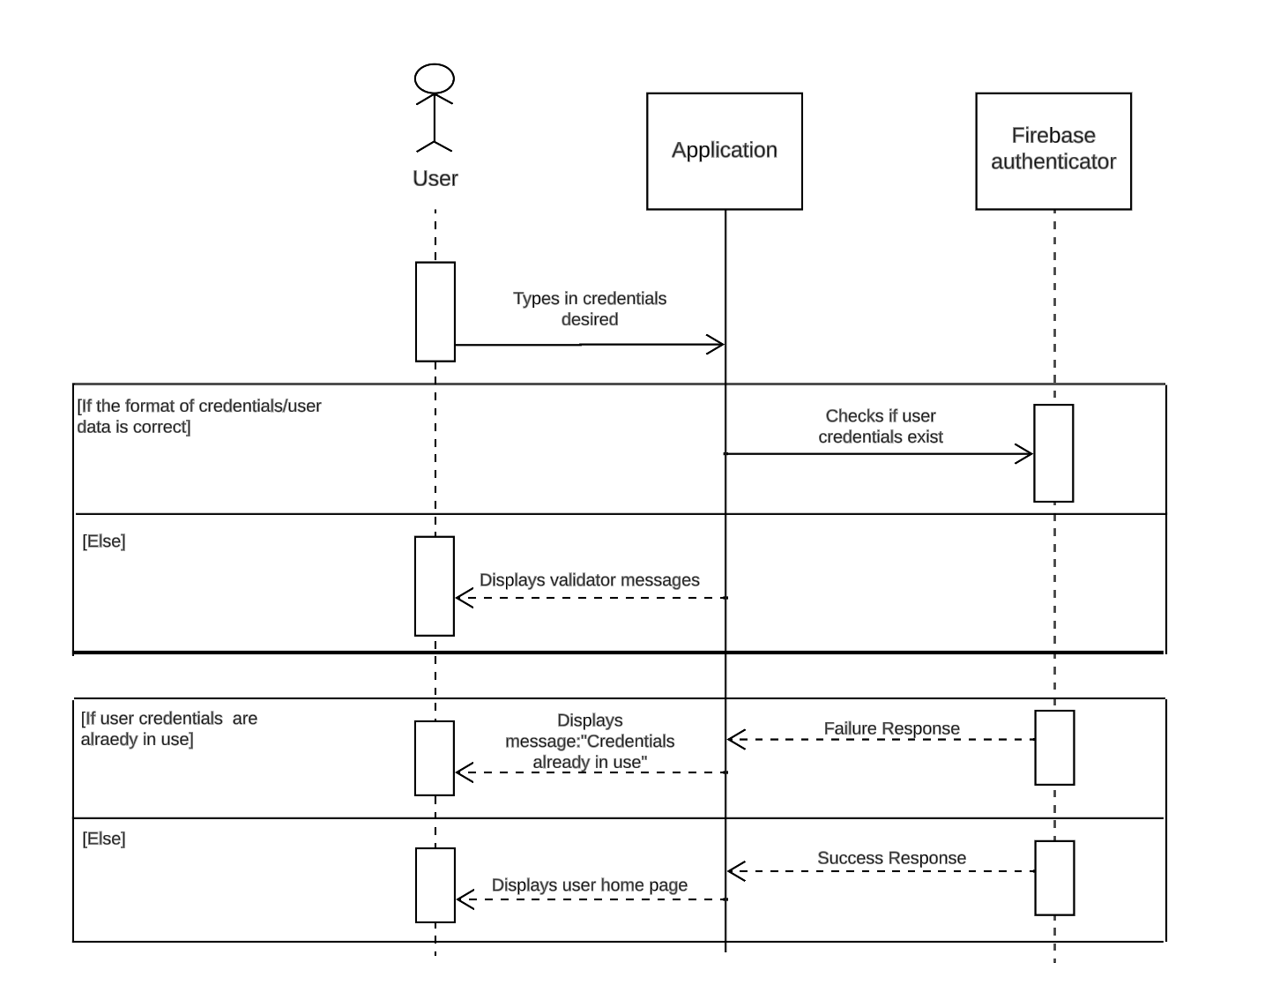

3. Changing user interface based on user type:

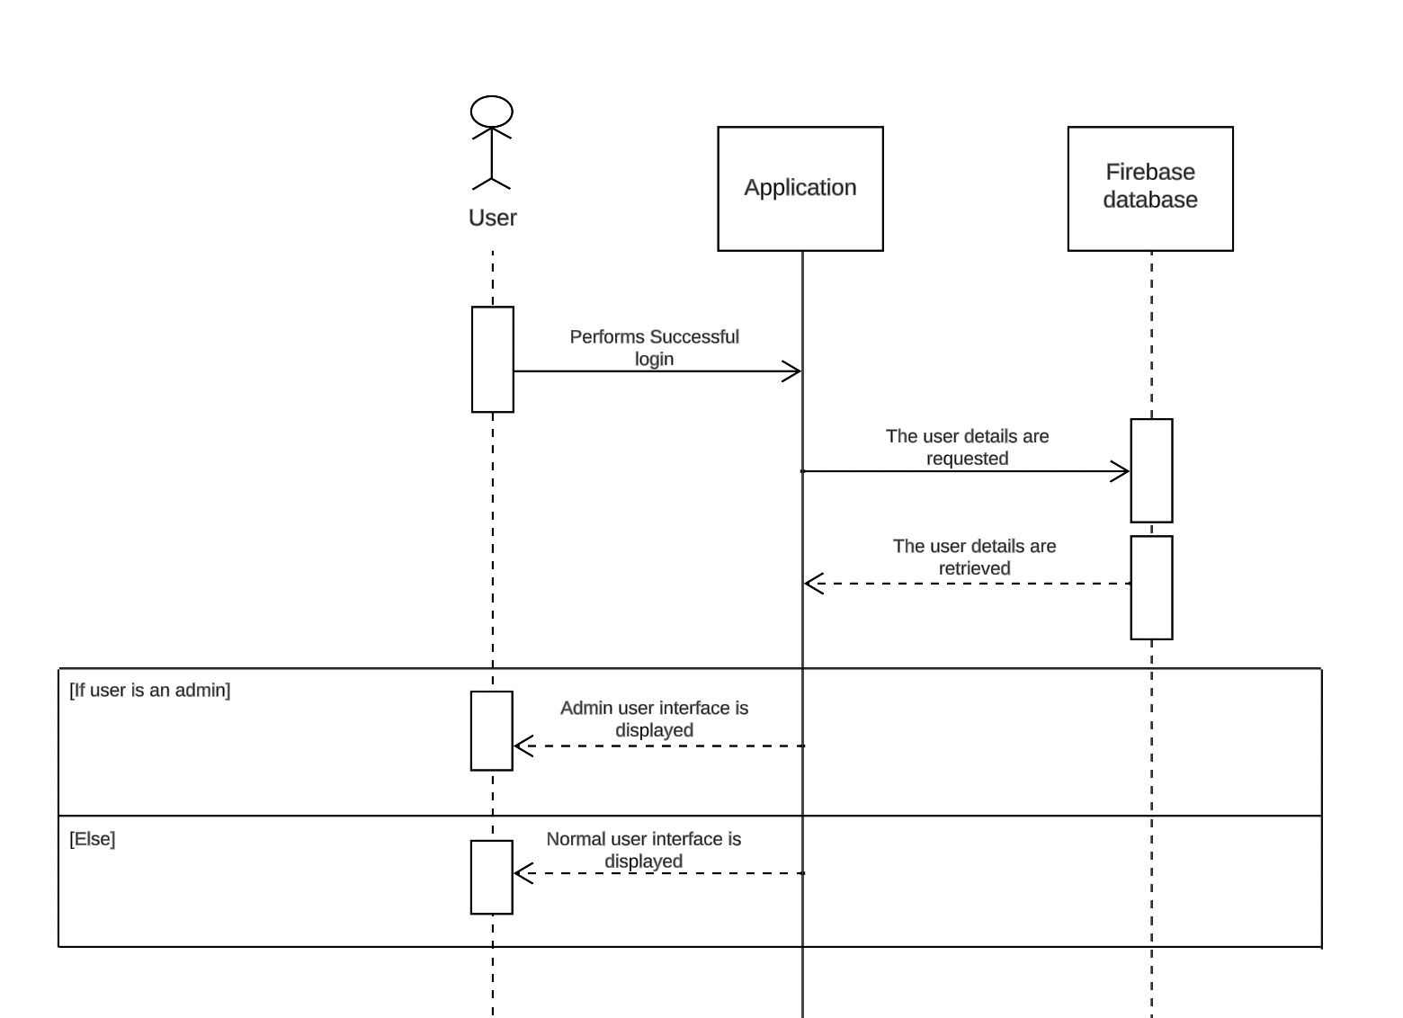

4. Attaining food nutritional values and calorie count:

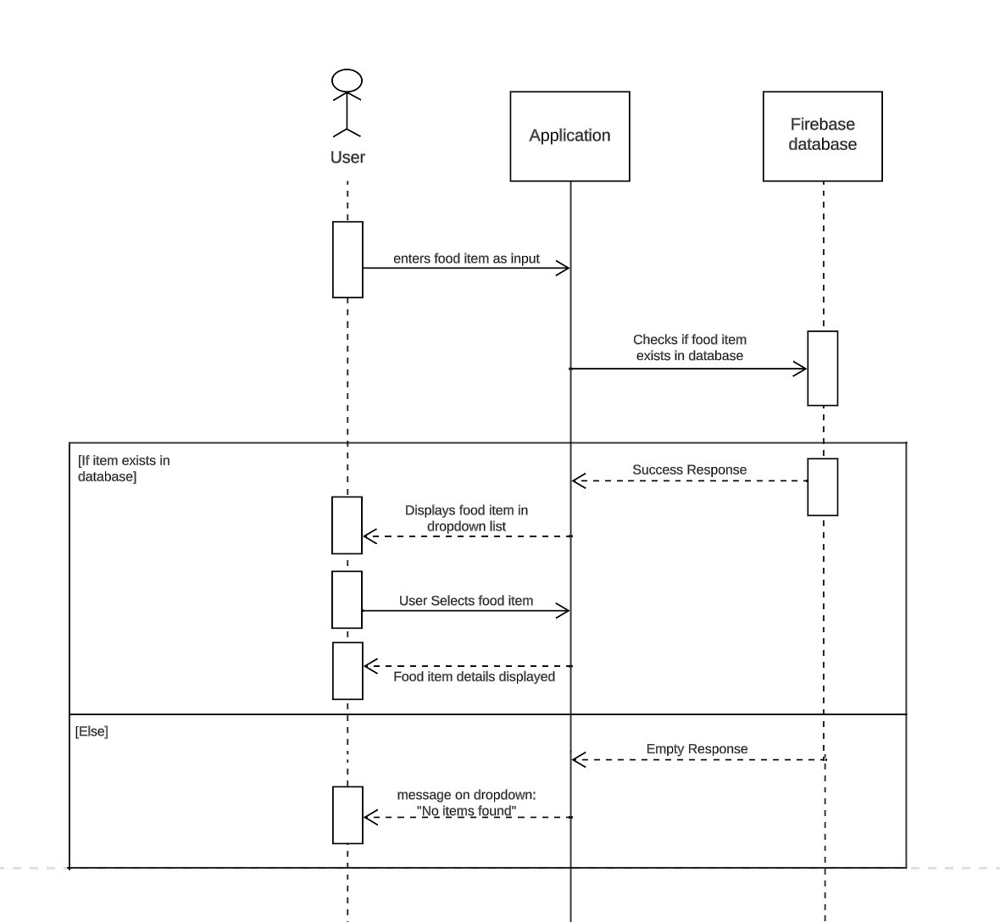

5. View user profile:

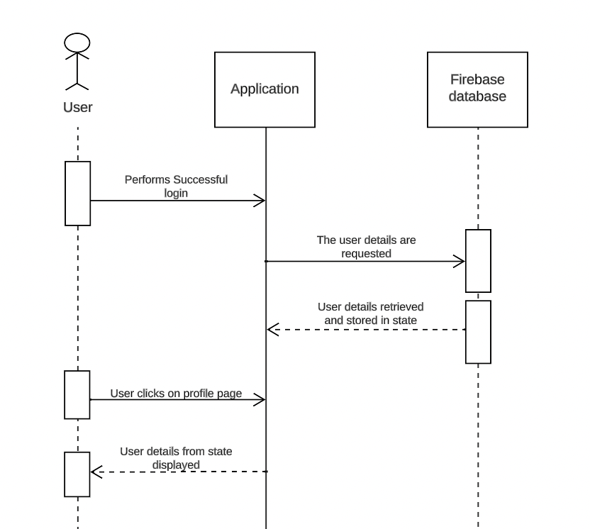

6. Graphical representation of calorie-goal analytics:

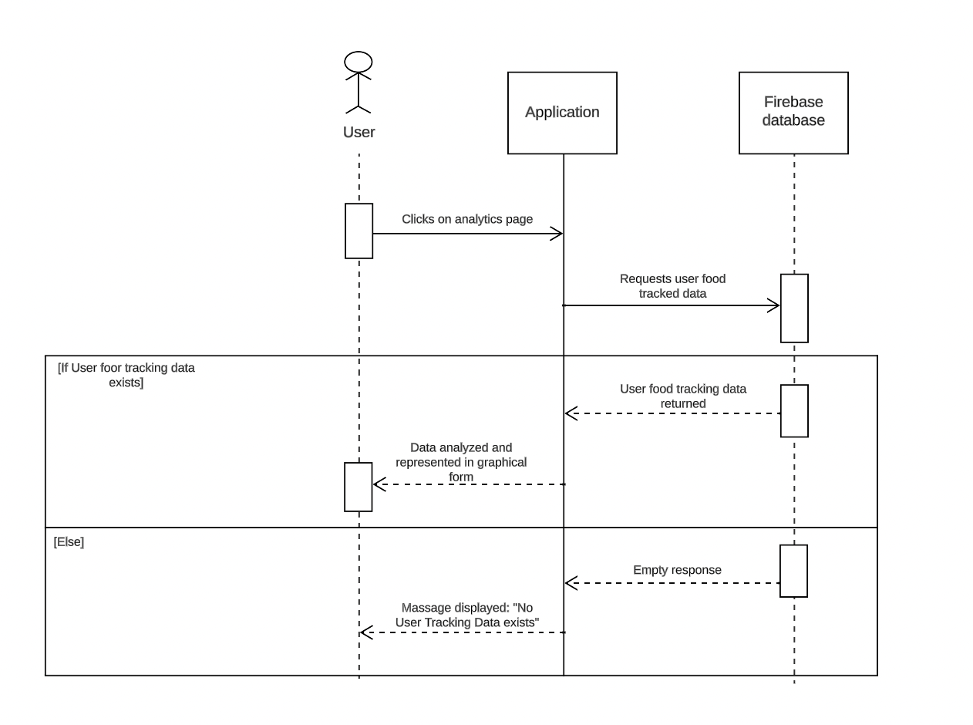

7. Calculating Body Mass Index based on user input data:

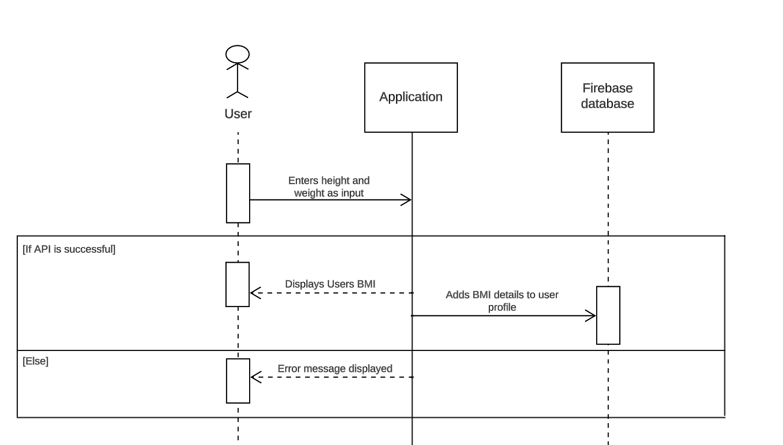

8. Update user information:

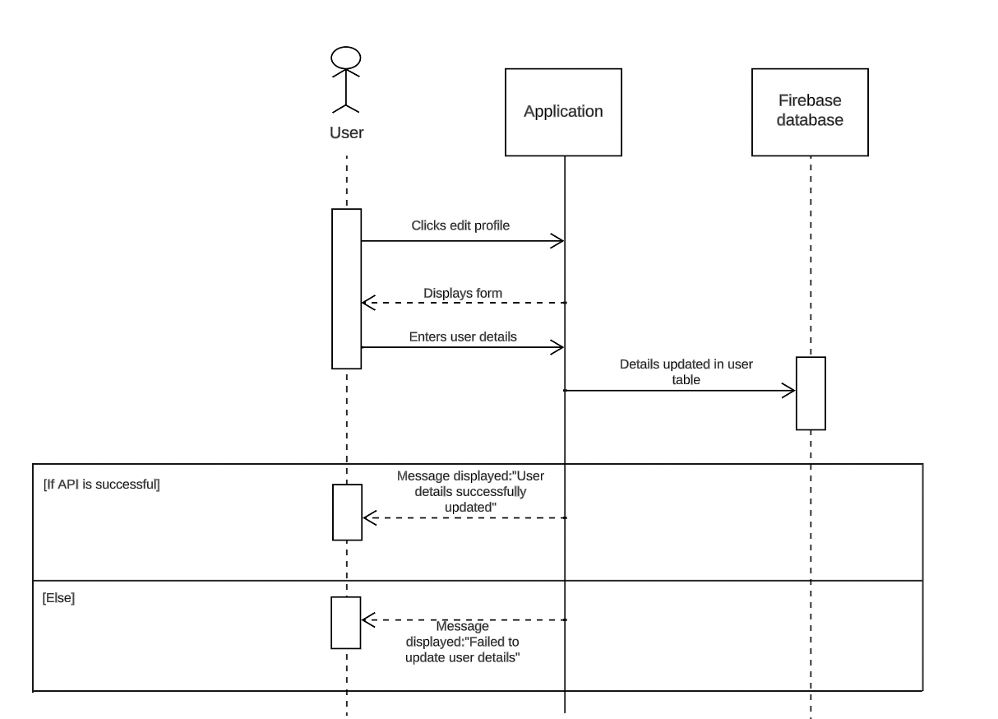

9. ETL of food data:

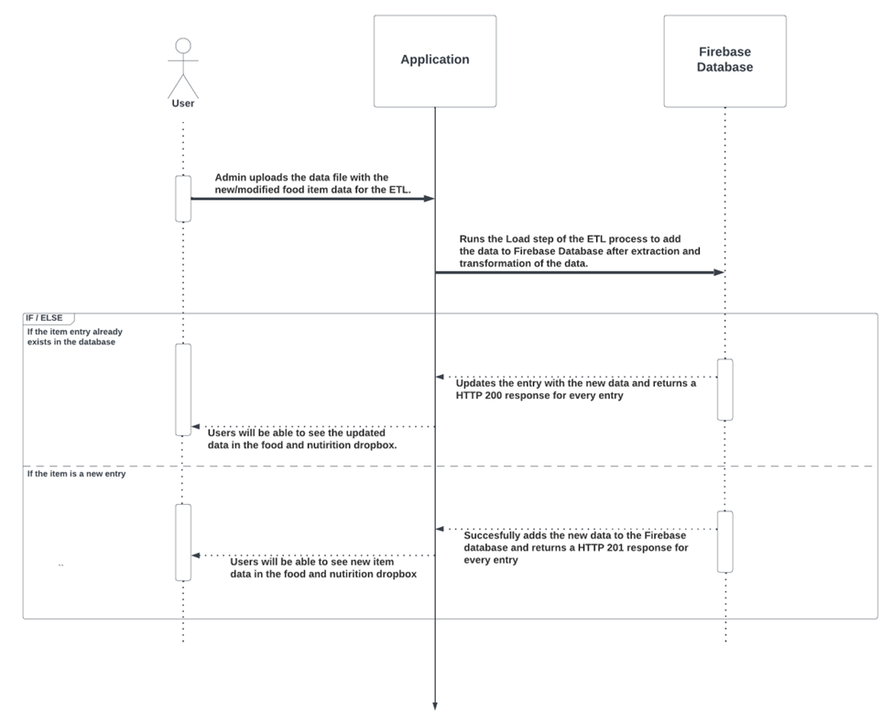

10. Notification pipeline:

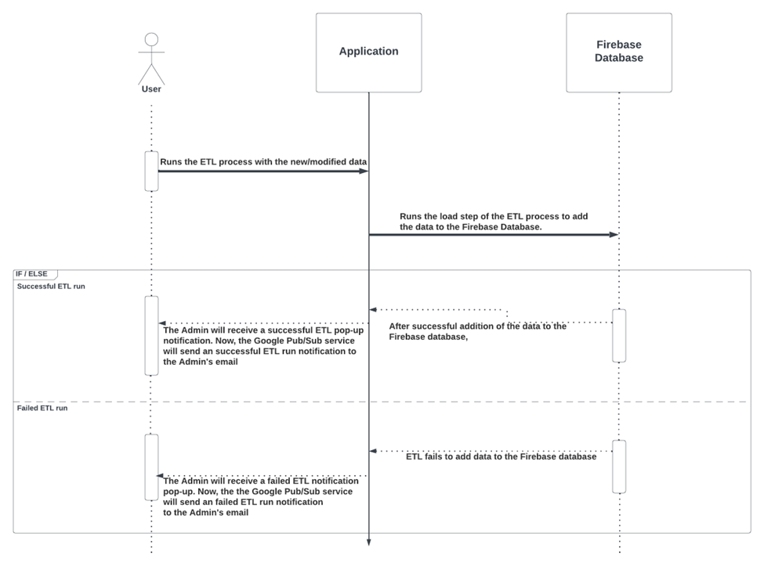

11. User goal tracking:

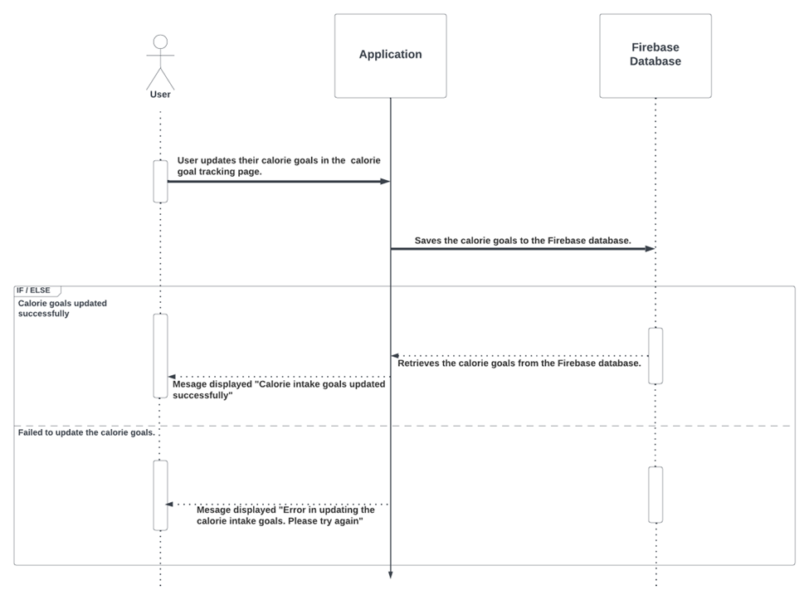

12. Delete tracked data:

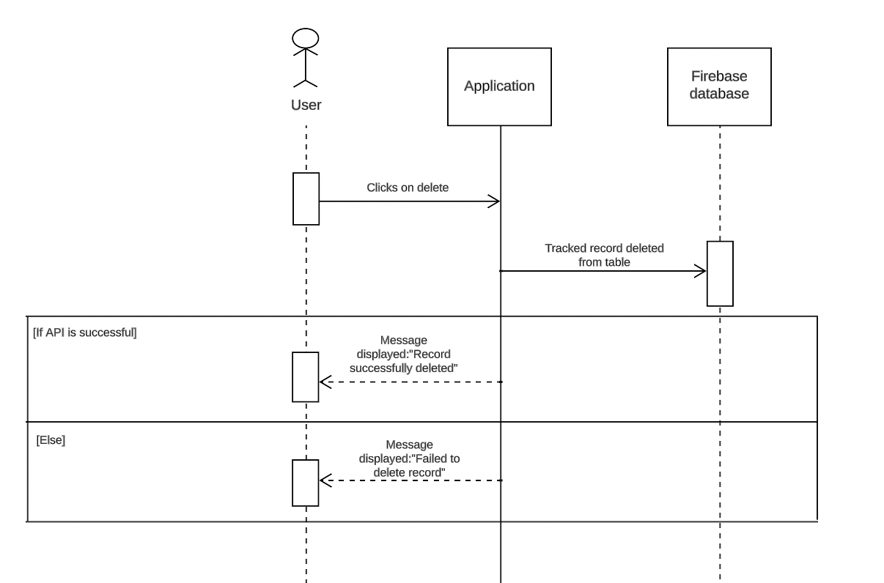

**3. System architecture diagram showing the front-end and back-end interactions**

