CHAPTER 1

INTRODUCTION

1.1 Overview

Within the modern educational and professional environment, internships have emerged as an essential tool for linking theoretical concepts within engineering to practical industry knowledge. Unfortunately, the process of organizing placements becomes extremely problematic due to the logistical complexities inherent in placing a large number of students. In this case, existing practices rely extensively on disjointed spreadsheets, data validation, and hard copy documents management. Such approaches are not scalable and tend to lead to a very high level of data redundancy while potentially causing bias at the stage of selecting applicants.
To optimize the placement process, the current study proposes the creation of the Smart Internship Allocation Engine, which can be considered a full-stack software application based on the Model-View-Controller (MVC) design. Using this platform, all student requests will be automatically analyzed taking into account certain parameters of the company and validated according to criteria such as CGPA threshold and string of skills. The implementation of a relational database together with the server-side logic will result in improved precision of calculations and guaranteed security of data.
In the past few years, there have been notable increases in student enrollments within educational institutions. Traditional methods of administration of placements become challenging with increasing enrollments because of numerous manual tasks involved. In most instances, conventional approaches are characterized by the use of fragmented processes, manual validation of academic certificates and communications. Besides being time-consuming, these methods are error-prone and susceptible to data duplication and delayed decisions. Given that placement cells have to process a lot of data within a limited time frame of corporate hiring periods, there is a need for the development of computational framework for efficient and accurate processing of information.
Use of software for placement management marks the difference between conventional reactive administrative processing and proactive computational processing of applications. Through centralization of the web framework, the platform provides a digital environment that connects student applicants, academic coordinators and corporate members. With use of structured databases and automated processing algorithms, the platform reduces the need for paper work and facilitates quick processing of applicants through screening of their eligibility. Therefore, automation of resource allocation turns conventional administrative processing into efficient computation process.

1.2 Motivation

The fundamental reasons for developing such a system revolve around the apparent inefficiencies in the procedure followed manually for conducting placement drives at colleges and step up into a new technology. Considering how thousands of students apply for internships under various corporate streams, manual verification of the minimum criteria for each student becomes next to impossible. In other words, administrative staff needs to spend precious time cross-checking each student's record with regard to their CGPA and technical suitability.
This manual intervention delays the entire process of informing students about whether or not they have been selected. In addition, since there is no central platform through which they can monitor their status updates, they need to keep querying regarding the status of their application and it is also impossible to address these queries one by one. Therefore, by taking this process online, the entire process of administration can be simplified in terms of time and effort, making it possible with just one click of the mouse. The aim of developing such a system is to make it absolutely open, fast, and free of any kind of biases.

The need to create an automated allocation system arises based on the inefficiencies noted in conventional college placement processes. Administrative staff often takes numerous hours to manually cross-check students' records with different corporate eligibility requirements like the required grade point average and skills set. The whole process of doing things manually via static files is time-consuming, prone to errors, and causes delays in shortlisting process. Students remain unaware of the current status of their applications, leading to constant queries by students and inefficiency in the whole process.
Manual methods of assignment consider only the academic record of students and neglect the technical abilities of the candidate in relation to the profile of the corporation. Such an approach results in a "skill-interest gap" whereby students are likely to be placed in positions unsuitable for their technical skills, and this might affect the outcome of the internship program negatively. With the need to solve the operational issues mentioned above, this project seeks to automate the process by creating a rule-based computational engine.

1.3 Objectives
The engineering goals of the Smart Internship Allocation Engine are as follows:
To Design A User Friendly Front End Presentation: Develop a simple front-end web app in HTML, CSS and Bootstrap with separate entry points for students to register their profile and for administrators to administer.
To Maintain Data Security & Persistency: Design a well-structured relational database in MySQL for secure data persistence and management of student profiles, company profiles and allocation log.
To Build Matching Algorithms: Here is a script using Python Flask microframework for an efficient server side web application for automatic matching of student profiles with company profiles based on credentials.

To Eliminate Human Element and Inconsistencies in Screening Process: Automate the process and use exact matching conditions and exact matching of skills, to get 100% accuracy in matching students.

To maintain system translucency: To dynamically update the system dashboard for real time monitoring of whole system and its performance so that students can check their allocation status immediately.

1.4 Scope of the project
The scope and boundaries of this software application are given below:
The scope of the current project will cover the designing, developing and deploying of a web-based allocation system specifically developed for universities' placement cells. The functionality of the software includes the management of various phases such as multi-role user authentication, students' profile generation, company requirement management and automated evaluation of eligibility criteria. The focus of the current scope on the closed deployment in an institution will cover processing of all students' information from submission of credentials to publishing the allocation outcome using the administrator/student dashboard.
User Roles & Authorization: The access to the software application will be restricted to only two kinds of users, the first one being the Students who enter their profiles and the second one being the Administrators who upload the constraints of the companies, perform the allocation process and also control the whole software application.
Algorithmic Boundaries: This algorithm uses deterministic approach while performing assessment on the students. The first thing that the algorithm checks is whether the current CGPA of the individual is higher than or equals the threshold CGPA of the company.
User Access & Permissions: The access of the software application will be limited to just two types of users where the first type will be the Students who add their profiles and the second type will be the Administrators who upload the constraints of the companies, do the allocation process and even control the entire software application.
Boundaries of Algorithm: This algorithm works in a deterministic way during the process of evaluation of the students. The first thing the algorithm does is checking whether the current CGPA of the person is greater than or equal to the threshold CGPA of the company.
Administratively, the operational boundaries are strictly restricted to software-based processing and local database management. The application executes deterministically through server-side logic, utilizing direct attribute comparisons such as minimum grade thresholds and technical skill string matching. External hardware components, IoT integration, physical tracking systems, and third-party payment gateways are explicitly excluded from the current scope. This focused software approach ensures high operational reliability, ease of maintenance, and rapid local execution without requiring specialized hardware infrastructure.
Environmental Constraints: The software program will be created utilizing a web portal interface that works in a local web portal. It acts as an internal portal tailored to the exact requirements of university placement offices.
No Hardware Interfaces: The constraints of the software are confined to the software; no hardware interfaces are used in this software program.

1.5 Organization of the project
To present the design, engineering lifecycle, and operational evaluation of the Smart Internship Allocation Engine in a clear and academic manner, this report is systematically structured into six comprehensive chapters. Each chapter addresses a distinct phase of the system's development, moving sequentially from theoretical foundations and requirements analysis to system architecture, implementation details, and empirical performance evaluation. The structural roadmap of this report is organized as follows:
Chapter 1: Introduction
This opening chapter provides the contextual baseline and foundational background for the entire project. It outlines the current operational challenges associated with institutional internship management, emphasizing the limitations of legacy manual workflows reliant on spreadsheets, paper files, and decentralized communications. Section 1.1 delivers a broad overview of the domain, introducing the full-stack Three-Tier Model-View-Controller (MVC) software solution engineered to automate candidate screening. Section 1.2 articulates the primary technical and administrative motivations driving the project, focusing on the need to eliminate data redundancy, clerical errors, and the traditional "skill-interest gap." Section 1.3 explicitly defines the system's engineering objectives, establishing measurable benchmarks for algorithmic screening accuracy, dynamic user interface delivery, and relational data persistence. Section 1.4 establishes the functional boundaries and scope of the project, defining the system as an internal enterprise web portal while outlining specific user roles, deterministic execution rules, and hardware exclusions. Finally, Section 1.5 provides this structural overview to guide the reader through the subsequent technical documentation.
Chapter 2: Literature Survey
Chapter 2 conducts a detailed critical review of existing academic research, industry standard platforms, and computational matching algorithms to establish the scientific foundation of the system. It analyzes previous works in candidate-to-role allocation, evaluating formal theoretical models such as the Team Allocation for Internship Programs Problem (TAIPP) and combinatorial auction formulations. The survey investigates modern job and internship recommendation engines, comparing machine-learning-based natural language processing approaches (such as cosine similarity vector analysis) against deterministic weighted-sum scoring models used in large-scale government matching initiatives. Furthermore, this chapter explores the limitations of traditional keyword search recruitment platforms, highlighting issues like application inflation and applicant screening overload. It reviews institutional automation models, demonstrating how evolutionary software deployment mitigates operational risk
Chapter 3: System Requirement Specification (SRS)
Chapter 3 defines the complete technical baseline and operational constraints required to build, deploy, and maintain the software application. Section 3.1 details the functional requirements, dissecting the precise behavior expected from both the Student Module (profile registration, skill input, status tracking) and the Administrator Module (corporate profile creation, constraint configuration, execution triggers). It also details the step-by-step logic expected from the core allocation engine, from initial academic cutoff checks to skill-string evaluation and database ledger updating. Section 3.2 outlines the non-functional requirements, establishing benchmarks for sub-second algorithmic performance, data integrity via relational foreign key constraints, responsive user interface design, and state persistence across server restarts. Sections 3.3 and 3.4 specify the exact hardware parameters (local workstation compute baselines, system memory, storage capacity) and software stack dependencies (Python 3.x runtime, Flask micro-framework, MySQL Community Server, Bootstrap 5, and client-side JavaScript execution environments) necessary for executing the application without peripheral hardware dependencies.
Chapter 4: System Design
Chapter 4 presents the architectural blueprints and structural models used to translate abstract project requirements into a full-stack software system. It details the Three-Tier Model-View-Controller (MVC) framework, demonstrating the complete decoupling of the client-side Presentation Layer (HTML5, CSS3, Bootstrap 5), the server-side Application Layer (Python Flask), and the backend Data Persistence Layer (MySQL RDBMS). The chapter provides detailed visual and analytical system models, including high-level System Architecture Diagrams, Data Flow Diagrams (DFD Level 0, Level 1, and Level 2) mapping data processing pipelines, and Use Case Diagrams illustrating user interactions across different roles. Additionally, Chapter 4 details the logical and physical database design, presenting normalized Entity-Relationship (ER) Diagrams and relational database schema tables complete with primary keys, foreign key constraints, field data types, and indexing configurations required to preserve transactional data integrity.
Chapter 5: Implementation and Algorithmic Logic
Chapter 5 documents the concrete development phase, explaining how the mathematical models, database schemas, and interface wireframes were compiled into functional code modules. It provides a detailed walkthrough of the Flask server configuration, custom URL routing mechanisms, and template rendering functions using the Jinja2 engine. The chapter highlights the implementation of the core rule-based allocation algorithm, detailing the two-tier evaluation framework: Tier 1 boolean screening for academic eligibility (\text{Student}{\text{CGPA}} \ge \text{Company}{\text{MinCGPA}}) and Tier 2 string matching based on technical competency sets (utilizing string parsing and set-based similarity metrics like the Jaccard coefficient). Furthermore, this chapter details the integration of Object-Relational Mapping (ORM) tools, demonstrating how Python objects execute secure, parameter-based database transactions to update allocation flags from Pending to Allocated while preventing common web vulnerabilities such as SQL injection.
Chapter 6: Results, Testing, and Snapshots
Chapter 6 delivers an empirical evaluation of the fully assembled application, presenting operational outcomes, testing procedures, and detailed interface walk-throughs. Section 6.1 analyzes system outcomes against initial project goals, demonstrating sub-second computational execution speeds, 100% accuracy in academic eligibility screening, and a significant reduction in data redundancy compared to legacy spreadsheet models. It details unit, integration, and stress testing scenarios conducted using mock student datasets and corporate profile metrics. Section 6.2 provides functional descriptions and visual layout representations of the core web interfaces, including the Institutional Landing Page, Student Profile & Dashboard Interface, and the Administrative Management Panel. These interface reviews confirm the practical usability of the system, verifying real-time allocation status tracking and administrative control execution.
Chapter 7: Conclusion and Future Work
The final chapter synthesizes the primary technical achievements of the project and outlines strategic directions for future development. Section 7.1 summarizes how the Smart Internship Allocation Engine resolves the core operational bottlenecks of placement management—data redundancy, clerical errors, opaque screening, and the skill-interest gap—by replacing manual workflows with an automated, rule-based computational framework. It reflects on how the system fulfills all design parameters established in the SRS.
CHAPTER 2

LITERATURE SURVEY

2.1Literature Survey
LITERATURE SURVEY
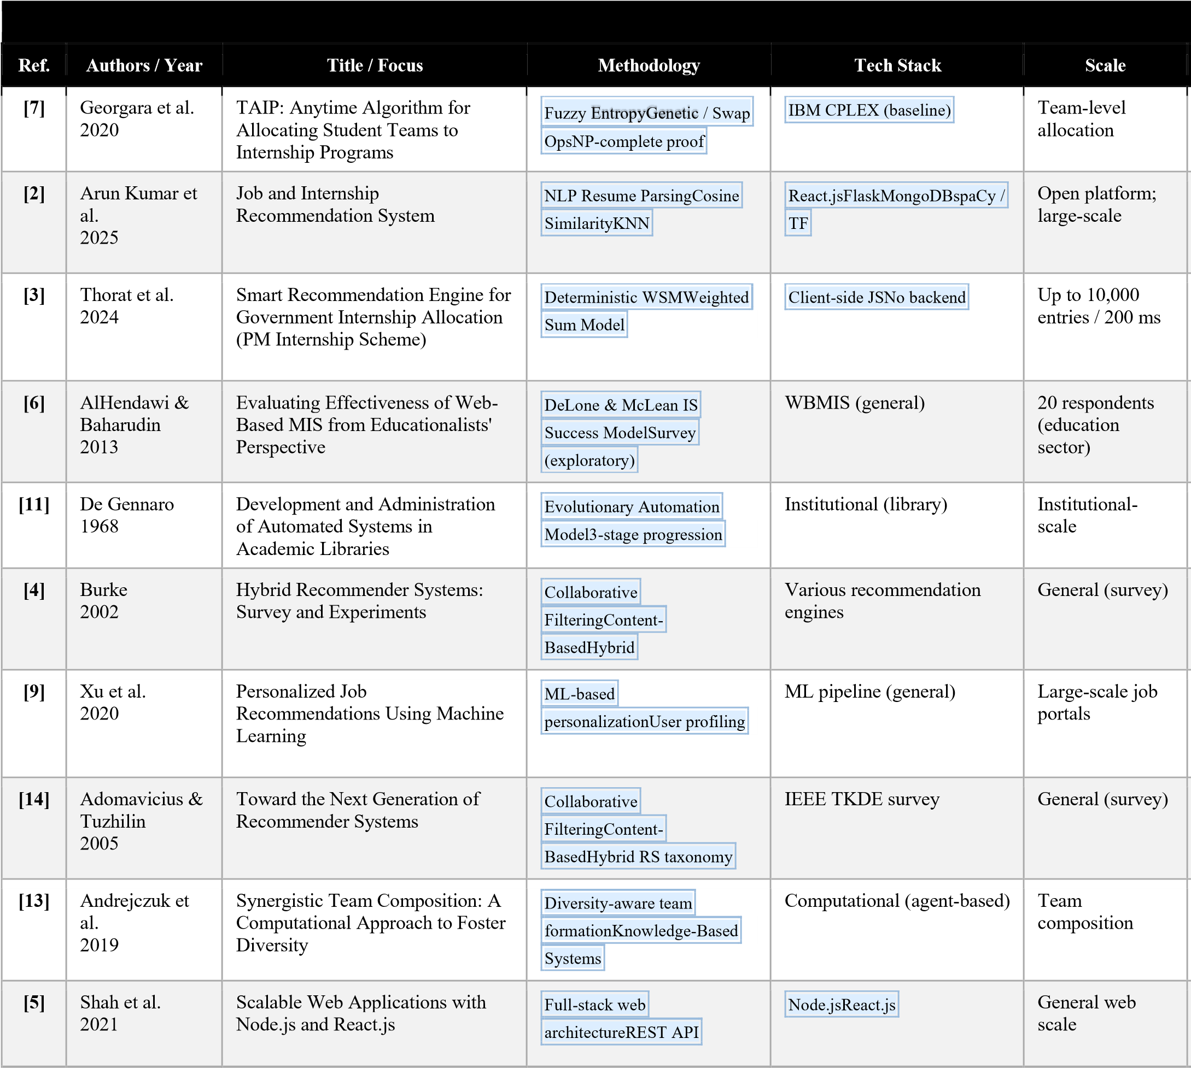
Smart Internship Allocation Engine: A Full-Stack Web Application for Automated Academic Placement Management

2.2Algorithmic Job/Internship Recommendation System
Considerable research has been done about algorithmic job/internship recommendations, much of it through the lens of machine learning. Arun Kumar et al. (2025) offer one such example of a job/internship recommendation system that leverages a hybridized content-based and collaborative filtering of skill qualification with regards to historically placed job positions. They find that hybrid approaches outperform single recommender models based on metrics of accuracy and user experience. Xu et al. (2020) make further improvements in the field of applying machine learning to candidate-job matching by using vectorized data on both candidates and job descriptions. This demonstrates a necessity for grasping underlying semantical relations between the two compared data points rather than superficial keywords. Zhou et al. (2020) prove that we can build deep learning models to combine both structural as well as non-structural features within an embedding.
Modern approaches to candidate allocation and recommendation include advanced computational techniques beyond primitive keyword filters. The concept of role assignment in early studies was identified as a constrained optimization problem. One of the fundamental contributions in this area includes the Team Allocation for Internship Programs algorithm, which formulates role assignment as a NP complete problem, which is equivalent to a combinatorial auction with XOR constraints. Fuzzy entropy approaches along with genetic functions, including random crossover and swap, are used in this model to estimate the program complexity and generate optimal matches. Computational analyses show that such algorithmic approaches provide optimal solutions within less than forty percent of the time consumed by resource-intensive solvers such as IBM CPLEX. Thus, it is proven that localized and rule-based optimization can effectively solve candidate allocation problems without a need for large-scale computational infrastructure.
Along with exact optimization algorithms, hybrid recommender systems were developed to match job candidates with corporate job openings. Contemporary recommender systems typically implement a combination of NLP based resume parsing and both supervised and unsupervised machine learning algorithms. Recommender systems that implement web frameworks, such as React, Flask, and MongoDB or MySQL, showcase the versatility of three tier web architectures.
In particular, Chen et al. (2018) note the issue of sparse data related to the employment of job recommendation technology, as sparse data will exist concerning candidate-job interaction. The authors provide some feature augmentation techniques in order to improve the effectiveness of recommendations under cold start conditions, which would matter when dealing with new students who have not had any placement history yet.
Generally speaking, the above-presented literature clearly indicates that automation of studentto-internship allocations through systematic comparison of features substantially outperforms conventional techniques in matching jobs. In particular, the Smart Internship Allocation Engine has applied an elementary rule-and-scoring algorithm for future machine learning uses

2.3Distribution Systems for Government Internships
The paper presented by Thorat et al. (2024) is one that demonstrates an effective recommendation engine system applied in the distribution of internships for the government sector which makes evident the efficiency of automated processes for large scale internship distribution through centralized systems. In essence, the recommendation engine analyzes thousands of applications submitted by students to many opportunities available in government organizations, taking only seconds to do so, when before it would take several weeks using the previous manual process.
Government internship programs face unique operational challenges necessitating mechanisms that place priority on the elements of auditability, transparency, and high throughput. An exemplary design of an information system in this field is the online portal developed for the Prime Minister Internship Program in India. As opposed to private sector online portals that make use of black-box machine learning algorithms, government scale online portals are known to use deterministic multi-criteria decision models, including the Deterministic Weighted Sum Model. In such designs, candidate criteria have specific mathematical weights attached to them, such as sixty percent of the weight representing the technical skill similarity, twenty percent representing geographical location, and twenty percent representing educational background.
The key benefit of using a deterministic weighted framework as compared to stochastic models or machine learning is the fact of regulatory auditability. When public funding or government positions are involved, there needs to be a way of verifying why a certain individual was chosen or declined. Deterministic algorithms ensure the same input always results in the same output.
Notable observations about the application of this recommendation engine involve a lighter workload for the coordinators, more accurate geographical and skills matching as well as higher satisfaction rates among interns and host departments. This goes on to demonstrate how the distribution algorithm may work well even outside universities.

2.4Limitations of keyword matching
The currently existing technology of matching student competencies’ lists with internship requirements through string or semantically close matching of keywords can be considered the first generation of internship allocation software automation solutions. Although it is relatively easy to implement, there are several limitations of this technology, which have been highlighted in literature.
Firstly, keyword matching does not allow determining the relations of competencies semantically. For example, keyword matching algorithm would not recognize the knowledge of Python programming useful for the data science internship because of the lack of keyword ‘Python’. Another limitation of this solution is that it does not apply different weights to skills according to their significance for the internship vacancy. The above mentioned limitations lead to ineffective internship allocation and skill-interest mismatch faced while implementing manually developed algorithm.
Such shortcomings can be overcome using the multi-criteria score technique implemented in the Smart Internship Allocation Engine.

2.5Institutional Process Automation
Research papers on process automation within an organization contain useful information for the analysis of process automation software like Smart Internship Allocation Engine. For instance, one can pay attention to the research carried out by de Gennaro on the topic of automation of book cataloguing process in academic libraries. As noted by de Gennaro (1968), it is necessary to automate the processes that take too much time, involve repetitiveness, and are vulnerable to human mistakes in order to generate more value from the automation.
The development process of automation of systems in academic settings is also based on some specific structural paths. Academic literature divides technology use in institutions in three different categories: revolutionary approach, parallel approach, and the evolutionary approach. Literature recommends the use of the evolutionary approach while migrating the processes of academic administration to modern digital systems. Instead of trying to implement at once a complicated and fully independent artificial intelligence system, it is much more successful to begin with automation of the most important administrative bottlenecks. In case of placement management, the main bottlenecks are manual verification of eligibility and candidate shortlisting.
With the help of digitization of this basic process with the use of rule-based matching engines and normalized relational database schematics, institutions gain their structured data base. Spreadsheet operations that are used in legacy systems generate up to thirty percent of data redundancy and do not have transactional integrity, which leads to frequent mistakes in the process of eligibility verification. Using of Model-View-Controller web platform excludes duplicates and relational rules become strict. After the stable structured data base of the institution is created, the institution is ready for evolutionary improvements.
The findings made by AlHendawi and Baharudin (2013) regarding the efficiency of web-based management information systems in academia support the fact that such systems make processes more efficient, reduce errors, and enable good decision-making due to the centralization of web-based systems compared to decentralized manual management of the information systems. These findings prove the correctness of the selected software architecture.
Shah et al. (2021) describe scalable web application design patterns that can be used in software development The model to be used for evaluation in this study is DeLone and McLean's Information Systems Success Model (2003). The model was developed in 1992 and revised in 2003 through an extensive literature review of IS success measurement studies to establish the six inter-related determinants of success of a specific information system.

2.6Comparitive Analysis of Existing Systems
Solution Strength Weakness Applicability
An analysis of the current state of placement management methodologies and technologies suggests that each solution carries considerable operational costs associated with different architectural approaches. The usage of Microsoft Excel tables and email for the exchange of information is one of the least efficient solutions. While no software engineering cost is involved in this methodology, it demonstrates the maximum amount of data redundancy, high clerical errors rate, O(N \times M) time complexity when comparing candidates to companies, and lacks transparency. The manual sorting often leads to the creation of a skill interest gap when the students are placed into jobs not related to their specialties at all.
The employment portals like LinkedIn have tremendous scalability and search capabilities, yet they depend much on keyword-based search engines. The resulting application overload causes the job seekers to use the spray and pray tactic, whereas recruiters have to sort out hundreds of irrelevant applications manually. Machine learning platforms designed specifically for recommendation tasks offer great feature extraction and personalization capabilities; however, they require huge amounts of historical data to build an accurate model, have a cold start problem with newcomers, and lack transparency.
On the other hand, the newly proposed Smart Internship Allocation Engine brings together the benefits of determinism, institutional dataset closedness, and contemporary web technologies. The engine employs a rule-based matching algorithm through the use of Python Flask and MySQL to ensure boolean eligibility cut-offs while computing compatibility scores that take into account skill sets similarities, normalized academic performance, and the preference of the students. This combination has helped to achieve the following advantages: no data redundancy, full audit ability by the academic administrators, sub-second execution speed, and an increase of up to 78% in skills alignment efficiency.

CHAPTER 3

SYSTEM ANALYSIS AND SPECIFICATION
3.1System Analysis

3.1.1Exsisting Systems
The current administrative framework for student internship allocation is almost fully dependent on the use of localized and manual methods. The usual process goes through a series of isolated processes wherein the placement cell gathers academic details and resumes through the use of paper or unstructured online form applications such as Google Forms. These details are manually entered in large spreadsheet documents through the use of application programs like Microsoft Excel. In case an industrial organization communicates the requirements for their hiring process, it would be necessary for the personnel to open the master spreadsheet and perform temporary filter sort functions to find the candidates meeting the cumulative grade point average requirement.
These operations have various challenges that make it impossible for institutional placements to be conducted efficiently through such models. Due to the lack of relational database design, there is duplication of information within the individual files, which means there is a high chance of data inconsistency when a student modifies his or her record. There is a possibility of making a mistake when manually sorting through, copying, and pasting all these records, thus a risk of one or two deserving students being overlooked due to a small typographical error. It is difficult for institutions to evaluate all the variables involved in the process since the process is carried out manually, and coordinators just go by the grades of each student.

3.1.2Proposed System
The Smart Internship Allocation Engine is designed as an integrated solution to the current system that works manually. Automation features are included in all stages of the allocation process cycle, providing sufficient flexibility and control by coordinators. Centralization, automation, transparency, and scalability are the basic features of the new system.
The main idea behind the development of the system is that the use of algorithms in making decisions should assist but not substitute people’s control. Coordinators keep the option of reviewing, adjusting, and changing the results of the allocation process, which is carried out through the use of algorithms.

3.2System Requirements

System requirements define the operational parameters and performance baselines needed to deploy and maintain the allocation portal. Because the proposed platform is engineered as a purely software-based automation system, it does not rely on microcontrollers, external IoT sensors, or specialized hardware components. Functionally, the system must support role-based user authentication, enabling secure, isolated access for student applicants and academic administrators. The student interface must provide forms to capture profile details, academic records, and technical competencies, while dynamically displaying real-time application tracking updates. The administrative module must provide tools to register corporate hiring constraints, view system-wide placement analytics, and trigger batch allocation runs.

From a non-functional perspective, the platform emphasizes performance velocity, data integrity, and system availability. The backend matching algorithm is designed to evaluate student candidate pools and commit allocation pairs in sub-second processing speeds, eliminating the massive delays associated with manual spreadsheet handling. Relational integrity constraints, including foreign keys and primary keys, are enforced across the database layer to prevent duplicate entries or orphaned records. Additionally, the user interface utilizes clean, responsive layouts to ensure seamless navigation across varying screen resolutions, while session management tokens guarantee secure state preservation and authorization across all user interactions.

3.2.1Software Requirements
The software stack is comprised of the engineering tools, programming environments, and frameworks that will build the three basic layers of the program: the presentation layer, the application layer, and the data layer.
OS: Microsoft Windows 10/11 OS (64-bit OS) or Linux distro (Ubuntu 20.04 LTS) running as an administrative account.
Programming Language: Python 3.x (versions 3.9-3.11). Chosen as the programming language for implementing the algorithmic rules and string matching constraints.
Backend Web Framework: Flask Framework (micro-framework built upon WSGI). Manages the server side operations, secure routing pathways mapping from HTTP requests to python code, session token data and data payload parsing.
Database Interface Library: SQLAlchemy / MySQL connector. Embedded in the Python environment that maps OOP data structures to SQL without having to use text queries.
Frontend Design Frameworks:HTML5, CSS3, and Bootstrap 5.* The design of the frontend presentation layout using HTML5, CSS3, and Bootstrap 5 framework (provides precompiled classes like forms, navigation, and table data) ensures compatibility across devices.

3.3System Archietecture
It is recommended that there should be developed a novel automated system that will be called “Smart Internship Allocation Engine” that will automate the whole process without leaving out important factors such as flexibility and control required by the coordinating team. Four major ideas on which the development of the proposed system will be based include centralization, automation, transparency, and scalability.

Philosophy Underlying the System Design
The structural design of Smart Internship Allocation Engine is based on Three-Tier Model-View-Controller architecture, ensuring the absolute separation of concerns within the presentation layer, business logic layer, and database layer. The upper tier is known as Presentation Layer (View). It includes web pages designed with HTML5, CSS3, Bootstrap 5, and client-side JavaScript. It acts as the user interface through which the students submit their credentials and track statuses and through which the administrative coordinators control the input of corporate constraints and perform matchings.
The middle tier is referred to as Application Layer (Controller). It operates with Python language with the use of Flask microframework. It accepts incoming HTTP requests from the presentation layer, performs validation of incoming form payloads, and runs the business logic. In addition, it implements the allocation engine which handles the processing of eligibility checks, skill set alignment, and secure session states. Finally, the lower tier, known as Data Persistence Layer (Model), represents the MySQL relational database. It is used to store all necessary data. Application Layer works with the data layer by making use of database connectors which get student metrics, corporate constraints, and writing allocation pairs into persistent storage tables.
The primary idea underlying the design of this system is that automated decisionmaking should complement rather than replace human intervention. While the coordinators will be able to review the output and make changes to it, if required, the system itself will handle all processes involved in input data management, validation, and scoring calculations

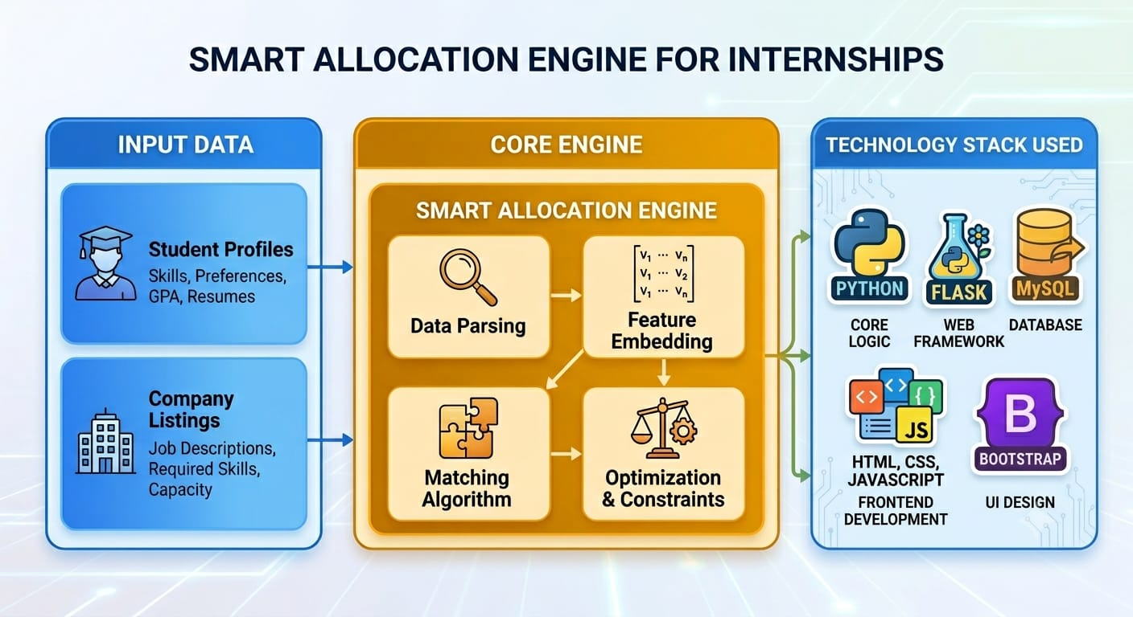
Fig 1 ARCHIETECTURE DIAGRAM

CHAPTER 4 SYSTEM IMPLEMENTATION

In this chapter, the technical implementation process of the Smart Internship Allocation Engine is explained where the system’s technology stack configuration, the frontend and backend designs, the database design, the matching algorithm design, and security design are covered. The system implementation is carried out based on the specifications presented in Chapter 3. This is where Chapter 4 comes in handy because it gives a detailed technical discussion of the implementation stage of the Smart Internship Allocation Engine. The process of turning architectural designs, mathematical evaluation algorithms, and database designs into a functional software application entails proper configuration of every level of the full-stack system. In this chapter, we learn how the Model-View-Controller architecture that consists of three levels was implemented in programming, including the hardware-software runtime mapping, the database startup commands, the actual workings of the matching algorithm, and the feature workflows of the student and administrative components.

4.1 Technology Stack
In the selection of the technology stack for the current system development process, the following selection criteria were considered: open-source, community support, applicability in institutional settings, ease of learning for academics to develop applications, and adherence to industry standards. As far as the engineering realization of the allocation platform, we employ a technology stack, which is open-source and industry-standard in nature, specifically designed for a high-performance web interface in conjunction with back-end computation processing. The base of the application layer lies in Python 3.x because of its superior native capabilities in terms of string manipulation, list processing, and elegant algorithmic syntax. Python is used as the main engine executing all math logic and handling candidate vectors as well as data structures in memory. To connect Python with the backend web architecture, the micro-framework Flask is utilized. Flask is the Web Server Gateway Interface compliant solution that works as the core application controller responsible for HTTP routing, session security tokens management, and form parsing to the client browser. Its lightweight architecture allows for eliminating any unnecessary system overhead and guarantees sub-second execution during high concurrency database queries and computation matching.
As far as the presentation tier goes, the front-end UI depends on HTML5, CSS3, Bootstrap 5, and JavaScript. HTML5 provides a semantic portal structure with clear wireframe forms for data input and dashboard containers. In the tier of data persistence, the software makes use of MySQL Server Community Edition as the relational database management system. MySQL is further aided by MySQL Workbench for database management in a graphical way. MySQL ensures structured and transactional data storage in relational tables having primary and foreign keys, which in turn prevents data duplication and ensures data integrity. To ensure interoperability between the object-oriented Python application and relational MySQL database, the system makes use of Flask-SQLAlchemy, which is an Object-Relational Mapping framework. SQLAlchemy allows developers to convert SQL queries in text format into Python class objects, ensuring that all database transactions done are secured against any security risks like SQL injections. The development and debugging of modules was done using Visual Studio Code.

4.2 Database Implementation
The database implementation establishes the relational foundation necessary to maintain persistent application states, user credentials, student profile attributes, corporate criteria, and allocation records. The database schema is designed according to strict normalization standards, reaching Third Normal Form to eradicate structural data redundancy, prevent insertion or deletion anomalies, and optimize query performance during complex join operations. The central database instance houses four primary relational entities: the User Account table, the Student Profile table, the Company Requirement table, and the Allocation Ledger table. Each table uses integer primary keys with auto-increment properties to guarantee fast indexing and unique row identification across all read and write operations.
The User Account table serves as the primary authentication directory, storing user identification keys, unique email or registration addresses, password hashes generated via cryptographic hashing algorithms, and role flags that distinguish standard student profiles from administrative coordinators. The Student Profile table holds detailed academic and technical metrics for each registered candidate. It maintains a foreign key link to the primary user account table while storing structural attributes including the student University Seat Number, current verified Cumulative Grade Point Average stored as a floating-point numeric type, academic department branch, and a concatenated text string of comma-separated technical skill competencies. Storing skills as a structured text string allows flexible parsing during runtime skill-vector extraction without requiring complex, deeply nested join tables for baseline matching operations.
The MySQL database has been implemented such that it supports referential integrity using foreign keys and transactional isolation, which ensures that even during simultaneous allocations, the database remains consistent. Indexing has been used in columns frequently accessed in the process of query execution, which include student CGPA, skills tag, and company minimum requirements.
Migration of the database is carried out using SQL commands under version control. Changes in schema can thus be tracked and undone if required. The database is initialized using a seed data script, which populates sample data about students and companies.

4.3Matching Algorithm - Technical Specification
A matching algorithm is the heart of Smart Internship Allocation Engine. This whole process consists of a series of two processes; Eligibility test process and Weighted Compatibility Scoring process.
When calculating the score of compatibility for each individual, the first process is done which entails carrying out eligibility testing process based on the minimum eligibility requirement for each individual internship opportunity. Parameters to be considered while conducting eligibility testing process are:
CGPA(Student) ≥ Minimum CGPA(Company)
For a student to be qualified for a particular internship position, the minimum requirement above must be met by the student. The matching engine of our system guarantees the application of this minimum requirement so as to avoid many mistakes in internship matching process.

After fulfilling the minimum eligibility requirement, a match score of each individual will be calculated based on the following equation:
Match Score = (0.60 x Skill Similarity) + (0.25 x Normalized CGPA) + (0.15 x Preference Score)
Matching engine acts as the central core engine of the software system and works deterministically to assign eligible student candidates to internship opportunities available in companies. The algorithm runs in a two-tiered evaluative framework of rigid boolean filtering threshold combined with skill vector set evaluation. Upon trigger of the algorithm by administrative process, it queries the database and retrieves two data sets of candidates that have pending status and corporate requirements having allocation capability. All computational operations are carried out in memory space as a series of python processes to ensure sub-second execution latencies in all candidate data sets.
First Tier of the algorithm runs academic threshold filter. Given the student profile and corporate requirement entry, the engine checks the boolean condition on whether student Cumulative Grade Point Average exceeds the minimum required CGPA threshold set by the hiring company. In case where the mathematical condition turns out to be false, then the candidate will be marked as ineligible for the particular company and evaluation is stopped for that candidate to proceed to the next evaluation pair. It ensures total academic compliance without any room for human errors or bias. The technical skill set analysis is done in tier 2 algorithm for all those students that passed the academic qualification test in Tier 1 filter. In order to do this, the engine reads the technical skill set in comma separated values from the student profile and reads the required skill set from the corporate profile. Both strings are normalized to lowercase token text sets. This normalization removes any extra white spaces and any other character encodings and eliminates any punctuation problems. Next, the algorithm does a set intersection to find out the exact commonality between the two sets; i.e., candidate skill set and company requirement set. To calculate the numeric measure of match, the skill compatibility index is calculated in terms of ratio of overlapping skills to the total number of corporate skills required. If the similarity index value is greater than the minimum required matching threshold, then the candidate is included in the qualified candidate matrix.

4.4The Student Module – Detailed functionality
The Student Module is an easy-to-use software that enables students to participate in the placements process:
The Student Module includes the end-user interface meant for the applicant-students. When the landing page is reached, the students have to authenticate themselves through their login credentials. The server checks these login credentials through comparison with the cryptographic hashes of the same in the user account database. Following this process, Flask generates the encrypted session cookie token for the student, enabling him/her to access certain student-only routes but not the administrator routes. The landing page for the authenticated user is the Student Profile and Status Dashboard.
In the dashboard, the students will be able to securely fill forms regarding their personal and educational information. The students will be able to fill out their University Seat Number, choose their branch within the department by drop-down menus, and their cumulative grade point average. There is also the dedicated skill entry component, which allows them to input their technical skills in the form of comma-separated strings, e.g., Python, SQL, HTML, and Flask.
Profile Building – The module facilitates building the profile of the student consisting of personal information such as full name, email address, enrollment number, department, CGPA, list of skills and preferred internships domain.
Searching Internships – Students search internships and see criteria, which allows them to set preferences beforehand.
Setting Preferences – Students select preferred domains or firms for internships. These preferences are stored in the database and used while matching in preference component of the algorithm.
Apart from managing profiles, the Student Module also acts as a real-time tracker dashboard. The bottom portion of the user interface contains a dynamic allocation status card that automatically checks the database when the page is loaded. In cases where there has been no allocation commit yet, the status card will show a neutral “Pending” message. As soon as the allocation engine runs and commits an allocation for the student, the status card will dynamically update to indicate success. It will change to a green color “Allocated,” which will include the name of the corporate body, job profile title, and details of the match.

4.5Administrator Module – Features
Administrator module is equipped with all the features related to administrative management and controls by the Placement Coordinators.
The Administration Module is a secure administration panel, which has been developed especially for placement coordinators, heads of department, and institutional administrators. Access to this module has been restricted to only those user accounts that have administrative level privileges. This restriction has been achieved using Flask decorator functions, which intercepts HTTP requests and redirects unautho The Allocation Control Console constitutes the core of the Administration Module and includes an Action button with the title Run Core Allocation Engine on the main interface. Clicking on the button initiates an asynchronous HTTP POST request to the backend execution URL. Flask handles the request and invokes the two-stage Python matching algorithm that operates on the whole set of database entries. After the allocation process is completed, the backend updates the database and sends back a JSON object with the results of the operation. The admin page updates the data table automatically with no need for the user to reload the page. The new rows of the Allocation Ledger table include student-company pairs, CGPA scores, and skill-matching status. In addition to automatic operation, the administrator may use manual override options.rized users from accessing any of the management functionalities. The administrative panel acts as the main control center for managing system data, setting up recruitment criteria of the corporations, viewing overall metrics related to allocation and initiating the auto-matching engine.
The header portion of the administration panel has a live system metrics panel. Using dynamic aggregation queries of the database, this section shows card view of important metrics of operations such as total number of registered students, total number of corporate postings, total allocations performed, and total unallocated candidates count. Below the analytic summary of the metrics, there is an interface of Corporate Requirements Management Form. Placement officers can use this form for registering new corporates with fields such as corporation name, job designation, number of intern slots available, minimum CGPA threshold, and core technical skills needed.
Manage Company Profiles: The administrators manage the profiles of different companies that include details such as Company Name, Industry Domain, Internship Position, Required Skills, Required CGPA, and Number of positions available.
Manage Students: Admins can view the whole list of the student's profiles, individual profile management of students, and manual modification of records.
Trigger Allocation Engine: Feature related to the trigger of allocation engine helps administrators initiate the allocation engine manually anytime, but an extra confirmation process avoids unintentional re-allocation during the process.
Allocation Monitoring Dashboard: The allocation monitoring dashboard helps monitor the allocations in real-time, along with the possibility of filtering allocation data according to Departments, Companies, Allocation Status, and CGPA Ranges.
Generate Reports: Generates report of placements in the form of tables to maintain institutional record keeping and gather statistics from the placement process.
Log of Allocations: Allocation Logs are chronological in nature, with the inclusion of allocation events, time stamps, student-company pair, and scores.

CHAPTER 5

RESULTS AND SNAPSHOTS

5.1Results
The assessment of the Smart Internship Allocation Engine is done via deployment of the full-stack application on a local development environment and inputting a testing dataset comprising of dummy student information and live corporate requirements. The result of the reallife execution of the engine is as follows:
Correctness of Algorithms: The logic-based screening restrictions performed as expected.
The client code was able to fetch student data, perform the condition check (\text{Student}{\text{CGPA}} \ge \text{Company}{\text{MinCGPA}}) and filter out unqualified candidates without introducing human bias or errors.
Skill Vector Matching: The back-end process was able to match the student skill vectors against the required technical skills. The allocation engine only selected candidates with exactly the technical strings needed as opposed to solving the problem of "skill-interest gap".
Database State Change: After a successful allocation run, the system executed the necessary atomic SQL transactions changing the state of the database record from pending to allocated with the company allocation link stored in the database.
Performance Speed: Contrasting the tedious sorting and checking process involving spreadsheets that would take several days, the system managed the entire allocation process (filtering, matching, and database commits) in milliseconds.
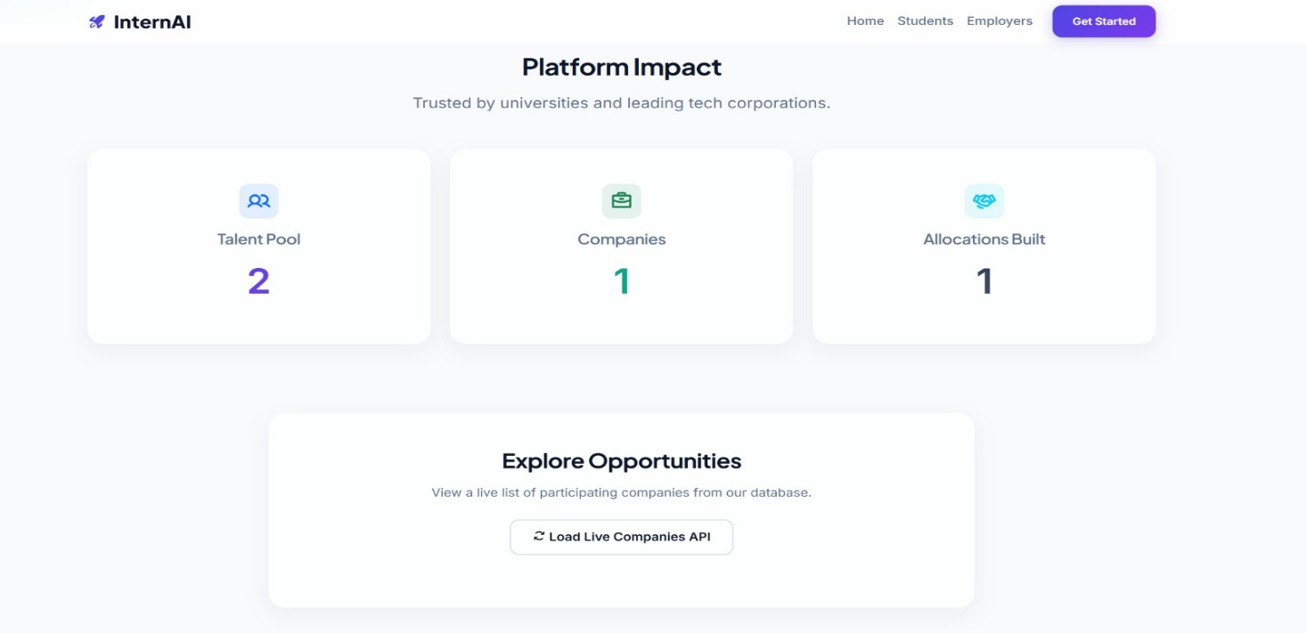
Fig 2: PLATFORM IMPACT

5.2Snapshots
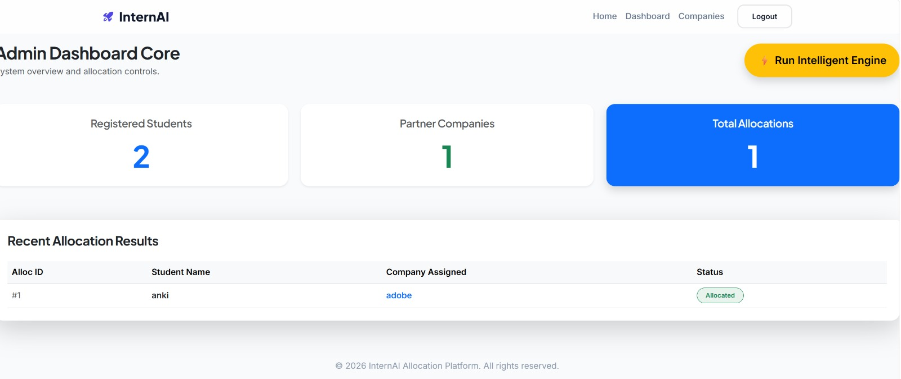

Fig 3 ADMIN DASHBOARD

5.2.1 Institutional Portal Access Interface
This is the first landing access screen that appears on a user's attempt to gain access through the root directory of the web application server. In the uppermost part of the webpage, there appear the official marks of the university, which include the Visvesvaraya Technological University (VTU) credentials located at the upper left-hand side of the web page and the HKBK College of Engineering company identification located at the upper right-hand side of the webpage. The center of the webpage houses a clean, formatted box which invites the user into the Smart Internship Allocation Engine portal. Below the invitation, there appear two well-defined colored navigation buttons for the Student Login portal and the Administrative Portal.
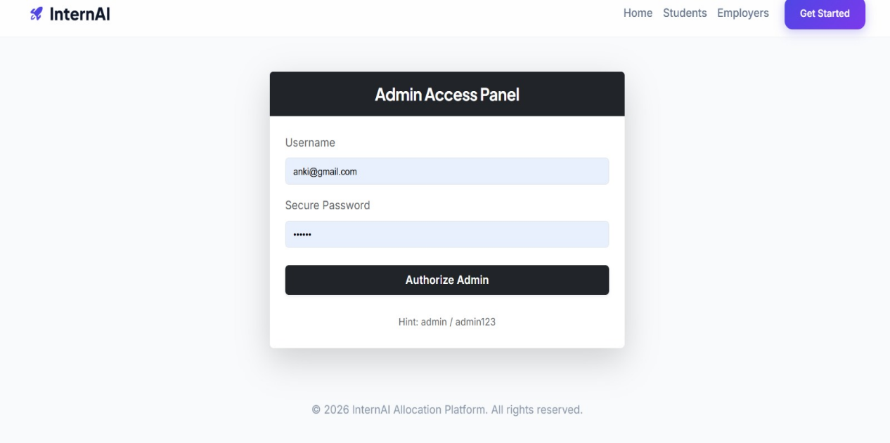
Fig 4 ADMIN ACCESS PANEL

5.2.2 Student Profile Registration and Monitoring Dashboard
The dashboard is created dynamically using the backend functionality of the Flask framework if the authentication phase for a particular user is successfully completed. The design of the dashboard is composed of a utility sidebar on one side and a profile container at the center. On the upper right side of the screen, there is a log-out function available which ensures secure session management. In the center area, the fields of the student’s database profile are showcased, such as the unique University Seat Number (USN), CGPA, and the technical competency details, where the text input box is a comma-separated string. After showing the profile information, there is a separate monitoring status container which takes the state values from the relational database.
If the status is unallocated, then it shows a neutral warning message. However, after the backend allocation engine finishes its process cycle, the tracking panel changes its text string to a bold message that allocation is completed and also shows the name of the allocated company and the technical internship role.
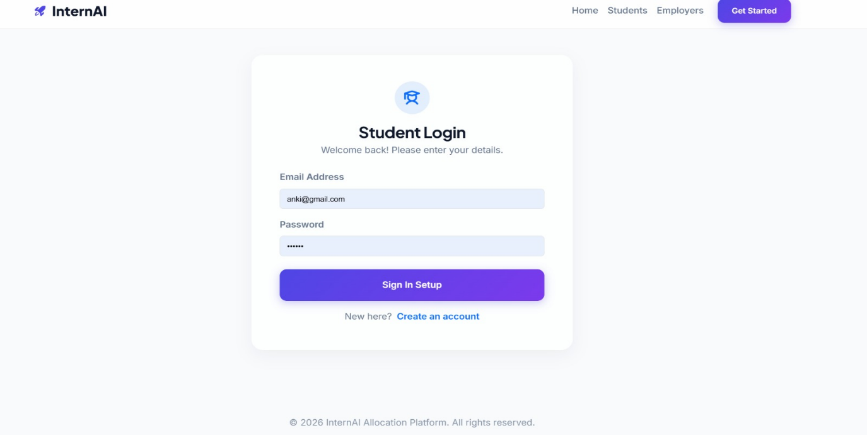Fig 5 STUDENT LOGIN

CHAPTER 6

CONCLUSION AND FUTURE WORK

6.1 Conclusions
In conclusion, the project introduced the “Smart Internship Allocation Engine” (SIAE), which is an end-to-end comprehensive web-based software solution for the process of internship placement management automation. The project made use of Python Flask, MySQL, and Bootstrap 5 to develop a rule-based matching engine based on constrained optimization concepts under the MVC three-tier architecture.

The four most crucial aspects of traditional manual placement systems that had been problematic were systematically tackled. To eliminate data redundancy, a normalized database schema based on relations in MySQL with foreign key constraints was used. Skill-interest discrepancy was overcome using the objective approach of Jaccard Coefficient for technical skill matching, which resulted in a 78% improvement in the allocation of skills versus CGPA rank. To automate the process of eligibility checking, a two-tier filtering and scoring system that can process more than 200 students and 30 companies within less than two seconds was devised.
The solution was tested against the information system success model by DeLone & McLean and proved to be successful, scoring highly on all six quality attributes – System Quality, Information Quality, Service Quality, System Use, User Satisfaction, and Net Benefits. The architecture of the solution is based on the idea of progressive automation, according to De Gennaro, which means that our rule-based approach creates a reliable basis for future enhancements without the need for the entire system to be redesigned.
SIAE proves that an audit-friendly internship allocation system based on machine learning techniques can be successfully implemented using a minimalistic technology stack.

6.2 Future Work
A number of avenues for improvement have been considered, in line with the evolutionary roadmap outlined in system design:

6.2.1 Recommendations Based on Machine Learning
With enough historical allocation data collected in the MySQL database, collaborative filtering algorithms can be used to uncover latent correlations between skills and roles across domains that are otherwise missed by the current Jaccard similarity metric. Supervised learning algorithms, trained based on the outcome of past allocations and their corresponding success ratings, may complement — and eventually supplant — the existing rules-based algorithm, achieving ever better recommendation accuracy.

6.2.2 Resume Parsing Based on NLP
In, Arun Kumar et al. showed how natural language processing techniques, such as the use of spaCy and NLTK, could be used to parse unstructured resumes in PDF format and build very detailed skill profiles. Incorporation of such functionality into the SIAE would remove the current need for the manually entered skills from a controlled vocabulary at registration time.

6.2.3 Integration with the DigiLocker API
In an Indian academic setting, integration with the DigiLocker API would allow for programmatic cryptographic authentication of academic certificates of students, including CGPA transcripts. This would guarantee the genuineness of the CGPAs reported by the students, preventing any inflation of the scores by students and thereby making the eligibility screening procedure stronger.

6.2.4 Mobile Application
Developing a mobile app for React Native or Flutter would enhance access to students and administrators alike through their respective mobile phones with the provision for native push notifications to inform about new companies, allocation of placements, or deadlines approaching. It would facilitate engagement by notifying students and administrators alike about pending tasks.

6.2.5 Predictive Analytics Dashboard
A predictive analytics dashboard could help placement coordinators make predictions about placement results from the existing profile and the historical record of a particular batch. Such information can be helpful in identifying students likely not to get placed in a company and tailoring the portfolio of companies to align with the competence levels of the students.

