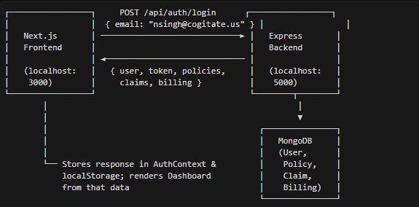
- Frontend calls this when the user submits the login form.
- Backend runs on port 5000, frontend on port 3000; CORS is enabled in Express.

API Used: Single Login API
Endpoint
POST /api/auth/login
Request
{ "email": "nsingh@cogitate.us" }
Backend Logic
- Validate email.
- Find user by email in MongoDB.
- If not found → return 404 with "No account with this email".
- If found:
- Find policies where insured.email matches.
- Get policy numbers from those policies.
- Find claims by those policy numbers.
- Find billing by those policy numbers.
- Generate JWT.
- Return all of this in one response.
- Frontend receives response: → Each dashboard component loads its data asynchronously. → All components fetch simultaneously. → Components appear one by one as their data arrives. → Better user experience.
Response 200
{
"success": true,
"token": "eyJhbGciOiJIUzI1NiIsInR5cCI6IkpXVCJ9...",
"user": {
"firstName": "Narotam",
"lastName": "Singh",
"email": "nsingh@cogitate.us"
},
"policies": [
{
"policyNumber": "FPP2000002139-00",
"policyType": "Farm",
"status": "Policy Cancelled",
"effectiveDate": "2025-11-11",
"expirationDate": "2026-11-11",
...
}
],
"claims": [
{
"claimNumber": "CFPD000201-00-02182026-01",
"title": "Mold Damage",
"status": "Open",
"filedDate": "2026-02-18",
...
}
],
"billing": [
{
"policyNumber": "FPP1900008896-00",
"currentAmountDue": 1894.58,
"currentDueDate": "2026-02-15",
"projectedStatements": [...],
...
}
]
}
How Data Reaches the Dashboard
Step 1: Login (/login)
- User enters email.
- LoginPage calls login(email) from AuthContext.
- AuthContext calls loginWithEmail() from api.ts.
- Backend returns { user, token, policies, claims, billing }.
- AuthContext:
- Saves this in useState.
- Persists to localStorage.
- Redirects to /dashboard.
Step 2: Dashboard (/dashboard)
- DashboardPage uses useAuth():
const { user, policies, claims, billing } = useAuth();
- It passes those into the dashboard components:
- PendingClaimsCard gets claims.
- UpcomingPaymentsCard gets billing.
- OverviewCards gets policies, claims, billing.
- Each component derives and displays its own data (no extra API calls).

backend/
├── config/db.js # MongoDB connection
├── controllers/
│ └── authController.js # POST /api/auth/login
├── models/
│ ├── User.js
│ ├── Policy.js
│ ├── Claim.js
│ └── Billing.js
├── routes/
│ └── authRoutes.js
├── data/ # JSON seed data
│ ├── users.json
│ ├── policies.json
│ ├── claims.json
│ └── billing.json
├── seed/seedData.js # Seed script
└── server.js

frontend/src/
├── app/
│ ├── (dashboard)/ # Authenticated layout (Sidebar + Header)
│ │ ├── dashboard/ # Main dashboard page
│ │ ├── policies/, claims/, billing/, etc. (placeholders)
│ │ └── layout.tsx
│ └── login/page.tsx
├── components/
│ ├── ui/ # Badge, Button, Card
│ ├── layout/ # Header, Sidebar
│ └── dashboard/ # Dashboard-specific components
├── context/AuthContext.tsx # Auth state (user, policies, claims, billing)
├── lib/api.ts # loginWithEmail()
├── config/env.ts # API base URL
├── types/ # Policy, Claim, Billing, User
├── utils/ # formatCurrency, formatDate
├── constants/ # Nav items, claim statuses
└── providers/ # AuthProvider wrapper

