Program 1

function fizzBuzz() {

for (let i = 1; i <= 100; i++) {

if (i % 3 === 0 && i % 5 === 0) {

console.log("FizzBuzz");

} else if (i % 3 === 0) { console.log("Fizz");

} else if (i % 5 === 0) { console.log("Buzz");

} else {

console.log(i);

}

}

}

fizzBuzz();

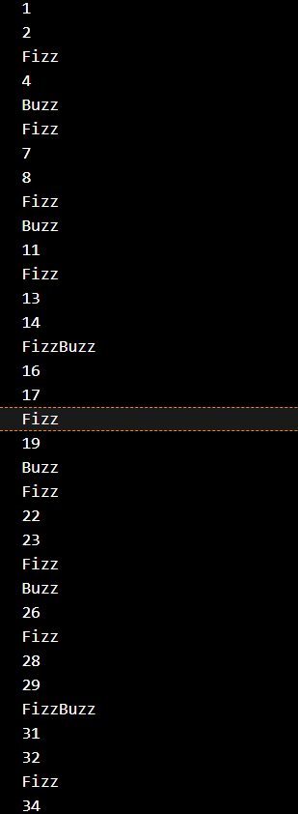

Program2

function evaluateExpression(expression) { return eval(expression);

}

console.log(evaluateExpression("3+5-2")); // 6

console.log(evaluateExpression("10-3+2")); // 9

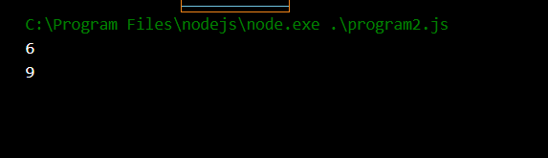

Program3

function flattenArray(arr) { return arr.flat(Infinity);

}

console.log(flattenArray([1, [2, [3, [4]], 5]])); // [1, 2, 3, 4, 5]

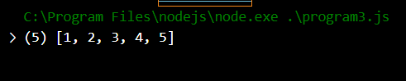

Program4

function areAnagrams(str1, str2) {

const normalize = str => str.toLowerCase().split('').sort().join(''); return normalize(str1) === normalize(str2);

}

console.log(areAnagrams("listen", "silent")); // true console.log(areAnagrams("hello", "world")); // false

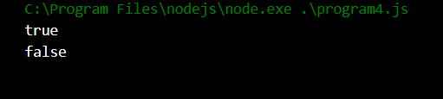

Program5

function removeDuplicates(arr) { return [...new Set(arr)];

}

console.log(removeDuplicates([1, 2, 2, 3, 4, 4, 5])); // [1, 2, 3, 4, 5]

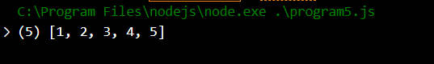

Program6

function capitalizeFirstLetter(str) {

return str.split(' ').map(word => word.charAt(0).toUpperCase() + word.slice(1)).join(' ');

}

console.log(capitalizeFirstLetter("hello world")); // "Hello World"



Program7

function generateFibonacci(n) { const fib = [0, 1];

for (let i = 2; i < n; i++) {

fib[i] = fib[i - 1] + fib[i - 2];

}

return fib.slice(0, n);

}

console.log(generateFibonacci(10)); // [0, 1, 1, 2, 3, 5, 8, 13, 21, 34]



Program8

class HashMap { constructor() {

this.map = {};

}

put(key, value) { this.map[key] = value;

}

get(key) {

return this.map[key];

}

remove(key) {

delete this.map[key];

}

}

const hashMap = new HashMap(); hashMap.put('key1', 'value1'); console.log(hashMap.get('key1')); // 'value1' hashMap.remove('key1');

console.log(hashMap.get('key1')); // undefined

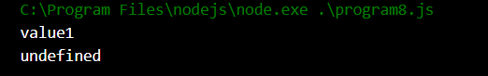

Program9 function filterEvenNumbers(arr) { return arr.filter(num => num % 2 !== 0);

}

console.log(filterEvenNumbers([1, 2, 3, 4, 5])); // [1, 3, 5]

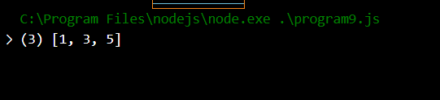

Program10

function toTitleCase(str) {

return str.toLowerCase().split(' ').map(word => word.charAt(0).toUpperCase()

+ word.slice(1)).join(' ');

}

console.log(toTitleCase("hello world")); // "Hello World"

