**Relay Module**

**Introduction**

A relay is an electromagnetic switch operated by a relatively small current that can control much larger current.

It uses an electric current to open or close the contacts of a switch. The single-channel relay module is much more than just a plain relay, it comprises of components that make switching and connection easier and act as indicators to show if the module is powered and if the relay is active or not.

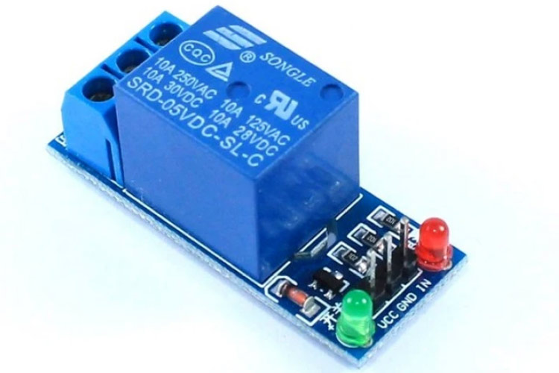

**Principle of Relay**

Here’s a simple animation illustrating how the relay uses one circuit to switch on another circuit.



Initially the first circuit is switched off and no current flows through it until something (either a sensor or switch closing) turns it on. The second circuit is also switched off.

When a small current flows through the first circuit, it activates the electromagnet, which generates a magnetic field all around it. The energized electromagnet attracts a contact in the second circuit toward it, closing the switch and allowing a much bigger current to flow through the second circuit.

When the current stops flowing, the contact goes back up to its original position, switching the second circuit off again.

**Pinout of Relay**

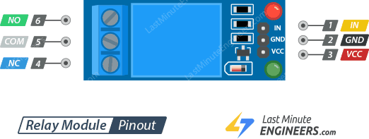

**Input Terminal:**

IN pin is used to control the relay. It is an active low pin, meaning the relay will be activated when you pull the pin LOW and it will become inactive when you pull the pin HIGH.

GND is the ground connection.

VCC pin supplies power to the module.

**Output Terminal:**

COM pin is connected to the signal you are planning to switch.

NC pin is connected to the COM pin by default, unless you send a signal from the Arduino to the relay module to break the connection.

NO pin is open by default, unless you send a signal from the Arduino to the relay module to make the connection.

**Working of Relay**

The mains electricity enters the relay at the common (COM) terminal. While use of NC & NO terminals depends upon whether you want to turn the device ON or OFF.

Between the remaining two pins (coil1 and coil2), there is a coil that acts like an electromagnet.



When current flows through the coil, the electromagnet becomes charged and moves the internal contacts of the switch. At that time the normally open (NO) terminal connects to the common (COM), and the normally closed (NC) terminal becomes disconnected.

When current stops flowing through the coil, the internal contact returns to its initial state i.e. the normally closed (NC) terminal connects to the common (COM), and the normally open (NO) terminal reopens.

This is known as a single pole, double throw switch (SPDT).