Object and it’s representation in JavaScript.

* Object is a **standalone entity**, with properties and types.
* It is an unordered collection of related data of primitive or reference types, in the form of “**key: Value**” pairs.
* An object can be created with figure brackets…..{} with an optional properties.

Eg:

**let school={**

**name:”acpuc”,**

**location:’arsikere’,**

**established:’1999’**

**}**

* In this example school is an object or data type,
* Name, location and established are **keys.**
* Acpuc, arsikere and 1999 are **values** of those keys.

Difference between HTTP1 and HTTP2.

* HTTP2 is a **binary protocol**, this is much more compressed which leads in less bandwidth usage and faster load time than HTTP1.
* HTTP2 is **multiplexed**, this allows client to make multiple requests over one TCP connection while HTTP1.1 allows only one request.

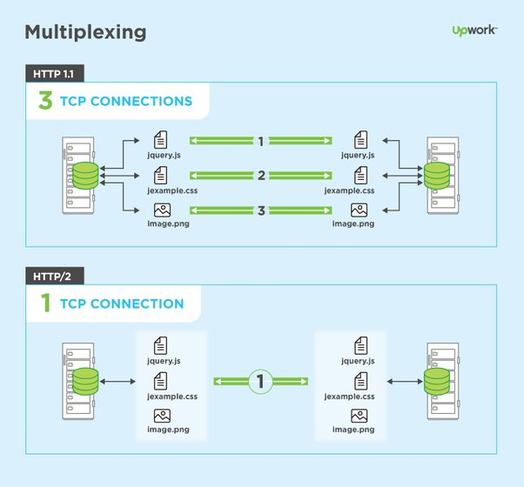

* HTTP2 requests can be **pushed**, by which request can be pre-sent and be ready before they have been requested.