linearregressionRmarkdown

Team

07/12/2020

##Road Type  
plot(Sale_Price~Road_Type, data = Pr, col = "red")

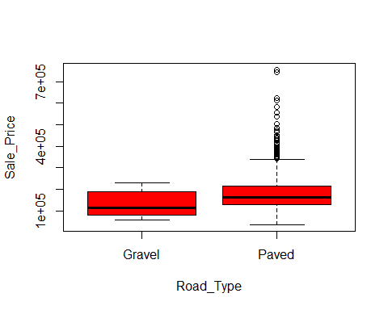

results<-aov (Sale_Price~Road_Type , data = Pr)  
summary(results)

## Df Sum Sq Mean Sq F value Pr(>F)  
## Road_Type 1 1.552e+10 1.552e+10 2.46 0.117  
## Residuals 1457 9.191e+12 6.308e+09

TukeyHSD(results)

## Tukey multiple comparisons of means  
## 95% family-wise confidence level  
##   
## Fit: aov(formula = Sale_Price ~ Road_Type, data = Pr)  
##   
## $Road_Type  
## diff lwr upr p adj  
## Paved-Gravel 50963.18 -12773.04 114699.4 0.1169861

##Lane Type  
plot(Sale_Price~Lane_Type, data = Pr, col = "red")

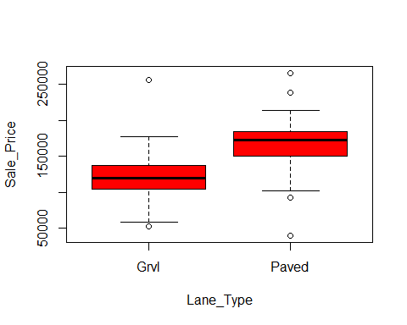

results<-aov (Sale_Price~Lane_Type , data = Pr)  
summary(results)

## Df Sum Sq Mean Sq F value Pr(>F)   
## Lane_Type 1 4.722e+10 4.722e+10 35.56 4.9e-08 ***  
## Residuals 89 1.182e+11 1.328e+09   
## ---  
## Signif. codes: 0 '***' 0.001 '**' 0.01 '*' 0.05 '.' 0.1 ' ' 1  
## 1368 observations deleted due to missingness

TukeyHSD(results)

## Tukey multiple comparisons of means  
## 95% family-wise confidence level  
##   
## Fit: aov(formula = Sale_Price ~ Lane_Type, data = Pr)  
##   
## $Lane_Type  
## diff lwr upr p adj  
## Paved-Grvl 45781.51 30527.29 61035.72 0

##Property_Shape  
plot(Sale_Price~Property_Shape, data = Pr, col = "red")

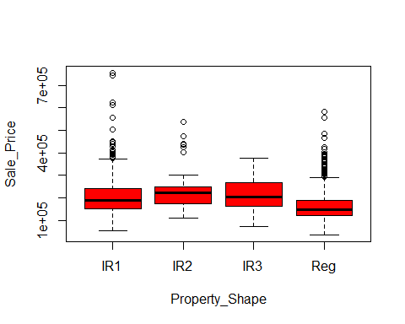

results<-aov (Sale_Price~Property_Shape , data = Pr)  
summary(results)

## Df Sum Sq Mean Sq F value Pr(>F)   
## Property_Shape 3 7.024e+11 2.341e+11 40.06 <2e-16 ***  
## Residuals 1455 8.504e+12 5.845e+09   
## ---  
## Signif. codes: 0 '***' 0.001 '**' 0.01 '*' 0.05 '.' 0.1 ' ' 1

TukeyHSD(results)

## Tukey multiple comparisons of means  
## 95% family-wise confidence level  
##   
## Fit: aov(formula = Sale_Price ~ Property_Shape, data = Pr)  
##   
## $Property_Shape  
## diff lwr upr p adj  
## IR2-IR1 33731.701 1748.229 65715.17 0.0340970  
## IR3-IR1 9934.835 -52885.660 72755.33 0.9772646  
## Reg-IR1 -41328.173 -52361.417 -30294.93 0.0000000  
## IR3-IR2 -23796.866 -93148.024 45554.29 0.8139399  
## Reg-IR2 -75059.873 -106443.007 -43676.74 0.0000000  
## Reg-IR3 -51263.008 -113779.990 11253.98 0.1506547

##Land_Outline  
plot(Sale_Price~Land_Outline, data = Pr, col = "red")

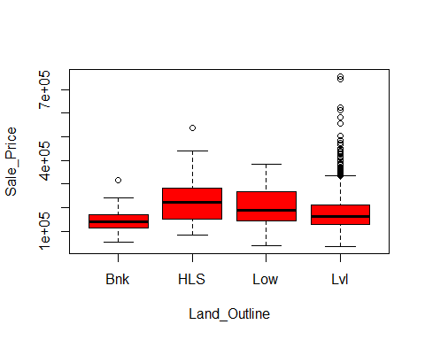

results<-aov (Sale_Price~Land_Outline , data = Pr)  
summary(results)

## Df Sum Sq Mean Sq F value Pr(>F)   
## Land_Outline 3 2.375e+11 7.915e+10 12.84 2.78e-08 ***  
## Residuals 1455 8.969e+12 6.164e+09   
## ---  
## Signif. codes: 0 '***' 0.001 '**' 0.01 '*' 0.05 '.' 0.1 ' ' 1

TukeyHSD(results)

## Tukey multiple comparisons of means  
## 95% family-wise confidence level  
##   
## Fit: aov(formula = Sale_Price ~ Land_Outline, data = Pr)  
##   
## $Land_Outline  
## diff lwr upr p adj  
## HLS-Bnk 88429.86 50182.28 126677.44 0.0000000  
## Low-Bnk 60557.03 18366.40 102747.67 0.0013195  
## Lvl-Bnk 37104.62 11058.12 63151.11 0.0014665  
## Low-HLS -27872.83 -72012.89 16267.24 0.3652653  
## Lvl-HLS -51325.24 -80423.62 -22226.86 0.0000366  
## Lvl-Low -23452.41 -57568.22 10663.39 0.2892213

##Utility_Type  
plot(Sale_Price~Utility_Type, data = Pr, col = "red")

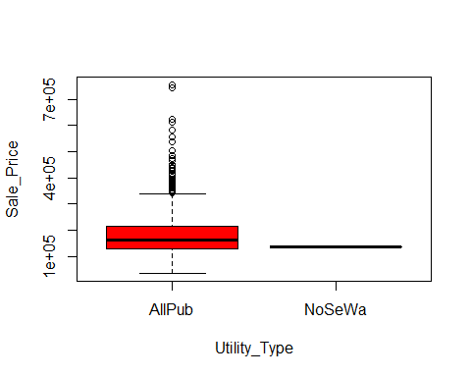

results<-aov (Sale_Price~Utility_Type , data = Pr)  
summary(results)

## Df Sum Sq Mean Sq F value Pr(>F)  
## Utility_Type 1 1.889e+09 1.889e+09 0.299 0.585  
## Residuals 1457 9.205e+12 6.318e+09

TukeyHSD(results)

## Tukey multiple comparisons of means  
## 95% family-wise confidence level  
##   
## Fit: aov(formula = Sale_Price ~ Utility_Type, data = Pr)  
##   
## $Utility_Type  
## diff lwr upr p adj  
## NoSeWa-AllPub -43473.9 -199442.7 112494.9 0.5846247

##Lot_Configuration  
plot(Sale_Price~Lot_Configuration, data = Pr, col = "red")

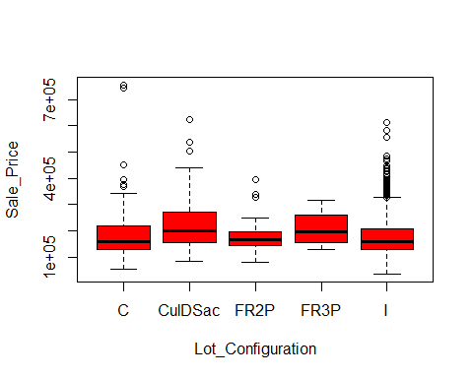

results<-aov (Sale_Price~Lot_Configuration , data = Pr)  
summary(results)

## Df Sum Sq Mean Sq F value Pr(>F)   
## Lot_Configuration 4 1.933e+11 4.832e+10 7.795 3.25e-06 ***  
## Residuals 1454 9.013e+12 6.199e+09   
## ---  
## Signif. codes: 0 '***' 0.001 '**' 0.01 '*' 0.05 '.' 0.1 ' ' 1

TukeyHSD(results)

## Tukey multiple comparisons of means  
## 95% family-wise confidence level  
##   
## Fit: aov(formula = Sale_Price ~ Lot_Configuration, data = Pr)  
##   
## $Lot_Configuration  
## diff lwr upr p adj  
## CulDSac-C 42231.1912 16390.11 68072.273 0.0000849  
## FR2P-C -3688.8514 -37743.19 30365.486 0.9983314  
## FR3P-C 26851.5741 -81482.77 135185.916 0.9614109  
## I-C -4657.3688 -19483.81 10169.070 0.9120756  
## FR2P-CulDSac -45920.0426 -84336.30 -7503.782 0.0098698  
## FR3P-CulDSac -15379.6170 -125163.23 94403.992 0.9954581  
## I-CulDSac -46888.5599 -70038.82 -23738.301 0.0000004  
## FR3P-FR2P 30540.4255 -81461.26 142542.110 0.9458744  
## I-FR2P -968.5174 -33028.94 31091.907 0.9999895  
## I-FR3P -31508.9429 -139233.14 76215.254 0.9309674

##Property_Slope  
plot(Sale_Price~Property_Slope, data = Pr, col = "red")

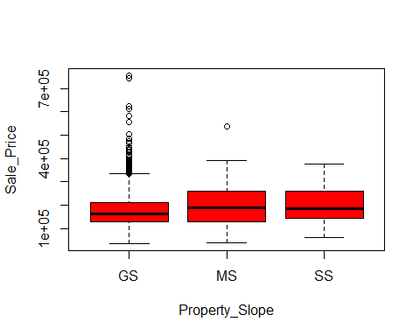

results<-aov (Sale_Price~Property_Slope , data = Pr)  
summary(results)

## Df Sum Sq Mean Sq F value Pr(>F)  
## Property_Slope 2 2.463e+10 1.231e+10 1.953 0.142  
## Residuals 1456 9.182e+12 6.306e+09

TukeyHSD(results)

## Tukey multiple comparisons of means  
## 95% family-wise confidence level  
##   
## Fit: aov(formula = Sale_Price ~ Property_Slope, data = Pr)  
##   
## $Property_Slope  
## diff lwr upr p adj  
## MS-GS 16753.837 -6892.825 40400.50 0.2202087  
## SS-GS 24398.929 -27517.173 76315.03 0.5126019  
## SS-MS 7645.092 -48960.345 64250.53 0.9461626

##Neighborhood  
plot(Sale_Price~Neighborhood, data = Pr, col = "red")

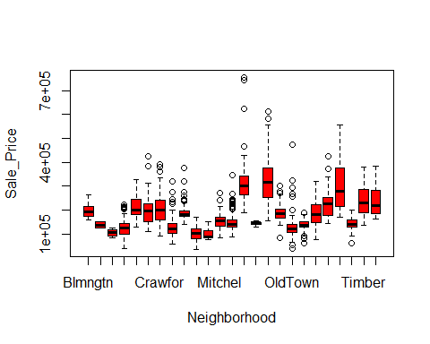

results<-aov (Sale_Price~Neighborhood , data = Pr)  
summary(results)

## Df Sum Sq Mean Sq F value Pr(>F)   
## Neighborhood 24 5.023e+12 2.093e+11 71.73 <2e-16 ***  
## Residuals 1434 4.184e+12 2.918e+09   
## ---  
## Signif. codes: 0 '***' 0.001 '**' 0.01 '*' 0.05 '.' 0.1 ' ' 1

TukeyHSD(results)

## Tukey multiple comparisons of means  
## 95% family-wise confidence level  
##   
## Fit: aov(formula = Sale_Price ~ Neighborhood, data = Pr)  
##   
## $Neighborhood  
## diff lwr upr p adj  
## Blueste-Blmngtn -57370.8824 -205367.150 90625.38507 0.9995677  
## BrDale-Blmngtn -90377.1324 -159335.336 -21418.92893 0.0004748  
## BrkSide-Blmngtn -70036.8306 -124638.459 -15435.20228 0.0007702  
## ClearCr-Blmngtn 17694.5462 -43177.262 78566.35416 0.9999975  
## CollgCr-Blmngtn 3094.8910 -47569.353 53759.13487 1.0000000  
## Crawfor-Blmngtn 15753.8431 -39690.639 71198.32483 0.9999984  
## Edwards-Blmngtn -66845.9329 -118821.634 -14870.23167 0.0007265  
## Gilbert-Blmngtn -2016.3760 -54947.490 50914.73751 1.0000000  
## IDOTRR-Blmngtn -94747.0986 -152754.709 -36739.48787 0.0000008  
## MeadowV-Blmngtn -96294.4118 -164199.756 -28389.06716 0.0000664  
## Mitchel-Blmngtn -38600.7599 -94327.404 17125.88382 0.6661229  
## NAmes-Blmngtn -49023.8024 -98821.055 773.45035 0.0602257  
## NoRidge-Blmngtn 140424.4347 83314.584 197534.28585 0.0000000  
## NPkVill-Blmngtn -52176.4379 -133788.505 29435.62937 0.8050756  
## NridgHt-Blmngtn 121399.7410 68347.037 174452.44501 0.0000000  
## NWAmes-Blmngtn -5820.8139 -59135.737 47494.10889 1.0000000  
## OldTown-Blmngtn -66645.5815 -118147.264 -15143.89934 0.0006335  
## Sawyer-Blmngtn -58077.7472 -111324.582 -4830.91251 0.0153017  
## SawyerW-Blmngtn -8315.0857 -62811.729 46181.55719 1.0000000  
## Somerst-Blmngtn 30508.9549 -22039.306 83057.21562 0.9140406  
## StoneBr-Blmngtn 115628.1176 53391.841 177864.39399 0.0000000  
## SWISU-Blmngtn -52279.5224 -114515.799 9956.75399 0.2612653  
## Timber-Blmngtn 47376.5650 -10390.261 105143.39104 0.3070252  
## Veenker-Blmngtn 43901.8449 -32705.716 120509.40540 0.9241387  
## BrDale-Blueste -33006.2500 -181488.549 115476.04916 1.0000000  
## BrkSide-Blueste -12665.9483 -155049.575 129717.67846 1.0000000  
## ClearCr-Blueste 75065.4286 -69838.458 219969.31516 0.9742467  
## CollgCr-Blueste 60465.7733 -80454.860 201386.40686 0.9978981  
## Crawfor-Blueste 73124.7255 -69584.244 215833.69471 0.9773524  
## Edwards-Blueste -9475.0505 -150872.479 131922.37825 1.0000000  
## Gilbert-Blueste 55354.5063 -86396.903 197105.91593 0.9995130  
## IDOTRR-Blueste -37376.2162 -181100.404 106347.97188 0.9999997  
## MeadowV-Blueste -38923.5294 -186919.797 109072.73801 0.9999997  
## Mitchel-Blueste 18770.1224 -124048.707 161588.95232 1.0000000  
## NAmes-Blueste 8347.0800 -132264.177 148958.33745 1.0000000  
## NoRidge-Blueste 197795.3171 54431.115 341159.51916 0.0001366  
## NPkVill-Blueste 5194.4444 -149570.826 159959.71468 1.0000000  
## NridgHt-Blueste 178770.6234 36973.766 320567.48069 0.0011170  
## NWAmes-Blueste 51550.0685 -90345.105 193445.24224 0.9998537  
## OldTown-Blueste -9274.6991 -150498.573 131949.17495 1.0000000  
## Sawyer-Blueste -706.8649 -142576.470 141162.73988 1.0000000  
## SawyerW-Blueste 49055.7966 -93287.603 191399.19630 0.9999416  
## Somerst-Blueste 87879.8372 -53729.057 229488.73189 0.8455562  
## StoneBr-Blueste 172999.0000 27516.652 318481.34751 0.0035675  
## SWISU-Blueste 5091.3600 -140390.988 150573.70751 1.0000000  
## Timber-Blueste 104747.4474 -38879.728 248374.62284 0.5588817  
## Veenker-Blueste 101272.7273 -50912.941 253458.39568 0.7407652  
## BrkSide-BrDale 20340.3017 -35565.296 76245.89905 0.9998500  
## ClearCr-BrDale 108071.6786 46027.541 170115.81606 0.0000001  
## CollgCr-BrDale 93472.0233 41405.109 145538.93801 0.0000000  
## Crawfor-BrDale 106130.9755 49401.895 162860.05573 0.0000000  
## Edwards-BrDale 23531.1995 -29812.699 76875.09801 0.9968488  
## Gilbert-BrDale 88360.7563 34085.525 142635.98801 0.0000009  
## IDOTRR-BrDale -4369.9662 -63606.618 54866.68539 1.0000000  
## MeadowV-BrDale -5917.2794 -74875.483 63040.92401 1.0000000  
## Mitchel-BrDale 51776.3724 -5228.512 108781.25659 0.1389348  
## NAmes-BrDale 41353.3300 -9870.340 92577.00003 0.3387992  
## NoRidge-BrDale 230801.5671 172443.765 289159.36938 0.0000000  
## NPkVill-BrDale 38200.6944 -44289.472 120690.86065 0.9937703  
## NridgHt-BrDale 211776.8734 157383.056 266170.69099 0.0000000  
## NWAmes-BrDale 84556.3185 29906.717 139205.92035 0.0000050  
## OldTown-BrDale 23731.5509 -29150.594 76613.69586 0.9959735  
## Sawyer-BrDale 32299.3851 -22283.794 86882.56387 0.8974455  
## SawyerW-BrDale 82062.0466 26258.981 137865.11181 0.0000239  
## Somerst-BrDale 120886.0872 66984.160 174788.01393 0.0000000  
## StoneBr-BrDale 206005.2500 142621.876 269388.62391 0.0000000  
## SWISU-BrDale 38097.6100 -25285.764 101480.98391 0.8820923  
## Timber-BrDale 137753.6974 78752.814 196754.58028 0.0000000  
## Veenker-BrDale 134278.9773 56736.626 211821.32904 0.0000001  
## ClearCr-BrkSide 87731.3768 42172.854 133289.89960 0.0000000  
## CollgCr-BrkSide 73131.7216 42520.162 103743.28155 0.0000000  
## Crawfor-BrkSide 85790.6738 47786.825 123794.52282 0.0000000  
## Edwards-BrkSide 3190.8978 -29545.558 35927.35309 1.0000000  
## Gilbert-BrkSide 68020.4546 33787.360 102253.54930 0.0000000  
## IDOTRR-BrkSide -24710.2679 -66364.618 16944.08228 0.8951054  
## MeadowV-BrkSide -26257.5811 -80859.209 28344.04721 0.9897088  
## Mitchel-BrkSide 31436.0707 -6978.260 69850.40156 0.3113627  
## NAmes-BrkSide 21013.0283 -8141.189 50167.24529 0.5842366  
## NoRidge-BrkSide 210461.2653 170066.500 250856.03096 0.0000000  
## NPkVill-BrkSide 17860.3927 -53067.257 88788.04260 0.9999999  
## NridgHt-BrkSide 191436.5717 157015.773 225857.37049 0.0000000  
## NWAmes-BrkSide 64216.0168 29392.419 99039.61482 0.0000000  
## OldTown-BrkSide 3391.2492 -28587.263 35369.76156 1.0000000  
## Sawyer-BrkSide 11959.0834 -22760.182 46678.34894 0.9999422  
## SawyerW-BrkSide 61721.7449 25114.559 98328.93112 0.0000002  
## Somerst-BrkSide 100545.7855 66907.687 134183.88445 0.0000000  
## StoneBr-BrkSide 185664.9483 138298.757 233031.13966 0.0000000  
## SWISU-BrkSide 17757.3083 -29608.883 65123.49966 0.9997511  
## Timber-BrkSide 117413.3956 76095.020 158731.77149 0.0000000  
## Veenker-BrkSide 113938.6755 48831.684 179045.66685 0.0000001  
## CollgCr-ClearCr -14599.6552 -55356.333 26157.02258 0.9998852  
## Crawfor-ClearCr -1940.7031 -48506.052 44624.64592 1.0000000  
## Edwards-ClearCr -84540.4791 -126916.353 -42164.60515 0.0000000  
## Gilbert-ClearCr -19710.9222 -63253.361 23831.51633 0.9954494  
## IDOTRR-ClearCr -112441.6448 -162031.201 -62852.08866 0.0000000  
## MeadowV-ClearCr -113988.9580 -174860.766 -53117.15004 0.0000000  
## Mitchel-ClearCr -56295.3061 -103196.266 -9394.34666 0.0029931  
## NAmes-ClearCr -66718.3486 -106392.113 -27044.58452 0.0000003  
## NoRidge-ClearCr 122729.8885 74193.549 171266.22822 0.0000000  
## NPkVill-ClearCr -69870.9841 -145731.189 5989.22087 0.1218953  
## NridgHt-ClearCr 103705.1948 60015.029 147395.36048 0.0000000  
## NWAmes-ClearCr -23515.3601 -67523.566 20492.84558 0.9633716  
## OldTown-ClearCr -84340.1277 -126133.242 -42547.01295 0.0000000  
## Sawyer-ClearCr -75772.2934 -119697.987 -31846.59955 0.0000001  
## SawyerW-ClearCr -26009.6320 -71442.277 19423.01344 0.9248913  
## Somerst-ClearCr 12814.4086 -30261.813 55890.63046 0.9999962  
## StoneBr-ClearCr 97933.5714 43457.932 152409.21067 0.0000000  
## SWISU-ClearCr -69974.0686 -124449.708 -15498.42933 0.0007466  
## Timber-ClearCr 29682.0188 -19625.662 78989.69940 0.8805215  
## Veenker-ClearCr 26207.2987 -44240.977 96655.57405 0.9997814  
## Crawfor-CollgCr 12658.9522 -19431.862 44749.76602 0.9994269  
## Edwards-CollgCr -69940.8238 -95576.800 -44304.84721 0.0000000  
## Gilbert-CollgCr -5111.2670 -32632.760 22410.22576 1.0000000  
## IDOTRR-CollgCr -97841.9895 -134182.225 -61501.75450 0.0000000  
## MeadowV-CollgCr -99389.3027 -150053.547 -48725.05885 0.0000000  
## Mitchel-CollgCr -41695.6509 -74271.541 -9119.76095 0.0008071  
## NAmes-CollgCr -52118.6933 -72987.238 -31250.14855 0.0000000  
## NoRidge-CollgCr 137329.5437 102440.220 172218.86704 0.0000000  
## NPkVill-CollgCr -55271.3289 -123214.388 12671.73043 0.3232635  
## NridgHt-CollgCr 118304.8500 90550.225 146059.47459 0.0000000  
## NWAmes-CollgCr -8915.7048 -37168.329 19336.91933 0.9999882  
## OldTown-CollgCr -69740.4724 -94401.232 -45079.71321 0.0000000  
## Sawyer-CollgCr -61172.6382 -89296.564 -33048.71262 0.0000000  
## SawyerW-CollgCr -11409.9767 -41833.880 19013.92630 0.9997496  
## Somerst-CollgCr 27414.0639 636.284 54191.84372 0.0372501  
## StoneBr-CollgCr 112533.2267 69765.436 155301.01685 0.0000000  
## SWISU-CollgCr -55374.4133 -98142.204 -12606.62315 0.0006256  
## Timber-CollgCr 44281.6740 8327.036 80236.31175 0.0018099  
## Veenker-CollgCr 40806.9539 -21035.168 102649.07637 0.7552328  
## Edwards-Crawfor -82599.7760 -116723.496 -48476.05640 0.0000000  
## Gilbert-Crawfor -17770.2192 -53332.243 17791.80419 0.9832811  
## IDOTRR-Crawfor -110500.9417 -153254.159 -67747.72400 0.0000000  
## MeadowV-Crawfor -112048.2549 -167492.737 -56603.77321 0.0000000  
## Mitchel-Crawfor -54354.6030 -93957.804 -14751.40183 0.0001560  
## NAmes-Crawfor -64777.6455 -95481.409 -34073.88184 0.0000000  
## NoRidge-Crawfor 124670.5916 83143.615 166197.56861 0.0000000  
## NPkVill-Crawfor -67930.2810 -139508.799 3648.23703 0.0903034  
## NridgHt-Crawfor 105645.8979 69903.149 141388.64715 0.0000000  
## NWAmes-Crawfor -21574.6570 -57705.471 14556.15690 0.8887490  
## OldTown-Crawfor -82399.4246 -115796.700 -49002.14946 0.0000000  
## Sawyer-Crawfor -73831.5904 -109861.857 -37801.32348 0.0000000  
## SawyerW-Crawfor -24068.9289 -61921.786 13783.92855 0.8129455  
## Somerst-Crawfor 14755.1117 -20234.522 49744.74496 0.9983787  
## StoneBr-Crawfor 99874.2745 51538.896 148209.65304 0.0000000  
## SWISU-Crawfor -68033.3655 -116368.744 -19697.98696 0.0000811  
## Timber-Crawfor 31622.7219 -10803.224 74048.66812 0.5112859  
## Veenker-Crawfor 28148.0018 -37667.445 93963.44866 0.9979975  
## Gilbert-Edwards 64829.5568 34962.510 94696.60336 0.0000000  
## IDOTRR-Edwards -27901.1657 -66048.519 10246.18791 0.5526343  
## MeadowV-Edwards -29448.4789 -81424.180 22527.22228 0.9321802  
## Mitchel-Edwards 28245.1730 -6335.118 62825.46372 0.3151231  
## NAmes-Edwards 17822.1305 -6054.722 41698.98259 0.5081719  
## NoRidge-Edwards 207270.3676 170502.545 244038.19026 0.0000000  
## NPkVill-Edwards 14669.4949 -54257.040 83596.02985 1.0000000  
## NridgHt-Edwards 188245.6739 158163.668 218327.67994 0.0000000  
## NWAmes-Edwards 61025.1190 30483.039 91567.19942 0.0000000  
## OldTown-Edwards 200.3514 -27053.290 27453.99245 1.0000000  
## Sawyer-Edwards 8768.1856 -21654.883 39191.25410 0.9999979  
## SawyerW-Edwards 58530.8471 25969.800 91091.89408 0.0000000  
## Somerst-Edwards 97354.8877 68171.718 126538.05748 0.0000000  
## StoneBr-Edwards 182474.0505 138160.488 226787.61256 0.0000000  
## SWISU-Edwards 14566.4105 -29747.152 58879.97256 0.9999751  
## Timber-Edwards 114222.4979 76442.293 152002.70271 0.0000000  
## Veenker-Edwards 110747.7778 47826.748 173668.80774 0.0000000  
## IDOTRR-Gilbert -92730.7225 -132169.914 -53291.53069 0.0000000  
## MeadowV-Gilbert -94278.0357 -147209.149 -41346.92221 0.0000000  
## Mitchel-Gilbert -36584.3839 -72584.742 -584.02589 0.0409479  
## NAmes-Gilbert -47007.4263 -72898.223 -21116.63005 0.0000000  
## NoRidge-Gilbert 142440.8107 104334.354 180547.26755 0.0000000  
## NPkVill-Gilbert -50160.0619 -119809.875 19489.75132 0.5859519  
## NridgHt-Gilbert 123416.1170 91711.916 155120.31794 0.0000000  
## NWAmes-Gilbert -3804.4378 -35945.501 28336.62535 1.0000000  
## OldTown-Gilbert -64629.2054 -93663.499 -35594.91164 0.0000000  
## Sawyer-Gilbert -56061.3712 -88089.365 -24033.37780 0.0000001  
## SawyerW-Gilbert -6298.7097 -40364.103 27766.68395 1.0000000  
## Somerst-Gilbert 32525.3309 1672.670 63377.99145 0.0251231  
## StoneBr-Gilbert 117644.4937 72214.096 163074.89151 0.0000000  
## SWISU-Gilbert -50263.1463 -95693.544 -4832.74849 0.0122783  
## Timber-Gilbert 49392.9410 10308.761 88477.12127 0.0010620  
## Veenker-Gilbert 45918.2209 -17794.300 109630.74152 0.5843693  
## MeadowV-IDOTRR -1547.3132 -59554.924 56460.29751 1.0000000  
## Mitchel-IDOTRR 56146.3387 13027.829 99264.84856 0.0005505  
## NAmes-IDOTRR 45723.2962 10601.886 80844.70637 0.0005532  
## NoRidge-IDOTRR 235171.5333 190279.639 280063.42755 0.0000000  
## NPkVill-IDOTRR 42570.6607 -31011.107 116152.42878 0.9168672  
## NridgHt-IDOTRR 216146.8396 176544.611 255749.06774 0.0000000  
## NWAmes-IDOTRR 88926.2847 48973.462 128879.10767 0.0000000  
## OldTown-IDOTRR 28101.5171 -9397.421 65600.45491 0.4994115  
## Sawyer-IDOTRR 36669.3514 -3192.566 76531.26902 0.1233466  
## SawyerW-IDOTRR 86432.0128 44915.376 127948.65003 0.0000000  
## Somerst-IDOTRR 125256.0534 86332.195 164179.91222 0.0000000  
## StoneBr-IDOTRR 210375.2162 159119.961 261630.47124 0.0000000  
## SWISU-IDOTRR 42467.5762 -8787.679 93722.83124 0.2871190  
## Timber-IDOTRR 142123.6636 96398.908 187848.41906 0.0000000  
## Veenker-IDOTRR 138648.9435 70660.228 206637.65871 0.0000000  
## Mitchel-MeadowV 57693.6519 1967.008 113420.29559 0.0321565  
## NAmes-MeadowV 47270.6094 -2526.643 97067.86212 0.0900746  
## NoRidge-MeadowV 236718.8465 179608.995 293828.69761 0.0000000  
## NPkVill-MeadowV 44117.9739 -37494.093 125730.04113 0.9583972  
## NridgHt-MeadowV 217694.1528 164641.449 270746.85677 0.0000000  
## NWAmes-MeadowV 90473.5979 37158.675 143788.52066 0.0000002  
## OldTown-MeadowV 29648.8303 -21852.852 81150.51243 0.9207259  
## Sawyer-MeadowV 38216.6645 -15030.170 91463.49925 0.5931966  
## SawyerW-MeadowV 87979.3260 33482.683 142475.96895 0.0000012  
## Somerst-MeadowV 126803.3666 74255.106 179351.62738 0.0000000  
## StoneBr-MeadowV 211922.5294 149686.253 274158.80576 0.0000000  
## SWISU-MeadowV 44014.8894 -18221.387 106251.16576 0.6240994  
## Timber-MeadowV 143670.9768 85904.151 201437.80281 0.0000000  
## Veenker-MeadowV 140196.2567 63588.696 216803.81717 0.0000000  
## NAmes-Mitchel -10423.0424 -41633.447 20787.36243 0.9999667  
## NoRidge-Mitchel 179025.1946 137122.234 220928.15504 0.0000000  
## NPkVill-Mitchel -13575.6780 -85372.980 58221.62362 1.0000000  
## NridgHt-Mitchel 160000.5009 123821.607 196179.39527 0.0000000  
## NWAmes-Mitchel 32779.9460 -3782.384 69342.27617 0.1561413  
## OldTown-Mitchel -28044.8216 -61908.464 5818.82056 0.2880048  
## Sawyer-Mitchel -19476.9873 -55939.960 16985.98571 0.9635099  
## SawyerW-Mitchel 30285.6742 -7979.285 68550.63315 0.3802396  
## Somerst-Mitchel 69109.7148 33674.666 104544.76387 0.0000000  
## StoneBr-Mitchel 154228.8776 105570.095 202887.65979 0.0000000  
## SWISU-Mitchel -13678.7624 -62337.545 34980.01979 0.9999987  
## Timber-Mitchel 85977.3249 43183.293 128771.35704 0.0000000  
## Veenker-Mitchel 82502.6048 16449.283 148555.92661 0.0013584  
## NoRidge-NAmes 189448.2371 155830.301 223066.17347 0.0000000  
## NPkVill-NAmes -3152.6356 -70451.670 64146.39919 1.0000000  
## NridgHt-NAmes 170423.5434 144285.067 196562.01984 0.0000000  
## NWAmes-NAmes 43202.9885 16536.314 69869.66320 0.0000011  
## OldTown-NAmes -17621.7791 -40448.382 5204.82410 0.4340945  
## Sawyer-NAmes -9053.9449 -35584.229 17476.33892 0.9999510  
## SawyerW-NAmes 40708.7166 11751.599 69665.83392 0.0000837  
## Somerst-NAmes 79532.7572 54433.947 104631.56716 0.0000000  
## StoneBr-NAmes 164651.9200 122914.830 206389.00956 0.0000000  
## SWISU-NAmes -3255.7200 -44992.810 38481.36956 1.0000000  
## Timber-NAmes 96400.3674 61678.087 131122.64755 0.0000000  
## Veenker-NAmes 92925.6473 31791.787 154059.50757 0.0000088  
## NPkVill-NoRidge -192600.8726 -265476.992 -119724.75311 0.0000000  
## NridgHt-NoRidge -19024.6937 -57299.864 19250.47672 0.9843430  
## NWAmes-NoRidge -146245.2486 -184883.057 -107607.43991 0.0000000  
## OldTown-NoRidge -207070.0162 -243164.649 -170975.38317 0.0000000  
## Sawyer-NoRidge -198502.1819 -237045.984 -159958.37988 0.0000000  
## SawyerW-NoRidge -148739.5205 -188992.264 -108486.77694 0.0000000  
## Somerst-NoRidge -109915.4799 -147488.329 -72342.63089 0.0000000  
## StoneBr-NoRidge -24796.3171 -75033.289 25440.65501 0.9856503  
## SWISU-NoRidge -192703.9571 -242940.929 -142466.98499 0.0000000  
## Timber-NoRidge -93047.8697 -137628.196 -48467.54378 0.0000000  
## Veenker-NoRidge -96522.5898 -163746.972 -29298.20737 0.0000472  
## NridgHt-NPkVill 173576.1789 103833.917 243318.44087 0.0000000  
## NWAmes-NPkVill 46355.6240 -23586.314 116297.56203 0.7477400  
## OldTown-NPkVill -14469.1436 -83038.940 54100.65272 1.0000000  
## Sawyer-NPkVill -5901.3093 -75791.359 63988.74081 1.0000000  
## SawyerW-NPkVill 43861.3522 -26985.509 114708.21371 0.8485334  
## Somerst-NPkVill 82685.3928 13326.086 152044.69935 0.0034043  
## StoneBr-NPkVill 167804.5556 90845.165 244763.94610 0.0000000  
## SWISU-NPkVill -103.0844 -77062.475 76856.30610 1.0000000  
## Timber-NPkVill 99553.0029 26160.906 172945.09984 0.0002093  
## Veenker-NPkVill 96078.2828 7094.509 185062.05676 0.0178136  
## NWAmes-NridgHt -127220.5549 -159561.466 -94879.64329 0.0000000  
## OldTown-NridgHt -188045.3225 -217300.695 -158789.94971 0.0000000  
## Sawyer-NridgHt -179477.4882 -211706.031 -147248.94529 0.0000000  
## SawyerW-NridgHt -129714.8268 -163968.844 -95460.80999 0.0000000  
## Somerst-NridgHt -90890.7862 -121951.586 -59829.98637 0.0000000  
## StoneBr-NridgHt -5771.6234 -51343.629 39800.38193 1.0000000  
## SWISU-NridgHt -173679.2634 -219251.269 -128107.25807 0.0000000  
## Timber-NridgHt -74023.1760 -113271.867 -34774.48477 0.0000000  
## Veenker-NridgHt -77497.8961 -141311.468 -13684.32468 0.0023893  
## OldTown-NWAmes -60824.7676 -90553.010 -31096.52472 0.0000000  
## Sawyer-NWAmes -52256.9334 -84915.325 -19598.54134 0.0000017  
## SawyerW-NWAmes -2494.2719 -37153.026 32164.48248 1.0000000  
## Somerst-NWAmes 36329.7687 4823.184 67836.35330 0.0062017  
## StoneBr-NWAmes 121448.9315 75571.930 167325.93289 0.0000000  
## SWISU-NWAmes -46458.7085 -92335.710 -581.70711 0.0427933  
## Timber-NWAmes 53197.3789 13594.963 92799.79487 0.0002656  
## Veenker-NWAmes 49722.6588 -14309.079 113754.39689 0.4212835  
## Sawyer-OldTown 8567.8343 -21038.125 38173.79384 0.9999977  
## SawyerW-OldTown 58330.4957 26531.572 90129.41910 0.0000000  
## Somerst-OldTown 97154.5363 68824.214 125484.85836 0.0000000  
## StoneBr-OldTown 182273.6991 138517.082 226030.31610 0.0000000  
## SWISU-OldTown 14366.0591 -29390.558 58122.67610 0.9999756  
## Timber-OldTown 114022.1465 76896.769 151147.52360 0.0000000  
## Veenker-OldTown 110547.4264 48017.388 173077.46525 0.0000000  
## SawyerW-Sawyer 49762.6615 15208.737 84316.58559 0.0000434  
## Somerst-Sawyer 88586.7021 57195.473 119977.93158 0.0000000  
## StoneBr-Sawyer 173705.8649 127908.008 219503.72152 0.0000000  
## SWISU-Sawyer 5798.2249 -39999.632 51596.08152 1.0000000  
## Timber-Sawyer 105454.3122 65943.608 144965.01673 0.0000000  
## Veenker-Sawyer 101979.5921 38004.535 165954.64903 0.0000019  
## Somerst-SawyerW 38824.0406 5356.624 72291.45721 0.0055825  
## StoneBr-SawyerW 123943.2034 76698.073 171188.33392 0.0000000  
## SWISU-SawyerW -43964.4366 -91209.567 3280.69392 0.1103019  
## Timber-SawyerW 55691.6508 14512.111 96871.19003 0.0002252  
## Veenker-SawyerW 52216.9307 -12802.040 117235.90165 0.3495783  
## StoneBr-Somerst 85119.1628 40135.410 130102.91516 0.0000000  
## SWISU-Somerst -82788.4772 -127772.230 -37804.72484 0.0000000  
## Timber-Somerst 16867.6102 -21696.493 55431.71359 0.9972134  
## Veenker-Somerst 13392.8901 -50001.922 76787.70221 1.0000000  
## SWISU-StoneBr -167907.6400 -223903.822 -111911.45833 0.0000000  
## Timber-StoneBr -68251.5526 -119234.142 -17268.96288 0.0002883  
## Veenker-StoneBr -71726.2727 -143356.829 -95.71646 0.0491943  
## Timber-SWISU 99656.0874 48673.498 150638.67712 0.0000000  
## Veenker-SWISU 96181.3673 24550.811 167811.92354 0.0002682  
## Veenker-Timber -3474.7201 -71258.115 64308.67527 1.0000000

##Condition1  
plot(Sale_Price~Condition1, data = Pr, col = "red")

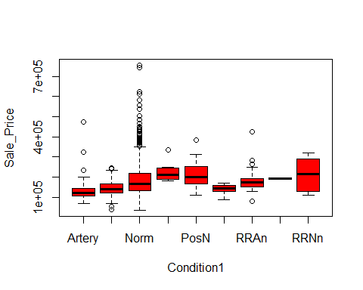

results<-aov (Sale_Price~Condition1 , data = Pr)  
summary(results)

## Df Sum Sq Mean Sq F value Pr(>F)   
## Condition1 8 3.007e+11 3.759e+10 6.12 8.85e-08 ***  
## Residuals 1450 8.906e+12 6.142e+09   
## ---  
## Signif. codes: 0 '***' 0.001 '**' 0.01 '*' 0.05 '.' 0.1 ' ' 1

TukeyHSD(results)

## Tukey multiple comparisons of means  
## 95% family-wise confidence level  
##   
## Fit: aov(formula = Sale_Price ~ Condition1, data = Pr)  
##   
## $Condition1  
## diff lwr upr p adj  
## Feedr-Artery 7383.8148 -36962.279 51729.91 0.9998720  
## Norm-Artery 49433.2102 13629.506 85236.91 0.0006450  
## PosA-Artery 90783.3333 -2188.640 183755.31 0.0618558  
## PosN-Artery 80092.5439 14104.747 146080.34 0.0053090  
## RRAe-Artery 3308.3333 -78074.479 84691.15 1.0000000  
## RRAn-Artery 49304.9487 -9978.330 108588.23 0.1943096  
## RRNe-Artery 55658.3333 -120042.181 231358.85 0.9873316  
## RRNn-Artery 77308.3333 -37099.553 191716.22 0.4742591  
## Norm-Feedr 42049.3954 14141.912 69956.88 0.0001086  
## PosA-Feedr 83399.5185 -6826.366 173625.40 0.0965427  
## PosN-Feedr 72708.7290 10649.791 134767.67 0.0086179  
## RRAe-Feedr -4075.4815 -82306.450 74155.49 1.0000000  
## RRAn-Feedr 41921.1339 -12955.360 96797.63 0.2996194  
## RRNe-Feedr 48274.5185 -125988.482 222537.52 0.9948326  
## RRNn-Feedr 69924.5185 -42263.212 182112.25 0.5885226  
## PosA-Norm 41350.1231 -44998.238 127698.48 0.8615107  
## PosN-Norm 30659.3336 -25613.581 86932.25 0.7512984  
## RRAe-Norm -46124.8769 -119850.135 27600.38 0.5833892  
## RRAn-Norm -128.2615 -48364.749 48108.23 1.0000000  
## RRNe-Norm 6225.1231 -166062.202 178512.45 1.0000000  
## RRNn-Norm 27875.1231 -81218.488 136968.73 0.9970484  
## PosN-PosA -10690.7895 -113299.383 91917.80 0.9999966  
## RRAe-PosA -87475.0000 -200600.136 25650.14 0.2834097  
## RRAn-PosA -41478.3846 -139909.281 56952.51 0.9288377  
## RRNe-PosA -35125.0000 -227595.271 157345.27 0.9997447  
## RRNn-PosA -13475.0000 -152267.286 125317.29 0.9999980  
## RRAe-PosN -76784.2105 -169022.477 15454.06 0.1932790  
## RRAn-PosN -30787.5951 -104267.135 42691.95 0.9310458  
## RRNe-PosN -24434.2105 -205418.758 156550.34 0.9999742  
## RRNn-PosN -2784.2105 -125152.099 119583.68 1.0000000  
## RRAn-RRAe 45996.6154 -41570.591 133563.82 0.7872776  
## RRNe-RRAe 52350.0000 -134797.480 239497.48 0.9944777  
## RRNn-RRAe 74000.0000 -57311.359 205311.36 0.7147320  
## RRNe-RRAn 6353.3846 -172295.781 185002.55 1.0000000  
## RRNn-RRAn 28003.3846 -90883.191 146889.96 0.9983415  
## RRNn-RRNe 21650.0000 -182041.388 225341.39 0.9999960

##Condition2  
plot(Sale_Price~Condition2, data = Pr, col = "red")

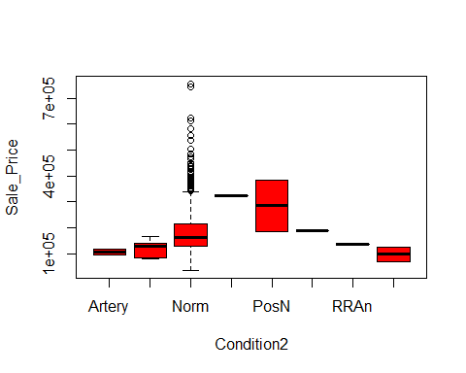

results<-aov (Sale_Price~Condition2 , data = Pr)  
summary(results)

## Df Sum Sq Mean Sq F value Pr(>F)   
## Condition2 7 9.117e+10 1.302e+10 2.073 0.0435 *  
## Residuals 1451 9.116e+12 6.282e+09   
## ---  
## Signif. codes: 0 '***' 0.001 '**' 0.01 '*' 0.05 '.' 0.1 ' ' 1

TukeyHSD(results)

## Tukey multiple comparisons of means  
## 95% family-wise confidence level  
##   
## Fit: aov(formula = Sale_Price ~ Condition2, data = Pr)  
##   
## $Condition2  
## diff lwr upr p adj  
## Feedr-Artery 14666.667 -181768.64 211101.97 0.9999985  
## Norm-Artery 74692.722 -95543.01 244928.46 0.8867563  
## PosA-Artery 218500.000 -76152.96 513152.96 0.3220073  
## PosN-Artery 178375.000 -62208.13 418958.13 0.3222234  
## RRAe-Artery 83500.000 -211152.96 378152.96 0.9893684  
## RRAn-Artery 30405.000 -264247.96 325057.96 0.9999857  
## RRNn-Artery -9750.000 -250333.13 230833.13 1.0000000  
## Norm-Feedr 60026.056 -38395.44 158447.55 0.5849204  
## PosA-Feedr 203833.333 -56026.15 463692.82 0.2514581  
## PosN-Feedr 163708.333 -32726.97 360143.64 0.1837363  
## RRAe-Feedr 68833.333 -191026.15 328692.82 0.9929246  
## RRAn-Feedr 15738.333 -244121.15 275597.82 0.9999996  
## RRNn-Feedr -24416.667 -220851.97 172018.64 0.9999492  
## PosA-Norm 143807.278 -96859.15 384473.70 0.6107826  
## PosN-Norm 103682.278 -66553.46 273918.01 0.5866771  
## RRAe-Norm 8807.278 -231859.15 249473.70 1.0000000  
## RRAn-Norm -44287.722 -284954.15 196378.70 0.9992995  
## RRNn-Norm -84442.722 -254678.46 85793.01 0.8046222  
## PosN-PosA -40125.000 -334777.96 254527.96 0.9999058  
## RRAe-PosA -135000.000 -475235.93 205235.93 0.9307892  
## RRAn-PosA -188095.000 -528330.93 152140.93 0.7016223  
## RRNn-PosA -228250.000 -522902.96 66402.96 0.2666248  
## RRAe-PosN -94875.000 -389527.96 199777.96 0.9776018  
## RRAn-PosN -147970.000 -442622.96 146682.96 0.7943912  
## RRNn-PosN -188125.000 -428708.13 52458.13 0.2552053  
## RRAn-RRAe -53095.000 -393330.93 287140.93 0.9997647  
## RRNn-RRAe -93250.000 -387902.96 201402.96 0.9797059  
## RRNn-RRAn -40155.000 -334807.96 254497.96 0.9999053

##House_Type  
plot(Sale_Price~House_Type, data = Pr, col = "red")

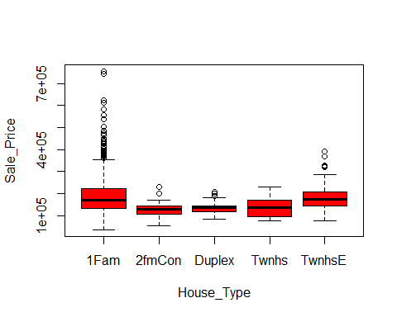

results<-aov (Sale_Price~House_Type , data = Pr)  
summary(results)

## Df Sum Sq Mean Sq F value Pr(>F)   
## House_Type 4 3.183e+11 7.958e+10 13.02 2.03e-10 ***  
## Residuals 1454 8.888e+12 6.113e+09   
## ---  
## Signif. codes: 0 '***' 0.001 '**' 0.01 '*' 0.05 '.' 0.1 ' ' 1

TukeyHSD(results)

## Tukey multiple comparisons of means  
## 95% family-wise confidence level  
##   
## Fit: aov(formula = Sale_Price ~ House_Type, data = Pr)  
##   
## $House_Type  
## diff lwr upr p adj  
## 2fmCon-1Fam -57362.939 -96200.972 -18524.91 0.0005521  
## Duplex-1Fam -52254.120 -82492.198 -22016.04 0.0000255  
## Twnhs-1Fam -49883.569 -83017.924 -16749.21 0.0003986  
## TwnhsE-1Fam -3835.855 -24750.270 17078.56 0.9872842  
## Duplex-2fmCon 5108.819 -43346.500 53564.14 0.9984992  
## Twnhs-2fmCon 7479.370 -42834.267 57793.01 0.9942902  
## TwnhsE-2fmCon 53527.084 10272.150 96782.02 0.0066706  
## Twnhs-Duplex 2370.551 -41645.475 46386.58 0.9998949  
## TwnhsE-Duplex 48418.265 12683.999 84152.53 0.0020773  
## TwnhsE-Twnhs 46047.714 7831.462 84263.97 0.0090391

##House_Design  
plot(Sale_Price~House_Design, data = Pr, col = "red")

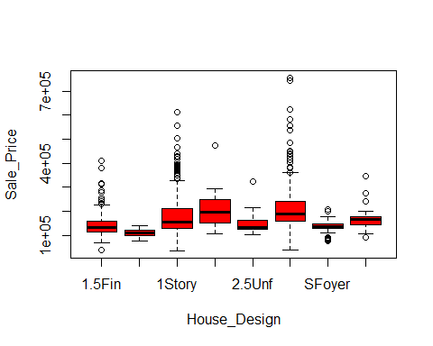

results<-aov (Sale_Price~House_Design , data = Pr)  
summary(results)

## Df Sum Sq Mean Sq F value Pr(>F)   
## House_Design 7 7.945e+11 1.135e+11 19.58 <2e-16 ***  
## Residuals 1451 8.412e+12 5.798e+09   
## ---  
## Signif. codes: 0 '***' 0.001 '**' 0.01 '*' 0.05 '.' 0.1 ' ' 1

TukeyHSD(results)

## Tukey multiple comparisons of means  
## 95% family-wise confidence level  
##   
## Fit: aov(formula = Sale_Price ~ House_Design, data = Pr)  
##   
## $House_Design  
## diff lwr upr p adj  
## 1.5Unf-1.5Fin -32966.740 -97481.723 31548.243 0.7793065  
## 1Story-1.5Fin 32908.028 12401.346 53414.710 0.0000337  
## 2.5Fin-1.5Fin 76883.260 -6924.162 160690.681 0.0996253  
## 2.5Unf-1.5Fin 14237.805 -57892.139 86367.749 0.9988933  
## 2Story-1.5Fin 66935.024 45327.581 88542.466 0.0000000  
## SFoyer-1.5Fin -8042.254 -50356.420 34271.912 0.9991348  
## SLvl-1.5Fin 23586.644 -10598.337 57771.625 0.4190367  
## 1Story-1.5Unf 65874.768 3512.842 128236.695 0.0298103  
## 2.5Fin-1.5Unf 109850.000 7418.707 212281.293 0.0255412  
## 2.5Unf-1.5Unf 47204.545 -45914.812 140323.902 0.7863343  
## 2Story-1.5Unf 99901.764 37169.257 162634.271 0.0000405  
## SFoyer-1.5Unf 24924.486 -47594.301 97443.274 0.9677098  
## SLvl-1.5Unf 56553.385 -11542.862 124649.631 0.1873546  
## 2.5Fin-1Story 43975.232 -38186.260 126136.723 0.7354167  
## 2.5Unf-1Story -18670.223 -88881.017 51540.571 0.9927554  
## 2Story-1Story 34026.996 20109.079 47944.913 0.0000000  
## SFoyer-1Story -40950.282 -79903.016 -1997.548 0.0312718  
## SLvl-1Story -9321.384 -39245.283 20602.516 0.9814716  
## 2.5Unf-2.5Fin -62645.455 -170035.936 44745.027 0.6402137  
## 2Story-2.5Fin -9948.236 -92391.357 72494.886 0.9999585  
## SFoyer-2.5Fin -84925.514 -175039.194 5188.167 0.0815600  
## SLvl-2.5Fin -53296.615 -139891.070 33297.840 0.5731761  
## 2Story-2.5Unf 52697.219 -17842.935 123237.372 0.3123901  
## SFoyer-2.5Unf -22280.059 -101649.576 57089.458 0.9899536  
## SLvl-2.5Unf 9348.839 -66001.307 84698.985 0.9999498  
## SFoyer-2Story -74977.278 -114520.584 -35433.971 0.0000003  
## SLvl-2Story -43348.379 -74037.096 -12659.663 0.0005094  
## SLvl-SFoyer 31628.898 -15967.366 79225.163 0.4705520

##Roof_Design  
plot(Sale_Price~Roof_Design, data = Pr, col = "red")

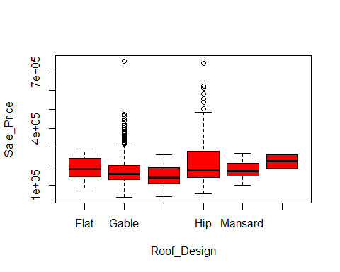

results<-aov (Sale_Price~Roof_Design , data = Pr)  
summary(results)

## Df Sum Sq Mean Sq F value Pr(>F)   
## Roof_Design 5 5.307e+11 1.061e+11 17.78 <2e-16 ***  
## Residuals 1453 8.676e+12 5.971e+09   
## ---  
## Signif. codes: 0 '***' 0.001 '**' 0.01 '*' 0.05 '.' 0.1 ' ' 1

TukeyHSD(results)

## Tukey multiple comparisons of means  
## 95% family-wise confidence level  
##   
## Fit: aov(formula = Sale_Price ~ Roof_Design, data = Pr)  
##   
## $Roof_Design  
## diff lwr upr p adj  
## Gable-Flat -23185.005 -84688.549 38318.54 0.8911049  
## Gambrel-Flat -45780.909 -136114.067 44552.25 0.6986137  
## Hip-Flat 24186.934 -38343.364 86717.23 0.8799529  
## Mansard-Flat -14121.571 -117493.803 89250.66 0.9988385  
## Shed-Flat 30310.000 -137172.157 197792.16 0.9955501  
## Gambrel-Gable -22595.904 -89399.291 44207.48 0.9288412  
## Hip-Gable 47371.939 32789.374 61954.50 0.0000000  
## Mansard-Gable 9063.434 -74533.405 92660.27 0.9996227  
## Shed-Gable 53495.005 -102559.108 209549.12 0.9249146  
## Hip-Gambrel 69967.843 2217.974 137717.71 0.0382657  
## Mansard-Gambrel 31659.338 -74951.285 138269.96 0.9584780  
## Shed-Gambrel 76090.909 -93409.178 245591.00 0.7955326  
## Mansard-Hip -38308.505 -122663.609 46046.60 0.7874243  
## Shed-Hip 6123.066 -150338.553 162584.69 0.9999976  
## Shed-Mansard 44431.571 -132362.146 221225.29 0.9799048

##Roof_Quality  
plot(Sale_Price~Roof_Quality, data = Pr, col = "red")

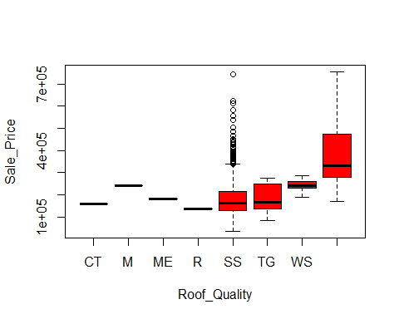

results<-aov (Sale_Price~Roof_Quality , data = Pr)  
summary(results)

## Df Sum Sq Mean Sq F value Pr(>F)   
## Roof_Quality 7 2.892e+11 4.131e+10 6.722 7.36e-08 ***  
## Residuals 1451 8.918e+12 6.146e+09   
## ---  
## Signif. codes: 0 '***' 0.001 '**' 0.01 '*' 0.05 '.' 0.1 ' ' 1

TukeyHSD(results)

## Tukey multiple comparisons of means  
## 95% family-wise confidence level  
##   
## Fit: aov(formula = Sale_Price ~ Roof_Quality, data = Pr)  
##   
## $Roof_Quality  
## diff lwr upr p adj  
## M-CT 81500.0000 -255020.362 418020.36 0.9959284  
## ME-CT 20000.0000 -316520.362 356520.36 0.9999997  
## R-CT -23000.0000 -359520.362 313520.36 0.9999992  
## SS-CT 19826.2219 -218212.621 257865.06 0.9999967  
## TG-CT 25406.3636 -223130.395 273943.12 0.9999866  
## WS-CT 81400.0000 -179267.552 342067.55 0.9812053  
## WSh-CT 230250.0000 -26771.672 487271.67 0.1175824  
## ME-M -61500.0000 -398020.362 275020.36 0.9993305  
## R-M -104500.0000 -441020.362 232020.36 0.9818028  
## SS-M -61673.7781 -299712.621 176365.06 0.9938195  
## TG-M -56093.6364 -304630.395 192443.12 0.9973863  
## WS-M -100.0000 -260767.552 260567.55 1.0000000  
## WSh-M 148750.0000 -108271.672 405771.67 0.6496519  
## R-ME -43000.0000 -379520.362 293520.36 0.9999387  
## SS-ME -173.7781 -238212.621 237865.06 1.0000000  
## TG-ME 5406.3636 -243130.395 253943.12 1.0000000  
## WS-ME 61400.0000 -199267.552 322067.55 0.9965781  
## WSh-ME 210250.0000 -46771.672 467271.67 0.2034553  
## SS-R 42826.2219 -195212.621 280865.06 0.9993960  
## TG-R 48406.3636 -200130.395 296943.12 0.9989855  
## WS-R 104400.0000 -156267.552 365067.55 0.9274351  
## WSh-R 253250.0000 -3771.672 510271.67 0.0568589  
## TG-SS 5580.1417 -66441.084 77601.37 0.9999980  
## WS-SS 61573.7781 -45028.797 168176.35 0.6519912  
## WSh-SS 210423.7781 113075.555 307772.00 0.0000000  
## WS-TG 55993.6364 -72350.194 184337.47 0.8897460  
## WSh-TG 204843.6364 84076.479 325610.79 0.0000082  
## WSh-WS 148850.0000 4760.589 292939.41 0.0370846

##Exterior1st  
plot(Sale_Price~Exterior1st, data = Pr, col = "red")

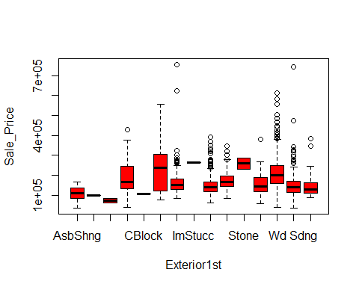

results<-aov (Sale_Price~Exterior1st , data = Pr)  
summary(results)

## Df Sum Sq Mean Sq F value Pr(>F)   
## Exterior1st 14 1.406e+12 1.004e+11 18.59 <2e-16 ***  
## Residuals 1444 7.801e+12 5.402e+09   
## ---  
## Signif. codes: 0 '***' 0.001 '**' 0.01 '*' 0.05 '.' 0.1 ' ' 1

TukeyHSD(results)

## Tukey multiple comparisons of means  
## 95% family-wise confidence level  
##   
## Fit: aov(formula = Sale_Price ~ Exterior1st, data = Pr)  
##   
## $Exterior1st  
## diff lwr upr p adj  
## AsphShn-AsbShng -7385.5500 -263246.717 248475.617 1.0000000  
## BrkComm-AsbShng -36385.5500 -221564.267 148793.167 0.9999974  
## BrkFace-AsbShng 87187.4500 21124.381 153250.519 0.0007644  
## CBlock-AsbShng -2385.5500 -258246.717 253475.617 1.0000000  
## CemntBd-AsbShng 124305.1057 59966.400 188643.811 0.0000000  
## HdBoard-AsbShng 55762.3867 -2542.790 114067.563 0.0783530  
## ImStucc-AsbShng 154614.4500 -101246.717 410475.617 0.7658617  
## MetalSd-AsbShng 42036.6273 -16279.545 100352.799 0.4785892  
## Plywood-AsbShng 68556.8296 7773.031 129340.628 0.0112151  
## Stone-AsbShng 151114.4500 -34064.267 336293.167 0.2631253  
## Stucco-AsbShng 55604.4500 -19304.029 130512.929 0.4252696  
## VinylSd-AsbShng 106347.3510 49440.048 163254.654 0.0000000  
## Wd Sdng-AsbShng 42456.0956 -16024.978 100937.169 0.4656560  
## WdShing-AsbShng 43269.5269 -30995.949 117535.003 0.8105427  
## BrkComm-AsphShn -29000.0000 -334812.586 276812.586 1.0000000  
## BrkFace-AsphShn 94573.0000 -157606.519 346752.519 0.9949731  
## CBlock-AsphShn 5000.0000 -348121.958 358121.958 1.0000000  
## CemntBd-AsphShn 131690.6557 -120042.635 383423.947 0.9071133  
## HdBoard-AsphShn 63147.9367 -187111.278 313407.151 0.9999414  
## ImStucc-AsphShn 162000.0000 -191121.958 515121.958 0.9669405  
## MetalSd-AsphShn 49422.1773 -200839.599 299683.953 0.9999973  
## Plywood-AsphShn 75942.3796 -174905.883 326790.642 0.9994998  
## Stone-AsphShn 158500.0000 -147312.586 464312.586 0.9131745  
## Stucco-AsphShn 62990.0000 -191649.865 317629.865 0.9999540  
## VinylSd-AsphShn 113732.9010 -136204.335 363670.137 0.9691599  
## Wd Sdng-AsphShn 49841.6456 -200458.607 300141.899 0.9999970  
## WdShing-AsphShn 50655.0769 -203796.376 305106.529 0.9999970  
## BrkFace-BrkComm 123573.0000 -56484.575 303630.575 0.5669206  
## CBlock-BrkComm 34000.0000 -271812.586 339812.586 1.0000000  
## CemntBd-BrkComm 160690.6557 -18741.422 340122.733 0.1386441  
## HdBoard-BrkComm 92147.9367 -85210.161 269506.035 0.9116149  
## ImStucc-BrkComm 191000.0000 -114812.586 496812.586 0.7202372  
## MetalSd-BrkComm 78422.1773 -98939.536 255783.890 0.9759817  
## Plywood-BrkComm 104942.3796 -73245.924 283130.683 0.7980045  
## Stone-BrkComm 187500.0000 -62194.931 437194.931 0.4044456  
## Stucco-BrkComm 91990.0000 -91497.552 275477.552 0.9322800  
## VinylSd-BrkComm 142732.9010 -34170.583 319636.385 0.2811031  
## Wd Sdng-BrkComm 78841.6456 -98574.355 256257.647 0.9748941  
## WdShing-BrkComm 79655.0769 -103570.910 262881.064 0.9793422  
## CBlock-BrkFace -89573.0000 -341752.519 162606.519 0.9971267  
## CemntBd-BrkFace 37117.6557 -10516.810 84752.121 0.3391940  
## HdBoard-BrkFace -31425.0633 -70528.347 7678.221 0.2875151  
## ImStucc-BrkFace 67427.0000 -184752.519 319606.519 0.9998824  
## MetalSd-BrkFace -45150.8227 -84270.500 -6031.145 0.0079985  
## Plywood-BrkFace -18630.6204 -61341.783 24080.542 0.9787107  
## Stone-BrkFace 63927.0000 -116130.575 243984.575 0.9971401  
## Stucco-BrkFace -31583.0000 -92745.517 29579.517 0.9154936  
## VinylSd-BrkFace 19159.9010 -17826.778 56146.580 0.9135040  
## Wd Sdng-BrkFace -44731.3544 -84096.431 -5366.278 0.0100728  
## WdShing-BrkFace -43917.9231 -104291.214 16455.367 0.4620000  
## CemntBd-CBlock 126690.6557 -125042.635 378423.947 0.9302651  
## HdBoard-CBlock 58147.9367 -192111.278 308407.151 0.9999787  
## ImStucc-CBlock 157000.0000 -196121.958 510121.958 0.9747862  
## MetalSd-CBlock 44422.1773 -205839.599 294683.953 0.9999993  
## Plywood-CBlock 70942.3796 -179905.883 321790.642 0.9997719  
## Stone-CBlock 153500.0000 -152312.586 459312.586 0.9316590  
## Stucco-CBlock 57990.0000 -196649.865 312629.865 0.9999834  
## VinylSd-CBlock 108732.9010 -141204.335 358670.137 0.9792123  
## Wd Sdng-CBlock 44841.6456 -205458.607 295141.899 0.9999992  
## WdShing-CBlock 45655.0769 -208796.376 300106.529 0.9999992  
## HdBoard-CemntBd -68542.7191 -104656.522 -32428.916 0.0000000  
## ImStucc-CemntBd 30309.3443 -221423.947 282042.635 1.0000000  
## MetalSd-CemntBd -82268.4785 -118400.031 -46136.926 0.0000000  
## Plywood-CemntBd -55748.2761 -95740.567 -15755.985 0.0002379  
## Stone-CemntBd 26809.3443 -152622.733 206241.422 0.9999999  
## Stucco-CemntBd -68700.6557 -127996.469 -9404.842 0.0075475  
## VinylSd-CemntBd -17957.7548 -51768.320 15852.811 0.8965175  
## Wd Sdng-CemntBd -81849.0101 -118246.114 -45451.906 0.0000000  
## WdShing-CemntBd -81035.5788 -139516.979 -22554.179 0.0002720  
## ImStucc-HdBoard 98852.0633 -151407.151 349111.278 0.9915838  
## MetalSd-HdBoard -13725.7594 -37506.290 10054.771 0.8210400  
## Plywood-HdBoard 12794.4430 -16521.216 42110.102 0.9786070  
## Stone-HdBoard 95352.0633 -82006.035 272710.161 0.8873567  
## Stucco-HdBoard -157.9367 -52845.867 52529.994 1.0000000  
## VinylSd-HdBoard 50584.9643 30505.650 70664.279 0.0000000  
## Wd Sdng-HdBoard -13306.2910 -37488.386 10875.804 0.8681346  
## WdShing-HdBoard -12492.8597 -64262.529 39276.810 0.9999660  
## MetalSd-ImStucc -112577.8227 -362839.599 137683.953 0.9720737  
## Plywood-ImStucc -86057.6204 -336905.883 164790.642 0.9980107  
## Stone-ImStucc -3500.0000 -309312.586 302312.586 1.0000000  
## Stucco-ImStucc -99010.0000 -353649.865 155629.865 0.9927880  
## VinylSd-ImStucc -48267.0990 -298204.335 201670.137 0.9999980  
## Wd Sdng-ImStucc -112158.3544 -362458.607 138141.899 0.9730017  
## WdShing-ImStucc -111344.9231 -365796.376 143106.529 0.9780979  
## Plywood-MetalSd 26520.2024 -2817.320 55857.724 0.1286346  
## Stone-MetalSd 109077.8227 -68283.890 286439.536 0.7421699  
## Stucco-MetalSd 13567.8227 -39132.275 66267.921 0.9999252  
## VinylSd-MetalSd 64310.7237 44199.503 84421.945 0.0000000  
## Wd Sdng-MetalSd 419.4684 -23789.126 24628.063 1.0000000  
## WdShing-MetalSd 1232.8997 -50549.153 53014.953 1.0000000  
## Stone-Plywood 82557.6204 -95630.683 260745.924 0.9640625  
## Stucco-Plywood -12952.3796 -68370.739 42465.980 0.9999771  
## VinylSd-Plywood 37790.5213 11364.106 64216.937 0.0001317  
## Wd Sdng-Plywood -26100.7340 -55764.690 3563.222 0.1588374  
## WdShing-Plywood -25287.3027 -79833.386 29258.781 0.9638805  
## Stucco-Stone -95510.0000 -278997.552 87977.552 0.9104124  
## VinylSd-Stone -44767.0990 -221670.583 132136.385 0.9999393  
## Wd Sdng-Stone -108658.3544 -286074.355 68757.647 0.7479030  
## WdShing-Stone -107844.9231 -291070.910 75381.064 0.7987133  
## VinylSd-Stucco 50742.9010 -393.833 101879.635 0.0542551  
## Wd Sdng-Stucco -13148.3544 -66030.869 39734.161 0.9999510  
## WdShing-Stucco -12334.9231 -82276.937 57607.091 0.9999994  
## Wd Sdng-VinylSd -63891.2553 -84475.746 -43306.764 0.0000000  
## WdShing-VinylSd -63077.8240 -113267.925 -12887.723 0.0019492  
## WdShing-Wd Sdng 813.4313 -51154.261 52781.124 1.0000000

##Exterior2nd  
plot(Sale_Price~Exterior2nd, data = Pr, col = "red")

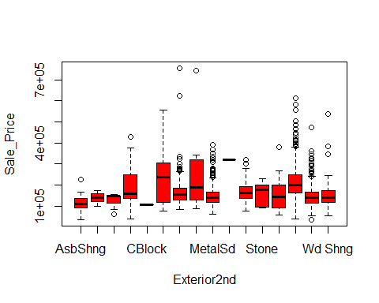

results<-aov (Sale_Price~Exterior2nd , data = Pr)  
summary(results)

## Df Sum Sq Mean Sq F value Pr(>F)   
## Exterior2nd 15 1.416e+12 9.438e+10 17.48 <2e-16 ***  
## Residuals 1443 7.791e+12 5.399e+09   
## ---  
## Signif. codes: 0 '***' 0.001 '**' 0.01 '*' 0.05 '.' 0.1 ' ' 1

TukeyHSD(results)

## Tukey multiple comparisons of means  
## 95% family-wise confidence level  
##   
## Fit: aov(formula = Sale_Price ~ Exterior2nd, data = Pr)  
##   
## $Exterior2nd  
## diff lwr upr p adj  
## AsphShn-AsbShng 23939.4500 -132203.116 180082.016 1.0000000  
## Brk Cmn-AsbShng 12653.7357 -98098.087 123405.559 1.0000000  
## BrkFace-AsbShng 81757.4500 6099.552 157415.348 0.0197398  
## CBlock-AsbShng -9060.5500 -267481.470 249360.370 1.0000000  
## CmentBd-AsbShng 116033.2833 50917.332 181149.235 0.0000001  
## HdBoard-AsbShng 53698.8869 -5367.259 112765.032 0.1245887  
## ImStucc-AsbShng 138009.4500 40335.523 235683.377 0.0001564  
## MetalSd-AsbShng 35742.6229 -23225.739 94710.985 0.7776517  
## Other-AsbShng 204939.4500 -53481.470 463360.370 0.3173430  
## Plywood-AsbShng 54051.8373 -6180.727 114284.402 0.1386397  
## Stone-AsbShng 44164.2500 -81932.247 170260.747 0.9982734  
## Stucco-AsbShng 41844.6038 -33163.859 116853.066 0.8691782  
## VinylSd-AsbShng 100371.9103 42871.837 157871.983 0.0000003  
## Wd Sdng-AsbShng 34325.5160 -24859.910 93510.942 0.8305198  
## Wd Shng-AsbShng 47268.3974 -22400.706 116937.500 0.6022416  
## Brk Cmn-AsphShn -11285.7143 -185315.414 162743.986 1.0000000  
## BrkFace-AsphShn 57818.0000 -96274.465 211910.465 0.9963079  
## CBlock-AsphShn -33000.0000 -324207.387 258207.387 1.0000000  
## CmentBd-AsphShn 92093.8333 -57105.554 241293.221 0.7530950  
## HdBoard-AsphShn 29759.4369 -116900.645 176419.519 0.9999983  
## ImStucc-AsphShn 114070.0000 -51943.753 280083.753 0.5796974  
## MetalSd-AsphShn 11803.1729 -134817.555 158423.901 1.0000000  
## Other-AsphShn 181000.0000 -110207.387 472207.387 0.7433100  
## Plywood-AsphShn 30112.3873 -117021.334 177246.109 0.9999981  
## Stone-AsphShn 20224.8000 -163950.923 204400.523 1.0000000  
## Stucco-AsphShn 17905.1538 -135869.485 171679.793 1.0000000  
## VinylSd-AsphShn 76432.4603 -69603.934 222468.855 0.9177642  
## Wd Sdng-AsphShn 10386.0660 -136322.096 157094.228 1.0000000  
## Wd Shng-AsphShn 23328.9474 -127913.091 174570.986 1.0000000  
## BrkFace-Brk Cmn 69103.7143 -38738.546 176945.975 0.6977177  
## CBlock-Brk Cmn -21714.2857 -291319.938 247891.366 1.0000000  
## CmentBd-Brk Cmn 103379.5476 2652.576 204106.519 0.0373468  
## HdBoard-Brk Cmn 41045.1512 -55880.826 137971.129 0.9871555  
## ImStucc-Brk Cmn 125355.7143 1073.650 249637.779 0.0454951  
## MetalSd-Brk Cmn 23088.8872 -73777.533 119955.307 0.9999850  
## Other-Brk Cmn 192285.7143 -77319.938 461891.366 0.5114159  
## Plywood-Brk Cmn 41398.1016 -56243.065 139039.268 0.9870023  
## Stone-Brk Cmn 31510.5143 -116158.583 179179.611 0.9999966  
## Stucco-Brk Cmn 29190.8681 -78196.771 136578.507 0.9999179  
## VinylSd-Brk Cmn 87718.1746 -8261.480 183697.829 0.1191820  
## Wd Sdng-Brk Cmn 21671.7803 -75326.932 118670.493 0.9999937  
## Wd Shng-Brk Cmn 34614.6617 -69113.924 138343.248 0.9990068  
## CBlock-BrkFace -90818.0000 -348005.400 166369.400 0.9981069  
## CmentBd-BrkFace 34275.8333 -25758.107 94309.774 0.8470001  
## HdBoard-BrkFace -28058.5631 -81470.139 25353.013 0.9154019  
## ImStucc-BrkFace 56252.0000 -38109.978 150613.978 0.7987148  
## MetalSd-BrkFace -46014.8271 -99318.248 7288.593 0.1862454  
## Other-BrkFace 123182.0000 -134005.400 380369.400 0.9600331  
## Plywood-BrkFace -27705.6127 -82404.322 26993.097 0.9363677  
## Stone-BrkFace -37593.2000 -161142.031 85955.631 0.9996677  
## Stucco-BrkFace -39912.8462 -110554.593 30728.900 0.8573229  
## VinylSd-BrkFace 18614.4603 -33059.956 70288.877 0.9976360  
## Wd Sdng-BrkFace -47431.9340 -100975.389 6111.521 0.1535697  
## Wd Shng-BrkFace -34489.0526 -99433.420 30455.315 0.9081930  
## CmentBd-CBlock 125093.8333 -129192.085 379379.752 0.9498708  
## HdBoard-CBlock 62759.4369 -190044.936 315563.809 0.9999744  
## ImStucc-CBlock 147070.0000 -117432.244 411572.244 0.8721339  
## MetalSd-CBlock 44803.1729 -207978.371 297584.717 0.9999997  
## Other-CBlock 214000.0000 -142654.753 570654.753 0.7906432  
## Plywood-CBlock 63112.3873 -189967.053 316191.828 0.9999729  
## Stone-CBlock 53224.8000 -223038.784 329488.384 0.9999992  
## Stucco-CBlock 50905.1538 -206091.949 307902.256 0.9999988  
## VinylSd-CBlock 109432.4603 -143010.602 361875.523 0.9838863  
## Wd Sdng-CBlock 43386.0660 -209446.202 296218.334 0.9999998  
## Wd Shng-CBlock 56328.9474 -199160.828 311818.722 0.9999947  
## HdBoard-CmentBd -62334.3964 -99331.234 -25337.559 0.0000011  
## ImStucc-CmentBd 21976.1667 -64164.140 108116.473 0.9999636  
## MetalSd-CmentBd -80290.6604 -117131.184 -43450.137 0.0000000  
## Other-CmentBd 88906.1667 -165379.752 343192.085 0.9983070  
## Plywood-CmentBd -61981.4460 -100813.370 -23149.522 0.0000060  
## Stone-CmentBd -71869.0333 -189258.484 45520.417 0.7643347  
## Stucco-CmentBd -74188.6795 -133402.072 -14975.287 0.0019400  
## VinylSd-CmentBd -15661.3730 -50102.843 18780.097 0.9747891  
## Wd Sdng-CmentBd -81707.7673 -118894.742 -44520.793 0.0000000  
## Wd Shng-CmentBd -68764.8860 -121050.069 -16479.703 0.0007574  
## ImStucc-HdBoard 84310.5631 2647.384 165973.742 0.0348545  
## MetalSd-HdBoard -17956.2640 -42572.246 6659.718 0.4694239  
## Other-HdBoard 151240.5631 -101563.809 404044.936 0.7943324  
## Plywood-HdBoard 352.9504 -27154.153 27860.054 1.0000000  
## Stone-HdBoard -9534.6369 -123679.306 104610.032 1.0000000  
## Stucco-HdBoard -11854.2830 -64341.884 40633.318 0.9999927  
## VinylSd-HdBoard 46673.0234 25817.874 67528.173 0.0000000  
## Wd Sdng-HdBoard -19373.3709 -44504.895 5758.153 0.3674253  
## Wd Shng-HdBoard -6430.4895 -50955.346 38094.366 1.0000000  
## MetalSd-ImStucc -102266.8271 -183859.309 -20674.346 0.0019264  
## Other-ImStucc 66930.0000 -197572.244 331432.244 0.9999672  
## Plywood-ImStucc -83957.6127 -166468.383 -1446.843 0.0412249  
## Stone-ImStucc -93845.2000 -231976.992 44286.592 0.5998508  
## Stucco-ImStucc -96164.8462 -190006.920 -2322.773 0.0380199  
## VinylSd-ImStucc -37637.5397 -118175.256 42900.176 0.9677574  
## Wd Sdng-ImStucc -103683.9340 -185433.429 -21934.439 0.0015447  
## Wd Shng-ImStucc -90741.0526 -180372.795 -1109.310 0.0436568  
## Other-MetalSd 169196.8271 -83584.717 421978.371 0.6258863  
## Plywood-MetalSd 18309.2144 -8987.285 45605.714 0.6222418  
## Stone-MetalSd 8421.6271 -105672.473 122515.727 1.0000000  
## Stucco-MetalSd 6101.9809 -46275.557 58479.519 1.0000000  
## VinylSd-MetalSd 64629.2874 44052.712 85205.862 0.0000000  
## Wd Sdng-MetalSd -1417.1069 -26317.943 23483.729 1.0000000  
## Wd Shng-MetalSd 11525.7745 -32869.281 55920.830 0.9999544  
## Plywood-Other -150887.6127 -403967.053 102191.828 0.7985574  
## Stone-Other -160775.2000 -437038.784 115488.384 0.8267462  
## Stucco-Other -163094.8462 -420091.949 93902.256 0.7126321  
## VinylSd-Other -104567.5397 -357010.602 147875.523 0.9896759  
## Wd Sdng-Other -170613.9340 -423446.202 82218.334 0.6117446  
## Wd Shng-Other -157671.0526 -413160.828 97818.722 0.7533680  
## Stone-Plywood -9887.5873 -124640.181 104865.007 1.0000000  
## Stucco-Plywood -12207.2335 -66004.079 41589.612 0.9999922  
## VinylSd-Plywood 46320.0730 22359.906 70280.240 0.0000000  
## Wd Sdng-Plywood -19726.3213 -47488.630 8035.988 0.5183706  
## Wd Shng-Plywood -6783.4400 -52844.433 39277.554 1.0000000  
## Stucco-Stone -2319.6462 -125471.850 120832.558 1.0000000  
## VinylSd-Stone 56207.6603 -57134.540 169549.861 0.9464190  
## Wd Sdng-Stone -9838.7340 -124045.172 104367.704 1.0000000  
## Wd Shng-Stone 3104.1474 -116870.766 123079.061 1.0000000  
## VinylSd-Stucco 58527.3065 7808.502 109246.111 0.0077524  
## Wd Sdng-Stucco -7519.0879 -60140.883 45102.708 1.0000000  
## Wd Shng-Stucco 5423.7935 -58762.830 69610.417 1.0000000  
## Wd Sdng-VinylSd -66046.3943 -87237.013 -44855.775 0.0000000  
## Wd Shng-VinylSd -53103.5129 -95528.879 -10678.147 0.0019748  
## Wd Shng-Wd Sdng 12942.8814 -31740.089 57625.852 0.9998181

##Brick_Veneer_Type  
plot(Sale_Price~Brick_Veneer_Type, data = Pr, col = "red")

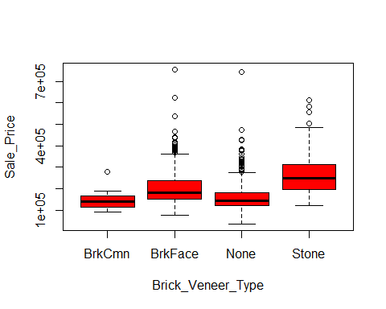

results<-aov (Sale_Price~Brick_Veneer_Type , data = Pr)  
summary(results)

## Df Sum Sq Mean Sq F value Pr(>F)   
## Brick_Veneer_Type 3 1.713e+12 5.709e+11 111.5 <2e-16 ***  
## Residuals 1447 7.407e+12 5.119e+09   
## ---  
## Signif. codes: 0 '***' 0.001 '**' 0.01 '*' 0.05 '.' 0.1 ' ' 1  
## 8 observations deleted due to missingness

TukeyHSD(results)

## Tukey multiple comparisons of means  
## 95% family-wise confidence level  
##   
## Fit: aov(formula = Sale_Price ~ Brick_Veneer_Type, data = Pr)  
##   
## $Brick_Veneer_Type  
## diff lwr upr p adj  
## BrkFace-BrkCmn 58373.805 10065.12 106682.49 0.0103550  
## None-BrkCmn 9913.931 -38011.74 57839.60 0.9512785  
## Stone-BrkCmn 119265.558 69044.10 169487.02 0.0000000  
## None-BrkFace -48459.874 -59199.53 -37720.22 0.0000000  
## Stone-BrkFace 60891.753 42434.62 79348.89 0.0000000  
## Stone-None 109351.627 91921.59 126781.67 0.0000000

##Exterior_Material  
plot(Sale_Price~Exterior_Material, data = Pr, col = "red")

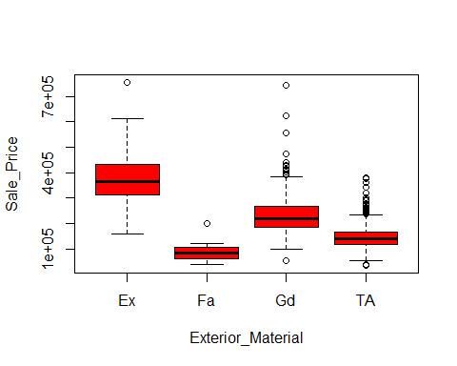

results<-aov (Sale_Price~Exterior_Material , data = Pr)  
summary(results)

## Df Sum Sq Mean Sq F value Pr(>F)   
## Exterior_Material 3 4.402e+12 1.467e+12 444.3 <2e-16 ***  
## Residuals 1455 4.805e+12 3.302e+09   
## ---  
## Signif. codes: 0 '***' 0.001 '**' 0.01 '*' 0.05 '.' 0.1 ' ' 1

TukeyHSD(results)

## Tukey multiple comparisons of means  
## 95% family-wise confidence level  
##   
## Fit: aov(formula = Sale_Price ~ Exterior_Material, data = Pr)  
##   
## $Exterior_Material  
## diff lwr upr p adj  
## Fa-Ex -279375.75 -323879.46 -234872.03 0.0000000  
## Gd-Ex -135554.69 -157118.14 -113991.24 0.0000000  
## TA-Ex -223019.65 -244096.56 -201942.74 0.0000000  
## Gd-Fa 143821.05 103754.65 183887.46 0.0000000  
## TA-Fa 56356.10 16549.44 96162.76 0.0015979  
## TA-Gd -87464.96 -95769.90 -79160.01 0.0000000

##Exterior_Condition  
plot(Sale_Price~Exterior_Condition, data = Pr, col = "red")

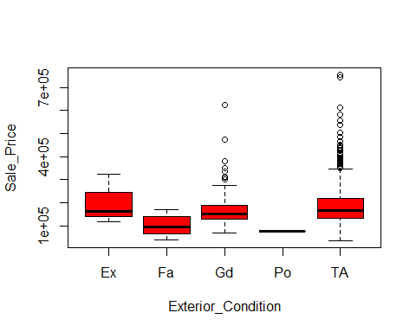

results<-aov (Sale_Price~Exterior_Condition , data = Pr)  
summary(results)

## Df Sum Sq Mean Sq F value Pr(>F)   
## Exterior_Condition 4 2.177e+11 5.442e+10 8.803 5.07e-07 ***  
## Residuals 1454 8.989e+12 6.182e+09   
## ---  
## Signif. codes: 0 '***' 0.001 '**' 0.01 '*' 0.05 '.' 0.1 ' ' 1

TukeyHSD(results)

## Tukey multiple comparisons of means  
## 95% family-wise confidence level  
##   
## Fit: aov(formula = Sale_Price ~ Exterior_Condition, data = Pr)  
##   
## $Exterior_Condition  
## diff lwr upr p adj  
## Fa-Ex -98738.19 -229196.317 31719.94 0.2350060  
## Gd-Ex -32435.76 -157688.153 92816.62 0.9548795  
## Po-Ex -124833.33 -372803.425 123136.76 0.6438937  
## TA-Ex -17269.92 -141400.059 106860.23 0.9955775  
## Gd-Fa 66302.43 21997.795 110607.06 0.0004419  
## Po-Fa -26095.14 -244644.694 192454.41 0.9975582  
## TA-Fa 81468.27 40443.502 122493.05 0.0000007  
## Po-Gd -92397.57 -307880.152 123085.02 0.7679291  
## TA-Gd 15165.85 -3592.342 33924.04 0.1771562  
## TA-Po 107563.42 -107268.787 322395.62 0.6486804

##Exterior_Material  
plot(Sale_Price~Exterior_Material, data = Pr, col = "red")



results<-aov (Sale_Price~Exterior_Material , data = Pr)  
summary(results)

## Df Sum Sq Mean Sq F value Pr(>F)   
## Exterior_Material 3 4.402e+12 1.467e+12 444.3 <2e-16 ***  
## Residuals 1455 4.805e+12 3.302e+09   
## ---  
## Signif. codes: 0 '***' 0.001 '**' 0.01 '*' 0.05 '.' 0.1 ' ' 1

TukeyHSD(results)

## Tukey multiple comparisons of means  
## 95% family-wise confidence level  
##   
## Fit: aov(formula = Sale_Price ~ Exterior_Material, data = Pr)  
##   
## $Exterior_Material  
## diff lwr upr p adj  
## Fa-Ex -279375.75 -323879.46 -234872.03 0.0000000  
## Gd-Ex -135554.69 -157118.14 -113991.24 0.0000000  
## TA-Ex -223019.65 -244096.56 -201942.74 0.0000000  
## Gd-Fa 143821.05 103754.65 183887.46 0.0000000  
## TA-Fa 56356.10 16549.44 96162.76 0.0015979  
## TA-Gd -87464.96 -95769.90 -79160.01 0.0000000

##Foundation_Type  
plot(Sale_Price~Foundation_Type, data = Pr, col = "red")

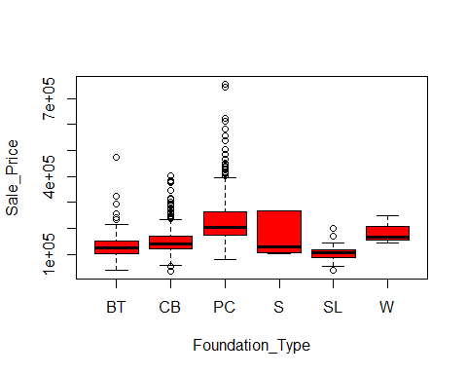

results<-aov (Sale_Price~Foundation_Type , data = Pr)  
summary(results)

## Df Sum Sq Mean Sq F value Pr(>F)   
## Foundation_Type 5 2.360e+12 4.719e+11 100.1 <2e-16 ***  
## Residuals 1453 6.847e+12 4.713e+09   
## ---  
## Signif. codes: 0 '***' 0.001 '**' 0.01 '*' 0.05 '.' 0.1 ' ' 1

TukeyHSD(results)

## Tukey multiple comparisons of means  
## 95% family-wise confidence level  
##   
## Fit: aov(formula = Sale_Price ~ Foundation_Type, data = Pr)  
##   
## $Foundation_Type  
## diff lwr upr p adj  
## CB-BT 17518.28 -466.1957 35502.759 0.0613270  
## PC-BT 92939.37 74991.3939 110887.339 0.0000000  
## S-BT 33668.09 -47929.4584 115265.641 0.8477192  
## SL-BT -24925.45 -68072.3693 18221.469 0.5663703  
## W-BT 53375.59 -60876.3152 167627.498 0.7665665  
## PC-CB 75421.09 64469.9693 86372.201 0.0000000  
## S-CB 16149.81 -64199.1626 96498.782 0.9927315  
## SL-CB -42443.73 -83180.1263 -1707.338 0.0354351  
## W-CB 35857.31 -77506.2443 149220.864 0.9459035  
## S-PC -59271.28 -139612.0846 21069.534 0.2850458  
## SL-PC -117864.82 -158585.1083 -77144.526 0.0000000  
## W-PC -39563.78 -152921.5438 73793.993 0.9193330  
## SL-S -58593.54 -148003.6782 30816.595 0.4211884  
## W-S 19707.50 -118806.0880 158221.088 0.9985867  
## W-SL 78301.04 -41655.2443 198257.328 0.4258452

##Basement_Height  
plot(Sale_Price~Basement_Height, data = Pr, col = "red")

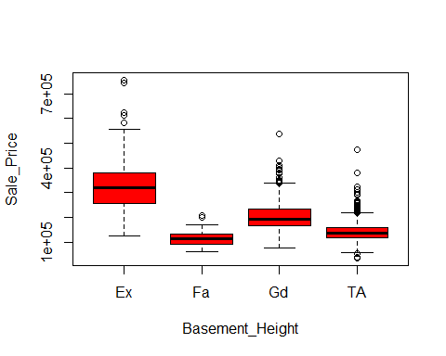

results<-aov (Sale_Price~Basement_Height , data = Pr)  
summary(results)

## Df Sum Sq Mean Sq F value Pr(>F)   
## Basement_Height 3 4.065e+12 1.355e+12 392.5 <2e-16 ***  
## Residuals 1418 4.895e+12 3.452e+09   
## ---  
## Signif. codes: 0 '***' 0.001 '**' 0.01 '*' 0.05 '.' 0.1 ' ' 1  
## 37 observations deleted due to missingness

TukeyHSD(results)

## Tukey multiple comparisons of means  
## 95% family-wise confidence level  
##   
## Fit: aov(formula = Sale_Price ~ Basement_Height, data = Pr)  
##   
## $Basement_Height  
## diff lwr upr p adj  
## Fa-Ex -211349.01 -240354.180 -182343.85 0.0000000  
## Gd-Ex -124352.56 -139376.199 -109328.93 0.0000000  
## TA-Ex -186291.62 -201258.211 -171325.04 0.0000000  
## Gd-Fa 86996.45 60738.059 113254.84 0.0000000  
## TA-Fa 25057.39 -1168.403 51283.18 0.0672033  
## TA-Gd -61939.06 -70436.244 -53441.88 0.0000000

##Basement_Condition  
plot(Sale_Price~Basement_Condition, data = Pr, col = "red")

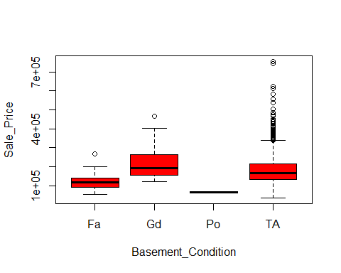

results<-aov (Sale_Price~Basement_Condition , data = Pr)  
summary(results)

## Df Sum Sq Mean Sq F value Pr(>F)   
## Basement_Condition 3 2.582e+11 8.608e+10 14.03 5.17e-09 ***  
## Residuals 1418 8.702e+12 6.137e+09   
## ---  
## Signif. codes: 0 '***' 0.001 '**' 0.01 '*' 0.05 '.' 0.1 ' ' 1  
## 37 observations deleted due to missingness

TukeyHSD(results)

## Tukey multiple comparisons of means  
## 95% family-wise confidence level  
##   
## Fit: aov(formula = Sale_Price ~ Basement_Condition, data = Pr)  
##   
## $Basement_Condition  
## diff lwr upr p adj  
## Gd-Fa 91790.37 52715.13 130865.622 0.0000000  
## Po-Fa -57809.53 -203421.14 87802.077 0.7370785  
## TA-Fa 61850.67 31301.73 92399.605 0.0000013  
## Po-Gd -149599.91 -294255.11 -4944.706 0.0394567  
## TA-Gd -29939.70 -55544.86 -4334.553 0.0142446  
## TA-Po 119660.20 -22928.33 262248.737 0.1355021

##Exposure_Level  
plot(Sale_Price~Exposure_Level, data = Pr, col = "red")

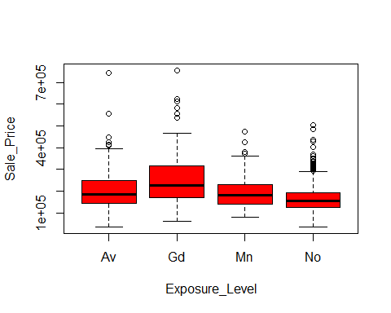

results<-aov (Sale_Price~Exposure_Level , data = Pr)  
summary(results)

## Df Sum Sq Mean Sq F value Pr(>F)   
## Exposure_Level 3 1.168e+12 3.893e+11 70.78 <2e-16 ***  
## Residuals 1417 7.793e+12 5.499e+09   
## ---  
## Signif. codes: 0 '***' 0.001 '**' 0.01 '*' 0.05 '.' 0.1 ' ' 1  
## 38 observations deleted due to missingness

TukeyHSD(results)

## Tukey multiple comparisons of means  
## 95% family-wise confidence level  
##   
## Fit: aov(formula = Sale_Price ~ Exposure_Level, data = Pr)  
##   
## $Exposure_Level  
## diff lwr upr p adj  
## Gd-Av 51046.39 30162.46 71930.310 0.0000000  
## Mn-Av -13853.76 -35848.58 8141.053 0.3675529  
## No-Av -40972.06 -55214.38 -26729.733 0.0000000  
## Mn-Gd -64900.15 -89203.57 -40596.722 0.0000000  
## No-Gd -92018.44 -109617.55 -74419.340 0.0000000  
## No-Mn -27118.29 -46022.32 -8214.274 0.0013305

##BsmtFinType1  
plot(Sale_Price~BsmtFinType1, data = Pr, col = "red")

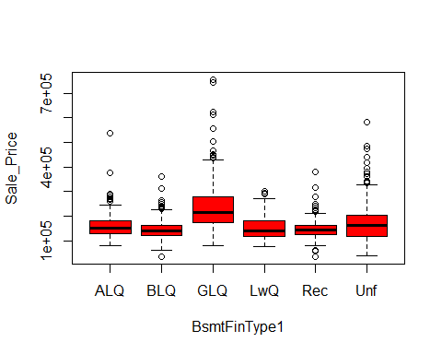

results<-aov (Sale_Price~BsmtFinType1 , data = Pr)  
summary(results)

## Df Sum Sq Mean Sq F value Pr(>F)   
## BsmtFinType1 5 1.725e+12 3.45e+11 67.51 <2e-16 ***  
## Residuals 1416 7.236e+12 5.11e+09   
## ---  
## Signif. codes: 0 '***' 0.001 '**' 0.01 '*' 0.05 '.' 0.1 ' ' 1  
## 37 observations deleted due to missingness

TukeyHSD(results)

## Tukey multiple comparisons of means  
## 95% family-wise confidence level  
##   
## Fit: aov(formula = Sale_Price ~ BsmtFinType1, data = Pr)  
##   
## $BsmtFinType1  
## diff lwr upr p adj  
## BLQ-ALQ -12065.850 -33796.586 9664.885 0.6090061  
## GLQ-ALQ 73840.652 56849.522 90831.782 0.0000000  
## LwQ-ALQ -9720.365 -37133.447 17692.716 0.9141033  
## Rec-ALQ -14683.820 -37089.678 7722.038 0.4211187  
## Unf-ALQ 9097.509 -7811.670 26006.687 0.6414013  
## GLQ-BLQ 85906.502 66345.603 105467.401 0.0000000  
## LwQ-BLQ 2345.485 -26730.404 31421.374 0.9999119  
## Rec-BLQ -2617.970 -27030.114 21794.174 0.9996423  
## Unf-BLQ 21163.359 1673.603 40653.115 0.0242442  
## LwQ-GLQ -83561.017 -109288.065 -57833.970 0.0000000  
## Rec-GLQ -88524.472 -108832.756 -68216.188 0.0000000  
## Unf-GLQ -64743.143 -78754.718 -50731.568 0.0000000  
## Rec-LwQ -4963.455 -34547.318 24620.409 0.9968888  
## Unf-LwQ 18817.874 -6855.123 44490.871 0.2921473  
## Unf-Rec 23781.329 3541.560 44021.097 0.0106167

##BsmtFinType2  
plot(Sale_Price~BsmtFinType2, data = Pr, col = "red")

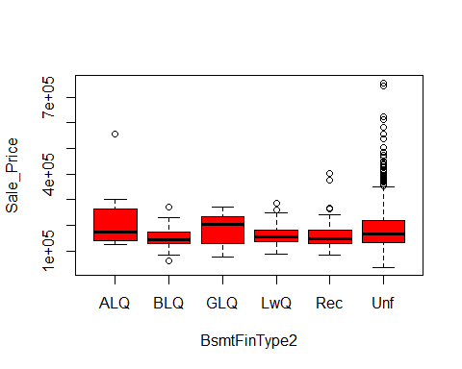

results<-aov (Sale_Price~BsmtFinType2 , data = Pr)  
summary(results)

## Df Sum Sq Mean Sq F value Pr(>F)   
## BsmtFinType2 5 8.366e+10 1.673e+10 2.67 0.0207 *  
## Residuals 1415 8.867e+12 6.266e+09   
## ---  
## Signif. codes: 0 '***' 0.001 '**' 0.01 '*' 0.05 '.' 0.1 ' ' 1  
## 38 observations deleted due to missingness

TukeyHSD(results)

## Tukey multiple comparisons of means  
## 95% family-wise confidence level  
##   
## Fit: aov(formula = Sale_Price ~ BsmtFinType2, data = Pr)  
##   
## $BsmtFinType2  
## diff lwr upr p adj  
## BLQ-ALQ -58841.1053 -123894.612 6212.401 0.1025490  
## GLQ-ALQ -28959.9624 -108524.393 50604.469 0.9048465  
## LwQ-ALQ -45203.2164 -107006.242 16599.810 0.2945241  
## Rec-ALQ -45024.9756 -105279.624 15229.673 0.2711308  
## Unf-ALQ -25247.4150 -77461.333 26966.503 0.7392412  
## GLQ-BLQ 29881.1429 -42168.321 101930.606 0.8448637  
## LwQ-BLQ 13637.8889 -38133.151 65408.928 0.9752522  
## Rec-BLQ 13816.1296 -36096.286 63728.545 0.9692767  
## Unf-BLQ 33593.6903 -6242.471 73429.851 0.1545807  
## LwQ-GLQ -16243.2540 -85371.978 52885.470 0.9851314  
## Rec-GLQ -16065.0132 -83812.996 51682.970 0.9845055  
## Unf-GLQ 3712.5474 -56995.440 64420.534 0.9999777  
## Rec-LwQ 178.2407 -45416.765 45773.246 1.0000000  
## Unf-LwQ 19955.8014 -14316.272 54227.875 0.5575903  
## Unf-Rec 19777.5607 -11616.447 51171.568 0.4674999

##Heating_Type  
plot(Sale_Price~Heating_Type, data = Pr, col = "red")

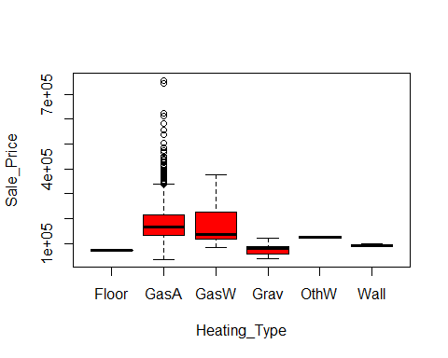

results<-aov (Sale_Price~Heating_Type , data = Pr)  
summary(results)

## Df Sum Sq Mean Sq F value Pr(>F)   
## Heating_Type 5 1.330e+11 2.660e+10 4.26 0.000753 ***  
## Residuals 1453 9.074e+12 6.245e+09   
## ---  
## Signif. codes: 0 '***' 0.001 '**' 0.01 '*' 0.05 '.' 0.1 ' ' 1

TukeyHSD(results)

## Tukey multiple comparisons of means  
## 95% family-wise confidence level  
##   
## Fit: aov(formula = Sale_Price ~ Heating_Type, data = Pr)  
##   
## $Heating_Type  
## diff lwr upr p adj  
## GasA-Floor 109545.387 -116031.38 335122.157 0.7357101  
## GasW-Floor 94132.167 -137544.77 325809.104 0.8559815  
## Grav-Floor 2771.429 -238295.83 243838.688 1.0000000  
## OthW-Floor 53250.000 -222927.24 329427.240 0.9940107  
## Wall-Floor 19600.000 -232514.17 271714.174 0.9999266  
## GasW-GasA -15413.220 -68897.72 38071.280 0.9634631  
## Grav-GasA -106773.958 -192212.89 -21335.023 0.0050193  
## OthW-GasA -56295.387 -215858.09 103267.317 0.9158040  
## Wall-GasA -89945.387 -202852.18 22961.411 0.2057167  
## Grav-GasW -91360.738 -191805.43 9083.953 0.0989578  
## OthW-GasW -40882.167 -208958.28 127193.949 0.9826336  
## Wall-GasW -74532.167 -199180.75 50116.417 0.5278078  
## OthW-Grav 50478.571 -130321.87 231279.016 0.9681192  
## Wall-Grav 16828.571 -124509.64 158166.780 0.9994039  
## Wall-OthW -33650.000 -228936.80 161636.800 0.9964702

##Heating_Quality  
plot(Sale_Price~Heating_Quality, data = Pr, col = "red")

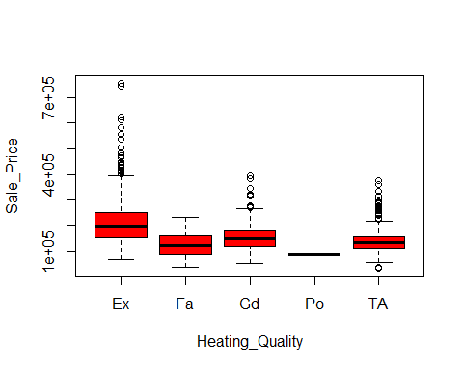

results<-aov (Sale_Price~Heating_Quality , data = Pr)  
summary(results)

## Df Sum Sq Mean Sq F value Pr(>F)   
## Heating_Quality 4 1.799e+12 4.498e+11 88.28 <2e-16 ***  
## Residuals 1454 7.408e+12 5.095e+09   
## ---  
## Signif. codes: 0 '***' 0.001 '**' 0.01 '*' 0.05 '.' 0.1 ' ' 1

TukeyHSD(results)

## Tukey multiple comparisons of means  
## 95% family-wise confidence level  
##   
## Fit: aov(formula = Sale_Price ~ Heating_Quality, data = Pr)  
##   
## $Heating_Quality  
## diff lwr upr p adj  
## Fa-Ex -90994.94 -119750.309 -62239.57 0.0000000  
## Gd-Ex -58016.56 -72495.354 -43537.77 0.0000000  
## Po-Ex -127914.43 -322991.129 67162.27 0.3792335  
## TA-Ex -72551.55 -84387.113 -60715.99 0.0000000  
## Gd-Fa 32978.38 2418.063 63538.69 0.0269439  
## Po-Fa -36919.49 -233843.882 160004.90 0.9861880  
## TA-Fa 18443.39 -10956.917 47843.69 0.4259645  
## Po-Gd -69897.87 -265248.782 125453.05 0.8655433  
## TA-Gd -14534.99 -30255.741 1185.76 0.0856407  
## TA-Po 55362.88 -139809.933 250535.68 0.9378942

##Air_Conditioning  
plot(Sale_Price~Air_Conditioning, data = Pr, col = "red")

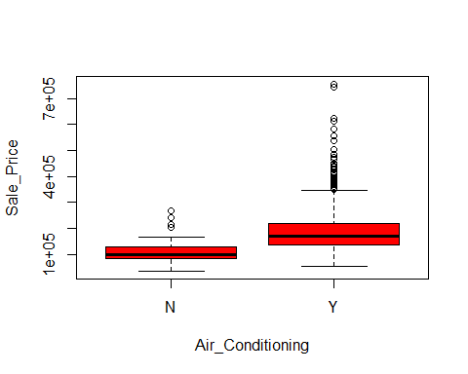

results<-aov (Sale_Price~Air_Conditioning , data = Pr)  
summary(results)

## Df Sum Sq Mean Sq F value Pr(>F)   
## Air_Conditioning 1 5.820e+11 5.82e+11 98.32 <2e-16 ***  
## Residuals 1457 8.625e+12 5.92e+09   
## ---  
## Signif. codes: 0 '***' 0.001 '**' 0.01 '*' 0.05 '.' 0.1 ' ' 1

TukeyHSD(results)

## Tukey multiple comparisons of means  
## 95% family-wise confidence level  
##   
## Fit: aov(formula = Sale_Price ~ Air_Conditioning, data = Pr)  
##   
## $Air_Conditioning  
## diff lwr upr p adj  
## Y-N 80951 64936.55 96965.45 0

##Electrical_System  
plot(Sale_Price~Electrical_System, data = Pr, col = "red")

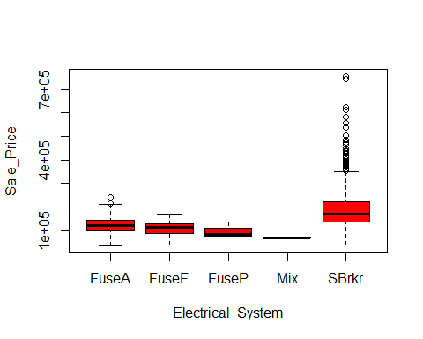

results<-aov (Sale_Price~Electrical_System , data = Pr)  
summary(results)

## Df Sum Sq Mean Sq F value Pr(>F)   
## Electrical_System 4 5.499e+11 1.375e+11 23.07 <2e-16 ***  
## Residuals 1453 8.657e+12 5.958e+09   
## ---  
## Signif. codes: 0 '***' 0.001 '**' 0.01 '*' 0.05 '.' 0.1 ' ' 1  
## 1 observation deleted due to missingness

TukeyHSD(results)

## Tukey multiple comparisons of means  
## 95% family-wise confidence level  
##   
## Fit: aov(formula = Sale_Price ~ Electrical_System, data = Pr)  
##   
## $Electrical_System  
## diff lwr upr p adj  
## FuseF-FuseA -14521.45 -60551.90 31509.00 0.9108055  
## FuseP-FuseA -24863.56 -148503.76 98776.64 0.9820446  
## Mix-FuseA -55196.89 -267128.76 156734.97 0.9539561  
## SBrkr-FuseA 64657.72 42160.37 87155.07 0.0000000  
## FuseP-FuseF -10342.11 -138639.11 117954.89 0.9994789  
## Mix-FuseF -40675.44 -255357.39 174006.50 0.9856297  
## SBrkr-FuseF 79179.17 38199.27 120159.07 0.0000015  
## Mix-FuseP -30333.33 -273759.77 213093.11 0.9971162  
## SBrkr-FuseP 89521.28 -32328.82 211371.39 0.2632436  
## SBrkr-Mix 119854.61 -91037.93 330747.16 0.5285518

##Kitchen_Quality  
plot(Sale_Price~Kitchen_Quality, data = Pr, col = "red")

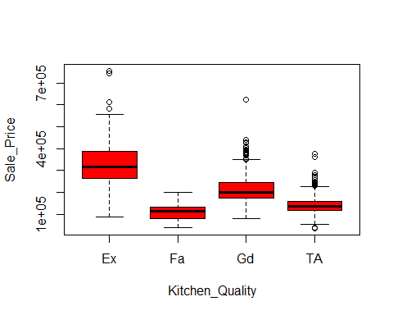

results<-aov (Sale_Price~Kitchen_Quality , data = Pr)  
summary(results)

## Df Sum Sq Mean Sq F value Pr(>F)   
## Kitchen_Quality 3 4.203e+12 1.401e+12 407.4 <2e-16 ***  
## Residuals 1455 5.004e+12 3.439e+09   
## ---  
## Signif. codes: 0 '***' 0.001 '**' 0.01 '*' 0.05 '.' 0.1 ' ' 1

TukeyHSD(results)

## Tukey multiple comparisons of means  
## 95% family-wise confidence level  
##   
## Fit: aov(formula = Sale_Price ~ Kitchen_Quality, data = Pr)  
##   
## $Kitchen_Quality  
## diff lwr upr p adj  
## Fa-Ex -222989.46 -251463.793 -194515.14 0.0000000  
## Gd-Ex -116438.65 -132757.575 -100119.72 0.0000000  
## TA-Ex -188602.43 -204679.738 -172525.12 0.0000000  
## Gd-Fa 106550.82 81608.473 131493.16 0.0000000  
## TA-Fa 34387.04 9602.101 59171.97 0.0020983  
## TA-Gd -72163.78 -80519.206 -63808.36 0.0000000

##Functional_Rate  
plot(Sale_Price~Functional_Rate, data = Pr, col = "red")

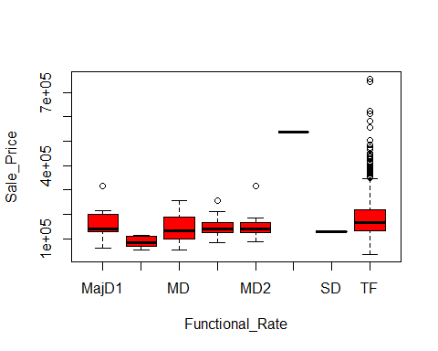

results<-aov (Sale_Price~Functional_Rate , data = Pr)  
summary(results)

## Df Sum Sq Mean Sq F value Pr(>F)   
## Functional_Rate 7 2.983e+11 4.261e+10 6.941 3.77e-08 ***  
## Residuals 1451 8.909e+12 6.140e+09   
## ---  
## Signif. codes: 0 '***' 0.001 '**' 0.01 '*' 0.05 '.' 0.1 ' ' 1

TukeyHSD(results)

## Tukey multiple comparisons of means  
## 95% family-wise confidence level  
##   
## Fit: aov(formula = Sale_Price ~ Functional_Rate, data = Pr)  
##   
## $Functional_Rate  
## diff lwr upr p adj  
## MajD2-MajD1 -68148.143 -192056.917 55760.63 0.7071883  
## MD-MajD1 -11955.286 -101848.158 77937.59 0.9999197  
## MD1-MajD1 -7562.659 -84146.240 69020.92 0.9999895  
## MD2-MajD1 -9707.496 -85232.615 65817.62 0.9999362  
## MS-MajD1 384051.857 137870.087 630233.63 0.0000654  
## SD-MajD1 -24948.143 -271129.913 221233.63 0.9999874  
## TF-MajD1 29507.442 -34382.986 93397.87 0.8566346  
## MD-MajD2 56192.857 -67715.917 180101.63 0.8680005  
## MD1-MajD2 60585.484 -54034.325 175205.29 0.7477883  
## MD2-MajD2 58440.647 -55474.670 172355.96 0.7757705  
## MS-MajD2 452200.000 191665.703 712734.30 0.0000044  
## SD-MajD2 43200.000 -217334.297 303734.30 0.9996476  
## TF-MajD2 97655.585 -8902.580 204213.75 0.1003504  
## MD1-MD 4392.627 -72190.955 80976.21 0.9999998  
## MD2-MD 2247.790 -73277.330 77772.91 1.0000000  
## MS-MD 396007.143 149825.372 642188.91 0.0000318  
## SD-MD -12992.857 -259174.628 233188.91 0.9999999  
## TF-MD 41462.728 -22427.701 105353.16 0.5028151  
## MD2-MD1 -2144.837 -61207.177 56917.50 1.0000000  
## MS-MD1 391614.516 149974.742 633254.29 0.0000265  
## SD-MD1 -17385.484 -259025.258 224254.29 0.9999988  
## TF-MD1 37070.101 -6130.631 80270.83 0.1549514  
## MS-MD2 393759.353 152452.952 635065.75 0.0000224  
## SD-MD2 -15240.647 -256547.048 226065.75 0.9999995  
## TF-MD2 39214.938 -2080.364 80510.24 0.0768923  
## SD-MS -409000.000 -745348.331 -72651.67 0.0056648  
## TF-MS -354544.415 -592466.088 -116622.74 0.0001773  
## TF-SD 54455.585 -183466.088 292377.26 0.9971441

##Fireplace_Quality  
plot(Sale_Price~Fireplace_Quality, data = Pr, col = "red")

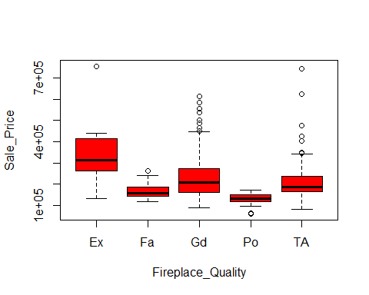

results<-aov (Sale_Price~Fireplace_Quality , data = Pr)  
summary(results)

## Df Sum Sq Mean Sq F value Pr(>F)   
## Fireplace_Quality 4 6.562e+11 1.640e+11 24.4 <2e-16 ***  
## Residuals 765 5.144e+12 6.724e+09   
## ---  
## Signif. codes: 0 '***' 0.001 '**' 0.01 '*' 0.05 '.' 0.1 ' ' 1  
## 689 observations deleted due to missingness

TukeyHSD(results)

## Tukey multiple comparisons of means  
## 95% family-wise confidence level  
##   
## Fit: aov(formula = Sale_Price ~ Fireplace_Quality, data = Pr)  
##   
## $Fireplace_Quality  
## diff lwr upr p adj  
## Fa-Ex -170414.02 -230561.708 -110266.322 0.0000000  
## Gd-Ex -111361.08 -158549.718 -64172.451 0.0000000  
## Po-Ex -207948.35 -275829.604 -140067.096 0.0000000  
## TA-Ex -131989.01 -179476.729 -84501.293 0.0000000  
## Gd-Fa 59052.93 18364.551 99741.311 0.0007528  
## Po-Fa -37534.33 -101068.907 26000.237 0.4879482  
## TA-Fa 38425.00 -2609.865 79459.873 0.0788940  
## Po-Gd -96587.27 -148023.284 -45151.248 0.0000036  
## TA-Gd -20627.93 -37741.740 -3514.114 0.0090630  
## TA-Po 75959.34 24248.797 127669.881 0.0006192

##Garage  
plot(Sale_Price~Garage, data = Pr, col = "red")

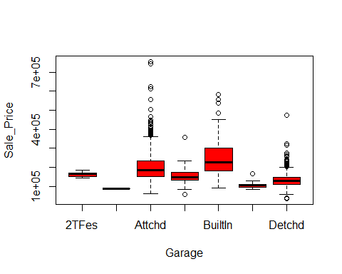

results<-aov (Sale_Price~Garage , data = Pr)  
summary(results)

## Df Sum Sq Mean Sq F value Pr(>F)   
## Garage 6 1.785e+12 2.975e+11 59.81 <2e-16 ***  
## Residuals 1371 6.819e+12 4.974e+09   
## ---  
## Signif. codes: 0 '***' 0.001 '**' 0.01 '*' 0.05 '.' 0.1 ' ' 1  
## 81 observations deleted due to missingness

TukeyHSD(results)

## Tukey multiple comparisons of means  
## 95% family-wise confidence level  
##   
## Fit: aov(formula = Sale_Price ~ Garage, data = Pr)  
##   
## $Garage  
## diff lwr upr p adj  
## 2Types-2TFes -77140.000 -305256.450 150976.450 0.9543964  
## Attchd-2TFes 38816.399 -54579.285 132212.083 0.8836479  
## Basment-2TFes -3569.316 -108236.321 101097.690 0.9999999  
## BuiltIn-2TFes 90611.739 -5125.548 186349.026 0.0773867  
## CarPort-2TFes -54177.889 -170329.100 61973.322 0.8140435  
## Detchd-2TFes -30048.837 -123776.660 63678.986 0.9648049  
## Attchd-2Types 115956.399 -92404.258 324317.056 0.6541086  
## Basment-2Types 73570.684 -140079.946 287221.314 0.9502664  
## BuiltIn-2Types 167751.739 -41668.981 377172.458 0.2143002  
## CarPort-2Types 22962.111 -196543.045 242467.267 0.9999300  
## Detchd-2Types 47091.163 -161418.584 255600.909 0.9943193  
## Basment-Attchd -42385.715 -90678.892 5907.462 0.1292733  
## BuiltIn-Attchd 51795.339 28499.910 75090.769 0.0000000  
## CarPort-Attchd -92994.288 -162766.437 -23222.140 0.0016871  
## Detchd-Attchd -68865.237 -81591.339 -56139.134 0.0000000  
## BuiltIn-Basment 94181.054 41501.786 146860.323 0.0000031  
## CarPort-Basment -50608.573 -134873.518 33656.372 0.5663917  
## Detchd-Basment -26479.521 -75411.944 22452.901 0.6837995  
## CarPort-BuiltIn -144789.628 -217666.421 -71912.834 0.0000001  
## Detchd-BuiltIn -120660.576 -145253.828 -96067.323 0.0000000  
## Detchd-CarPort 24129.052 -46087.070 94345.173 0.9507532

##Garage_Finish_Year  
plot(Sale_Price~Garage_Finish_Year, data = Pr, col = "red")

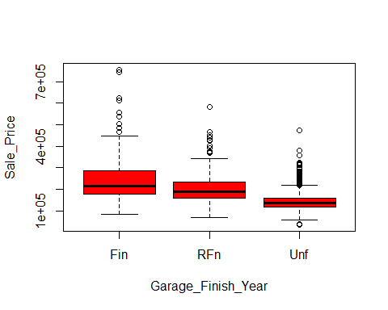

results<-aov (Sale_Price~Garage_Finish_Year , data = Pr)  
summary(results)

## Df Sum Sq Mean Sq F value Pr(>F)   
## Garage_Finish_Year 2 2.307e+12 1.154e+12 251.9 <2e-16 ***  
## Residuals 1375 6.297e+12 4.579e+09   
## ---  
## Signif. codes: 0 '***' 0.001 '**' 0.01 '*' 0.05 '.' 0.1 ' ' 1  
## 81 observations deleted due to missingness

TukeyHSD(results)

## Tukey multiple comparisons of means  
## 95% family-wise confidence level  
##   
## Fit: aov(formula = Sale_Price ~ Garage_Finish_Year, data = Pr)  
##   
## $Garage_Finish_Year  
## diff lwr upr p adj  
## RFn-Fin -38247.50 -49717.39 -26777.61 0  
## Unf-Fin -98159.95 -108813.07 -87506.83 0  
## Unf-RFn -59912.45 -69982.47 -49842.42 0

##Garage_Quality  
plot(Sale_Price~Garage_Quality, data = Pr, col = "red")

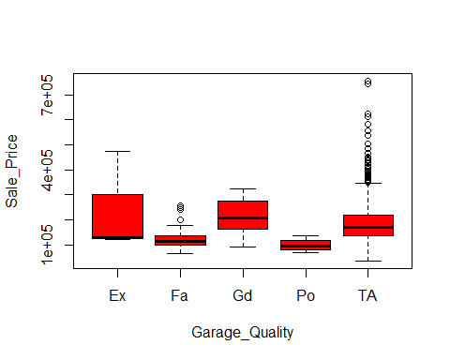

results<-aov (Sale_Price~Garage_Quality , data = Pr)  
summary(results)

## Df Sum Sq Mean Sq F value Pr(>F)   
## Garage_Quality 4 2.334e+11 5.835e+10 9.572 1.24e-07 ***  
## Residuals 1373 8.370e+12 6.096e+09   
## ---  
## Signif. codes: 0 '***' 0.001 '**' 0.01 '*' 0.05 '.' 0.1 ' ' 1  
## 81 observations deleted due to missingness

TukeyHSD(results)

## Tukey multiple comparisons of means  
## 95% family-wise confidence level  
##   
## Fit: aov(formula = Sale_Price ~ Garage_Quality, data = Pr)  
##   
## $Garage_Quality  
## diff lwr upr p adj  
## Fa-Ex -117426.65 -244346.29 9493.002 0.0852673  
## Gd-Ex -25139.29 -160822.10 110543.525 0.9867836  
## Po-Ex -140833.33 -314965.65 33298.986 0.1768478  
## TA-Ex -53479.64 -176750.69 69791.415 0.7600566  
## Gd-Fa 92287.36 27508.06 157066.656 0.0009896  
## Po-Fa -23406.69 -150326.33 103512.960 0.9870128  
## TA-Fa 63947.01 32605.59 95288.426 0.0000003  
## Po-Gd -115694.05 -251376.86 19988.763 0.1363162  
## TA-Gd -28340.35 -85642.29 28961.590 0.6592619  
## TA-Po 87353.70 -35917.36 210624.748 0.2989090

##Garage_Condition  
plot(Sale_Price~Garage_Condition, data = Pr, col = "red")

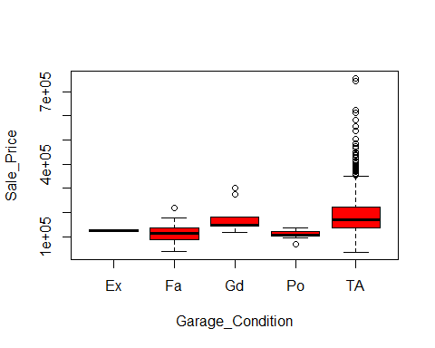

results<-aov (Sale_Price~Garage_Condition , data = Pr)  
summary(results)

## Df Sum Sq Mean Sq F value Pr(>F)   
## Garage_Condition 4 2.328e+11 5.819e+10 9.544 1.3e-07 ***  
## Residuals 1373 8.371e+12 6.097e+09   
## ---  
## Signif. codes: 0 '***' 0.001 '**' 0.01 '*' 0.05 '.' 0.1 ' ' 1  
## 81 observations deleted due to missingness

TukeyHSD(results)

## Tukey multiple comparisons of means  
## 95% family-wise confidence level  
##   
## Fit: aov(formula = Sale_Price ~ Garage_Condition, data = Pr)  
##   
## $Garage_Condition  
## diff lwr upr p adj  
## Fa-Ex -9345.971 -164403.912 145711.97 0.9998354  
## Gd-Ex 55930.000 -110795.589 222655.59 0.8907054  
## Po-Ex -15500.000 -186501.298 155501.30 0.9991716  
## TA-Ex 63916.215 -87006.529 214838.96 0.7759740  
## Gd-Fa 65275.971 -14434.106 144986.05 0.1667932  
## Po-Fa -6154.029 -94458.719 82150.66 0.9997071  
## TA-Fa 73262.187 36738.916 109785.46 0.0000005  
## Po-Gd -71430.000 -178911.046 36051.05 0.3650636  
## TA-Gd 7986.215 -63346.851 79319.28 0.9981006  
## TA-Po 79416.215 -1407.223 160239.65 0.0568673

##Pavedd_Drive  
plot(Sale_Price~Pavedd_Drive, data = Pr, col = "red")

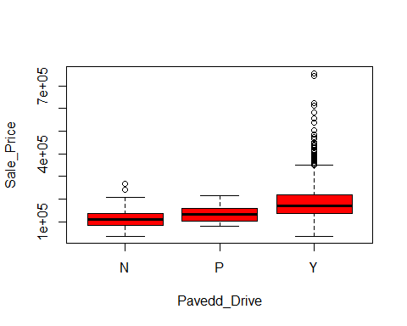

results<-aov (Sale_Price~Pavedd_Drive , data = Pr)  
summary(results)

## Df Sum Sq Mean Sq F value Pr(>F)   
## Pavedd_Drive 2 5.026e+11 2.513e+11 42.04 <2e-16 ***  
## Residuals 1456 8.704e+12 5.978e+09   
## ---  
## Signif. codes: 0 '***' 0.001 '**' 0.01 '*' 0.05 '.' 0.1 ' ' 1

TukeyHSD(results)

## Tukey multiple comparisons of means  
## 95% family-wise confidence level  
##   
## Fit: aov(formula = Sale_Price ~ Pavedd_Drive, data = Pr)  
##   
## $Pavedd_Drive  
## diff lwr upr p adj  
## P-N 17290.88 -20951.05 55532.80 0.5386631  
## Y-N 71423.93 51670.81 91177.04 0.0000000  
## Y-P 54133.05 20645.62 87620.48 0.0004556

##Pool_Quality  
plot(Sale_Price~Pool_Quality, data = Pr, col = "red")

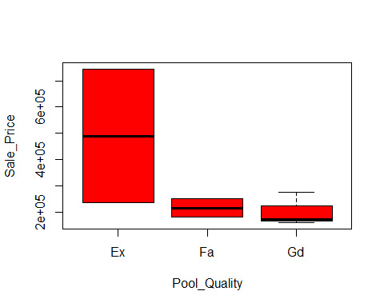

results<-aov (Sale_Price~Pool_Quality , data = Pr)  
summary(results)

## Df Sum Sq Mean Sq F value Pr(>F)  
## Pool_Quality 2 1.143e+11 5.716e+10 1.627 0.304  
## Residuals 4 1.405e+11 3.512e+10   
## 1452 observations deleted due to missingness

TukeyHSD(results)

## Tukey multiple comparisons of means  
## 95% family-wise confidence level  
##   
## Fit: aov(formula = Sale_Price ~ Pool_Quality, data = Pr)  
##   
## $Pool_Quality  
## diff lwr upr p adj  
## Fa-Ex -274500 -942403.6 393403.6 0.3960559  
## Gd-Ex -288010 -897719.8 321699.8 0.3165006  
## Gd-Fa -13510 -623219.8 596199.8 0.9965706

##Fence_Quality  
plot(Sale_Price~Fence_Quality, data = Pr, col = "red")

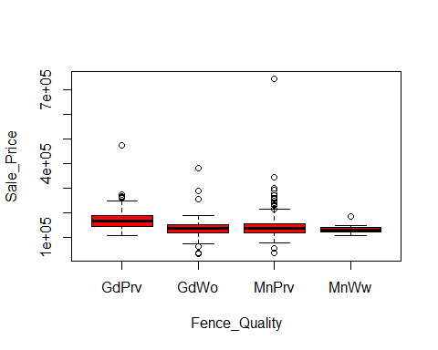

results<-aov (Sale_Price~Fence_Quality , data = Pr)  
summary(results)

## Df Sum Sq Mean Sq F value Pr(>F)   
## Fence_Quality 3 5.495e+10 1.832e+10 4.948 0.00231 **  
## Residuals 277 1.025e+12 3.702e+09   
## ---  
## Signif. codes: 0 '***' 0.001 '**' 0.01 '*' 0.05 '.' 0.1 ' ' 1  
## 1178 observations deleted due to missingness

TukeyHSD(results)

## Tukey multiple comparisons of means  
## 95% family-wise confidence level  
##   
## Fit: aov(formula = Sale_Price ~ Fence_Quality, data = Pr)  
##   
## $Fence_Quality  
## diff lwr upr p adj  
## GdWo-GdPrv -38548.143 -68163.46 -8932.826 0.0048296  
## MnPrv-GdPrv -30176.368 -54189.63 -6163.110 0.0071060  
## MnWw-GdPrv -44641.094 -96285.91 7003.721 0.1166308  
## MnPrv-GdWo 8371.774 -16436.39 33179.935 0.8192201  
## MnWw-GdWo -6092.951 -58112.13 45926.230 0.9903469  
## MnWw-MnPrv -14464.726 -63511.28 34581.831 0.8713228

##Miscellaneous_Feature  
plot(Sale_Price~Miscellaneous_Feature, data = Pr, col = "red")

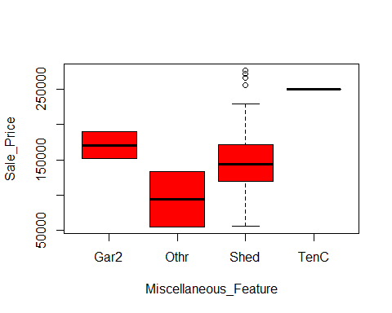

results<-aov (Sale_Price~Miscellaneous_Feature , data = Pr)  
summary(results)

## Df Sum Sq Mean Sq F value Pr(>F)  
## Miscellaneous_Feature 3 1.706e+10 5.687e+09 2.157 0.105  
## Residuals 50 1.318e+11 2.636e+09   
## 1405 observations deleted due to missingness

TukeyHSD(results)

## Tukey multiple comparisons of means  
## 95% family-wise confidence level  
##   
## Fit: aov(formula = Sale_Price ~ Miscellaneous_Feature, data = Pr)  
##   
## $Miscellaneous_Feature  
## diff lwr upr p adj  
## Othr-Gar2 -76750.00 -213194.62 59694.62 0.4481576  
## Shed-Gar2 -19562.39 -117992.61 78867.83 0.9518487  
## TenC-Gar2 79250.00 -87859.84 246359.84 0.5920581  
## Shed-Othr 57187.61 -41242.61 155617.83 0.4195230  
## TenC-Othr 156000.00 -11109.84 323109.84 0.0753391  
## TenC-Shed 98812.39 -39017.49 236642.26 0.2389342

##Sale_Type  
plot(Sale_Price~Sale_Type, data = Pr, col = "red")

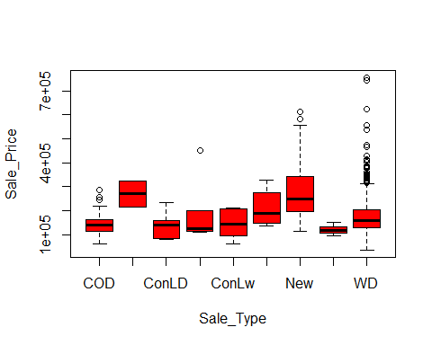

results<-aov (Sale_Price~Sale_Type , data = Pr)  
summary(results)

## Df Sum Sq Mean Sq F value Pr(>F)   
## Sale_Type 8 1.264e+12 1.580e+11 28.84 <2e-16 ***  
## Residuals 1450 7.943e+12 5.478e+09   
## ---  
## Signif. codes: 0 '***' 0.001 '**' 0.01 '*' 0.05 '.' 0.1 ' ' 1

TukeyHSD(results)

## Tukey multiple comparisons of means  
## 95% family-wise confidence level  
##   
## Fit: aov(formula = Sale_Price ~ Sale_Type, data = Pr)  
##   
## $Sale_Type  
## diff lwr upr p adj  
## Con-COD 125626.7442 -40688.709 291942.20 0.3149314  
## ConLD-COD -5192.3669 -89471.830 79087.10 0.9999999  
## ConLI-COD 56416.7442 -52220.055 165053.54 0.7977229  
## ConLw-COD -273.2558 -108910.055 108363.54 1.0000000  
## CWD-COD 66626.7442 -53561.026 186814.51 0.7329302  
## New-COD 130972.1622 90196.277 171748.05 0.0000000  
## Oth-COD -24123.2558 -161419.809 113173.30 0.9998079  
## WD-COD 29449.0404 -6203.815 65101.90 0.2020314  
## ConLD-Con -130819.1111 -310555.355 48917.13 0.3668209  
## ConLI-Con -69210.0000 -261574.351 123154.35 0.9716617  
## ConLw-Con -125900.0000 -318264.351 66464.35 0.5202596  
## CWD-Con -59000.0000 -258116.021 140116.02 0.9918501  
## New-Con 5345.4180 -158559.318 169250.15 1.0000000  
## Oth-Con -149750.0000 -359636.715 60136.71 0.3953829  
## WD-Con -96177.7038 -258883.621 66528.21 0.6578432  
## ConLI-ConLD 61609.1111 -66633.790 189852.01 0.8593309  
## ConLw-ConLD 4919.1111 -123323.790 133162.01 1.0000000  
## CWD-ConLD 71819.1111 -66345.239 209983.46 0.7968662  
## New-ConLD 136164.5291 56748.156 215580.90 0.0000041  
## Oth-ConLD -18930.8889 -172210.473 134348.70 0.9999871  
## WD-ConLD 34641.4073 -42270.319 111553.13 0.8983618  
## ConLw-ConLI -56690.0000 -202103.781 88723.78 0.9542174  
## CWD-ConLI 10210.0000 -144024.606 164444.61 0.9999999  
## New-ConLI 74555.4180 -30353.526 179464.36 0.4010822  
## Oth-ConLI -80540.0000 -248449.372 87369.37 0.8603935  
## WD-ConLI -26967.7038 -129993.622 76058.21 0.9965063  
## CWD-ConLw 66900.0000 -87334.606 221134.61 0.9167179  
## New-ConLw 131245.4180 26336.474 236154.36 0.0034016  
## Oth-ConLw -23850.0000 -191759.372 144059.37 0.9999619  
## WD-ConLw 29722.2962 -73303.622 132748.21 0.9931905  
## New-CWD 64345.4180 -52483.656 181174.49 0.7399158  
## Oth-CWD -90750.0000 -266353.824 84853.82 0.8020772  
## WD-CWD -37177.7038 -152318.860 77963.45 0.9856605  
## Oth-New -155095.4180 -289461.618 -20729.22 0.0104571  
## WD-New -101523.1218 -123318.958 -79727.29 0.0000000  
## WD-Oth 53572.2962 -79328.904 186473.50 0.9445008

##Sale_Condition  
plot(Sale_Price~Sale_Condition, data = Pr, col = "red")

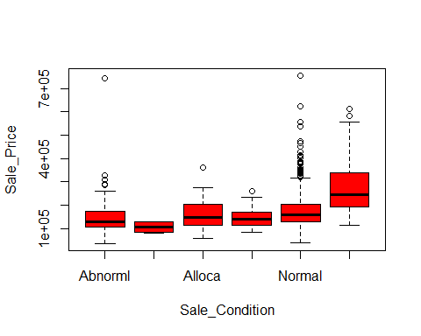

results<-aov (Sale_Price~Sale_Condition , data = Pr)  
summary(results)

## Df Sum Sq Mean Sq F value Pr(>F)   
## Sale_Condition 5 1.247e+12 2.495e+11 45.54 <2e-16 ***  
## Residuals 1453 7.959e+12 5.478e+09   
## ---  
## Signif. codes: 0 '***' 0.001 '**' 0.01 '*' 0.05 '.' 0.1 ' ' 1

TukeyHSD(results)

## Tukey multiple comparisons of means  
## 95% family-wise confidence level  
##   
## Fit: aov(formula = Sale_Price ~ Sale_Condition, data = Pr)  
##   
## $Sale_Condition  
## diff lwr upr p adj  
## AdjLand-Abnorml -42401.624 -150071.639 65268.39 0.8716214  
## Alloca-Abnorml 20850.793 -43637.179 85338.76 0.9407719  
## Family-Abnorml 3073.376 -48616.776 54763.53 0.9999806  
## Normal-Abnorml 28698.739 6815.057 50582.42 0.0026046  
## Partial-Abnorml 125765.128 97507.915 154022.34 0.0000000  
## Alloca-AdjLand 63252.417 -58683.088 185187.92 0.6770505  
## Family-AdjLand 45475.000 -70203.177 161153.18 0.8724611  
## Normal-AdjLand 71100.363 -34675.175 176875.90 0.3913531  
## Partial-AdjLand 168166.752 60891.224 275442.28 0.0001210  
## Family-Alloca -17777.417 -94896.201 59341.37 0.9863665  
## Normal-Alloca 7847.946 -53424.647 69120.54 0.9991499  
## Partial-Alloca 104914.335 41087.184 168741.49 0.0000438  
## Normal-Family 25625.363 -21992.952 73243.68 0.6412121  
## Partial-Family 122691.752 71828.420 173555.08 0.0000000  
## Partial-Normal 97066.389 77214.381 116918.40 0.0000000

## R Markdown

This is an R Markdown document. Markdown is a simple formatting syntax for authoring HTML, PDF, and MS Word documents. For more details on using R Markdown see <http://rmarkdown.rstudio.com>.

When you click the **Knit** button a document will be generated that includes both content as well as the output of any embedded R code chunks within the document. You can embed an R code chunk like this:

summary(cars)

## speed dist   
## Min. : 4.0 Min. : 2.00   
## 1st Qu.:12.0 1st Qu.: 26.00   
## Median :15.0 Median : 36.00   
## Mean :15.4 Mean : 42.98   
## 3rd Qu.:19.0 3rd Qu.: 56.00   
## Max. :25.0 Max. :120.00

## Including Plots

You can also embed plots, for example:



Note that the echo = FALSE parameter was added to the code chunk to prevent printing of the R code that generated the plot.