***Functionality suggestion:***

**1.Select connection type check box**:

When user is clicking on any radio button of connection type, one pop up comes but user is not able to read what is written on it.

The pop up display time should be increased.

**2.Tile or first and last name accept only 20 characters.**

If user name containing character more than 20 then it is problem for end user.

**3.Pin code dropdown**:

After clicking on dropdown, it opens up list but title is missing

Should display any title, it only blank blue box displayed. Attached image below.

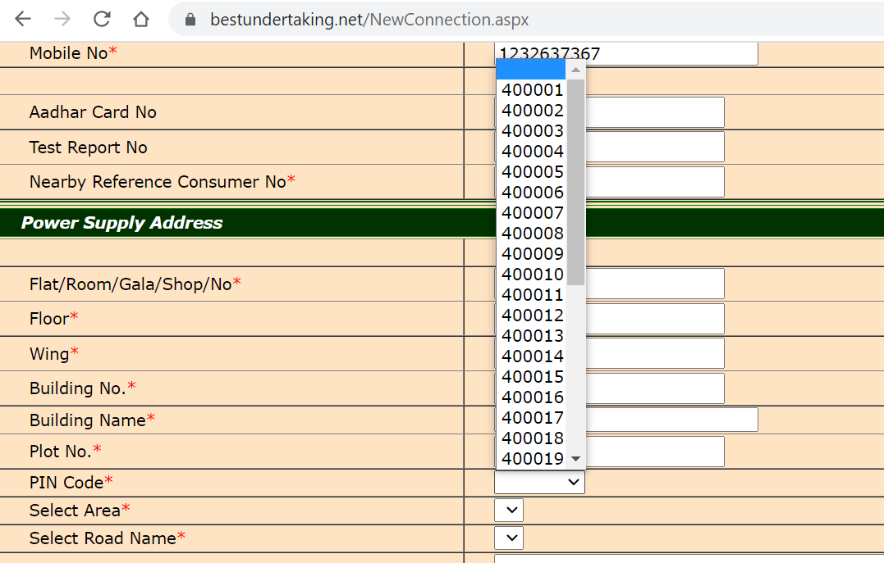

4.After clicking on upload photo, signature, occupancy proof, identity proof user navigates to top of the same page.

User should be stay at the same location i.e. photo, occupancy proof, identity proof.

*5. Enter OTP field*.

Enter OTP field taking too many numbers, Ideally OTP contains only 4-6 numbers.

So I think this field should improve.

**6.First name or title field.**

It took special characters.

The requirement is it should only accept characters with dot(.) and spaces



***UI Aesthetics:***

UI should have more well designed.

To see the copyright user, need to scroll down more.

There should be not that much distance between last row of form and copyright footer.