1. Query all columns for all American cities in the **CITY** table with populations larger than 100000. The **CountryCode** for America is USA.

The **CITY** table is described as follows:

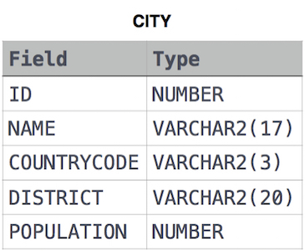

**select * From CITY where COUNTRYCODE = "USA" and POPULATION >= 100000**

1. Query the **NAME** field for all American cities in the **CITY** table with populations larger than 120000. The CountryCode for America is USA.

The **CITY** table is described as follows:   


Select NAME From CITY where COUNTRYCODE = 'USA' and POPULATION >= 120000

1. Query all columns (attributes) for every row in the **CITY** table.

The **CITY** table is described as follows:   


select * from CITY

1. Query all columns for a city in **CITY** with the ID 1661.

The **CITY** table is described as follows:   


select * from CITY where ID = 1661

1. Query all attributes of every Japanese city in the **CITY** table. The **COUNTRYCODE** for Japan is JPN.

The **CITY** table is described as follows:   


select * from CITY where COUNTRYCODE = 'JPN'

1. Query the names of all the Japanese cities in the **CITY** table. The **COUNTRYCODE** for Japan is JPN.   
   The **CITY** table is described as follows:   
   

select NAME from CITY where COUNTRYCODE = "JPN"

1. Query a list of **CITY** and **STATE** from the **STATION** table.   
   The **STATION** table is described as follows:   
   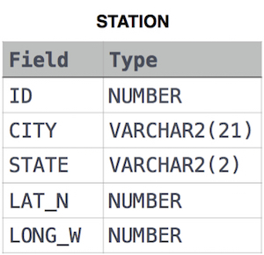

where **LAT_N** is the northern latitude and **LONG_W** is the western longitude.

select CITY, STATE from STATION