

REPORT ON ONLINE FOOD DELIVERY SYSTEM

Course Name: Introduction to Software Engineering
Course Code: IS1103-1
Assignment Number &Title: 1. Software Process Models and Requirements Engineering
Submitted by
Student Name: Ashwini Rao
USN: NNM24IS045
Semester & Section: IV A
Department: Information Science & Engineering
Institution Name: NMAM Institute of Technology
Academic Year: 2025-26
Under the guidance of
Instructor Name: Dr. Jason Elroy Martis
Date of Submission:14-02-2026
Abstract:
The Online Food Delivery System is a technology-based solution which connects restaurants, delivery person and customer through a single platform. It allows customers to make their work easier and also the restaurant people to improve their business. There will be continuous communication taking place to ensure proper receiving of orders. By digitalizing the entire work, manual work can be reduced completely.

Building such a system involves not only technical skills but both technical and business aspects. The system should ensure smooth performance in peak time, securing the data of the customers and easy to use software.

In this project, we compare the Online food Delivery system with different models and compare it based on time and cost constraints, functional and non- functional requirements and many more factors. Then try to analyse the best suitable model to develop the system.

GITHUB REPOSITORY LINK:
https://github.com/Ashwini732/Online_Food_Delivery_System

INTRODUCTION:

In today’s world, people prefer fast and convenient solutions for their daily need. Online Food Delivery System is designed to order food online and make people’s life easier. Instead of a person going to restaurants and waiting in queue to buy food, one can do it by sitting in their home. One can just open this app, see the menu and order the food. They can also make secure payments. They can even track the order until it is delivered to their home.

Along with the customers even the restaurant people have lots of benefit, restaurant people can change menu, add offers to improve their business. Since this system is preferred by large number of users, maintaining it securely is the major task. Maintaining it during peak hours is a big deal. Overall, the Online Food Delivery System plays an important role in making food services faster, easier and convenient.

Moreover, the development of such a model requires proper planning and software engineering processes. Choosing the suitable model to ensure all the requirements are satisfied and proper functioning of the system is the major task.
Problem statement:

In today’s busy world, people don’t have enough time to visit restaurant and wait for their food. Traditional methods like phone calls, visiting restaurants can be time consuming. Hence there is a need for the more reliable and optimised interface that connects restaurants with their customers. The system should be potential enough to handle multiple requests at a time. It should also handle the customer data safely to develop a good connection between customer and restaurant.

MODEL DESCRIPTION:
1.Waterfall Model:

Waterfall model works based on the plan made. In this model, we need to plan things clearly before executing them. The plan that we make is of great importance here.[1]

The waterfall model works step by step linearly. One cannot move to the next phase, without completing the current phase. It ensures proper implementation of planned things, while the changing requirements is the major task here.[2]

1.Requirements analysis and definition:
According to this model first, we need to analyse the requirements that are needed for this system. Requirements include description of all the food items that are available in the particular system, payment facility, data privacy etc.
2.System and software design
Once we come to know about the requirements, then we need to convert these into a practical program unit. In the system which I chose, we need to design different units such as payment unit, order unit etc as per the requirements specified.
3.Implementation and unit testing
In this phase, we need to implement these small units into the real- world. Then check if these units can meet the requirements specified.
If there are any changes required, then we need go back and make the required changes.
In this system, we need to check if all the units such as payment, security, ordering work as per the need. May be sometimes there can be some mistakes like payment may be complete, login is invalid etc.
We need to test with different cases and fix the error if identified.
4.Integration and system testing:
In this part, the individual modules are integrated to form a complete system. Then this system is again tested to identify if all the requirements are satisfied or not. Then the system is delivered for the customers to use.
In the food delivery system, we need to merge all the small units into a complete system.
5.Operation and maintenance:
In this phase, the system is ready to be used by the customers and can install it. The system should be maintained even after the implementation to check if there is any error in the software and need to fix it. It should also identify the new requirements required and make necessary changes.
Once the delivery system is open to all, then we need to continuously monitor if the software is working properly or not.
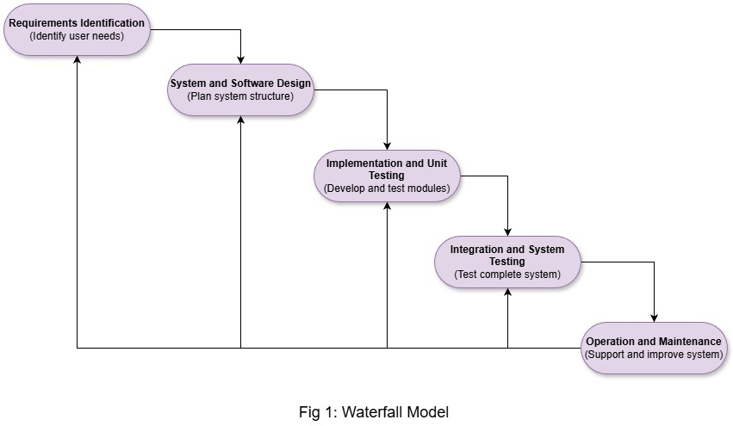

Suitability:
1.Functional and Non-Functional Requirements:
Waterfall model does not allow frequent changes to be done. It accepts only fewer changes. In the case our system, most of the requirements can be defined priorly. Almost all the customer requirements will be satisfied during the implementation only. Since the requirements are common and stable, this model can well fit to our System.
2.Risk and change Management:
Once after release of software to customers only we get to know about the requirements that are additionally required by them. Then again it has to start from the step 1 and merge it to the existing software and then again release the improvised version of it.
3.Time constraints:
If there is delay in gathering information then the whole time is consumed in gathering itself. This will make it slower to proceed with the further steps.
2.Incremental Development Model:

Incremental Development Model works based on the idea of incrementing the work level by level. At each level, we need to expose it to the users, get the feedback and update it as per the need.[2]

According to this model, a part of the system which satisfies a particular requirement is designed, developed and implemented as initial version of final software. Then the level of this model is incremented when new requirement is necessary. In this type of model, there is no need to know all the requirements in prior. The system can be upgraded each time when a requirement is specified, then the software can be developed adding that feature to existing software and finally validating it by testing.

In the Online food delivery system if we use this model, then we need to add the login page first and see if it works or not, and then go on incrementing by adding other features like food description, payment facility, location info, and check the software at each step.

Through this model, the easy to implement features like customer info, food description can be added first and checked for the errors. Then the comparatively difficult tasks such as payments, location tracking can be added later so that it can be checked separately. Later if there is any updating required, it can be done easily.

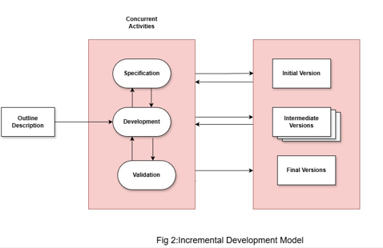

Suitability:
Functional and non- functional requirements:
In the case of functional requirements like payment facility, location tracking, customer info etc, this model is efficient because each requirement can be designed and tested for the errors step by step. It makes us easy to find the changes required and changes can be made at that particular step only. In the case of non-functional requirements like data privacy, security, accuracy etc, also this model is helpful since it can be checked step by step. Improvements can be made at each step.

Risk and change Management:
Risks can be handled at each increment. So that the final system having risk is reduced.
The functionalities are added in each step so the changes corresponding to that particular functionalities can be added easily in that step only after testing.
Time Constraints:
In this model, the earlier partial software is launched faster but the final model takes time. It depends on planning, dependencies and integration of smaller parts.

3.Spiral Model:
The spiral model involves risk analysis along with multiple cycles. This is effective when building advanced systems that require strong security and performance.[1]
Each loop in the spiral has four parts:
Objective setting:
Specific objectives for the desired project are set based on the requirements that are required. Risk of including that objective is noted. Many methods that can reduce the risk can be found out.

Here, in this step the requirements like payment facility, ordering procedure or location tracking can be identified and set as objectives in this first phase.

Risk Assessment and reduction:
One of the new concepts of this model is, here the risk analysis is done at the beginning before the implementation. This helps us to understand the difficulty of including the particular requirement. Steps to solve it can be identified. We can reduce the risks by developing a simple prototype and check it.
Now the risk for the chosen requirements should be noted. If we choose payment in the previous step, then in this step we need to think about the risks like is the payment secure?

Development and validation:
After the analysis of risk, the next step is to choose the suitable model so that we can develop our system and then validating it using different methods.
We need to convert all the features that are considered in the previous step to codes and develop a system.

Planning:
Once the system is developed, now we need to plan if we need to continue with this system or not. We have to collect reviews from customer and see if we can meet the requirements of them or not. If everything is satisfied then move to the next spiral. Here the management will collect reviews from customers and sets the goal for the next loop based on the reviews.
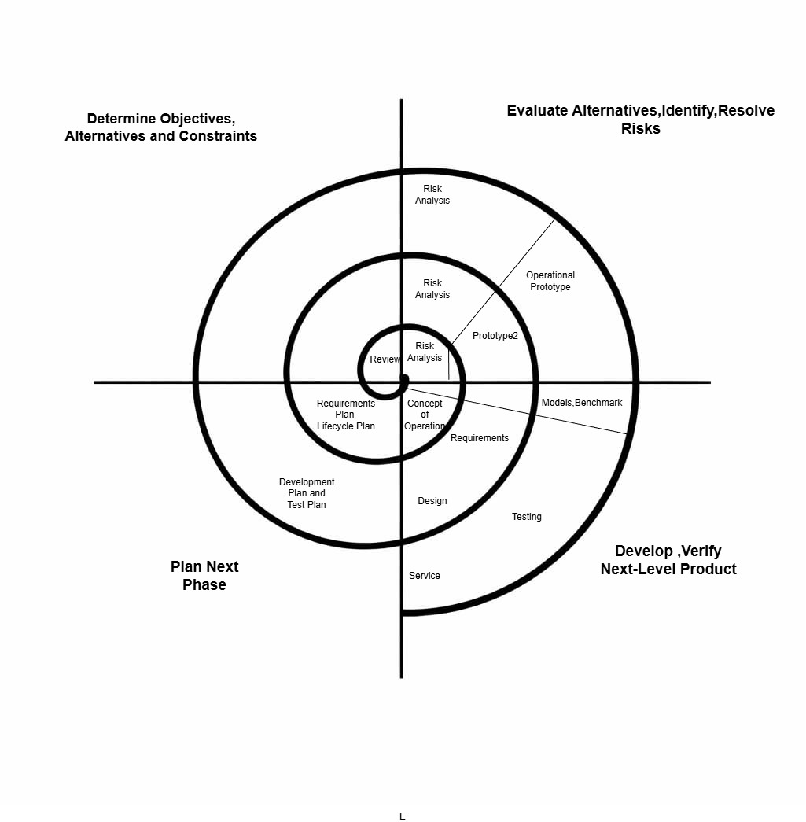
Fig 3: Spiral Model

Suitability:

1.Functional and Non-Functional Requirements:
Through this model basic functional requirements like user login, online payment, food menu can be developed step by step. This makes it structured and easy to manage.
Non- functional requirements like high performance, security and scalability carry more risks and these can be handled efficiently.
Response time can be developed through multiple cycles.
2.Risk Management:
Spiral model was introduced mainly to focus on risk. Food-delivery system has many risks like data breaches, payment failure etc which can be identified, analysed and reduced at each step.
3.Time Constraints:
This model might take more time since it includes many cycles. Even though it includes many cycles the result will be better than the results of many other models.

Comparison of Models:
 | Waterfall Model | Incremental Development Model | Spiral model
Functional Requirements | All the functional requirements must be clearly defined at the beginning | Able to add and modify the functional requirements at each step | Functional requirements can improve in each step
Non-Functional Requirements | These are usually checked at the end, so difficult to handle | These are improved in each step and may not be efficient in the beginning | These are evaluated at each cycle
Customer involvement | Minimum | Moderate | High
Cost | Less costly | Moderate cost | High cost due to many cycles
Risk Management | Less focus on risks | Moderate focus on risks | Very high focus on risk at each level

Requirements Engineering Process:
Functional Requirements:
1.User Registration and Login:
The system should have the facility of login for multiple users, so that a particular user can use his/her own account for the required services.

2.Menu Display:
There should be a panel to display the food item names clearly with price, so that users can understand things clearly.

3.Order Placement:
There should be a proper order placement procedure. It should be easy enough so that anyone can place the order.

4.Online Payment:
Payment is one of the major thing that is needed. There should be options to make payments via different methods.
5.Order Tracking and Notifications:
Once the order is placed, then the customer should get the facility of tracking their order until the order is delivered.
6. Admin Panel:
There should be a panel for admin where he can control customers, orders and restaurants.

Non-Functional Requirements:

1.Security:
The system should ensure secure online payment facility and it should also handle the customer information with at most care by authentication and encryption.

2.Response time:
The system should respond to user requests immediately.

3.Performance:
The performance takes its importance during the peak hours of ordering. At this time the system should be efficient enough to look after the traffic.

4.Usuability:
The system should be designed such that, anybody of any age should be able to use it. It should even look attractive to attract customers.

5.Reliability:
The system should be available 24/7.

6.Scalability:
The system should allow future expansion in the number of users and also the restaurants.

Strategies for Requirements Validation:
Requirements Validation is a way of making sure that the system that we are planning can meet the user requirements or not. Few methods include:
1.Review meetings to be conducted to examine the requirements carefully and to identify if any changes are required.
2.Prototyping is another effective method, where a general sample model is developed and shown to stakeholders and evaluated.
3.Developing the checklist and having a look on it such that our system can satisfy all conditions and requirements mentioned in it.
Potential Challenges in Requirement Validation:
1.Changing Requirements:
If the requirements change every now and then, the validators may find it difficult to decide on which to work on.
2.Communication gap:
Communication gap between the technical team and non-technical users can create misunderstanding.
3.Conflicting Expectation:
We have multiple stakeholders involved in out system. They might have different expectations. A person who orders may require the food on time while the restaurants need their time to prepare.

References:
[1] Acuitysoftware, “Which SDLC model is used in the online food ordering system?,” Acuity Software Services Pvt. Ltd., https://acuitysoftwareservices.com/blog/which-sdlc-model-is-used-in-the-online-food-ordering-system/ (accessed Feb. 13, 2026).
[2] https://engineering.futureuniversity.com/BOOKS%20FOR%20IT/Software-Engineering-9th-Edition-by-Ian-Sommerville.pdf
All figures:[2]

Conclusion:
The development of the Online Food Delivery System has shown us in detail about the different steps that needs to be taken while building a complete software . By analysing different models like waterfall model, incremental model and spiral model we come to the conclusion that each and every model has its own advantages and disadvantages. We come to know that waterfall model follows sequence of steps but it fails in handling changing requirements while the incremental development model, model is developed in increments but it is difficult to integrate. The spiral model, which is risk-based approach proves to be more suitable for complex and dynamic food delivery.
Overall this project, highlights the importance of comparison of models and then concluding about the best model which is best fit for our project.

Declaration of Academic Integrity:

I hereby declare that this assignment is my original work and has not been copied or plagiarized from any source. All references and resources used have been properly cited. Any ambiguities will lead to forfeiting my marks.

Student Signature:
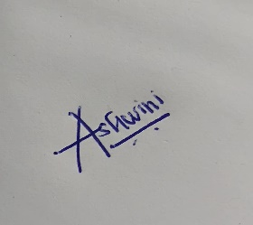

Date:14-02-2026

