**ADA LAB TEST-1**

**SELECTION SORT PROGRAM:**

#include <stdio.h>

#include <time.h>

#include <stdlib.h>

int minIndex(int arr[], int i, int j)

{

if (i == j)

return i;

int k = minIndex(arr, i + 1, j);

return (arr[i] < arr[k])? i : k;

}

void recurSelectionSort(int arr[], int n, int index)

{

int temp;

if (index == n)

return;

int k = minIndex(arr, index, n-1);

if (k != index) {

temp = arr[k];

arr[k] = arr[index];

arr[index] = temp;

}

recurSelectionSort(arr, n, index + 1);

}

int main()

{

int size,i,n;

clock_t start, end;

printf("Enter the size of the list: ");

scanf("%d", &n);

int arr[n];

for (i = 0; i < n; i++)

{

int no = rand() % n + 1;

arr[i] = no;

}

start = clock();

recurSelectionSort(arr, n,0);

end = clock();

float ti = ((double)(end - start)/CLOCKS_PER_SEC);

for (int i = 0; i<n ; i++)

printf("%d ",arr[i]);

printf("\nTime taken: %f", ti);

return 0;

}

**OUTPUT:**

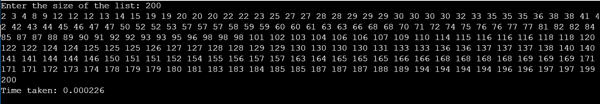

**Modified Program:**

#include <stdio.h>

#include <time.h>

#include <stdlib.h>

int main()

{

int a[100], n, i, j, position, swap,m;

clock_t start, end;

printf("Enter number of elements\n");

scanf("%d", &n);

printf("Enter %d Numbers\n", n);

for (i = 0; i < n; i++)

scanf("%d", &a[i]);

start = clock();

for(i = 0; i < n - 1; i++)

{

position=i;

for(j = i + 1; j < n; j++)

{

if(a[position] > a[j])

position=j;

}

if(position != i)

{

swap=a[i];

a[i]=a[position];

a[position]=swap;

}

}

printf("Sorted Array: ");

for(i = 0; i < n; i++)

printf("%d\t", a[i]);

printf("\nEnter the kth largest element you want to find\n");

scanf("%d",&m);

printf("\nThe largest number in array is:- %d", a[n- m]);

end = clock();

float ti = ((double)(end - start)/CLOCKS_PER_SEC);

printf("\nTime taken: %f", ti);

return 0;

}

**OUTPUT:**

