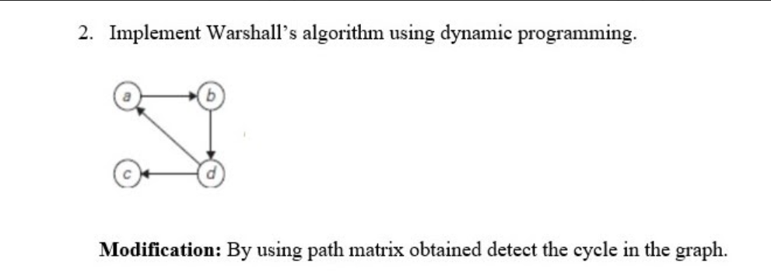

PROGRAM:

#include<stdio.h>

#include <time.h>

#include <stdlib.h>

int warshalls();

int a[10][10], p[10][10], i,j,k,n;

int main()

{

clock_t start, end;

printf("Enter number of vertices\n");

scanf("%d",&n);

printf("enter adjacency matrix\n");

for(i=1;i<=n;i++)

{

for(j=1;j<=n;j++)

{

scanf("%d",&a[i][j]);

}

}

start = clock();

warshalls();

end = clock();

float ti = ((double)(end - start)/CLOCKS_PER_SEC);

printf("Path Matrix");

printf("\n\n");

for(i=1;i<=n;i++)

{

for(j=1;j<=n;j++)

{

printf("%d",p[i][j]);

}

printf("\n");

}

printf("\nTime taken: %f", ti);

}

int warshalls()

{

for(i=1;i<=n;i++)

{

for(j=1;j<=n;j++)

{

p[i][j]=a[i][j];

}

}

for(k=1;k<=n;k++)

{

for(i=1;i<=n;i++)

{

for(j=1;j<=n;j++)

{

if((p[i][j]!=1) && (p[i][k]==1 && p[k][j]==1))

p[i][j]=1;

}

}

}

}

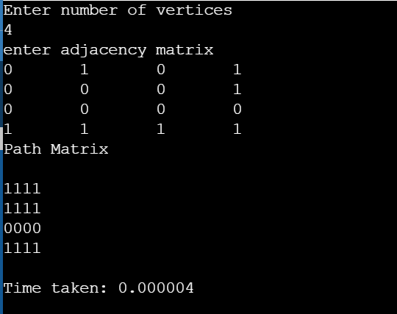

MODIFICATION PROGRAM:

#include<stdio.h>

#include <time.h>

#include <stdlib.h>

int a[10][10], p[10][10],i,j,k,n,cycle[10];

void warshalls()

{

for(i=1;i<=n;i++)

{

for(j=1;j<=n;j++)

{

p[i][j]=a[i][j];

}

}

for(k=1;k<=n;k++)

{

for(i=1;i<=n;i++)

{

for(j=1;j<=n;j++)

{

if((p[i][j]!=1) && (p[i][k]==1 && p[k][j]==1))

p[i][j]=1;

}

}

}

}

void main()

{

int c;

clock_t start, end;

printf("Enter number of vertices\n");

scanf("%d",&n);

printf("Enter adjacency matrix\n");

for(i=1;i<=n;i++)

{

for(j=1;j<=n;j++)

{

scanf("%d",&a[i][j]);

}

}

start = clock();

warshalls();

end = clock();

float ti = ((double)(end - start)/CLOCKS_PER_SEC);

printf("Path Matrix\n");

int z=0;

for(i=1;i<=n;i++)

{

c=0;

for(j=1;j<=n;j++)

{

printf("%d",p[i][j]);

if(p[i][j]==1)

c++;

}

if(c==n)

{

cycle[z]=i;

z++;

}

printf("\n");

}

if(z>1)

{

printf("Cycle formed:\n");

for(int i=0;i<z;i++)

printf("%d ",cycle[i]);

}

else

printf("No cycle\n");

printf("\nTime taken: %f", ti);

}

