Ashwini

1BM20CS402

CSE-4A

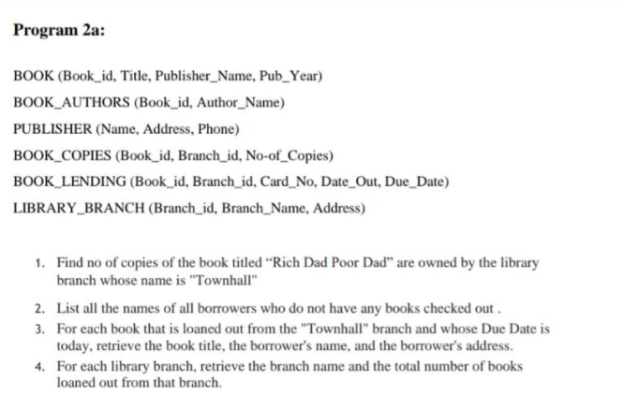

CREATE DATABASE BOOK_DATABASE9;

USE BOOK_DATABASE9;

CREATE TABLE PUBLISHER

(

Name varchar(50) primary key,

Phone_no bigint,

Address varchar(100)

);

CREATE TABLE BOOK

(

Book_id int primary key,

Title varchar(50),

Publisher_Name varchar(50),

Foreign Key(Publisher_Name) references PUBLISHER(Name)

);

CREATE TABLE BOOK_AUTHORS

(

Author_name varchar(50) primary key,

Book_id int,

Foreign Key(Book_id) references BOOK(Book_id)

);

CREATE TABLE LIBRARY_BRANCH

(

Branch_id int primary key,

Address varchar(50),

Branch_name varchar(50)

);

CREATE TABLE BOOK_COPIES

(

Book_id int,

Branch_id int,

No_of_Copies int,

Foreign Key(Book_id) references BOOK(Book_id),

Foreign Key(Branch_id) references LIBRARY_BRANCH(Branch_id)

);

CREATE TABLE BORROWER

(

Card_no int primary key,

Name varchar(50),

Address varchar(50),

Phone bigint

);

CREATE TABLE BOOK_LENDING

(

Book_id int,

Branch_id int,

Card_no int,

Date_out date,

Due_date date,

Foreign Key(Book_id) references BOOK(Book_id),

Foreign Key(Branch_id) references LIBRARY_BRANCH(Branch_id),

Foreign Key(Card_no) references BORROWER(Card_no)

);

insert into PUBLISHER

values ("MCGRAW-HILL",9989076587,"BANGALORE"),("PEARSON",9889076565,"NEWDELHI"),

("RANDOM HOUSE",7455679345,"HYDERABAD"),("HACHETTE LIVRE",8970862340,"CHENAI"),

("GRUPO PLANETA",77566120238,"BANGALORE");

select * from PUBLISHER;

insert into BOOK

values (1,"DBMS","MCGRAW-HILL"),(2,"ADBMS","MCGRAW-HILL"),

(3,"CN","PEARSON"),(4,"CG","GRUPO PLANETA"),

(5,"OS","PEARSON");

select * from BOOK;

insert into BOOK_AUTHORS

values ("NAVATHE",1),("TANENBAUM",3),("EDWARD ANGEL",4),("GALVIN",5);

select * from BOOK_AUTHORS;

insert into LIBRARY_BRANCH

values (10,"BANGALORE","RR NAGAR"),(11,"BANGALORE","RNSIT"),(12,"BANGALORE","RAJAJI NAGAR"),

(13,"MANGALORE","NITTE"),(14,"UDUPI","NANIPAL");

select * from LIBRARY_BRANCH;

insert into BOOK_COPIES

values (1,10,10),(1,11,5),(2,12,2),(2,13,5),(3,14,7),(5,10,1),(4,11,3);

select * from BOOK_COPIES;

insert into BORROWER

values(101,"Ashwini","BANGALORE",1234567890),(102,"Ambika","BANGALORE",1234567891),

(103,"Nagraj","BANGALORE",1234567892),(104,"Ujwala","BANGALORE",1234567893);

select * from BORROWER;

insert into BOOK_LENDING

values('2017-01-01','2017-06-01', 1, 10, 101);

('2017-01-01','2017-03-11', 3, 14, 101),

('2017-02-21','2017-04-21', 2, 13, 101),

('2017-03-15','2017-07-15', 4, 11, 101),

('2017-04-12','2017-05-12', 1, 11, 104);

select * from BOOK_LENDING;

select No_of_Copies

from ((BOOK join BOOK_COPIES) join LIBRARY_BRANCH)

where Title="Rich Dad Poor Dad" AND Branch_name="Townhall";



//No values are displayed because there is no title called “Rich Dad Poor Dad”//

select Name

from BORROWER B

where not exists (select *

from BOOK_LENDING L

where B.Card_no=L.Card_no);

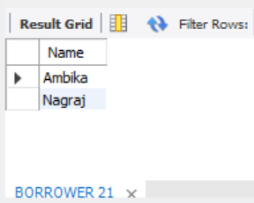

select B.Title,R.Name,R.Address

from Book B,BORROWER R,BOOK_LENDING BL,LIBRARY_BRANCH LB

where LB.Branch_name="Townhall" and LB.Branch_id=BL.Branch_id and

BL.Due_date="2017-05-12" and BL.Card_no=R.Card_no and BL.Book_id=B.Book_id;

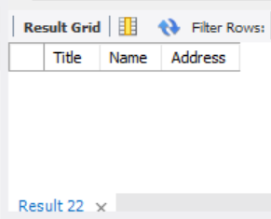

//No values are displayed because there is no branch in “Townhall”//

select L.Branch_name,count(*)

from BOOK_LENDING B,LIBRARY_BRANCH L

where B.Branch_id=L.Branch_id

group by L.Branch_name;

