**PROGRAM 1: INSURANCE DATABASE**

Consider the Insurance database given below. The primary keys are underlined and the data types are specified.

PERSON (driver-id #: String, name: String, address: String)

CAR (Regno: String, model: String, year: int)

ACCIDENT (report-number: int, date: date, location: String)

OWNS (driver-id #: String, Regno: String)

PARTICIPATED (driver-id: String, Regno: String, report-number: int, damage-amount: int)

i. Create the above tables by properly specifying the primary keys and the foreign keys.

ii. Enter at least five tuples for each relation.

iii. Demonstrate how you

a. Update the damage amount for the car with a specific Regno in the accident with report number 12 to

25000.

b. Add a new accident to the database.

iv. Find the total number of people who owned cars that involved in accidents in 2008.

v. Find the number of accidents in which cars belonging to a specific model were involved

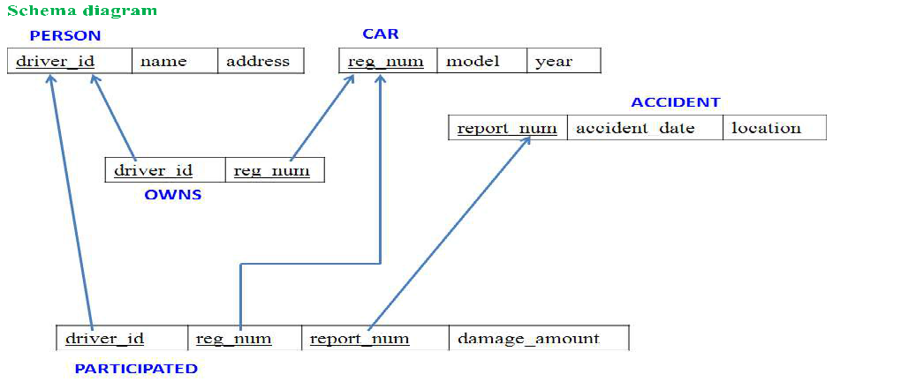

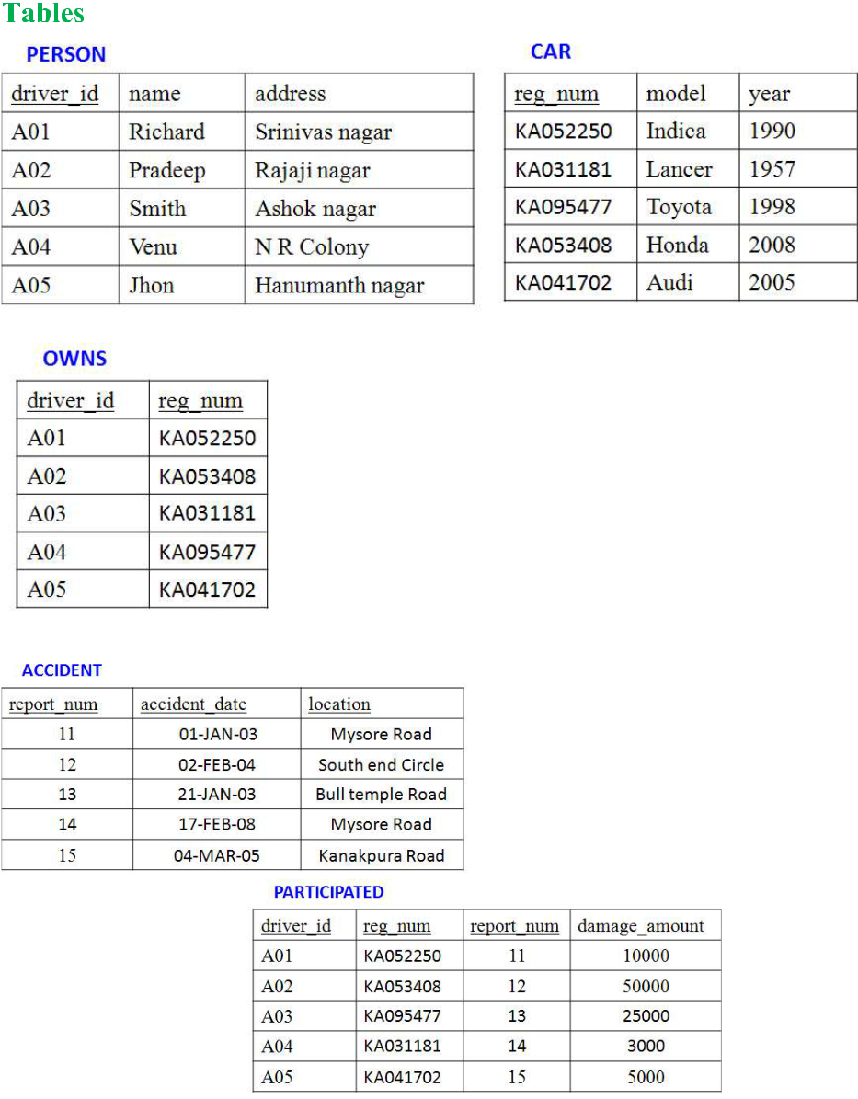

CREATE DATABASE INSURANCE_DATABASE;

USE INSURANCE_DATABASE;

create table person

(

driver_ id varchar(15) unique NOT NULL,

name varchar(20) NOT NULL,

address varchar(30),

primary key(driver_id)

);

create table car

(

reg _num varchar(20) unique NOT NULL,

model varchar(25),

year int,

primary key(reg_num)

);

create table accident

(

report_num int unique NOT NULL,

accident_date date,

location varchar(30),

primary key(report_num)

);

create table owns

(

driver_id varchar(20),

reg_num varchar(20),

FOREIGN KEY(driver_id) REFERENCES person(driver_id),

FOREIGN KEY(reg_num) REFERENCES car(reg_num)

);

create table participated

(

driver_id varchar(15) unique NOT NULL,

reg_num varchar(20) unique NOT NULL,

report_num int unique NOT NULL,

damage_amount int,

FOREIGN KEY(driver_id) REFERENCES person(driver_id),

FOREIGN KEY(reg_num) REFERENCES car(reg_num),

FOREIGN KEY(report_num) REFERENCES accident(report_num)

);

insert into person

values ("A01","Richard","Srinivas nagar"),("A02","Pradeep","Rajaji nagar"),

("A03","Smith","Ashok nagar"),("A04","Venu","N R Colony"),("A05","Jhon","Hanumanth nagar");

select * from person;

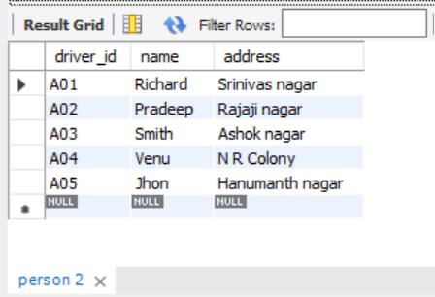

insert into car

values ("KA052250","Indica",1990),("KA031181","Lancer",1957),("KA095477","Toyota",1998),

("KA053408","Honda",2008),("KA041702","Audi",2005);

select * from car;

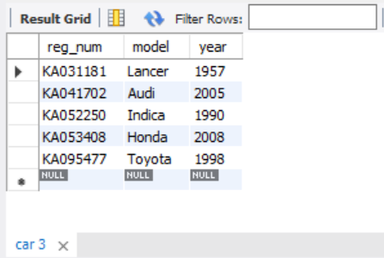

insert into owns

values ("A01","KA052250"),("A02","KA053408"),("A03","KA031181"),

("A04","KA095477"),("A05","KA041702");

select * from owns;

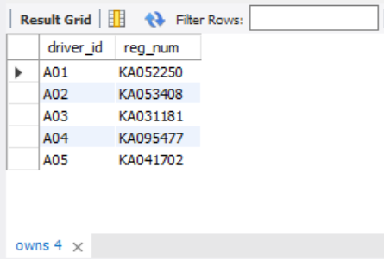

insert into accident

values (11,'2003-01-03',"Mysore Road") , (12,'2002-02-04',"South end Circle"),(13,'2021-01-03',"Bull temple Road"), (14,'2017-02-08',"Mysore Road"),(15,'2004-03-05',"Kanakpura Road");

select * from accident;

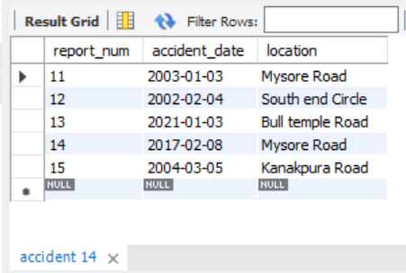

insert into participated

values ("A01","KA052250",11,10000),("A02","KA053408",12,50000),("A03","KA095477",13,25000),

("A04","KA031181",14,3000),("A05","KA041702",15,5000);

select * from participated;

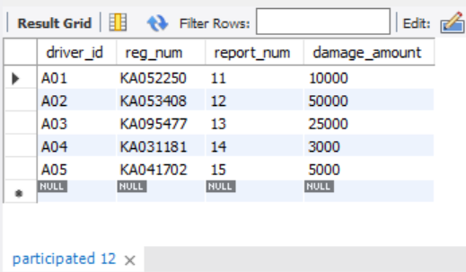

a. Update the damage amount for the car with a specific Regno in the accident with report number 12 to 25000

update PARTICIPATED

SET damage_amount=25000

WHERE reg_num="KA053408";

select* from PARTICIPATED;

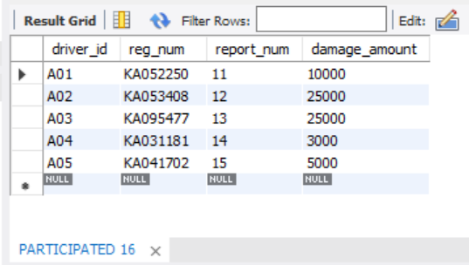

b. Add a new accident to the database.

insert into ACCIDENT

values (16,"2018-03-29","KORMANGLA");

select* from ACCIDENT;

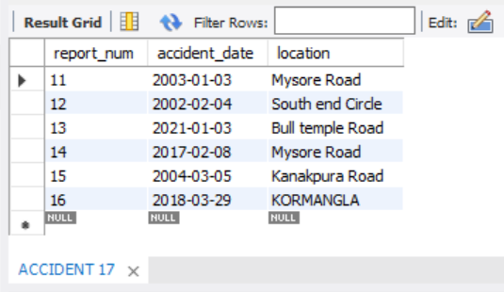

iv. Find the total number of people who owned cars that involved in accidents in 2008.

SELECT COUNT(accident_date) AS accidentsin2008

FROM ACCIDENT

WHERE YEAR(accident_date)=2008;

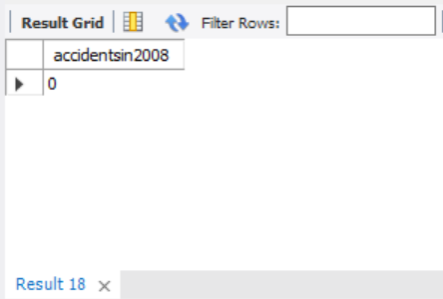

v. Find the number of accidents in which cars belonging to a specific model were involved

SELECT COUNT(model) AS carwithhondaomodel

FROM car

WHERE model="HONDA";

