**Ashwini**

**1BM20CS402**

**CSE-4A**

**PROGRAM 2: BANKING ENTERPRISE**

**DATABASE**

Consider the following database for a banking enterprise.

**Branch** (branch-name: String, branch-city: String, assets: real)

**BankAccount**(accno: int, branch-name: String, balance: real)

**BankCustomer** (customer-name: String, customer-street: String, customer-city: String)

**Depositer**(customer-name: String, accno: int)

**Loan** (loan-number: int, branch-name: String, amount: real)

i. Create the above tables by properly specifying the primary keys and the

foreign keys.

ii. Enter at least five tuples for each relation.

iii. Find all the customers who have at least two accounts at the *Main* branch (ex. SBI_ResidencyRoad).

iv. Find all the customers who have an account at *all* the branches located in a

specific city (Ex. Delhi).

v. Demonstrate how you delete all account tuples at every branch located in

a specific city (Ex. Bombay).

**INTRODUCTION:** This database is developed for supporting banking facilities. Details of the branch along with the accounts and loans handled by them are recorded. Also details of the depositors of the corresponding branches are maintained.

**Schema Diagram**

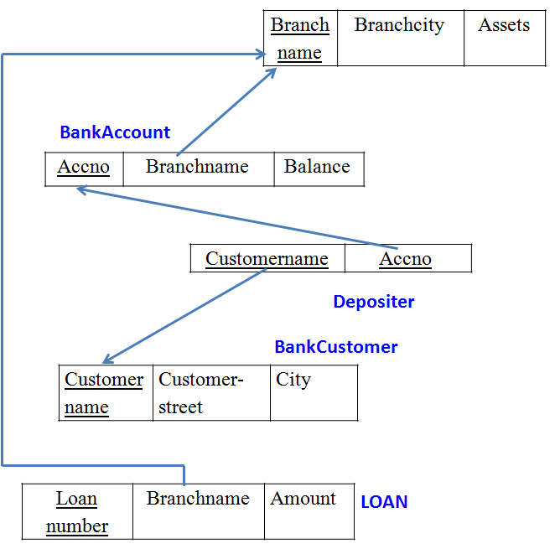

**Sample Table data**

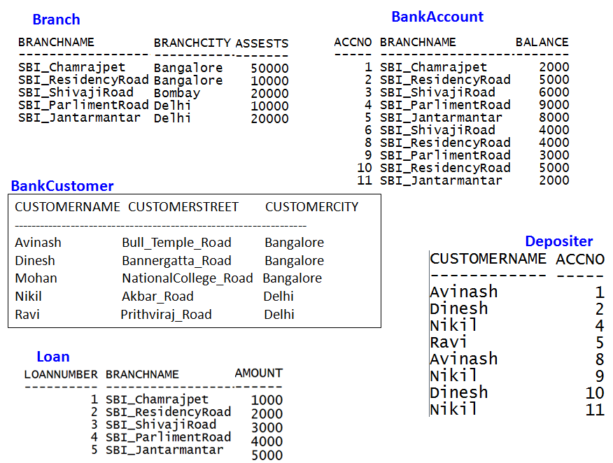

create database Bankingenterprise;

use Bankingenterprise;

CREATE TABLE BRANCH

(

branch_name varchar(50),

branch_city varchar(50),

assets real,

primary key(branch_name)

);

CREATE TABLE BankAccount

(

accno int,

branch_name varchar(50),

balance real,

primary key(accno),

FOREIGN KEY(branch_name) REFERENCES BRANCH(branch_name) ON DELETE SET NULL ON UPDATE CASCADE

);

CREATE TABLE BankCustomer

(

customer_name varchar(50) primary key,

customer_street varchar(50),

customer_city varchar (50)

);

CREATE TABLE Depositor

(

customer_name varchar(50),

accno int,

foreign key(accno) references BankAccount(accno),

foreign key(customer_name) references BankCustomer(customer_name)

);

CREATE TABLE Loan

(

loan_number int,

branch_name varchar(50),

amount real,

primary key(loan_number),

foreign key(branch_name) references Branch(branch_name)

);

INSERT INTO Branch

VALUES ("SBI_Chamrajpet", "BANGALORE",50000),("SBI_ResidencyRoad", "BANGALORE",10000),

("SBI_ShivajiRoad", "Bombay",20000),("SBI_ParlimentRoad", "Delhi",10000),

("SBI_Jantarmantar", "Delhi",20000);

select * from Branch;

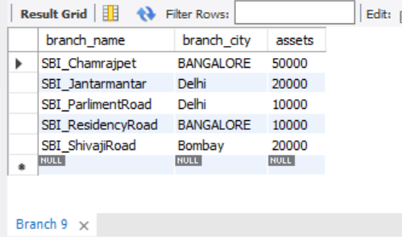

INSERT INTO BankAccount

VALUES (1,"SBI_Chamrajpet",2000),(2,"SBI_ResidencyRoad",5000),

(3,"SBI_ShivajiRoad",6000),(4,"SBI_ParlimentRoad",9000),(5,"SBI_Jantarmantar",8000),

(6,"SBI_ShivajiRoad",4000),(8,"SBI_ResidencyRoad",4000),(9,"SBI_ParlimentRoad",3000),

(10,"SBI_ResidencyRoad",5000),(11,"SBI_Jantarmantar",2000);

select * from BankAccount;

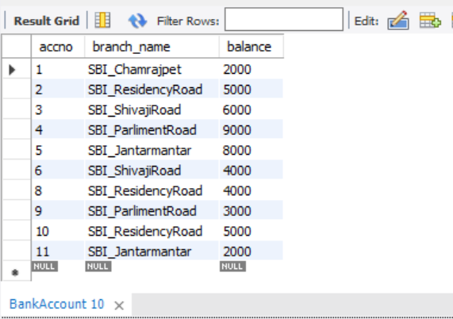

INSERT INTO BankCustomer

VALUES ("Avinash","Bull_Temple_Road","Bangalore");

INSERT INTO BankCustomer

VALUES("Dinesh","Bannergatta_Road","Bangalore");

INSERT INTO BankCustomer

VALUES ("Mohan","NationtalCollege__Road","Bangalore");

INSERT INTO BankCustomer

VALUES("Nikil","Akbar_Road","Delhi");

INSERT INTO BankCustomer

VALUES ("Ravi","Prithviraj_Road","Delhi");

select * from BankCustomer;

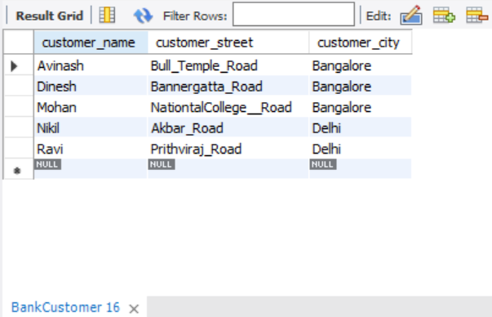

INSERT INTO Depositor

VALUES("Avinash",1),("Dinesh",2),("Nikil",4),

("Ravi",5),("Avinash",8),("Nikil",9),("Dinesh",10),("Nikil",11);

select * from Depositor;

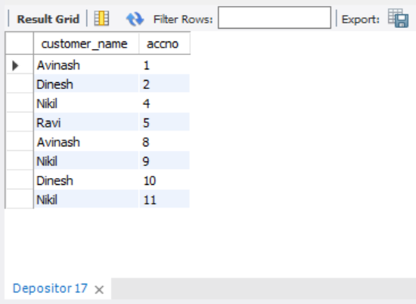

INSERT INTO Loan

VALUES (1,"SBI_Chamrajpet",1000),(2,"SBI_ResidencyRoad",2000),(3,"SBI_ShivajiRoad",3000),

(4,"SBI_ParlimentRoad",4000),(5,"SBI_Jantarmantar",5000);

select * from Loan;

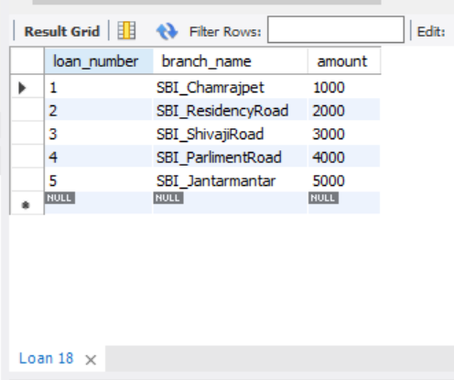

iii. Find all the customers who have at least two accounts at the *Main* branch (ex. SBI_ResidencyRoad).

SELECT *

FROM BankCustomer

WHERE customer_name IN ( SELECT customer_name

FROM depositor

group by customer_name

having COUNT(customer_name)>=2);

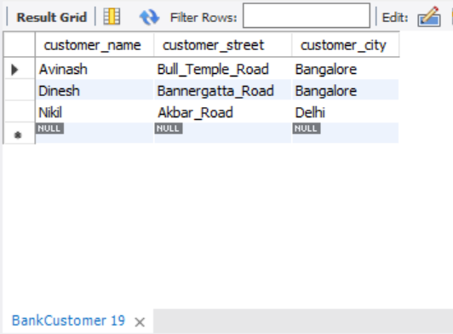

iv. Find all the customers who have an account at *all* the branches located in a

specific city (Ex. Delhi).

SELECT d.customer_name

FROM BankAccount a, Depositor d, Branch b

WHERE d.accno=a.accno AND b.branch_name=a.branch_name AND b.branch_city="Bangalore"

GROUP BY d.customer_name

HAVING count(distinct b.branch_name)=

(SELECT COUNT(branch_name)

FROM branch

WHERE branch_city="Bangalore");

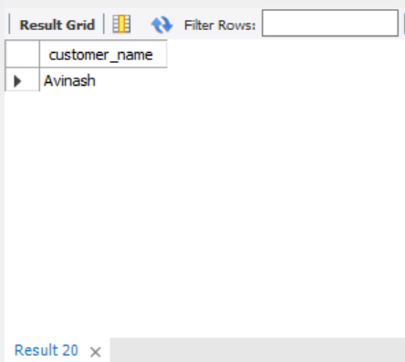

v. Demonstrate how you delete all account tuples at every branch located in

a specific city (Ex. Bombay).

DELETE FROM depositor

WHERE accno IN

(SELECT accno

FROM Branch b, BankAccount a

WHERE branch_city = 'delhi' and b.branch_name = a.branch_name);

DELETE FROM BankAccount WHERE branch_name IN(SELECT branch_name FROM BRANCH WHERE branch_city='delhi');

SELECT * FROM BankAccount;

