**PROGRAM 3: SUPPLIER DATABASE**

**Consider the following schema:**

**SUPPLIERS(sid: integer, sname: string, address: string)**

**PARTS(pid: integer, pname: string, color: string)**

**CATALOG(sid: integer, pid: integer, cost: real)**

**The Catalog relation lists the prices charged for parts by Suppliers.**

**Write the following queries in SQL:**

1. Find the pnames of parts for which there is some supplier.
2. Find the snames of suppliers who supply every part.
3. Find the snames of suppliers who supply every red part.
4. Find the pnames of parts supplied by Acme Widget Suppliers and by no one else.
5. Find the sids of suppliers who charge more for some part than the average cost of that part (averaged over all the suppliers who supply that part).
6. For each part, find the sname of the supplier who charges the most for that part.

**Schema Diagram**

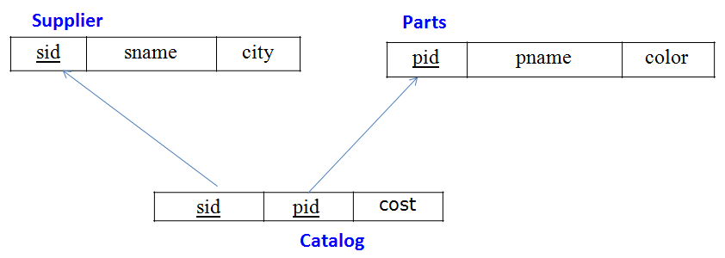

**Table Data**

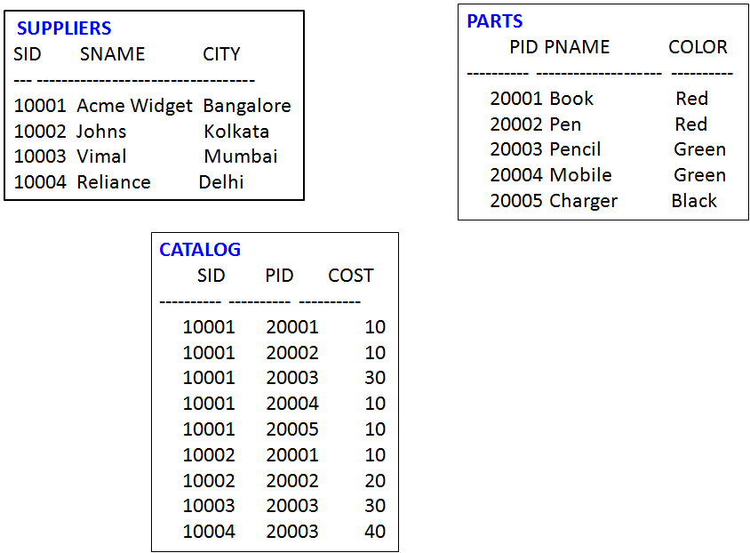

CREATE DATABASE Supplier_Database1;

USE Supplier_Database1;

CREATE TABLE SUPPLIER

(

sid int,

sname varchar(20),

address varchar(40),

primary key(sid)

);

CREATE TABLE PARTS

(

pid int,

pname varchar(40),

color varchar(20),

primary key(pid)

);

CREATE TABLE CATALOG

(

sid int,

pid int,

cost real,

FOREIGN KEY(sid) REFERENCES SUPPLIER(sid),

FOREIGN KEY(pid) REFERENCES PARTS(pid)

);

INSERT INTO SUPPLIER

VALUES (10001,"Acme Widget","Bangalore"),(10002,"Johns","Kolkata"),(10003,"Vimal","Mumbai"),

(10004,"Reliance","Delhi");

SELECT * FROM SUPPLIER;

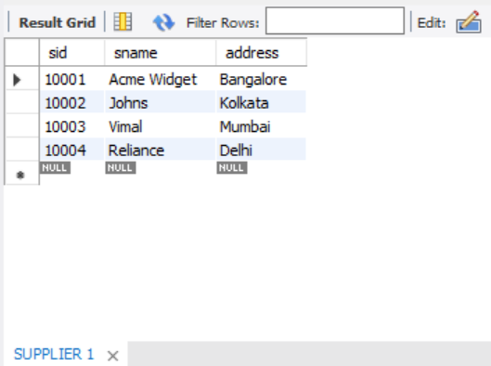

INSERT INTO PARTS

VALUES (20001,"Book","Red"), (20002,"Pen","Red"), (20003,"Pencil","Green"), (20004,"Mobile","Green"), (20005,"Charger","Black");

SELECT * FROM PARTS;

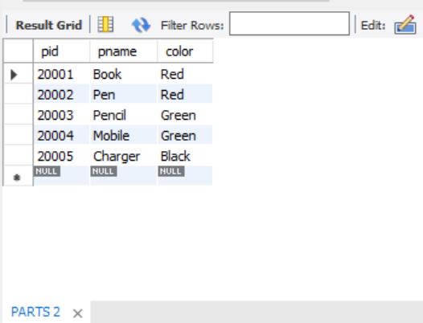

INSERT INTO CATALOG

VALUES (10001,20001,10),(10001,20002,10),(10001,20003,30),(10001,20004,10),(10001,20005,10),

(10002,20001,10),(10002,20002,20),(10003,20003,30),(10004,20003,40);

SELECT * FROM CATALOG;

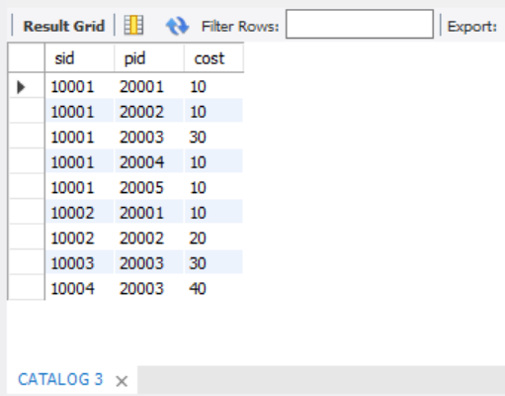

a.Find the pnames of parts for which there is some supplier.

SELECT DISTINCT p.pname

FROM parts p, catalog c

WHERE p.pid = c.pid;

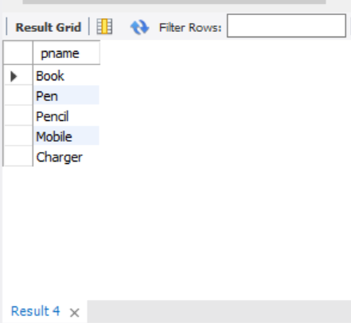

b.Find the snames of suppliers who supply every part.

SELECT SUPPLIER.sname, CATALOG.sid

FROM SUPPLIER, CATALOG

WHERE SUPPLIER.sid = CATALOG.sid

group by SUPPLIER.sname

having count(CATALOG.sid)=(select count(pid)

from PARTS);

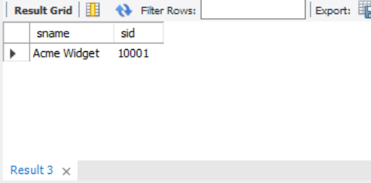

c.Find the snames of suppliers who supply every red part.

SELECT distinct s.sname

FROM SUPPLIER s, CATALOG c

WHERE s.sid = c.sid and c.pid in (select pid from PARTS WHERE color="Red");

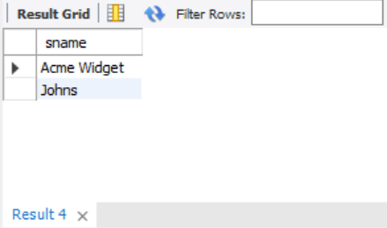

d. Find the pnames of parts supplied by Acme Widget Suppliers and by no one else.

SELECT pname

FROM PARTS P , CATALOG C

WHERE p.pid = c.pid AND sid in (SELECT sid from SUPPLIER WHERE sname = "Acme Widget");

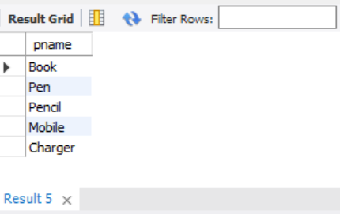

e. Find the sids of suppliers who charge more for some part than the average cost of that part (averaged over all the suppliers who supply that part).

SELECT c.sid

FROM CATALOG c WHERE c.cost > (SELECT AVG(cost)

FROM CATALOG

WHERE pid = c.pid) ;

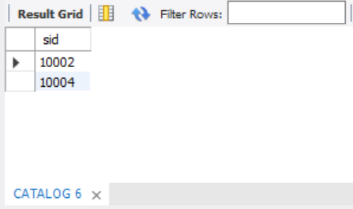

f. For each part, find the sname of the supplier who charges the most for that part.

SELECT c.pid, s.sname

FROM PARTS p, SUPPLIER s, CATALOG c

WHERE s.sid = c.sid AND c.cost = (SELECT MAX(cost)

FROM catalog

WHERE pid = c.pid);

