**PROGRAM 4: STUDENT  FACULTY DATABASE**

**Consider the following database for**

**student enrollment for course :**

**STUDENT(snum: integer, sname:string, major: string, lvl: string, age: integer)**

**CLASS(cname: string, meetsat: time, room: string, fid: integer)**

**ENROLLED(snum: integer, cname:string)**

**FACULTY(fid: integer, fname:string, deptid: integer)**

**The meaning of these relations is straightforward; for example, Enrolled has one record per student-class pair such that the student is enrolled in the class. Level(lvl) is a two character**

**code with 4 different values (example: Junior: JR etc)**

**Write the following queries in SQL.**

**No duplicates should be printed in any of the answers.**

i. Find the names of all Juniors (level = JR) who are enrolled in a class taught by

ii. Find the names of all classes that either meet in room R128 or have five or more

Students enrolled.

iii. Find the names of all students who are enrolled in two classes that meet at the same

time.

iv. Find the names of faculty members who teach in every room in which some class is

taught.

v. Find the names of faculty members for whom the combined enrollment of the courses

that they teach is less than five.

vi. Find the names of students who are not enrolled in any class.

vii. For each age value that appears in Students, find the level value that appears most

often. For example, if there are more FR level students aged 18 than SR, JR, or

SO students aged 18, you should print the pair (18, FR).

**SQL> select * from student;**

      SNUM SNAME      MA LV      AGE

---------- ---------- -- -- ----------

         1 jhon       CS Sr         19

         2 Smith      CS Jr          20

         3 Jacob      CV Sr         20

         4 Tom        CS Jr         20

         5 Rahul      CS Jr         20

         6 Rita       CS Sr         21

**SQL> select * from faculty;**

       FID FNAME                    DEPTID

---------- -------------------- ----------

        11 Harish                     1000

        12 MV                         1000

        13 Mira                       1001

        14 Shiva                      1002

        15 Nupur                      1000

SQL> select * from class;

CNAME     METTS_A                        ROOM              FID

Class1         12/11/15 10:15:16.00000      R1                   14

Class10      12/11/15 10:15:16.00000      R128               14

Class2        12/11/15 10:15:20.000000    R2                 12

Class3        12/11/15 10:15:25.000000   R3                 11

Class4        12/11/15 20:15:20.000000   R4                 14

Class5        12/11/15 20:15:20.000000    R3                 15

Class6       12/11/15 13:20:20.000000    R2                 14

Class7       12/11/15 10:10:10.000000    R3                 14

**SQL> select * from enrolled;**

      SNUM CNAME

---------- --------------------

         1 class1

         2 class1

         3 class3

         4 class3

         5 class4

CREATE DATABASE STUDENT_FACULTY1;

USE STUDENT_FACULTY1;

CREATE TABLE STUDENT

(

snum int,

sname varchar(40),

major varchar(30),

lvl varchar(20),

age int,

primary key(snum)

);

CREATE TABLE FACULTY

(

fid int,

fname varchar(40),

deptid int,

primary key(fid)

);

CREATE TABLE CLASS

(

cname varchar(40),

meetsat datetime;

room varchar(20),

fid int,

primary key(cname),

FOREIGN KEY(fid) REFERENCES FACULTY(fid)

);

CREATE TABLE ENROLLED

(

snum int,

cname varchar(40),

FOREIGN KEY(snum) REFERENCES STUDENT(snum),

FOREIGN KEY(cname) REFERENCES CLASS(cname)

);

INSERT INTO STUDENT

VALUES (1,"john","CS","Sr",19),(2,"Smith","CS","Jr",20),(3,"Jacob","CV","Sr",20),

(4,"Tom","CS","Jr",20),(5,"Rahul","CS","Jr",20),(6,"Rita","CS","Sr",21);

SELECT * FROM STUDENT;

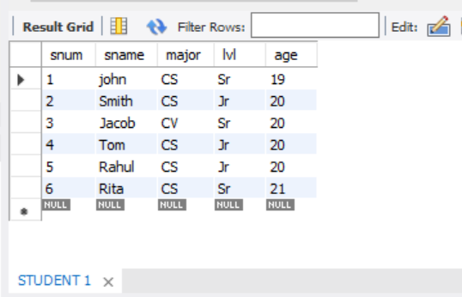

INSERT INTO FACULTY

VALUES (11,"Harish",1000),(12,"MV",1000),(13,"Mira",1001),(14,"Shiva",1002),

(15,"Nupur",1000);

SELECT * FROM FACULTY;

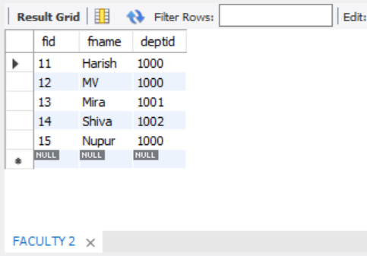

INSERT INTO CLASS

VALUES ("Class1",'2015-11-12:10:15:16.00000',"R1",14);

SELECT * FROM CLASS;

update CLASS

set meetsat='2015-11-12:10:15:16.00000'

where cname="Class1";

INSERT INTO CLASS

VALUES ("Class10",'2015-11-12:10:15:16.00000',"R 128",14),

("Class2",'2015-11-12:10:15:20.00000',"R2",12),

("Class3",'2015-11-12:10:15:25.00000',"R3",11),

("Class4",'2015-11-12:20:15:20.00000',"R4",14),

("Class5",'2015-11-12:20:15:20.00000',"R3",15),

("Class6",'2015-11-12:13:20:20.00000',"R2",14),

("Class7",'2015-11-12:10:10:10.00000',"R3",14);

select * from CLASS;

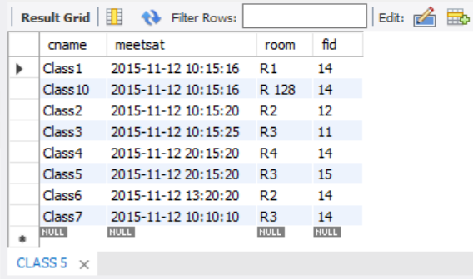

INSERT INTO ENROLLED

VALUES (1,"class1"),(2,"class1"),(3,"class3"),(4,"class3"),(5,"class4");

select * from ENROLLED;

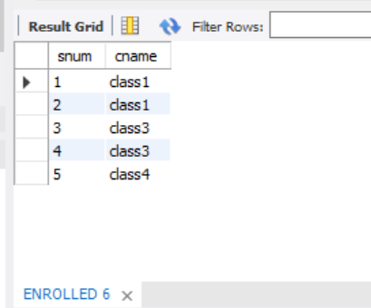

i. Find the names of all Juniors (level = JR) who are enrolled in a class taught by

SELECT s.sname

FROM STUDENT s, CLASS c, ENROLLED e

WHERE s.snum=e.snum and c.cname=e.cname and c.fid = (select fid

from FACULTY

where fname="Harish") and S.lvl="Jr";

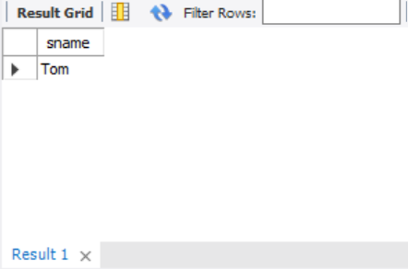

ii. Find the names of all classes that either meet in room R128 or have five or more

Students enrolled.

SELECT c.cname

FROM CLASS c

WHERE c.room = 'R 128' or c.cname in (select e.cname

from ENROLLED e

group by e.cname

having count(*)>=5);

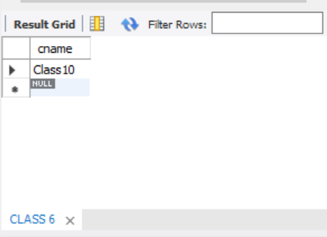

iii. Find the names of all students who are enrolled in two classes that meet at the same

time.

SELECT distinct s.sname

FROM STUDENT s

WHERE S.snum in (select e1.snum

from ENROLLED e1, ENROLLED e2, CLASS c1, CLASS c2

where e1.snum = e2.snum and e1.cname <> e2.cname and e1.cname = c1.cname

and e2.cname = c2.cname and c1.meetsat = c2.meetsat);

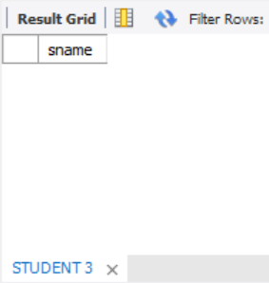

iv. Find the names of faculty members who teach in every room in which some class is

taught.

SELECT f.fname, c.fid

FROM FACULTY f, CLASS c

WHERE f.fid = c.fid

group by c.fid

having count(c.fid)=(select COUNT(distinct room)

from CLASS);

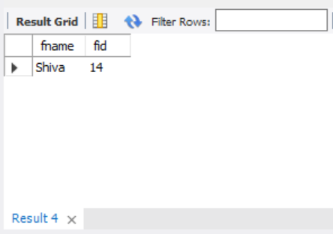

v. Find the names of faculty members for whom the combined enrollment of the courses

that they teach is less than five.

SELECT distinct fname

FROM FACULTY f

WHERE 5> (select COUNT(e.snum)

from ENROLLED e,CLASS c

where c.cname=e.cname and c.fid=f.fid);

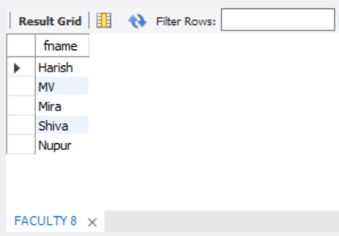

vi. Find the names of students who are not enrolled in any class.

SELECT s.sname

FROM STUDENT s

WHERE snum not in (select snum

from ENROLLED);

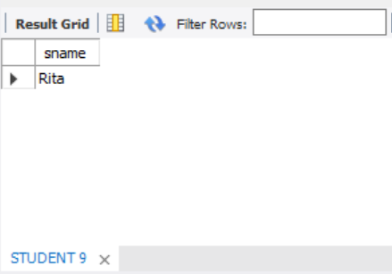

vii. For each age value that appears in Students, find the level value that appears most

often. For example, if there are more FR level students aged 18 than SR, JR, or

SO students aged 18, you should print the pair (18, FR).

SELECT s.age ,s.lvl

FROM STUDENT s

group by s.age

having s.lvl in (select s1.lvl

from STUDENT s1

where s1.age=s.age

group by s1.age

having count(*)>= all (select s2.lvl

from STUDENT s2

where s2.age=s1.age

group by s2.age));

