**Ashwini**

**1BM20CS402**

**CSE-4A**

**PROGRAM 5: AIRLINE FLIGHT DATABASE**

**Consider the following database that keeps track of airline flight information:**

**FLIGHTS(flno: integer, from: string, to: string, distance: integer, departs: time, arrives: time, price: integer)**

**AIRCRAFT(aid: integer, aname: string, cruisingrange: integer)**

**CERTIFIED(eid: integer, aid: integer)**

**EMPLOYEES(eid: integer, ename: string, salary: integer)**

**Note that the Employees relation describes pilots and other kinds of employees as well; Every pilot is certified for some aircraft, and only pilots are certified to fly.**

**Write each of the following queries in SQL.**

1. Find the names of aircraft such that all pilots certified to operate them have salaries more than Rs.80,000.
2. For each pilot who is certified for more than three aircrafts, find the eid and the maximum cruisingrange of the aircraft for which she or he is certified.
3. Find the names of pilots whose salary is less than the price of the cheapest route from Bengaluru to Frankfurt.
4. For all aircraft with cruisingrange over 1000 Kms, find the name of the aircraft and the average salary of all pilots certified for this aircraft.
5. Find the names of pilots certified for some Boeing aircraft.
6. Find the aids of all aircraft that can be used on routes from Bengaluru to New Delhi.
7. A customer wants to travel from Bangalore to Kolkata New with no more than two changes of flight. List the choice of departure times from Madison if the customer wants to arrive in Kolkata by 6 p.m.

**SQL> select * from Flights;**

 FLNO FFROM           TO               DISTANCE    DEPARTS    ARRIVES     PRICE

 101 Bangalore  Delhi  2500 13-MAY-05 07.15.31.000000 AM13-MAY-05 07.15.31.000000 A   5000

102 Bangalore  Lucknow               3000  05/05/13 07:15:31.000000 05/05/13 11:15:31.000000  6000

103 Lucknow         Delhi                   500 05/05/13 12:15:31.000000  05/05/13 17:15:31.000000  3000

107 Bangalore       Frankfurt             8000  05/05/13 07:15:31.000000  05/05/13 22:15:31.000000  60000

104 Bangalore       Frankfurt             8500  05/05/13 07:15:31.000000    05/05/13 23:15:31.00000   75000

105 Kolkata         Delhi                  3400   05/05/13 07:15:31.000000   05/05/13 09:15:31.000000  7000

**SQL> select * from Aircraft;**

       AID ANAME      CRUISINGRANGE

---------- ---------- -------------

       101 747                 3000

       102 Boeing               900

       103 647                  800

       104 Dreamliner         10000

       105 Boeing              3500

       106 707                 1500

       107 Dream             120000

7 rows selected.

**SQL> select * from Certified;**

       EID        AID

---------- ----------

       701        101

       701        102

       701        106

       701        105

       702        104

       703        104

       704        104

       702        107

       703        107

       704        107

       702        101

       EID        AID

---------- ----------

       703        105

       704        105

       705        103

14 rows selected.

**SQL> select * from Employees;**

       EID ENAME               SALARY

---------- --------------- ----------

       701 A                    50000

       702 B                   100000

       703 C                   150000

       704 D                    90000

       705 E                    40000

       706 F                    60000

       707 G                    90000

7 rows selected.

CREATE DATABASE AIRLINE_FLIGHT_DATABASE;

USE AIRLINE_FLIGHT_DATABASE;

CREATE TABLE FLIGHTS

(

flno int,

ffrom varchar(40),

tto varchar(40),

distance int,

departs datetime,

arrives datetime,

price int,

primary key(flno)

);

CREATE TABLE AIRCRAFT

(

aid int,

aname varchar(40),

cruisingrange int,

primary key(aid)

);

CREATE TABLE EMPLOYEES

(

eid int,

ename varchar(40),

salary int,

primary key(eid)

);

CREATE TABLE CERTIFIED

(

eid int,

aid int,

FOREIGN KEY(aid) REFERENCES AIRCRAFT(aid),

FOREIGN KEY(eid) REFERENCES EMPLOYEES(eid)

);

INSERT INTO FLIGHTS

VALUES (101,"Bangalore","Delhi",2500,'2005-05-13:07:15:31.000000','2005-05-13:07:15:31.000000',5000),

(102,"Bangalore","Lucknow",3000,'2013-05-05:07:15:31.000000','2013-05-05:11:15:31.000000',6000),

(103,"Lucknow","Delhi",500,'2013-05-05:12:15:31.000000','2013-05-05:17:15:31.000000',3000),

(107,"Bangalore","Frankfurt",8000,'2013-05-05:07:15:31.000000','2013-05-05:22:15:31.000000',60000),

(104,"Bangalore","Frankfurt",8500,'2013-05-05:07:15:31.000000','2013-05-05:23:15:31.000000',75000),

(105,"Kolkata","Delhi",3400,'2013-05-05:07:15:31.000000','2013-05-05:09:15:31.000000',7000);

SELECT * FROM FLIGHTS;

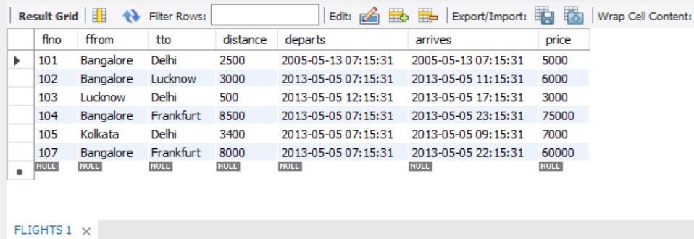

INSERT INTO AIRCRAFT

VALUES (101,747,3000),(102,"Boeing",900),(103,647,800),(104,"Dreamliner",10000),

(105,"Boeing",3500),(106,707,1500),(107,"Dream",120000);

SELECT * FROM AIRCRAFT;

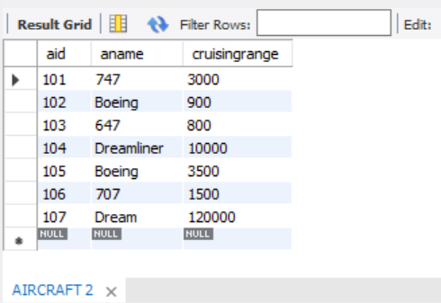

INSERT INTO EMPLOYEES

VALUES (701,"A",50000),(702,"B",100000),(703,"C",150000),(704,"D",90000),

(705,"E",40000),(706,"F",60000),(707,"G",90000);

SELECT * FROM EMPLOYEES;

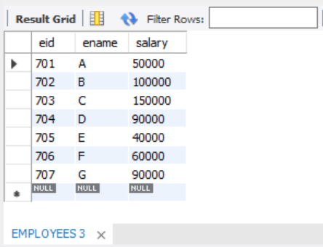

INSERT INTO CERTIFIED

VALUES (701,101),(701,102),(701,106),(701,105),(702,104),(703,104),(704,104),(702,107),

(703,107),(704,107),(702,101),(703,105),(704,105),(705,103);

SELECT * FROM CERTIFIED;

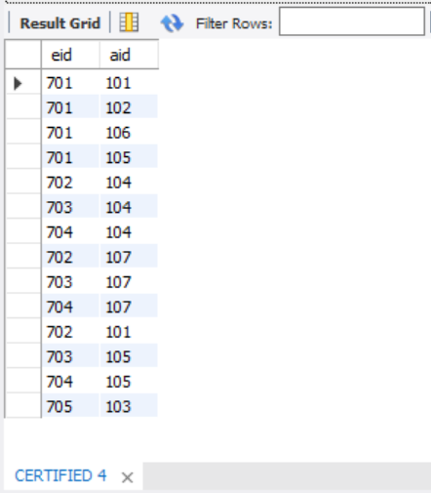

a.Find the names of aircraft such that all pilots certified to operate them have salaries more than Rs.80,000.

SELECT distinct a.aname

FROM AIRCRAFT a,EMPLOYEES e,CERTIFIED c

WHERE a.aid=c.aid and e.eid=c.eid and e.salary>80000;

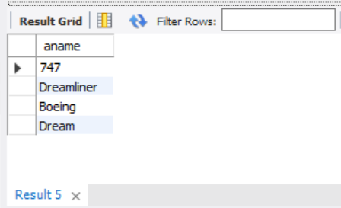

b.For each pilot who is certified for more than three aircrafts, find the eid and the maximum cruisingrange of the aircraft for which she or he is certified.

SELECT e.eid,e.ename,max(a. cruisingrange)

FROM EMPLOYEES e,CERTIFIED c,AIRCRAFT a

WHERE e.eid=c.eid and a.aid=c.aid

group by e.ename

having count(c.aid)>3;

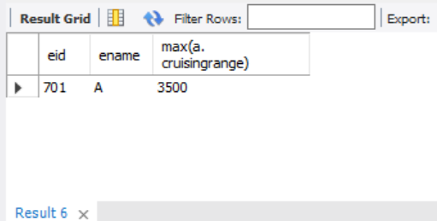

c.Find the names of pilots whose salary is less than the price of the cheapest route from Bengaluru to Frankfurt.

SELECT e.ename

FROM EMPLOYEES e

WHERE salary < (select min(price)

from FLIGHTS

where ffrom="Bangalore" and tto="Frankfurt");

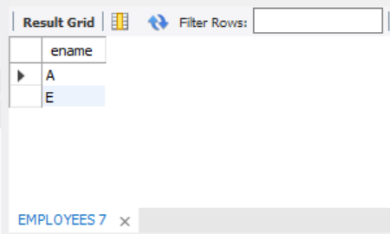

d.For all aircraft with cruisingrange over 1000 Kms, find the name of the aircraft and the average salary of all pilots certified for this aircraft.

SELECT a.aname,a.cruisingrange,avg(e.salary)

FROM AIRCRAFT a,EMPLOYEES e,CERTIFIED c

WHERE c.eid=e.eid and c.aid=a.aid

group by a.aname

having a.cruisingrange > 1000;

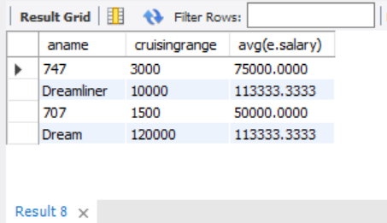

e.Find the names of pilots certified for some Boeing aircraft.

SELECT distinct e.ename

FROM EMPLOYEES e,CERTIFIED c,AIRCRAFT a

WHERE e.eid=c.eid and a.aid=c.aid and aname like "Boeing";

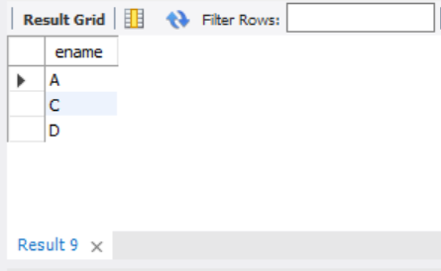

f.Find the aids of all aircraft that can be used on routes from Bengaluru to New Delhi.

SELECT a.aid

FROM AIRCRAFT a

WHERE a. cruisingrange >= (select distance

from FLIGHTS

where ffrom="Bangalore" and tto="Delhi");

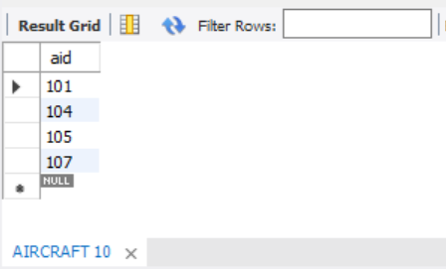

g. A customer wants to travel from Bangalore to Kolkata New with no more than two changes of flight. List the choice of departure times from Madison if the customer wants to arrive in Kolkata by 6 p.m.

SELECT f.ffrom,f.tto,f.arrives

FROM FLIGHTS f

WHERE (f.ffrom="Bangalore" and f.tto=(select ffrom

from FLIGHTS

where tto="Kolkata")) or f.tto="Kolkata";

