**Ashwini**

**1BM20CS402**

**CSE-4A**

**Program 6 : Order Database**

**Consider the following schema for Order Database:**

**SALESMAN** (Salesman_id, Name, City, Commission)

**CUSTOMER** (Customer_id, Cust_Name, City, Grade, Salesman_id)

**ORDERS** (Ord_No, Purchase_Amt, Ord_Date, Customer_id, Salesman_id)

**Write SQL queries to**

1. Count the customers with grades above Bangalore’s average.

2. Find the name and numbers of all salesmen who had more than one customer.

3. List all salesmen and indicate those who have and don’t have customers in their cities (Use UNION operation.)

4. Create a view that finds the salesman who has the customer with the highest order of a day.

5. Demonstrate the DELETE operation by removing salesman with id 1000. All his orders must also be deleted.

SELECT * FROM SALESMAN;

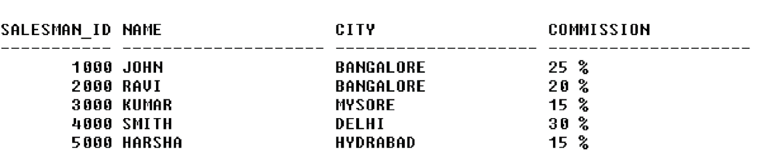

SELECT * FROM CUSTOMER1;

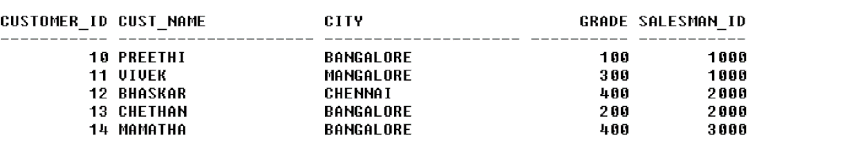

SELECT * FROM ORDERS;

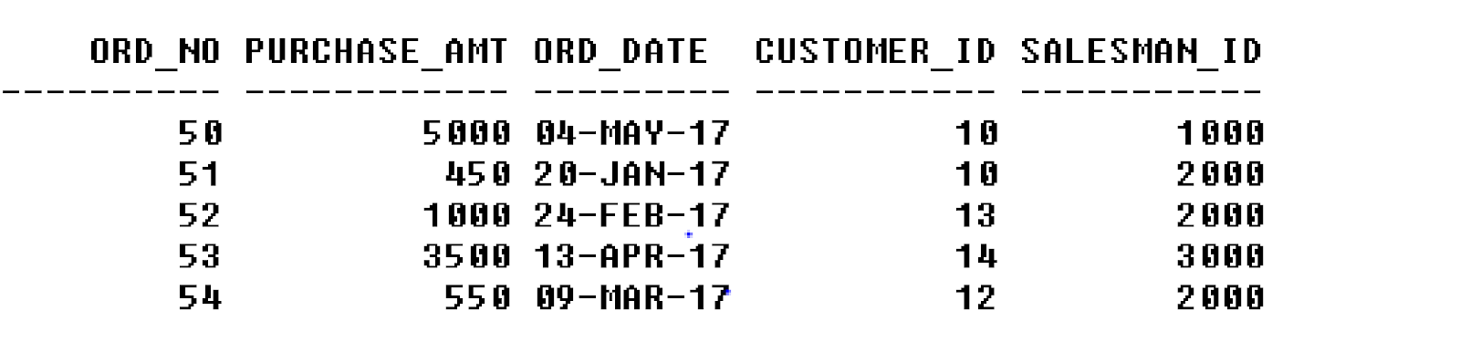

CREATE DATABASE ORDER_DATABASE;

USE ORDER_DATABASE;

CREATE TABLE SALESMAN

(

Salesman_id int primary key,

Name varchar(40),

City varchar(20),

Commission decimal

);

CREATE TABLE CUSTOMER

(

Customer_id int primary key,

Cust_Name varchar(40),

City varchar(20),

Grade int,

Salesman_id int,

Foreign Key(Salesman_id) references SALESMAN(Salesman_id)

);

CREATE TABLE ORDERS

(

Ord_No int primary key,

Purchase_Amt int,

Ord_Date Date,

Customer_id int,

Salesman_id int,

Foreign Key(Salesman_id) references SALESMAN(Salesman_id),

Foreign Key(Customer_id) references CUSTOMER(Customer_id)

);

insert into SALESMAN

values (1000,"John","Bangalore",25),

(2000,"Ravi","Bangalore",20),

(3000,"Kumar","Mysore",15),

(4000,"Smith","Delhi",30),

(5000,"Harsha","Hydrabad",15);

SELECT Salesman_id,Name,city,concat(Commission,'%') AS COMMISSION FROM SALESMAN;

select * from SALESMAN;

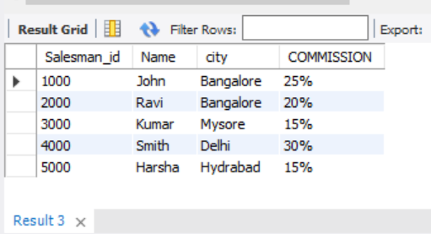

insert into CUSTOMER

values (10,"Preethi","Bangalore",100,1000),

(11,"Vivek","Mangalore",300,1000),

(12,"Bhaskar","Chennai",400,2000),

(13,"Chethan","Bangalore",200,2000),

(14,"Mamatha","Bangalore",400,3000);

select * from CUSTOMER;

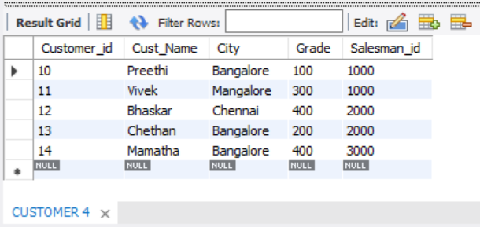

insert into ORDERS

values (50,5000,'2017-05-04',10,1000),

(51,450,'2017-01-20',10,2000),

(52,1000,'2017-02-24',13,2000),

(53,3500,'2017-04-13',14,3000),

(54,550,'2017-03-09',12,2000);

select * from ORDERS;

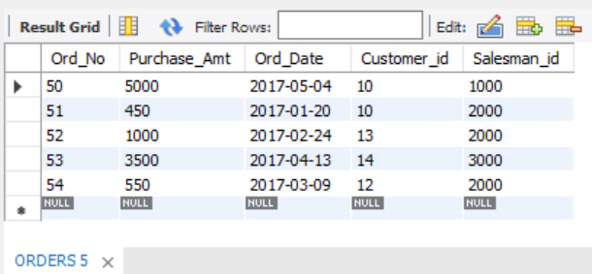

1. Count the customers with grades above Bangalore’s average.

select count(Cust_Name)

from CUSTOMER

where grade> (Select avg(grade)

from CUSTOMER

where city ='Bangalore');

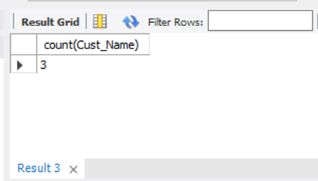

1. Find the name and numbers of all salesmen who had more than one customer.

select distinct c.Salesman_id,s.name

from CUSTOMER c,SALESMAN s

where c.Salesman_id=s.Salesman_id and 1<(select count(Customer_id)

from CUSTOMER

where Salesman_id=c.Salesman_id);

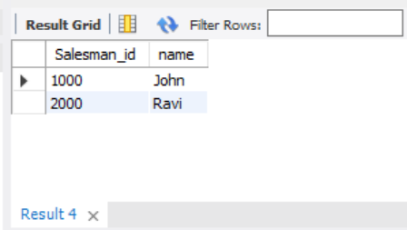

1. List all salesmen and indicate those who have and don’t have customers in their cities (Use UNION operation.)

select s.Name,c.Cust_name

from SALESMAN s,CUSTOMER c

where s.Salesman_id=c.Salesman_id and c.City=s.City

union

select s.Name,'No Match' from SALESMAN s,CUSTOMER c

where s.Salesman_id = c.Salesman_id and c.City!=s.City;

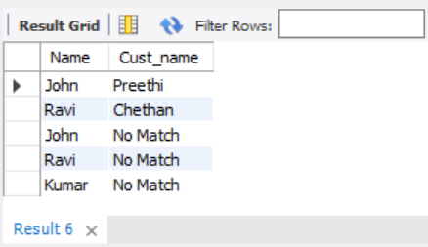

1. Create a view that finds the salesman who has the customer with the highest order of a day.

create view Salesman_view as

select o.Ord_Date ,Salesman_id,sum(o.Purchase_Amt)

from ORDERS o

group by Ord_Date

having sum(Purchase_Amt)=(select max(sum(Purchase_Amt))from CUSTOMER

where Ord_Date =o.Ord_Date and Salesman_id =o.Salesman_id);

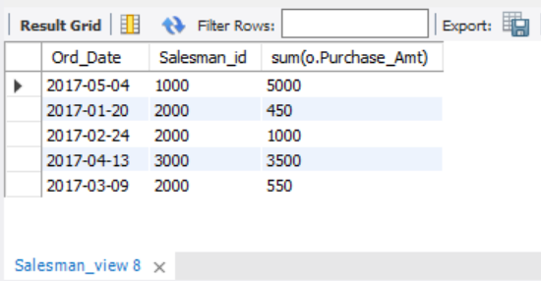

5.Demonstrate the DELETE operation by removing salesman with id 1000. All his orders must also be deleted.

