**Ashwini**

**1BM20CS402**

**CSE-4A**

**Program 7 : Book Database**

BOOK (Book_id, Title, Publisher_Name, Pub_Year) BOOK_AUTHORS (Book_id, Author_Name) PUBLISHER (Name, Address, Phone) BOOK_COPIES (Book_id, Branch_id, No-of_Copies)

BOOK_LENDING (Book_id, Branch_id, Card_No, Date_Out, Due_Date)

LIBRARY_BRANCH (Branch_id, Branch_Name, Address)

# Write SQL queries to

1. Retrieve details of all books in the library – id, title, name of publisher, authors, number of copies in each branch, etc.
2. Get the particulars of borrowers who have borrowed more than 3 books, but from Jan 2017 to Jun 2017
3. Delete a book in BOOK table. Update the contents of other tables to reflect this data manipulation operation.
4. Partition the BOOK table based on year of publication. Demonstrate its working with a simple query.
5. Create a view of all books and its number of copies that are currently available in the Library.

create database bookdb; use bookdb;

create table publisher( name varchar(30) not null, address varchar(20) , phone varchar(10), primary key(name)

);

create table book( book_id int not null, title varchar(20),

publisher_name varchar(20), pub_year varchar(20), primary key(book_id),

foreign key(publisher_name) references publisher(name)

);

create table book_authors( book_id int not null,

author_name varchar(30) not null, primary key(book_id,author_name),

foreign key(book_id) references book(book_id)

);

create table library_branch( branch_id int not null, address varchar(20), branch_name varchar(20), primary key(branch_id)

);

create table book_copies( book_id int not null, branch_id int not null, no_of_copies int,

primary key(book_id,branch_id),

foreign key(book_id) references book(book_id), foreign key(branch_id) references library_branch(branch_id)

);

create table Card( card_no int(10) not null, primary key(card_no)

);

create table book_lending

( date_out date,

due_date date, book_id int not null, branch_id int not null, card_no int not null,

primary key(book_id,branch_id,card_no), foreign key(book_id) references book(book_id), foreign key(branch_id) references library_branch(branch_id),

foreign key(card_no) references Card(card_no)

);

insert into publisher

values('MCGRAW-HILL','BANGALORE',9989076587), ('PEARSON', 'NEWDELHI', 9889076565),

('RANDOM HOUSE', 'HYDRABAD', 7455679345), ('HACHETTE LIVRE', 'CHENAI', 8970862340), ('GRUPO PLANETA', 'BANGALORE', 7756120238);

insert into book

values(1,'DBMS', 'MCGRAW-HILL','JAN-2017'),

(2,'ADBMS', 'MCGRAW-HILL','JUN-2016'),

(3,'CN', 'PEARSON','SEP-2016'),

(4,'CG', 'GRUPO PLANETA','SEP-2015'),

(5,'OS', 'PEARSON','MAY-2016');

insert into book_authors values(1,'NAVATHE'), (2,'NAVATHE'),

(3,'TANENBAUM'),

(4,'EDWARD ANGEL'),

(5,'GALVIN');

insert into library_branch values(10,'RR NAGAR','BANGALORE'),

(11,'RNSIT','BANGALORE'), (12,'RAJAJI NAGAR', 'BANGALORE'), (13,'NITTE','MANGALORE'),

(14,'MANIPAL','UDUPI');

insert into book_copies values( 1, 10,10),

( 1, 11,5),

( 2, 12,2),

( 2, 13,5),

( 3, 14,7),

( 5, 10,1),

( 4, 11,3);

insert into Card values(100), (101),

(102),

(103),

(104);

insert into book_lending

values('2017-01-01','2017-06-01', 1, 10, 101),

('2017-01-01','2017-03-11', 3, 14, 101),

('2017-02-21','2017-04-21', 2, 13, 101),

('2017-03-15','2017-07-15', 4, 11, 101),

('2017-04-12','2017-05-12', 1, 11, 104);

-------Retrieve details of all books in the library – id, title, name of publisher, authors, number of copies in each branch, etc.

select b.book_id,b.title,b.publisher_name,a.author_name,c.no_of_copies,l.branc h_id

from book b,book_authors a,book_copies c,library_branch l where b.book_id=a.book_id and b.book_id=c.book_id and l.branch_id=c.branch_id;

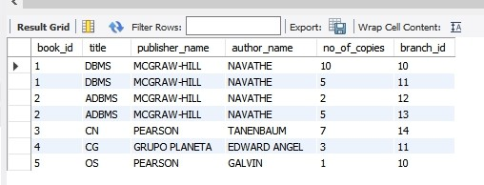

------Get the particulars of borrowers who have borrowed more than 3 books, but from Jan 2017 to Jun 2017

select card_no from book_lending

where date_out between '2017-01-01' and '2017-07-01' group by card_no

having count(*)>3;

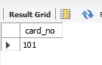

------Delete a book in BOOK table. Update the contents of other tables to reflect this data manipulation operation.

DELETE FROM BOOK WHERE BOOK_ID=3;

select * from book;

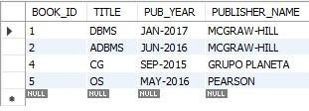

select * from book_authors;

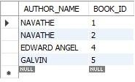

select * from book_lending;

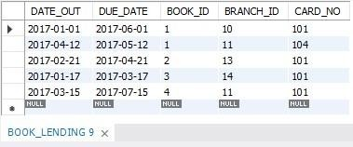

select * from book_copies;

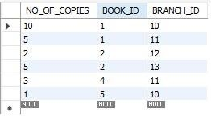

-------Partition the BOOK table based on year of publication. Demonstrate its working with a simple query.

CREATE VIEW YEAR_OF_PUBLICATION AS SELECT PUB_YEAR FROM BOOK;

SELECT * FROM YEAR_OF_PUBLICATION;

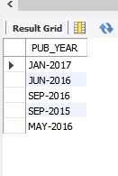

-------Create a view of all books and its number of copies that are currently available in the Library.

CREATE VIEW BOOKS_AVAILABLE_IN_LIBRARY

AS SELECT B.BOOK_ID, B.TITLE, C.NO_OF_COPIES FROM BOOK B, BOOK_COPIES C, LIBRARY_BRANCH L

WHERE B.BOOK_ID=C.BOOK_ID AND C.BRANCH_ID=L.BRANCH_ID;

SELECT * FROM BOOKS_AVAILABLE_IN_LIBRARY;

