**Ashwini**

**1BM20CS402**

**CSE-4A**

**PROGRAM 8. STUDENT ENROLLMENT DATABASE**

Consider the following database of student enrollment in courses and books adopted for each course.

STUDENT (regno: String, name: String, major: String, bdate: date)

COURSE (course #: int, cname: String, dept: String)

ENROLL (regno: String, cname: String, sem: int, marks: int)

BOOK_ADOPTION (course #: int, sem: int, book-ISBN: int)

TEXT(book-ISBN:int, book-title:String, publisher:String, author:String)

i. Create the above tables by properly specifying the primary keys and the foreign keys.

ii. Enter at least five tuples for each relation.

iii. Demonstrate how you add a new text book to the database and make this book be adopted by some

department.

iv. Produce a list of text books (include Course #, Book-ISBN, Book-title) in the alphabetical order for courses

offered by the ‘CS’ department that use more than two books.

v. List any department that has all its adopted books published by a specific publisher.

CREATE DATABASE COLLEGE;

USE COLLEGE;

CREATE TABLE student(

regno VARCHAR(15),

sname VARCHAR(20),

major VARCHAR(20),

bdate DATE,

PRIMARY KEY (regno) );

CREATE TABLE course(

courseno INT,

cname VARCHAR(20),

dept VARCHAR(20),

PRIMARY KEY (courseno) );

select * from course;

CREATE TABLE enroll(

regno VARCHAR(15),

courseno INT,

sem INT(3),

marks INT(4),

PRIMARY KEY (regno,courseno),

FOREIGN KEY (regno) REFERENCES student (regno),

FOREIGN KEY (courseno) REFERENCES course (courseno) );

select * from enroll;

CREATE TABLE text(

book_isbn INT(5),

book_title VARCHAR(20),

publisher VARCHAR(20),

author VARCHAR(20),

PRIMARY KEY (book_isbn) );

CREATE TABLE book_adoption(

courseno INT,

sem INT,

book_isbn INT,

PRIMARY KEY (courseno,book_isbn),

FOREIGN KEY (courseno) REFERENCES course (courseno),

FOREIGN KEY (book_isbn) REFERENCES text(book_isbn) );

INSERT INTO student (regno,sname,major,bdate) VALUES

('1pe11cs002','b','sr','19930924'),

('1pe11cs003','c','sr','19931127'),

('1pe11cs004','d','sr','19930413'),

('1pe11cs005','e','jr','19940824');

INSERT INTO student (regno,sname,major,bdate) VALUES

('1pe11cs001','a','jr','19930922');

INSERT INTO course VALUES (111,'OS','CSE'),

(112,'EC','CSE'),

(113,'SS','ISE'),

(114,'DBMS','CSE'),

(115,'SIGNALS','ECE');

INSERT INTO text VALUES

(10,'DATABASE SYSTEMS','PEARSON','SCHIELD'),

(900,'OPERATING SYS','PEARSON','LELAND'),

(901,'CIRCUITS','HALL INDIA','BOB'),

(902,'SYSTEM SOFTWARE','PETERSON','JACOB'),

(903,'SCHEDULING','PEARSON','PATIL'),

(904,'DATABASE SYSTEMS','PEARSON','JACOB'),

(905,'DATABASE MANAGER','PEARSON','BOB'),

(906,'SIGNALS','HALL INDIA','SUMIT');

INSERT INTO enroll (regno,courseno,sem,marks) VALUES ('1pe11cs001',115,3,100),

('1pe11cs002',114,5,100),

('1pe11cs003',113,5,100),

('1pe11cs004',111,5,100),

('1pe11cs005',112,3,100);

INSERT INTO book_adoption (courseno,sem,book_isbn) VALUES

(111,5,900),

(111,5,903),

(111,5,904),

(112,3,901),

(113,3,10),

(114,5,905),

(113,5,902),

(115,3,906);

select * from student;

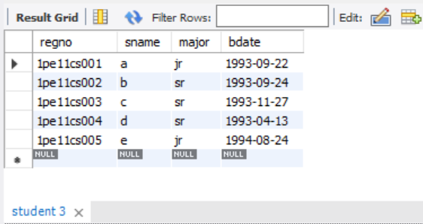

select * from course;

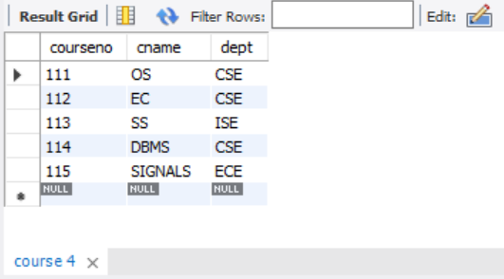

select * from enroll;

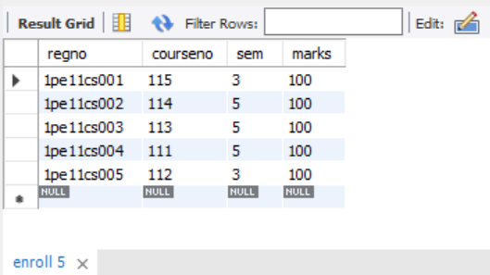

select * from book_adoption;

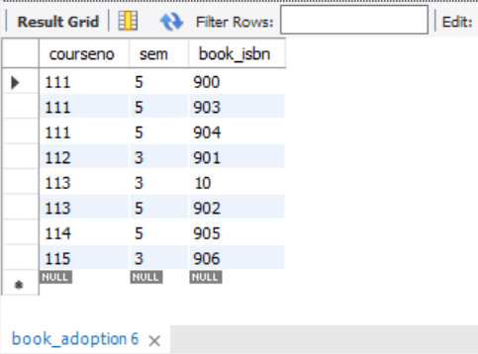

select * from text;

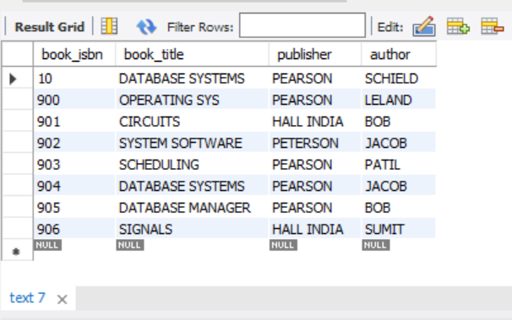

4. Produce a list of text books (include Course #, Book-ISBN, Book-title) in the alphabetical order for courses offered by the 'CS' department that use more than two books.

SELECT c.courseno,t.book_isbn,t.book_title

FROM course c,book_adoption ba,text t

WHERE c.courseno=ba.courseno

AND ba.book_isbn=t.book_isbn

AND c.dept='CSE'

AND 2<(

SELECT COUNT(book_isbn)

FROM book_adoption b

WHERE c.courseno=b.courseno)

ORDER BY t.book_title;

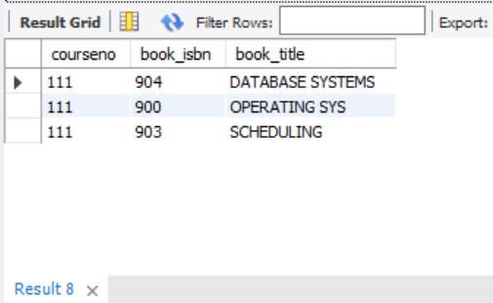

5.List any department that has all its adopted books published by a specific publisher.

SELECT DISTINCT c.dept

FROM course c

WHERE c.dept IN

( SELECT c.dept

FROM course c,book_adoption b,text t

WHERE c.courseno=b.courseno

AND t.book_isbn=b.book_isbn

AND t.publisher='HALL INDIA')

AND c.dept NOT IN

(SELECT c.dept

FROM course c,book_adoption b,text t

WHERE c.courseno=b.courseno

AND t.book_isbn=b.book_isbn

AND t.publisher != 'HALL INDIA');

