**INSURANCE DATABSE**

CREATE DATABASE Test1;

USE Test1;

create table person

(

driver_id varchar(15) unique NOT NULL,

name varchar(20) NOT NULL,

address varchar(30),

primary key(driver_id)

);

create table car

(

reg_num varchar(20) unique NOT NULL,

model varchar(25),

year int,

primary key(reg_num)

);

create table accident

(

report_num int unique NOT NULL,

accident_date date,

location varchar(30),

primary key(report_num)

);

create table owns

(

driver_id varchar(20),

reg_num varchar(20),

FOREIGN KEY(driver_id) REFERENCES person(driver_id),

FOREIGN KEY(reg_num) REFERENCES car(reg_num)

);

create table participated

(

driver_id varchar(15) unique NOT NULL,

reg_num varchar(20) unique NOT NULL,

report_num int unique NOT NULL,

damage_amount int,

FOREIGN KEY(driver_id) REFERENCES person(driver_id),

FOREIGN KEY(reg_num) REFERENCES car(reg_num),

FOREIGN KEY(report_num) REFERENCES accident(report_num)

);

insert into person

values ("A01","Richard","Srinivas nagar"),("A02","Pradeep","Rajaji nagar"),

("A03","Smith","Ashok nagar"),("A04","Venu","N R Colony"),("A05","Jhon","Hanumanth nagar");

select * from person;

insert into car

values ("KA052250","Indica",1990),("KA031181","Lancer",1957),("KA095477","Toyota",1998),

("KA053408","Honda",2008),("KA041702","Audi",2005);

select * from car;

insert into owns

values ("A01","KA052250"),("A02","KA053408"),("A03","KA031181"),

("A04","KA095477"),("A05","KA041702");

select * from owns;

insert into accident

values (11,'2003-01-03',"Mysore Road"),

(12,'2002-02-04',"South end Circle"),(13,'2021-01-03',"Bull temple Road"),

(14,'2017-02-08',"Mysore Road"),(15,'2004-03-05',"Kanakpura Road");

select * from accident;

insert into participated

values ("A01","KA052250",11,10000),("A02","KA053408",12,50000),("A03","KA095477",13,25000),

("A04","KA031181",14,3000),("A05","KA041702",15,5000);

select * from participated;

1.List the driver_ids which have not been in any accident

select driver_id

from person

where driver_id NOT IN ( select driver_id

from participated);

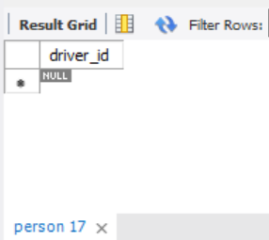

2. List the owner’s name and the corresponding model name of their car

select p.name,c.model

from person p,car c,owns o

where p.driver_id = o.driver_id and c.reg_num=o.reg_num;

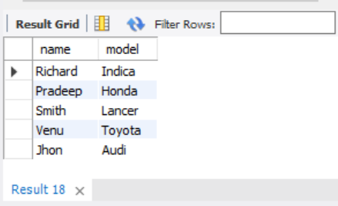

3. List total number of accidents that happened at South Bangalore

select count(report_num) AS total_accidents

from accident

where location="South Bangalore";

